WALT: To subtract whole numbers with more than 4 digits, including using formal written methods
WILF:
- Layout the addition calculation ensuring:
- the biggest number is first
- place value is accurate
- Begin by subtracting from your ones column (if you don’t have enough, borrow from next door)
- Repeat with all the other columns

Enjoy playing these games
https://www.topmarks.co.uk/maths-games/daily10
https://www.bbc.co.uk/games/embed/guardians-mathematica

Example
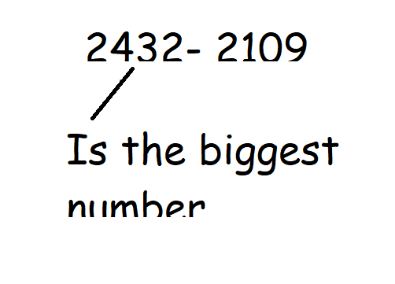

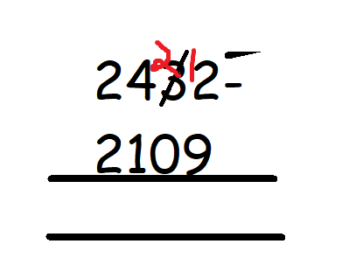

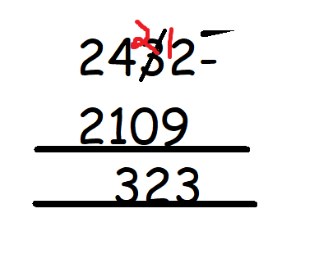

Fluency
- 3545 - 2314=
- 5467 - 1294=
- 7351 - 1034=
- 7463 - 3466=
Challenging
- 12543 - 4563=
- 24300 - 3268=
- 34563 - 23837=

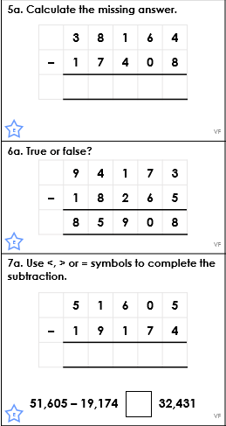

Reasoning

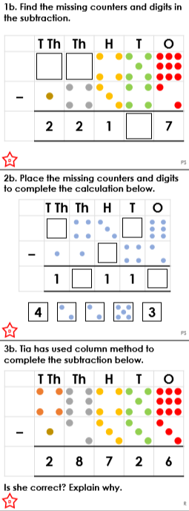

Missing Digits

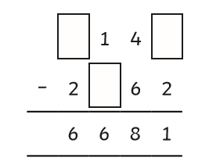

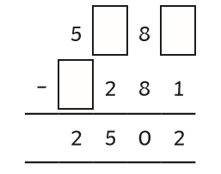

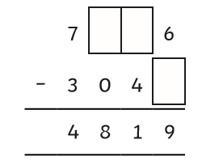

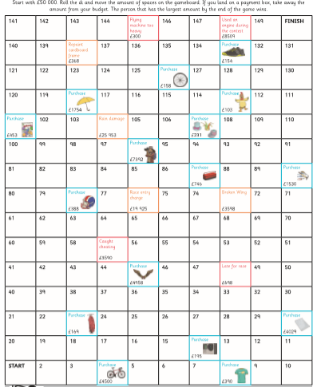
Game

