WALT: To add and subtract whole numbers with more than 4 digits, including using formal written methods
WILF:
- Layout the addition calculation ensuring:
- the biggest number first
- place value is accurate
- Begin by adding the ones column
- Repeat with all the other columns
- If a column adds up to over 10/100/1000, carry underneath
Enjoy playing these games
https://www.topmarks.co.uk/maths-games/daily10
https://www.bbc.co.uk/games/embed/guardians-mathematica

Example
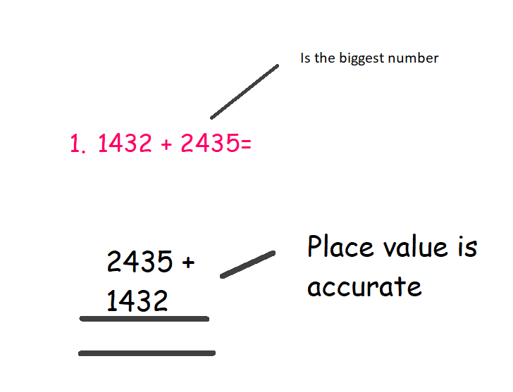

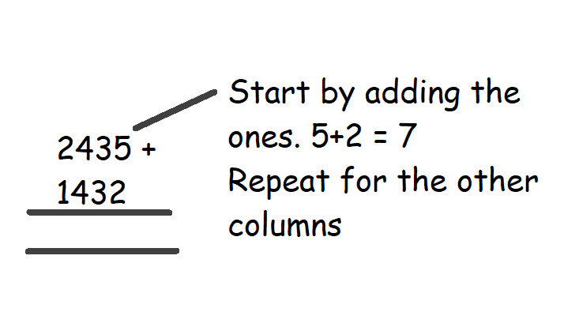

Fluency
- 3545 + 2314=
- 5467 + 1294=
- 7351 + 1034=
- 7463 +3466=
Challenging
- 7351 + 1034=
- 7463 +3466=
- 12543 + 4563=
- 24300 + 3268=
- 34563 + 23837=

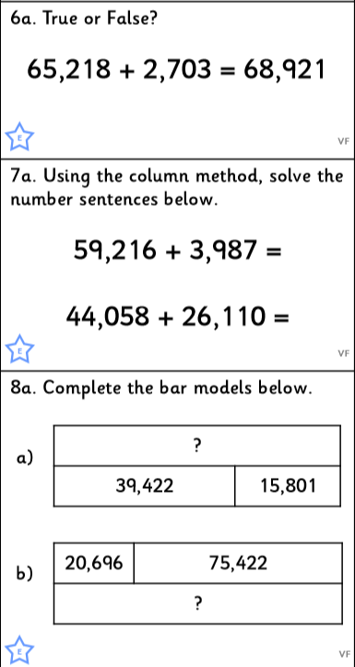

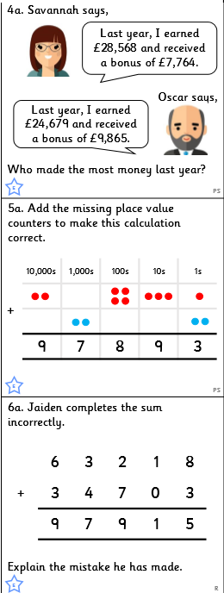
Reasoning

Missing Digits

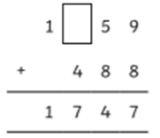

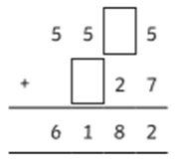

Magic Square
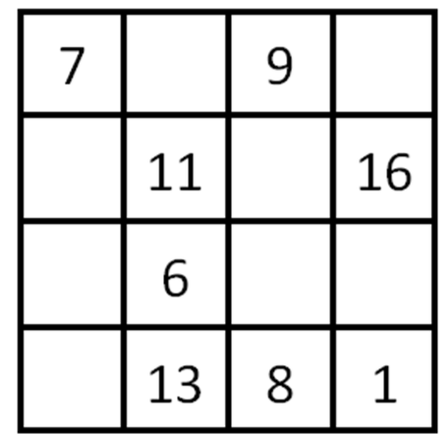

Which boxes can we complete? How?
Which boxes can we NOT complete yet? Why?

