Arithmetic practise
- Remember to locate the hundreds column and add on the hundred
- Short division/ count in 8s
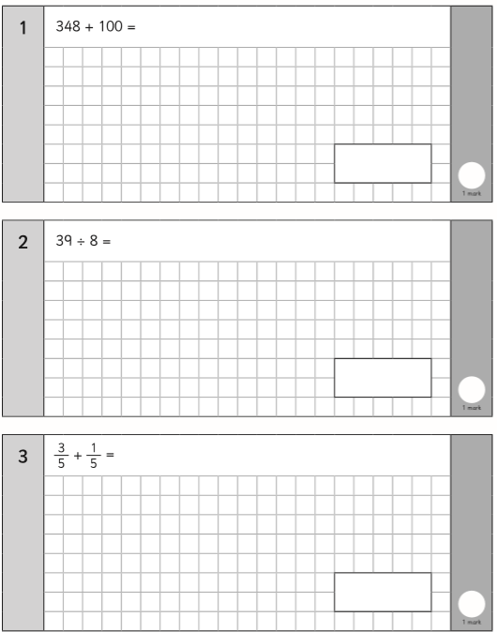
- If the denominator is the same, the answers denominator will be the same

- Remember to put the biggest number first and your place value is lined up accurately

- You could do ten times eight and take one lot away

- Remember your decimal point never moves, put it in the answer box ready
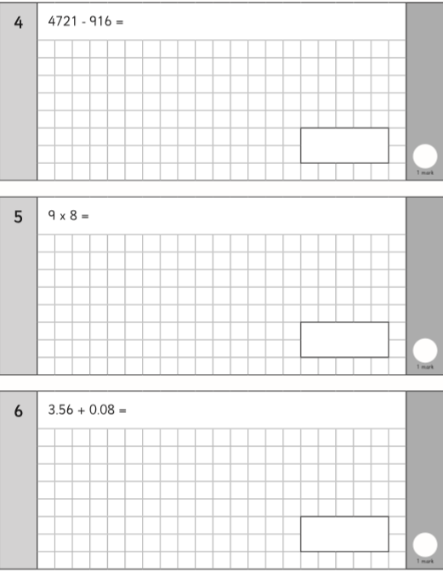

- Put a decimal point after your whole number, remember if you are dividing you move your number left how ever many zeros there are.
- Remember to put the biggest number first and your place value is lined up accurately
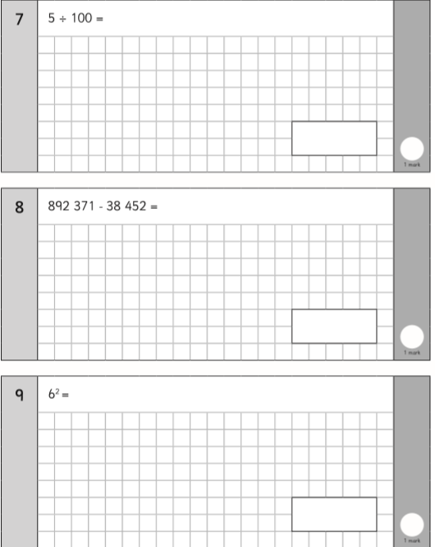
- Remember to square a number, you multiply it by itself
- Short multiplication or cross the zero, do the calculation, place the zero back on to ensure place value is accurate
- You need to change the smallest denominator into an 8, whatever you do to the bottom, you must do to the top
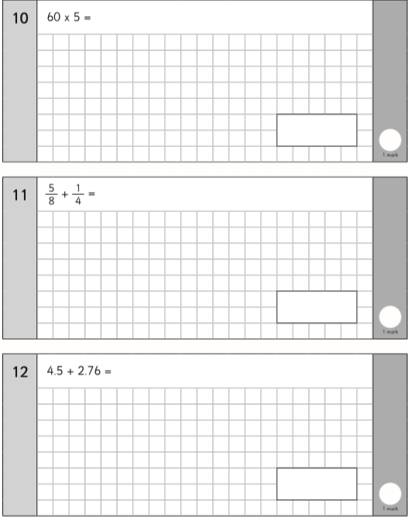
- Ensure your decimal points line up, remember the decimal point never moves

