Arithmetic practise
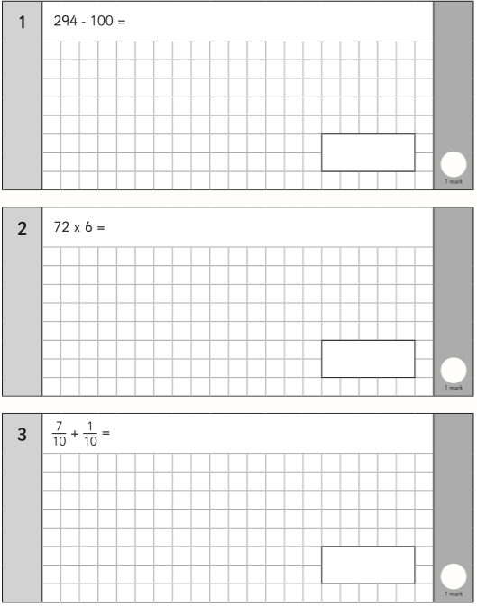
- Locate the correct column and subtract a 100
- Short multiplication
- If the denominators are the same, the answer’s denominator should be the same

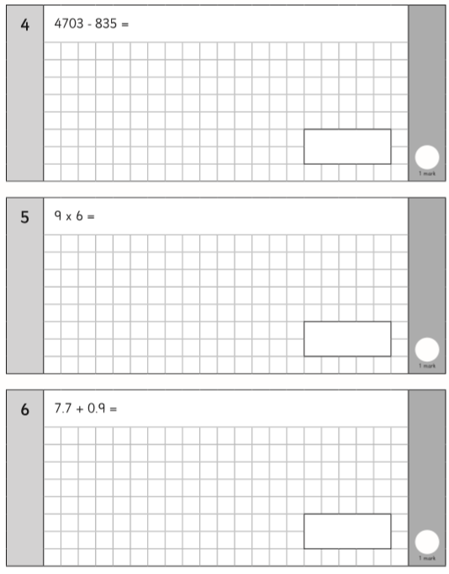
- Column subtraction, biggest number first
- 10 x 6 take away one lot of 6
- Column addition, remember the decimal point never moves

- Remember the number will get smaller, 65.0 move it one place to the left

- Column addition

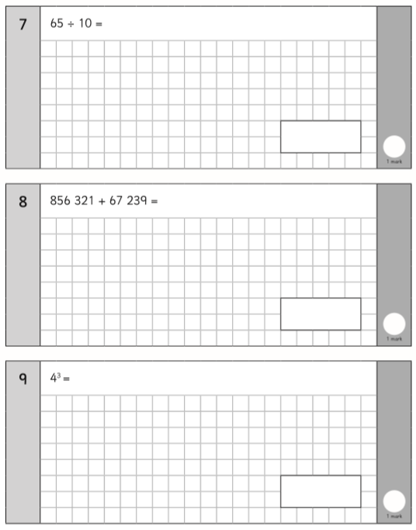
- Cubed = times it by itself and itself again

