To my class,
I hope you enjoyed last week’s learning and I also hope that you managed to check any answers and got some good scores! Remember, it’s my job to help you learn, so if you have any ideas for things that you want to learn about, please let me know.

MrStallard@newvillage.doncaster.sch.uk
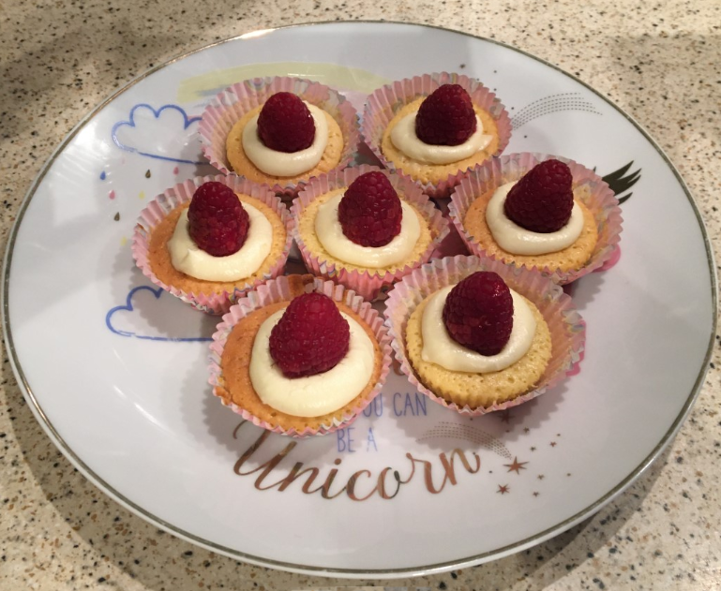
I’m attaching some more photos of things I made last week Yes, my plate does have unicorns on it!

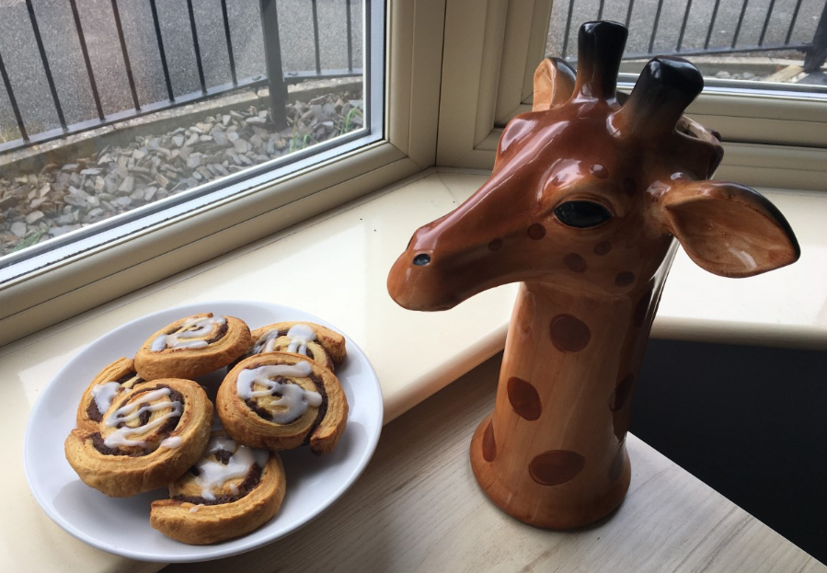
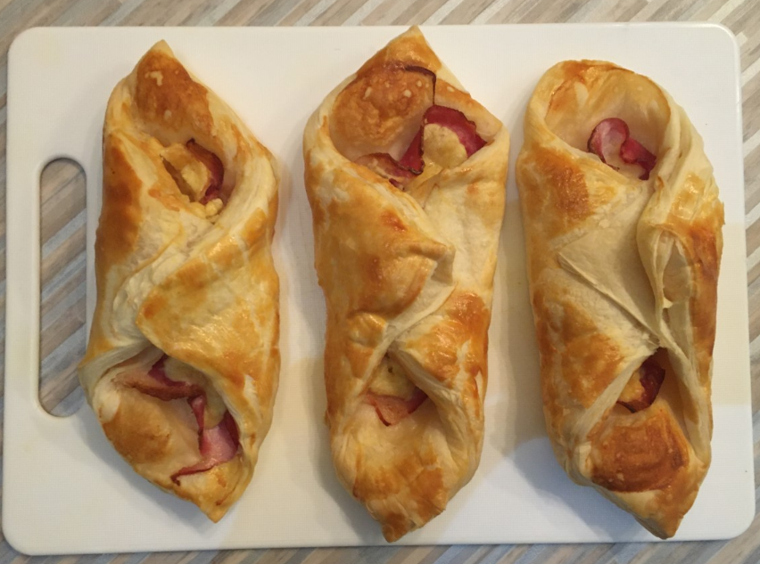
 |  | Week 4
1 | PE | Youth Sport Trust Activity Bingo
2 | Reading and spellings | One for each day  Complete reading activities 1-5  Spelling activities 1-5
3 | Maths | Times Tables Rockstars logins provided and daily learning tasks. I’ll be updating the TTRS website and setting individual Times Tables for those of you who want to use Garage.
4 | English | SPaG mats
Lunch
5 | Science and Music | Introduction to Light and Dark:  https://www.bbc.co.uk/bitesize/articles/zr8thbk  Developing your singing skills:  https://www.bbc.co.uk/bitesize/articles/z7xsf4j
6 | Thrive and Wellbeing | I’m attaching a list of Thrive activities – one for each day. I’ll also write the links for the websites to go to on the page!  I’ve also attached a balloon sheet. I want you to write about all the things that make you amazing and email me some of your favourite ones. Remember – you are amazing!

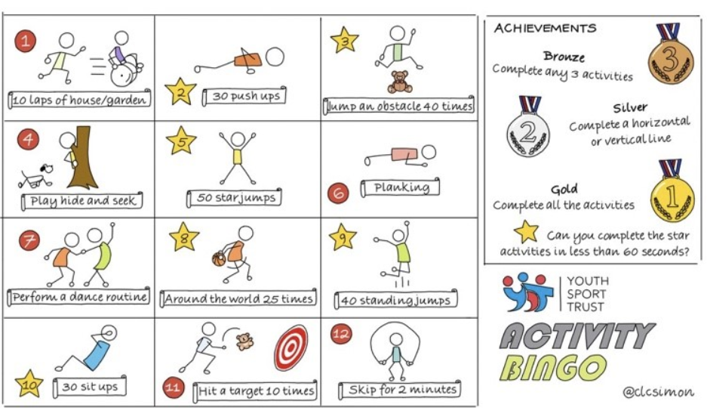

NETFLEX
If you go on our class area on the website and click on ‘Try Mr Stallard’s Exercises’, you can download NETFLEX!

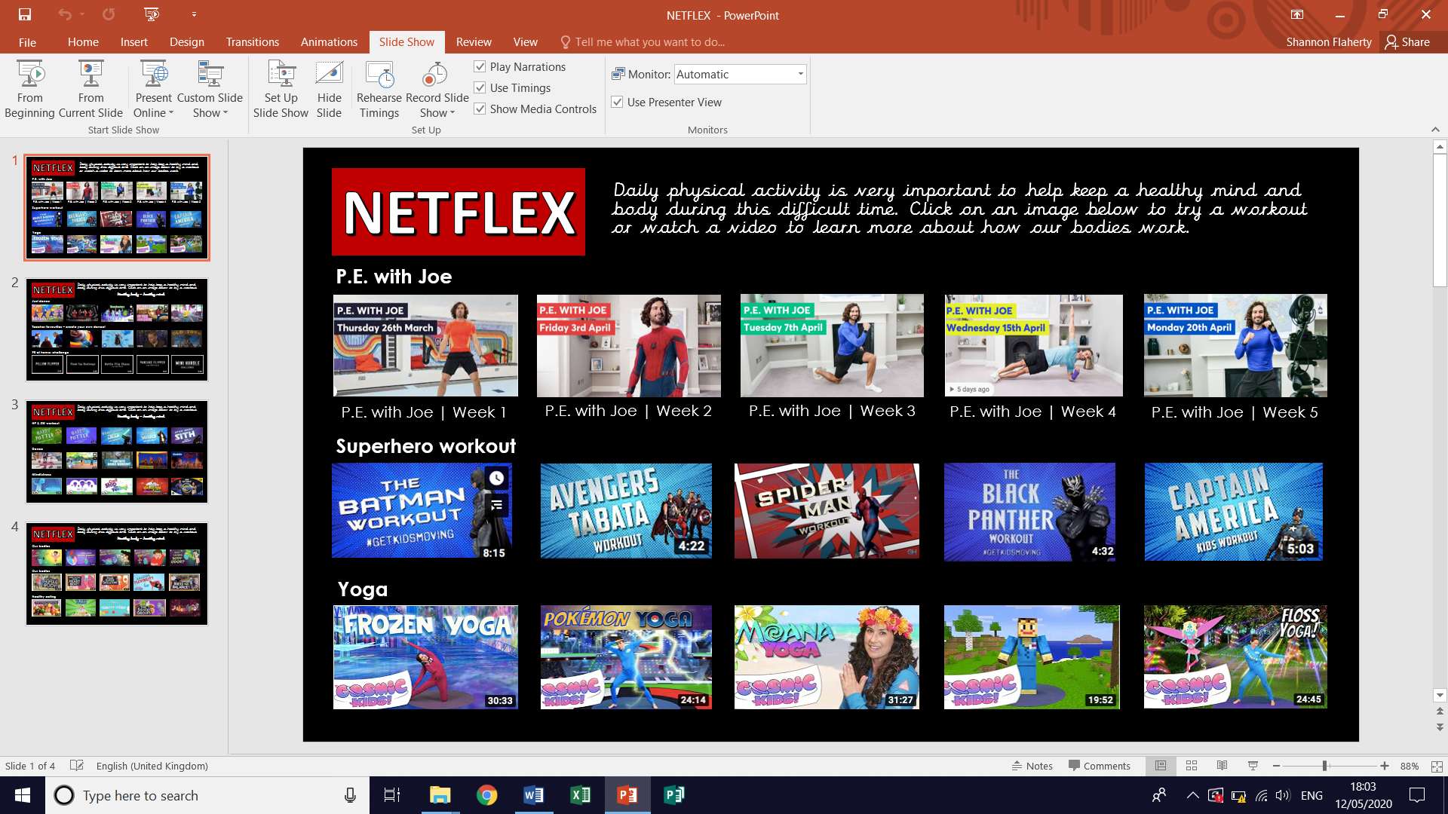
- Scroll through just like you would on Netflix and look at the different exercise activities by clicking on them after it’s gone full screen!
- Click on ‘Slide Show’
- Click on ‘From Beginning’

Reading – choose a book they want to read for Days 1-3

Day 1 | Listen to your child read and ask the questions from the Retrieval with Rex mat.  Ask your child to say some of the answers and possibly write some of them down too.
Day 2 | Listen to your child read and ask 5 questions from the Summarising with Sheba mat.
Day 3 | Listen to your child read and ask 5 questions from the Be an Author with Arlo mat
Day 4 | Spotting a Tsunami reading comprehension activity.
Day 5 | The Official Safe-Tea Shelter reading comprehension activity
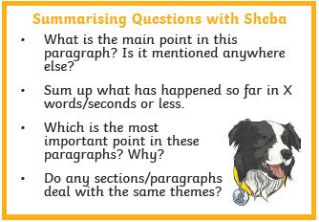
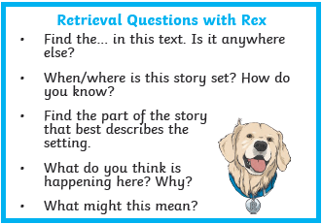

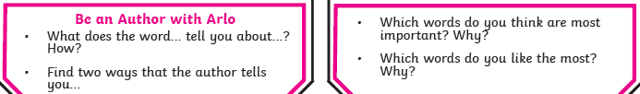

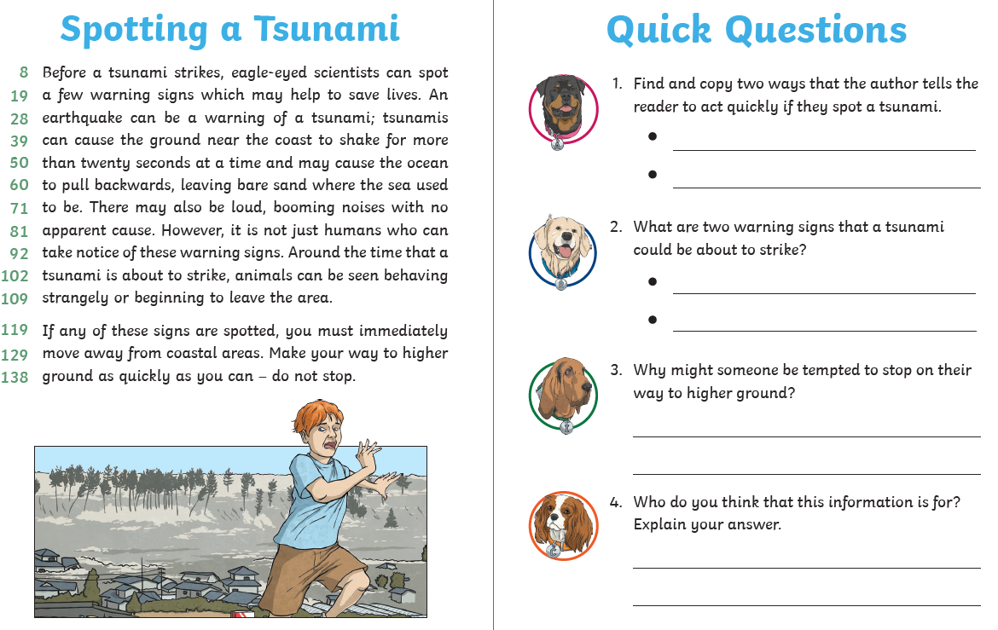
Comprehension Activity 1 Week 6
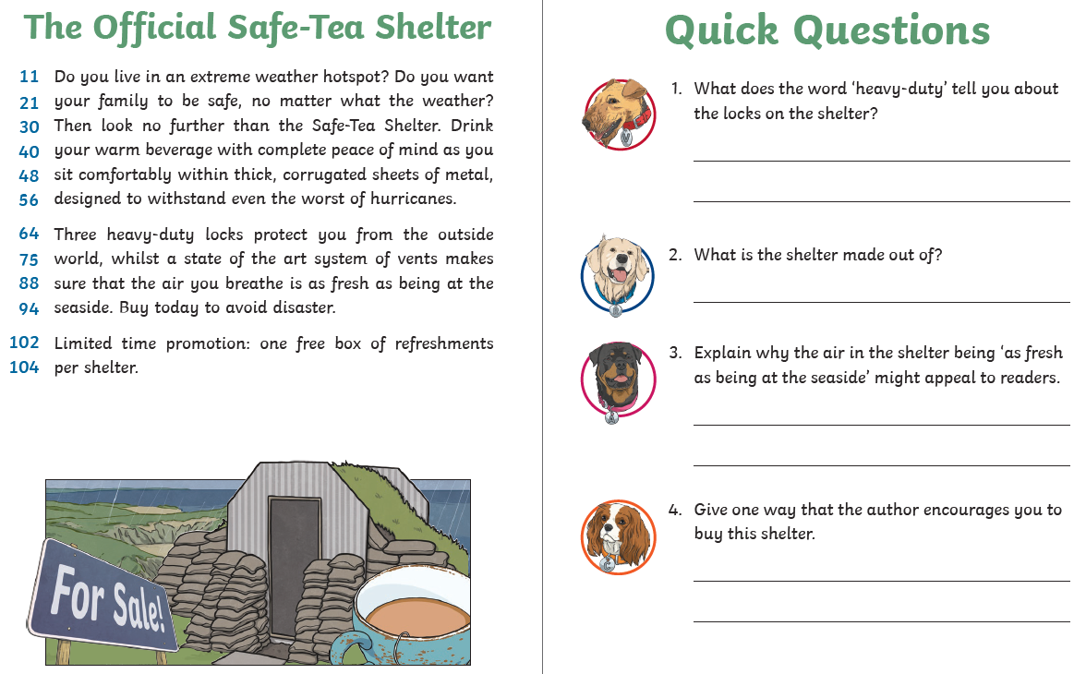
Comprehension Activity 2 Week 6
Spelling – Some of the children are in Group 1 and some are in
Group 2, your child will know which group they’re in.
 | Group 1 – Common exception words Group 2 – Common exception words
DAY 1 | Look, Say, Cover, Write, Check
DAY 2 | Word search
DAY 3 | Handwriting sheet | Which word where?
DAY 4 | ‘climb’ word mat | ‘difference’ word mat
DAY 5 | ‘could’ word mat | ‘difficult’ word mat

NOTE FOR PARENTS AND CHILDREN:
If you’re unable to print any of the sheets off, they can all be adapted. If you can just see the sheet on the screen, all you need is pencil and paper to practice the spellings for Day 1 and Day 3 and the same for Day 4 and Day 5. For the word searches, can you just find the words in order on the screen?
Group 1 – Day 1
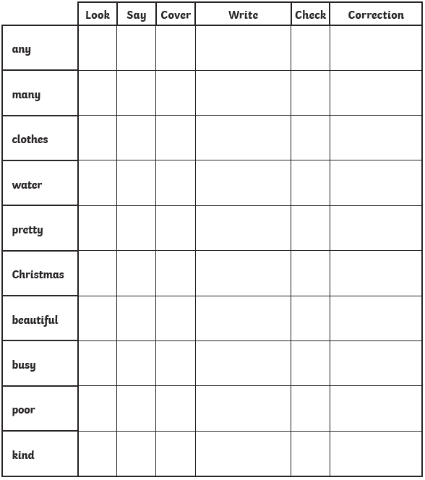

Group 1 – Day 2
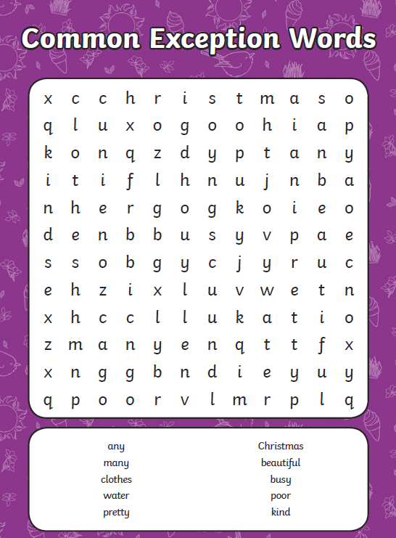

Group 1 – Day 3
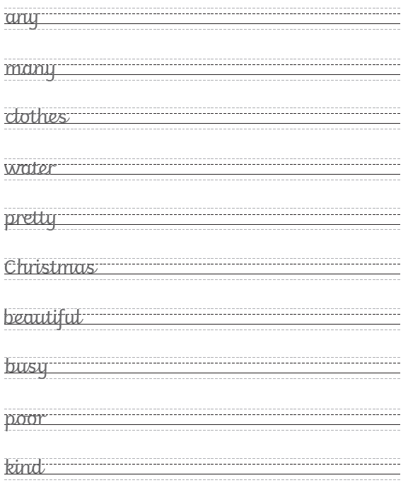

Group 1 – Day 4
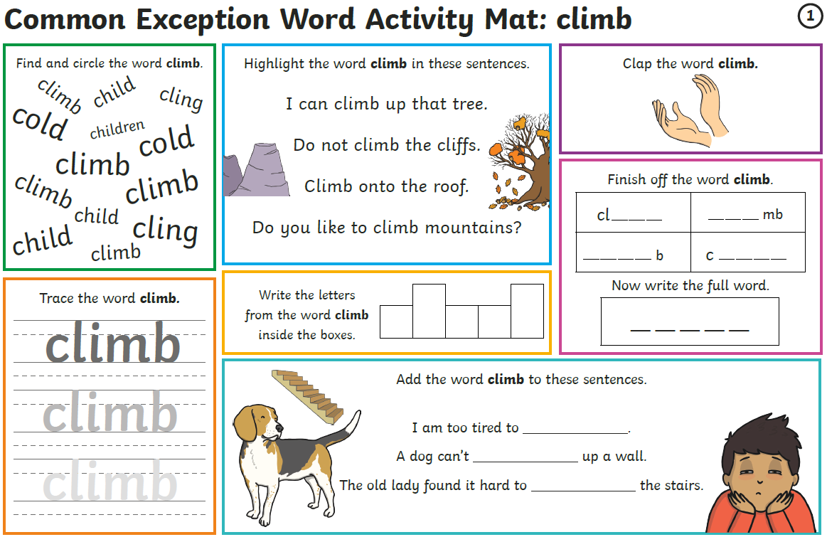
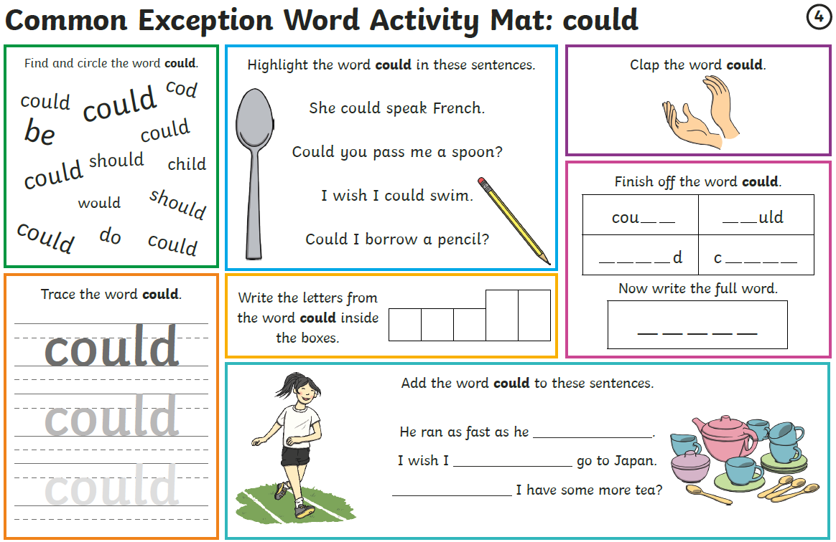
Group 1 – Day 5

Group 2 – Day 1
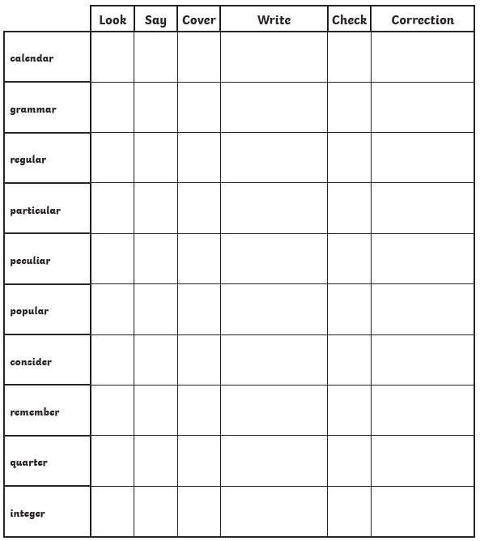
Group 2 – Day 2
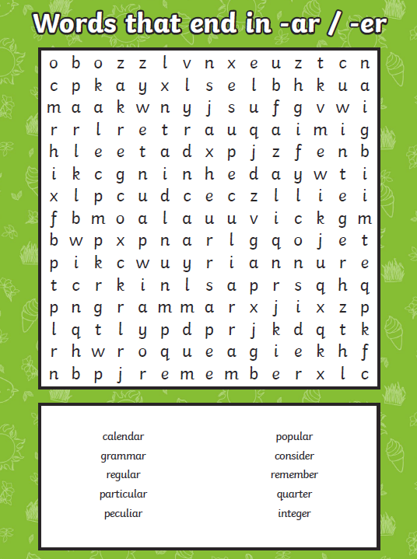

Group 2 – Day 3 ANSWERS AT THE END!
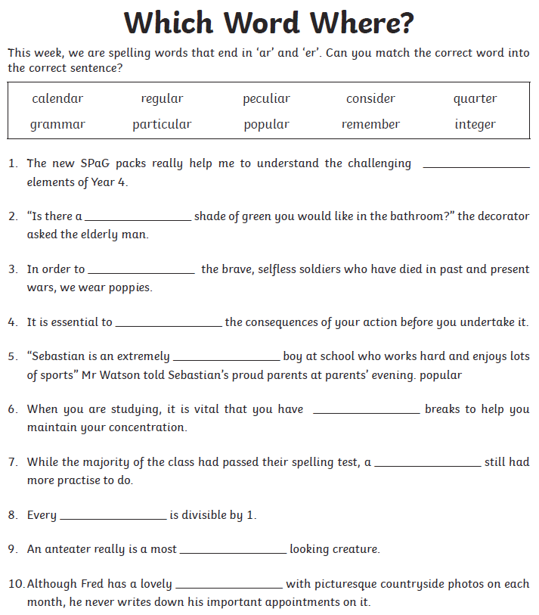

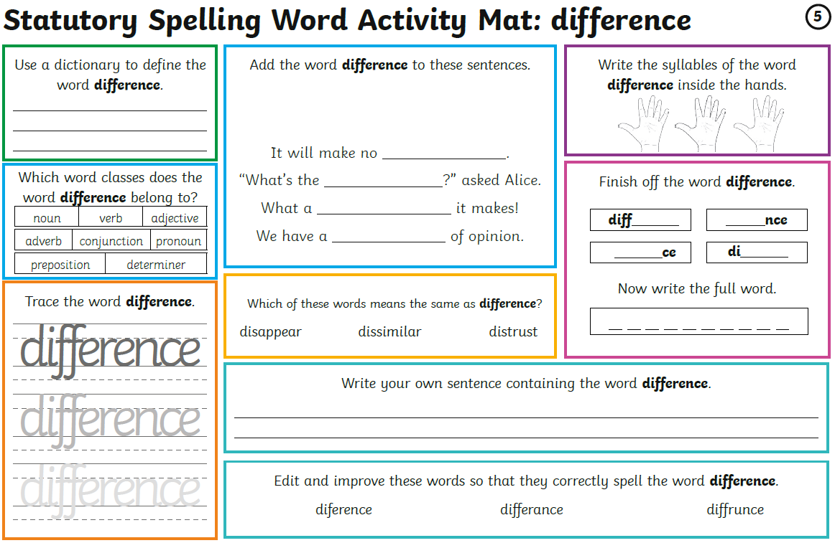
Group 2 – Day 4

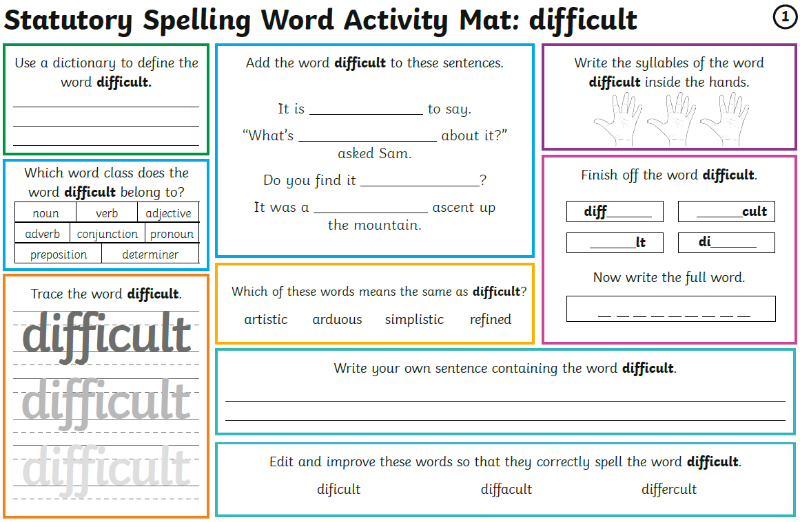
Group 2 – Day 5

Maths – Times Tables Rockstars logins – Please ensure your child is only logging in using their own login details.
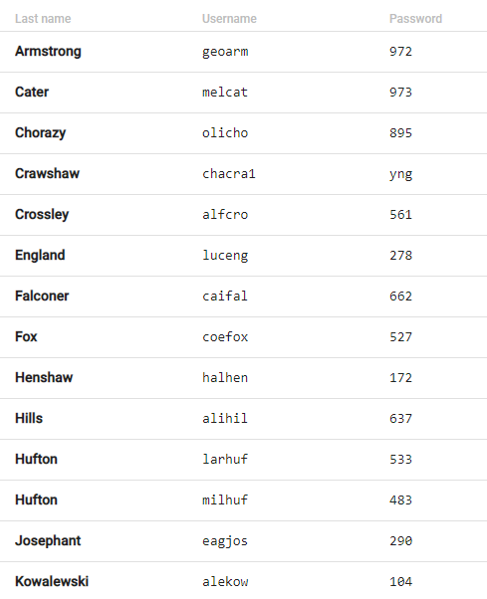
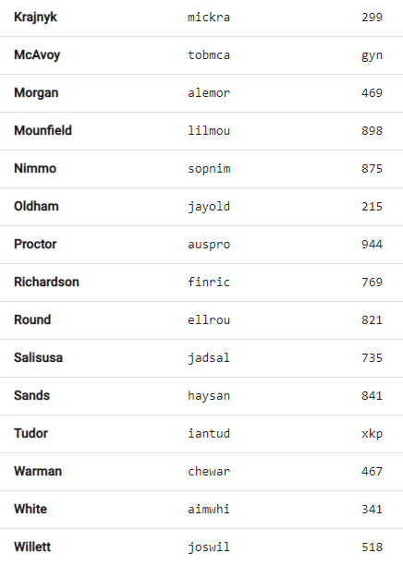
Times Tables Rockstars
WELL DONE to the three most-improved people on Times Tables Rockstars last week – Lily, Halle and Ellie! The challenge is on you now, boys!

We currently have 17 people who are under 6 seconds on Studio which is AMAZING! Unfortunately though, only 11 people went on last week. Let’s try and get that number up this week!

Maths – Week 5 – Place Value

Monday | Tuesday | Wednesday | Thursday | Friday
Go on the BBC link.  Watch the videos and complete the activities.  Answers provided on a link at the bottom of the webpage. | Applying yesterday’s learning to reasoning problems.  Answers in the last pages. | Work on Times Tables Rockstars. | Go on the BBC link.  Watch the videos and complete the activities.  Answers provided on a link at the bottom of the webpage. | Applying yesterday’s learning to a reasoning problem.  Answers in the last pages.

Week 5 – Day 1 - https://www.bbc.co.uk/bitesize/articles/z6vr47h

Week 5 – Day 2
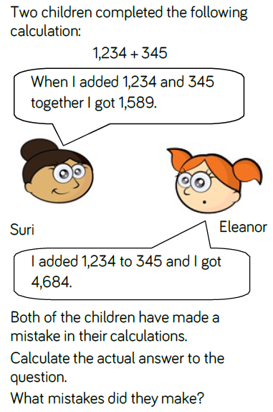
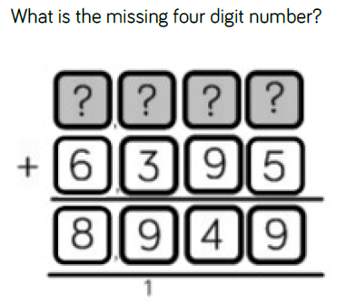

Week 5 – Day 4 - https://www.bbc.co.uk/bitesize/articles/zrtsy9q

Week 5 – Day 5
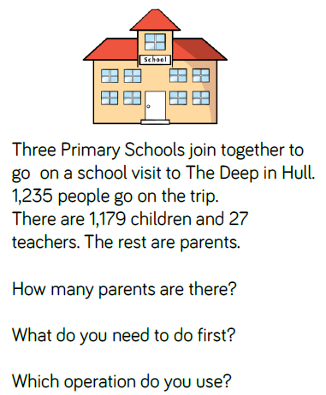
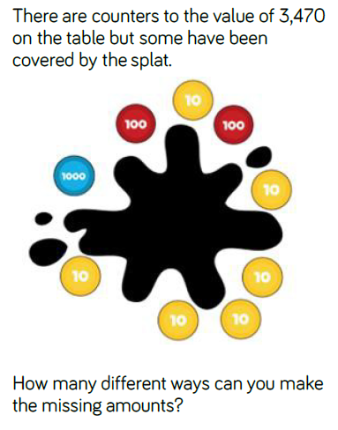

Writing – Day 1
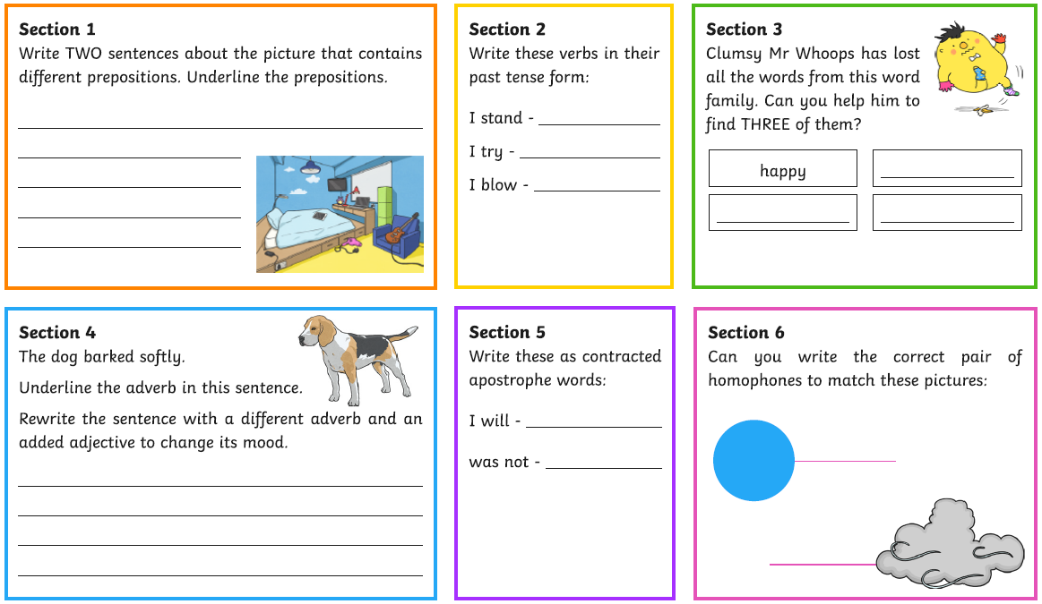

Writing – Day 2
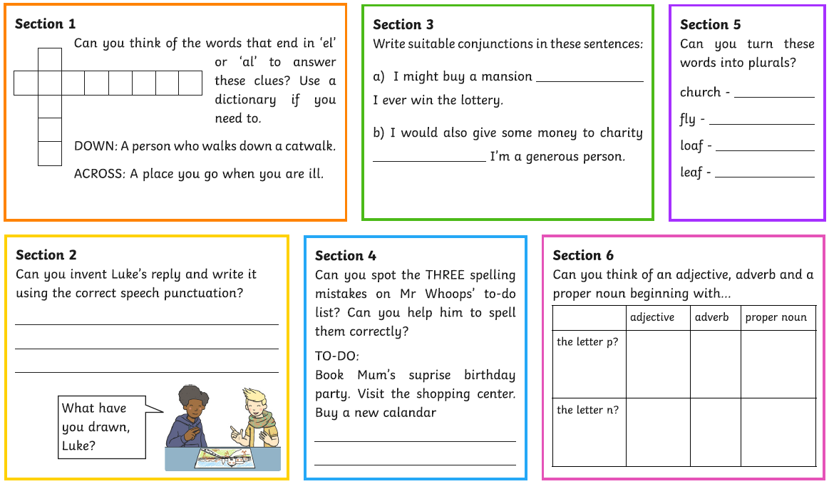
Writing – Day 3
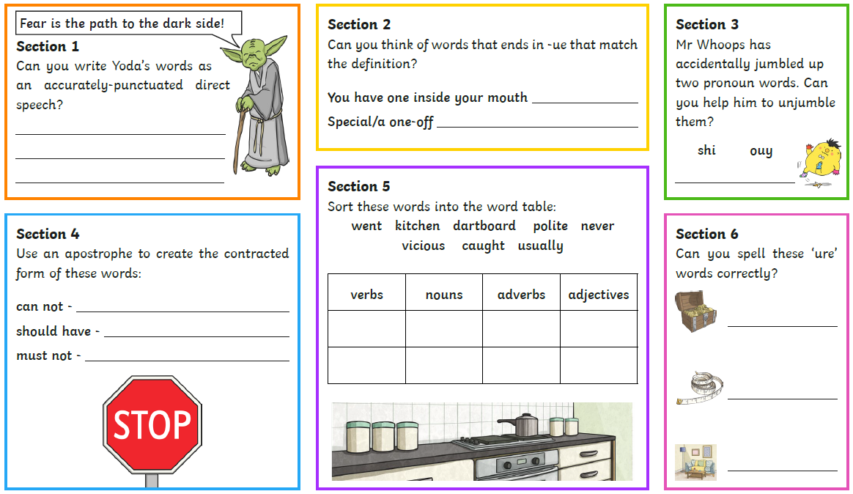

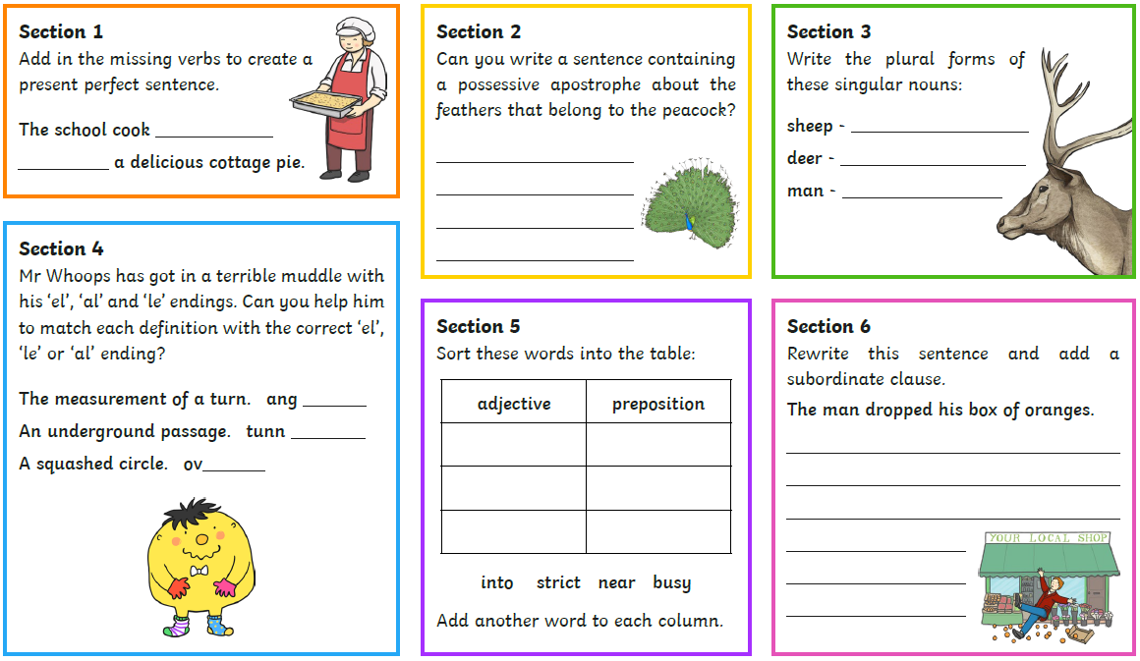
Writing – Day 4

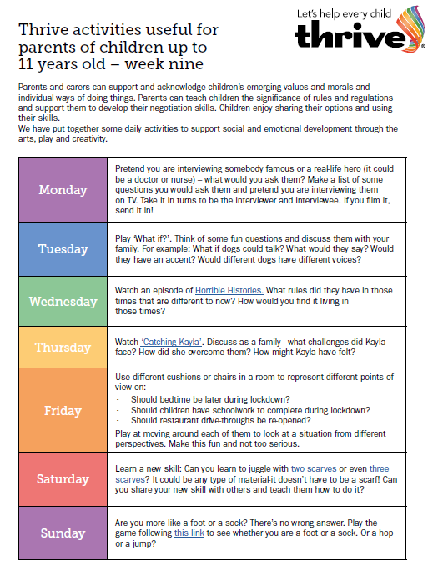
Horrible Histories - https://www.bbc.co.uk/iplayer/episodes/b00sp0l8/horrible-histories#
Catching Kayla - https://www.youtube.com/watch?v=6rZSP9Qqngk
Scarf juggling - https://www.youtube.com/watch?v=ve2FKNctOBg
Are you more? - https://family.gonoodle.com/activities/are-you-more-like-a-foot-or-a-sock

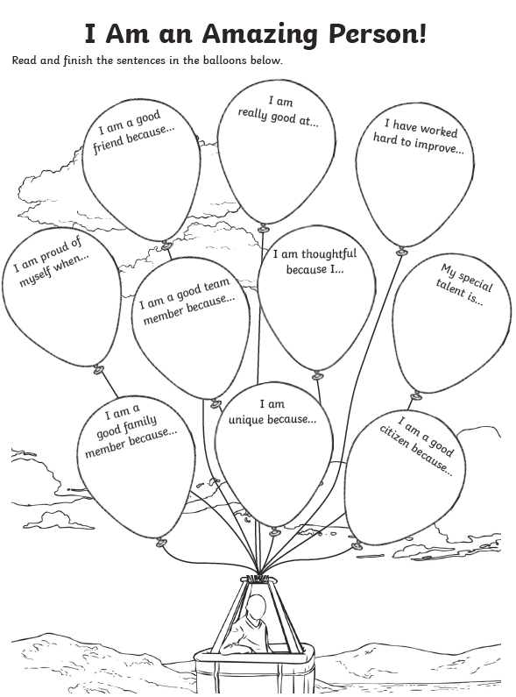
WELLBEING - https://www.bbc.co.uk/bitesize/articles/zbcthbk
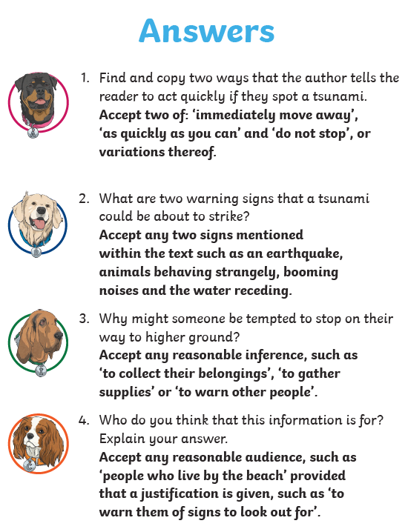
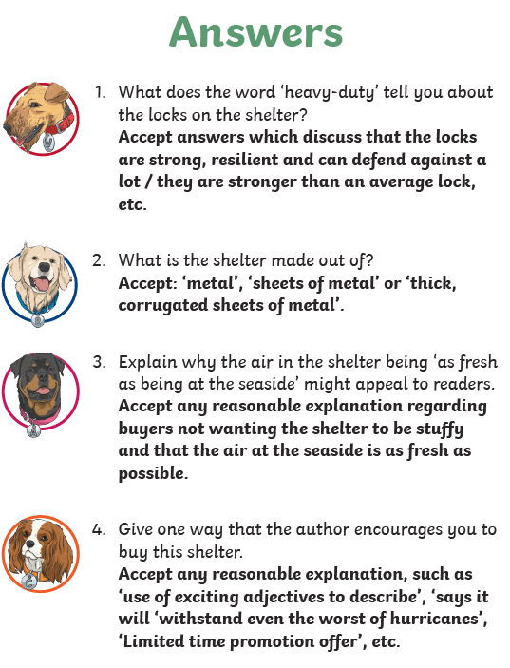
READING ANSWERS
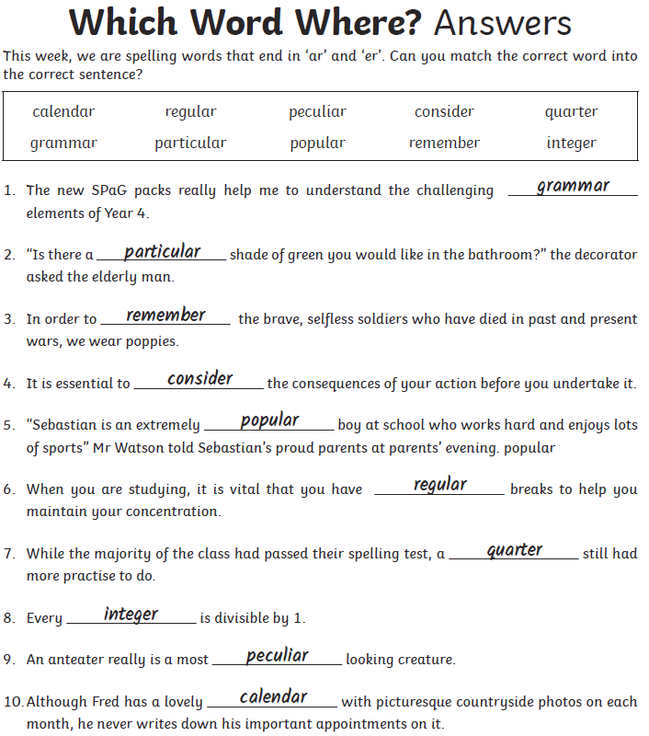
SPELLING ANSWERS

MATHS ANSWERS
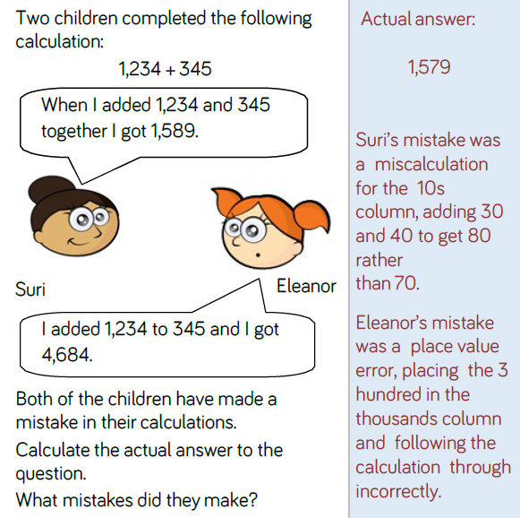
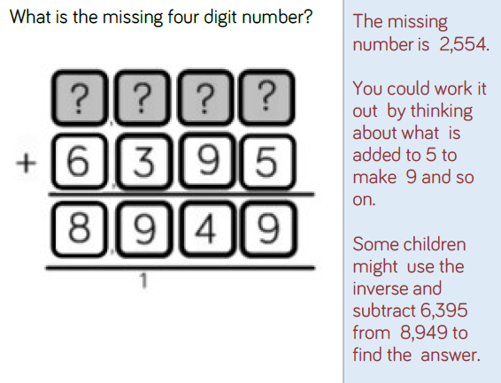

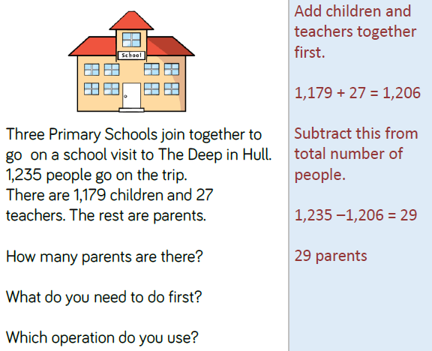
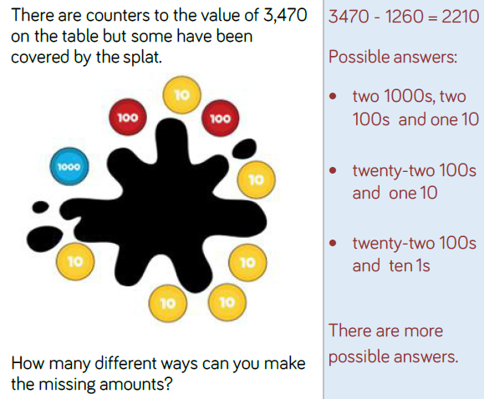
MATHS ANSWERS

WRITING ANSWERS
Day 1
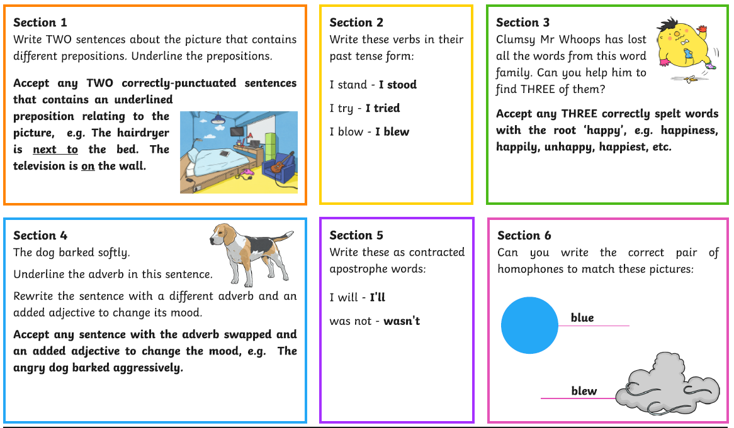
Day 2
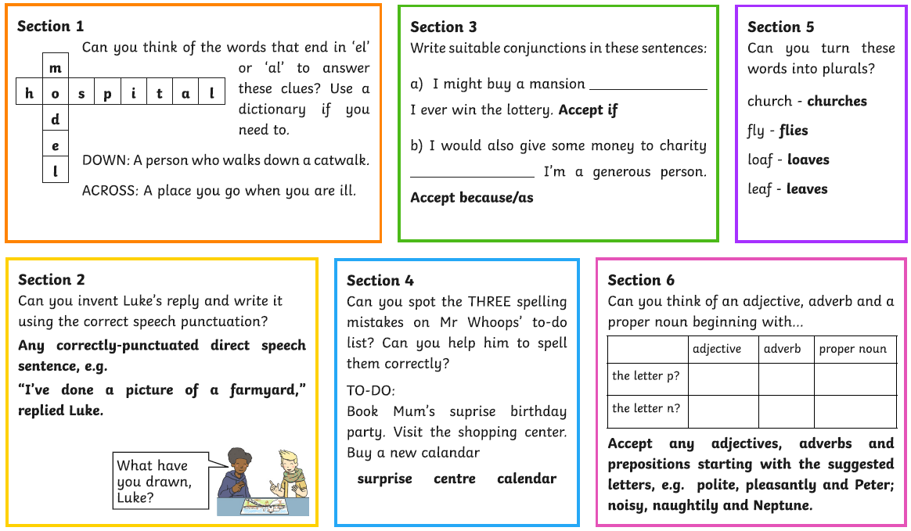
WRITING ANSWERS
Day 3
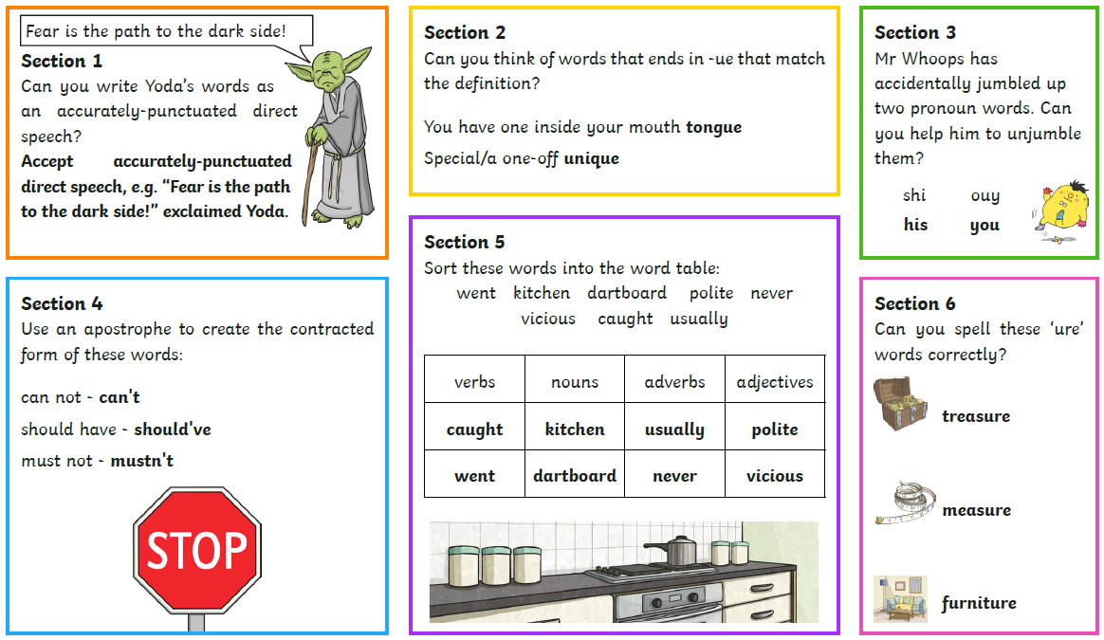
Day 4
