Y3S - Home Learning
Dear Y3S, since we are not able to be together at school at the moment, I have put together some more learning activities that you can complete with your adults at home. Some activities can be printed and there are also some on-line links that may be helpful. I hope that you are all well and look forward to being back together as soon as we can. Miss Shaw
Daily Activities:
 | Activity
9.00 | PE | Take a look at the NETFLEX powerpoint, open it up and choose a link to an exercise of your choice……..superhero….frozen…….Joe Wickes…….anything you like!  You will find the instructions below.
Activity 1 | Maths  (30 mins) | Follow the link below to find daily BBC bitesize Maths activities  https://www.bbc.co.uk/bitesize/tags/zmyxxyc/year-3-and-p4-lessons/1
Activity 2 | Times tables  (15 mins) | Log in to Splat 100 square and splat your counting patterns.  https://www.primarygames.co.uk/pg2/splat/splatsq100.html  Monday 2’s  Tuesday 4’s  Wednesday 8’s  Thursday 3’s  Friday 6’s  For each daily pattern count it forwards and backwards….as a challenge, can you count them forwards then backwards with your eyes closed?  Then log into TTRS and complete 10 minutes practice on the studio section.  Studio helps you to extend your learning as you are using all the times tables.
Activity 3 | Spelling  (10 mins) | Write the spellings for this week just like we do every day in the classroom. Remember LOOK / COVER / WRITE / CHECK  LOOK at the word carefully  COVER the word  WRITE it from memory  CHECK your spelling  Then use the words in a sentence – if you are not sure of the meaning you can ask an adult / check it in a dictionary / check using an on-line dictionary.  The words that I have selected this week all belong to word families.  scope  telescope  microscope  horoscope  periscope  inspect  respect  spectacles  spectator  perspective
Activity 4 | Handwriting  (5 mins) | Use the prepared line guide or just a piece of paper to write the joins used in our selected spellings.  scope spect
Activity 5 | English  (30 mins) | Follow the link below to find daily BBC bitesize English activities  https://www.bbc.co.uk/bitesize/tags/zmyxxyc/year-3-and-p4-lessons/1
Activity 6 | (30 mins) | Look at the other learning opportunities listed below and select one to do each day!

Other learning opportunities
Choose an activity each day

Music | https://www.outoftheark.co.uk/ootam-at-home/?utm_source=homepage&utm_campaign=ootamathome2&utm_medium=banner  Log on to the above website. Here you will find lovely songs to sing, just like the ones that we use every week in singing assembly.  Choose a song  Listen to it all the way through and spot any repetition  Join in with the song the 2nd time through, following the words on screen.  Make up your own actions or even dance moves, and don’t forget to follow the links for other activities related to each song  This week, I’ve been singing “Florence Nightingale” from the “Sing in every subject” pack because the Nightingale hospitals around the United Kingdom are named after her. Once you have joined in with the song, have a look at the related activities page……just click and download.
Geography | Florence Nightingale was named after a city in Italy. Can you find out some key facts about Italy? Click on the links below to help you.  https://www.natgeokids.com/uk/discover/geography/countries/facts-about-italy/  https://www.kids-world-travel-guide.com/italy-facts.html
Art | I hope that you enjoyed the workshops last week, provided by local Sheffield Artist Pete McKee. Have a go at drawing characters with super powers … all you need is a pencil and paper. Mrs Charlesworth and I had a go and it was really good fun. Don’t forget to look out for little Eric and keep watching until the end for a top tip!  https://www.youtube.com/watch?v=0K42wc8nKTQ
ICT | Send me an email to the address below and include an emoji to let me know how you feel. Some people like to include a photograph of something that they have made or something enjoyable that they have done.  MissShaw@newvillage.doncaster.sch.uk
PSHE | Think about ways that you can enjoy yourself after the lockdown ends.  Did you know that Florence Nightingale lived in Derbyshire? Derbyshire is not too far from Doncaster and is lovely for a day out. Why not plan a day in Derbyshire with your family for later in the year?  Make a list of things that you would like to see and do in Derbyshire and pop it in a “dream jar” so that you can keep it for when the lockdown is over. The first thing on my list is a trip to Chatsworth and a visit to the Bakewell Pudding shop!
History | Around the UK we have a number of Nightingale hospitals named after Florence Nightingale. Follow the links below to find out why Florence Nightingale was so famous.  https://www.youtube.com/watch?v=jONlz7vaMnU  https://www.florence-nightingale.co.uk/florence-nightingale-biography/  https://www.natgeokids.com/uk/discover/history/general-history/florence-nightingale/
DT | In science we are learning all about the body, digestion and how to keep healthy. For your DT homework, why not have a go at making your own fun pizza faces using the recipe below. Pizzas originate in Italy and you may have already found out some facts about Italy using the links above.
Science | Since we have an Italian theme to our learning this week, why don’t you have a go at making structures with spaghetti!!!!!!!  Follow the link below and download “Spaghetti structures” – all you need is some uncooked spaghetti and some marshmallows  https://learning.sciencemuseumgroup.org.uk/learning-resources/  If you can’t print off the resource, I have included it below for you to read online.
Exercise outdoors a little bit each day. Set yourself a daily challenge! |  | A zoom night in!  I have just learned how to use “Zoom” to connect with other people. Why not link up via zoom with friends or relatives for a quiz night.
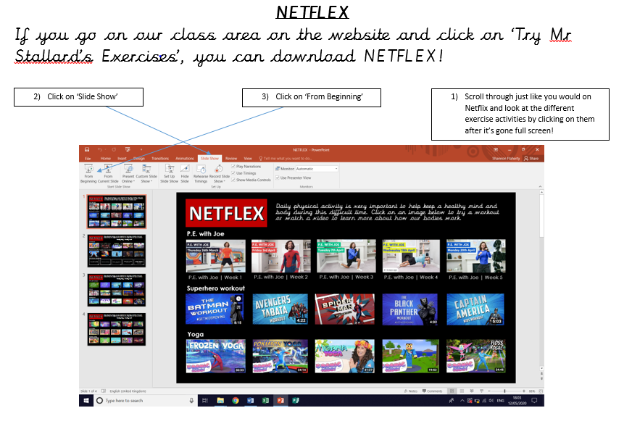
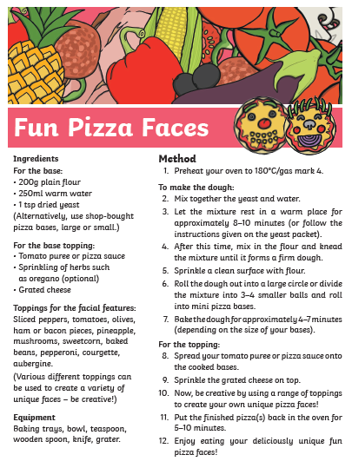

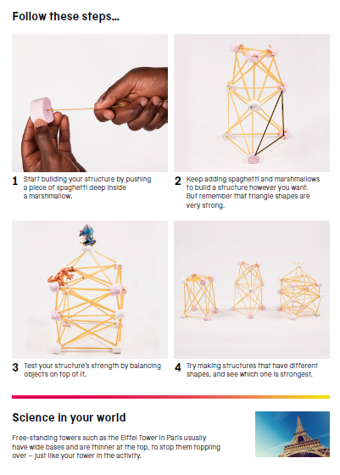

Use the lines below to write a sentence using each of these words – remember to use

your joined handwriting

