Colour the box when you have completed the challenge!
LIFE SKILLS BINGO
Make a sandwich | Bake some cakes | Make your bed | Lay the table for dinner | Practice wrapping up gifts in paper
Help with the washing up/ stack the dishwasher | Clear the table | Get dressed independently | Tidy a cupboard/drawer | Price comparison searching for groceries online
Peel vegetables | Help with the dusting | Help pull the weeds in the garden | Vacuuming | Learn how to tie shoelaces
Tidy up your toys | Help to feed your pets | Help to wash the car | Fold the laundry

GENERAL LEARNING SKILLS BINGO
Create and fly a kite | Make a paper boat | Write a letter / email to a relative | Hide something and make a treasure map | Record sounds and ask others to guess what they are
Make a puppet from your favourite book | Create a board game | Learn a poem/song off by heart | Create a shop where you buy/get change | Create a detailed self-portrait using a mirror

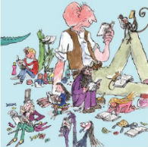
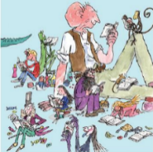
Home Learning Menu
Choose a minimum of three learning challenges to complete.
Art
Choose one of the interesting characters from a Roald Dahl book and draw/paint/create it using your own choice of paper, paint, pencils, crayons, charcoal, pastels or felt tip pens.
Roald Dahl Book Review
Choose a Roald Dahl book. It might be your own or one you have heard or seen in a film. Write a short book review…what is the book about?, Is it funny or sad? Do you like it? Why?
Science Investigation
Carry out the Science Investigation on the back of this page

Reading challenge
Read a book every day/night for one week!
Maths
Copy these number sentences and work out each of the fractions of all of these numbers.
What is ½, $⅓$, ¼, $2/4$, ¾ of 12?
What is ½,$⅓$, ¼, $2/4$, ¾ of 24?
What is ½,$⅓$, ¼, $2/4$, ¾ of 36?

Science / Gardening
Try and grow a plant (fruit/vegetable/flower/herb) in your home or garden. Take photographs to show what the seed or cutting looked like at the beginning and at the end.
Physical Challenge
Use https://www.jumpstartjonny.co.uk/ and learn the three dances.

Roald Dahl story
Choose a character from a Roald Dahl story such as Matilda or Charlie and write a short story involving them. Maybe you will also be in the story? Where will the story be set? Will it have a happy or sad or funny ending?

Maths
Carry out the Maths Investigation on the back of this page, either cut it out or copy the circles and squares onto a blank piece of paper and colour in.

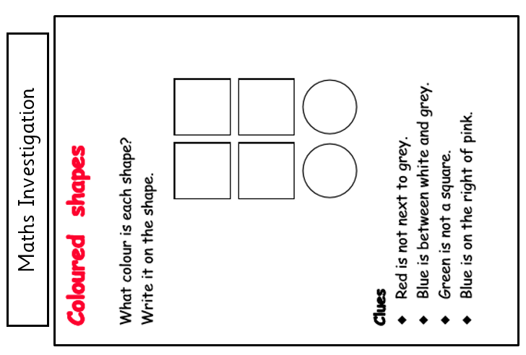

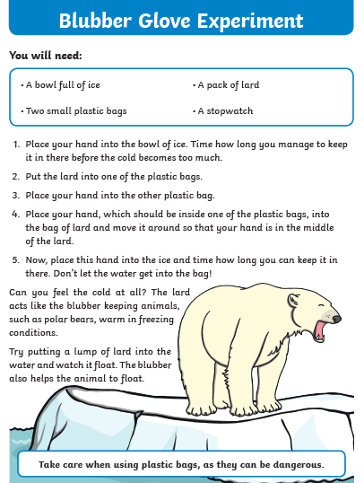
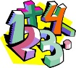

Ideas for home learning activities
Using and Applying Mathematics
- Use buttons, shells, toys etc. to make up number problems e.g. how many shells will I have if I add 3 shells and 2 shells? Or how many shells will I have if I start with 5 and take 2 away? Ask your child to talk about what they are doing. Encourage them to use mathematical language.
- Play shops and use real money, pay and give change.
- Create patterns with shapes and ask your child to describe them.
- Create number patterns with magnetic numbers, can your child explain what the pattern is and perhaps continue the pattern.
Counting and Understanding Numbers
- Exploit opportunities for counting around the house - when putting jigsaws away count the pieces; count how many pieces of fruit there are in the fruit bowl etc. Encourage your child to estimate first and then check by counting.
- Cut cakes, sandwiches and fruit into halves and quarters.
Calculating
- Exploit opportunities for adding and taking away in the home e.g. laying the table, ‘how many more knives do we need if nanny and granddad come to dinner?’
- Use a pack of playing cards to find pairs of cards that total 10. Write down the relevant number sentences. How many different ways are there of making 10, 11, 12…20? Can more cards be used?
- Count pairs of socks (counting in twos), count fingers and toes (counting in fives), count fingers on both hands and toes on both feet for a group of people (counting in tens).
- Sort socks, gloves, shoes etc. into pairs. Share buttons, shells, sweets etc. into equal groups of 2, 5 and 10.
Measuring
- Estimate and measure distances in standard measures like centimetres. Estimate how many apples weigh the same as a bag of flour. Weigh accurately. Estimate how many cups of water would fill a bowl. Test.
- Write the names of the days of the week and the months of the year on cards and ask your child to arrange them in order.
- Link the days to things that mean something to your child e.g. swimming, gym club and the months to special family events like birthdays.
- Refer to the clock throughout the day. What time is it now? We have to leave in 15 minutes, what time will it be then?
- Go to the shop and pay with real money – let your child gather the right amount of money. If you need change, how much change will you need?
Shape
- Look for and identify different shapes around the house and in the environment. Ask how they know it is a triangle or a square or a cube etc. Make up shape games. How quickly can they find 5 triangles in a particular room?
Statistics
- Make up a simple shopping list. Ask questions about it.
- Invite your child to ask people what their favourite fruit is and use stickers, draw pictures or plastic fruit to display the results.

Writing ideas and activities

Riddle  Write a riddle of an animal and see if your family can guess what you are.  You could even write a riddle about someone in your family. |  | Alphabet adjectives  Can you write the alphabet a….z and think of an adjective that begins with each letter,  e.g. a – angry, b – beautiful.
Letter  Write a letter to a friend or family member. |  | Synonyms  How many words can you make that mean the same as said?  e.g. whispered, shouted  What about big or little?
Boggle  How many words can you make using these letters?  a e s t h m n i g r  e.g. ring shirt hit |  | Boggle  How many words can you make using these letters?  b d o u n r s g t e  e.g. gate bed sound
Rhyming words  Write lists of rhyming words. How many words can you write in one minute?  e.g. cat, hat, bat, flat….. |  | Spelling  Practise the common exception words that came home in your Year Two Home Learning pack.

Arithmetic practice
It would be beneficial for your child if they practised simple arithmetic daily.
Calculation | Types of numbers | Examples
Addition | Add 2-digit numbers where the total equals less than 100. | 23 + 45 = | 59 + 34 = | 12 + 10 + 15 =
Subtraction | Subtract 2-digit numbers less than 100. | 50 – 20 = | 65 – 22 = | 94 – 68 =
Multiplication | Multiply two numbers less than 12, where one of the numbers is 0, 1, 2, 3, 5 or 10. | 8 x 0 = | 12 x 5 = | 2 x 7 =
Division | Divide two numbers where the divisor is either 0, 1, 2, 3, 5 or 10.  The answer should not include remainders. | 20 ÷ 5 = | 60 ÷ 10 = | 24 ÷ 2 =

Answer these questions over a few days and then ask an adult write out new number sentences for you to do.
32 + 15 =  42 + 49 =  70 – 25 =  11 x 5 =  3 x 10 =  48 + 48 =  18 ÷ 3 =  20 ÷ 2 =  48 – 25 = | 48 + 23 =  51 + 39 =  40 – 32 =  8 x 5 =  4 x 10 =  48 - 28 =  21 ÷ 3 =  18 ÷ 2 =  19 – 15 = | 64 + 8 =  74 + 11 =  87 – 7 =  6 x 5 =  6 x 10 =  31 -20 =  24 ÷ 3 =  40 ÷ 2 =  38 – 27 = | 20 + 75 =  8 + 9 + 7 =  51 – 24 =  4 x 5 =  7 x 10 =  68 - 40 =  20 ÷ 5 =  60 ÷ 2 =  84 – 38 = | 19+ 79 =  10 + 10 + 7 =  45 – 28 =  10 x 5 =  8 x 10 =  87 - 29 =  40 ÷ 5 =  8 ÷ 2 =  56 – 27 =

