Hello Year 2,
Well this week should have marked half term so I am not setting you too much work this week ( I hear you all cheer!) YOU DO NOT NEED TO PRINT ANYTHING OUT!

I am really missing you and I know Mrs McKechnie will be explaining everything about coming back to school as soon as she knows more.

For now, I hope you are just being children, discovering life and new things every day. I have had some lovely family time with my boys, Charlie and Harry and it is time I will probably never get again so we should feel blessed that we have this time.

I hope you are all keeping safe and well and I hope you enjoy your work this week. Stay safe and I hope to see you all soon!

Be nice to your parents!

Mrs Hemmingway

Monday
Reading | Phone another family member and read to them on the phone for 5 minutes.
Writing | Using the writing sheet, make your own poster about the seaside and write one word next to each letter that reminds you of the beach. | 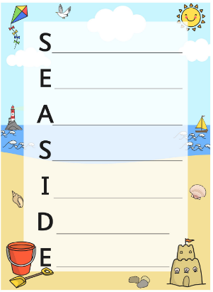
Maths | Spend half an hour playing on the maths games. Login details are at the end of the document. | https://sso.prodigygame.com
Topic | Look at the picture with an adult. What can you see in the picture that is dangerous? What should you do to keep the children as safe as possible? | 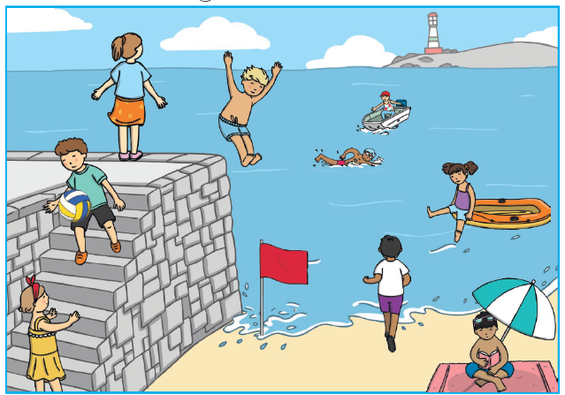

Tuesday
Reading  Read the text and answer the questions your adult asks you (also included) | 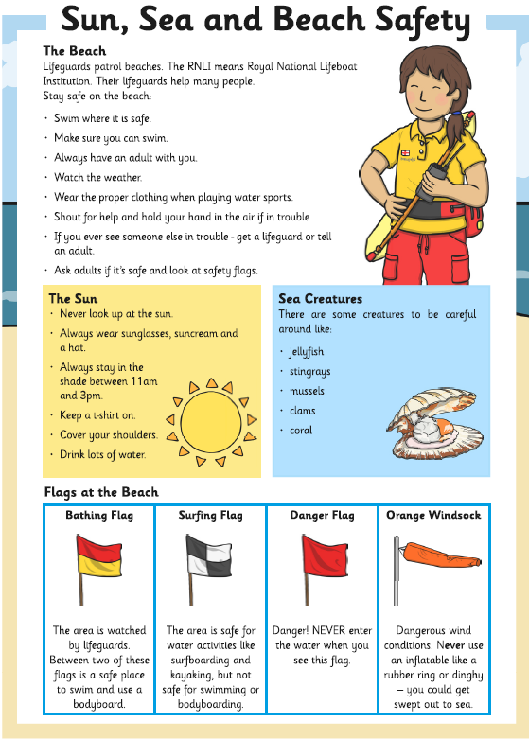 | 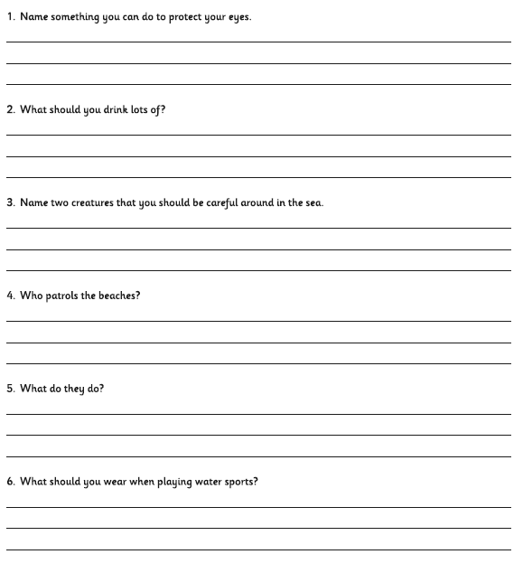
Writing | Write a short paragraph about a trip to the beach you remember. Make sure you include capital letters, full stops and finger spaces.
Maths | Spend half an hour playing on the maths games. Login details are at the end of the document. | https://sso.prodigygame.com
Topic | Discuss the beach safety flags with an adult.  Make sure you know what they mean.  Maybe you could make your own poster to explain their meaning. | 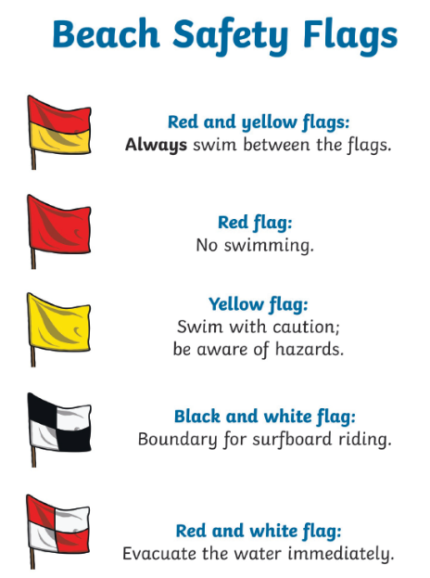

Wednesday
Reading | Set a timer for 1 minute. Read a book to your parents. How many words did you read? Try again 4 more times, can you beat how many words. | Your child should be reading 90 words per minute.
Writing | Copy the common exception words here in your best handwriting.  Can you learn how to spell the words? | 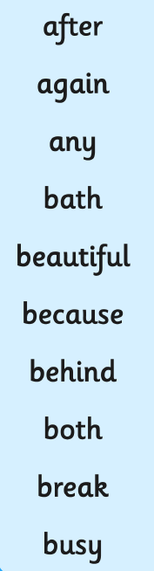
Maths | Spend half an hour playing on the maths games. Login details are at the end of the document. | https://sso.prodigygame.com
Topic | Draw a beach bag on a piece of paper and label inside what you are going to take to the beach with you. Think what would be helpful to keep you safe.

Thursday
Reading | Sit with your adult – read as many of the Common Exception words as you can. Let your adult help you with those you struggle with. | 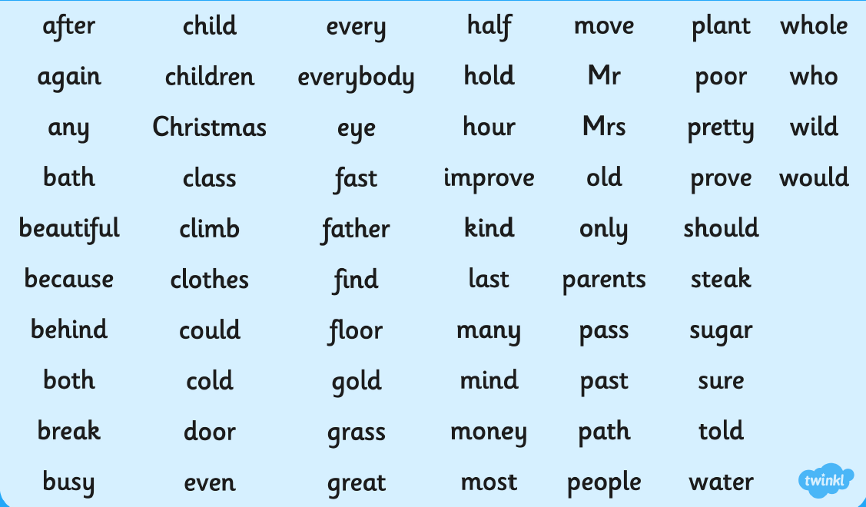
Writing | Use the spelling words from yesterday, write them all again and then write 3 of them into a sentence.
Maths | Spend half an hour playing on the maths games. Login details are at the end of the document. |  | https://sso.prodigygame.com
Art | Draw around your families handprints onto a piece of paper and make a family lockdown picture. See the examples on the right. |  | 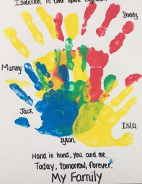  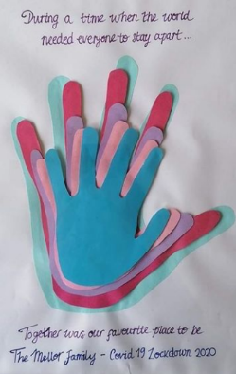  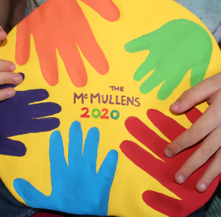

Friday
Reading | Put the link in the internet and complete some of the sound videos – pick the ones you do not know very well. | https://www.bbc.co.uk/bitesize/topics/zvq9bdm
Writing | Can you send me an email to mrshemmingway@newvillage.doncaster.sch.uk  I want to hear from you, not your parents. Type me a short message to tell me what you have been doing. I cannot wait to hear from you!
Maths | Spend half an hour playing on the maths games. Login details are at the end of the document. | https://sso.prodigygame.com
PE | Make an obstacle course in your garden and time all your family completing it. Make them work hard and make sure they are all sweaty!! You have to do it too!

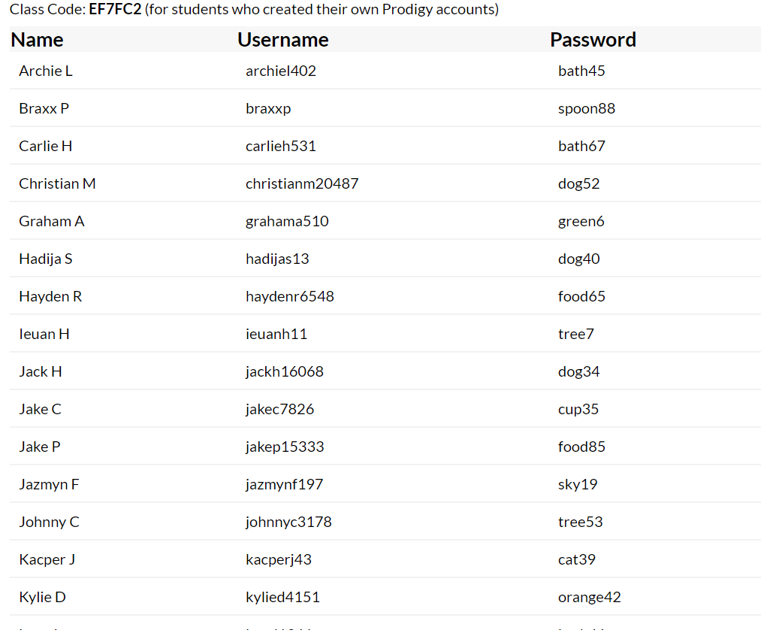
Prodigy Play logins
