Learning Pack for Year 1, - week 6
Hi Everyone,
This is Miss Shah here. I hope you’re all keeping safe and keeping healthy. So this week’s learning pack is abit different – it’s a challenge! I’d like you to have a go at these 5 activities without writing anything down at all! How many can you do? You get a star for each one you do! Take some selfies of yourself doing the activities and send them to –mrsgeaney@newvillage.doncaster.sch.uk
Activity 1  Have a competition with someone in your family.  a) Who can do 10 hops first?  b) How many star jumps can you do in a minute?  e) Jog from on the spot for 1 minute. Did you manage it? | Activity 2  Learn how to spell your own first name. Can you spell it without writing it down?  What about your last name? | Activity 3  Complete this science activity  Make 3 different paper airplanes –  - One made of paper  - One made of card  - One made of bubble wrap, wrapping paper or a tea towel!  Which do you think will go furthest? Try them. Which did go further? | Activity 4  Maths Activity  Collect some twigs outside.  What shapes can you make?  How many edges (sides) does each shape have?  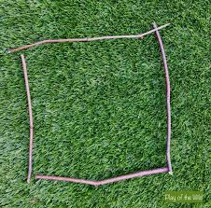 | Activity 5  Plant Hunt  Go outside and find some leaves.  Can you sort them into 2 piles? How did you sort them?
Four In A Row – Choose an activity to do and put a counter on it when you’ve done it. Can you get Four counters in a row across? What about down? How about diagonally? Send in your pics – it’d be great to see!
Make someone smile – you might make them a card, tell them a joke or say something kind. | Kindly tell a family member to sit down and look after them for ten minutes | Match the socks up after the washing has been done | Ring a family member you can’t visit and read to them.
Help clear the pots away after lunch or dinner | Make your clothes look neat and tidy in your drawers | Do some gardening | Do an activity that you are allowed to do at home but do it silently for ten minutes.
Help to fill the washing machine with your parent | Pick up the toys that are on the floor and put them away | Set the table ready for lunch or dinner | Sort through your books and toys and sort a pile to give to a charity shop when they reopen
Pull some weeds out with a family member – pull the weeds not the plants! | Make your bed | Water the plants | Pick up the toys that are on the floor around the house and put them away
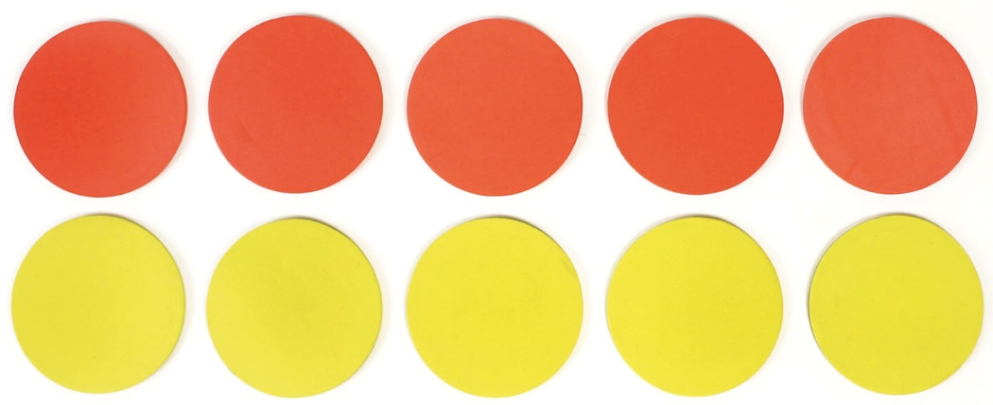

And Finally,
3 short daily activities to do with your family for each subject…
Reading | Writing | Maths
1. Read for 5 minutes to your parent or brother or sister and ask them to read to you.  2. Get on the phone and read for 5 minutes to another family member, a neighbour or a friend.  3. Tell a family member what you read in the book – tell them who was in it, what happened and where it happened. | 1. Write your name and your address. Check you know your full name and address off by heart.  2. Practice your letters – get them right. Then practice the numbers too.  3. Check your name begins with a capital letter. Your address should begin with a capital too. | 1. Count in 2’s, 5’s and 10’s.  Here are some songs and games to help you:  https://www.bbc.co.uk/bitesize/topics/zqbg87h/articles/zc7ygdm  https://www.bbc.co.uk/bitesize/topics/zqbg87h/articles/zw8qxfr  https://www.bbc.co.uk/bitesize/topics/zqbg87h/articles/zq3rk2p  https://www.bbc.co.uk/bitesize/topics/zjkphbk/articles/zd4b382  2. What time is it? You must tell your adult what time it is when they ask – adults please ask as many times as sanely possible – ask them when it’s something o’clock or half past something.  3. Number bonds to 10 and 20.  Say a number to the child, how many more to make 10? Try a few different numbers. If they can do this – how many more to make 20? They need to be able to do this quickly.

And that’s it – Smile

