To my class,

Another week of hearing about how you’ve been doing and another week of setting you some more work! I’m putting the answers at the end of these work packs now for you. Don’t cheat! If you make mistakes, rather than just correcting them, can you look at the correct answer and work out why it is correct? Remember, if you have any questions, my email is below and there is an email for you to log into on the school website.
MrStallard@newvillage.doncaster.sch.uk
To parents, carers and family,

I’m now attaching answers to these learning packs so that the children can mark their work too. If they make mistakes or get different answers, encourage them to work to try and understand where their mistake was or why the correct answer is correct.
The most important thing for the children isn’t necessarily to have help with their work, but to feel encouraged by the adults around them.

From Mr Stallard and Mrs Shakespeare

 |  | Week 4
1 | PE | Youth Sport Trust Activity Bingo
2 | Reading and spellings | One for each day  Complete reading activities 1-5  Spelling activities 1-5
3 | Maths | Times Tables Rockstars logins provided and daily learning tasks. I’ll be updating the TTRS website and setting individual Times Tables for those of you who want to use Garage.
4 | English | SPaG mats
Lunch
5 | History and Geography | Look at this website and watch the three videos before completing the activity on how to be a historian.  https://www.bbc.co.uk/bitesize/articles/z6fmxyc  On a different day, visit this website and watch the two videos and complete the two activities to develop your map-reading skills!  https://www.bbc.co.uk/bitesize/articles/zkngrj6
6 | Thrive | I’m attaching a list of Thrive activities – one for each day. I’ll also write the links for the websites to go to on the page!

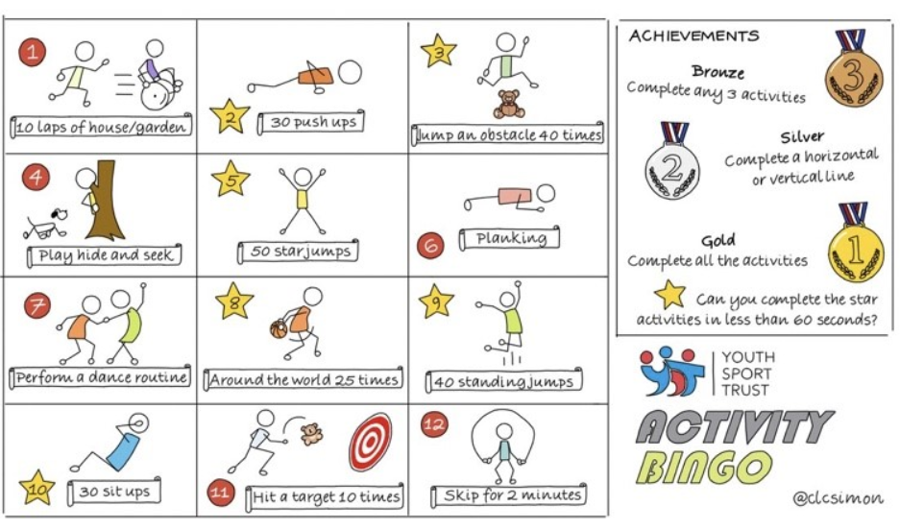

NETFLEX
If you go on our class area on the website and click on ‘Try Mr Stallard’s Exercises’, you can download NETFLEX!

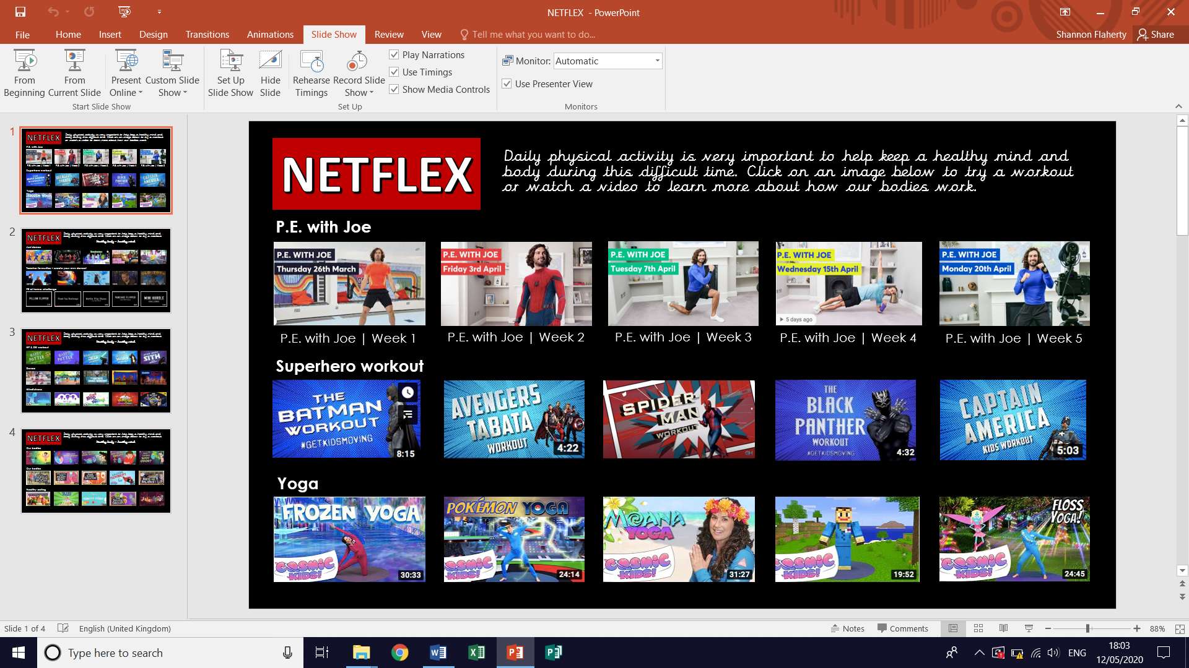
- Scroll through just like you would on Netflix and look at the different exercise activities by clicking on them after it’s gone full screen!
- Click on ‘Slide Show’
- Click on ‘From Beginning’

Reading – choose a book they want to read for Days 1-3

Day 1 | Listen to your child read and ask the questions from the Vocabulary Questions with Victor mat.  Ask your child to say some of the answers and possibly write some of them down too.
Day 2 | Listen to your child read and ask 5 questions from the Inference Questions with Iggy mat.
Day 3 | Listen to your child read and ask 5 questions from the Compare, Contrast and Comment with Cassie mat
Day 4 | A Storm is Brewing… reading comprehension activity.
Day 5 | A Very Unusual Winter reading comprehension activity
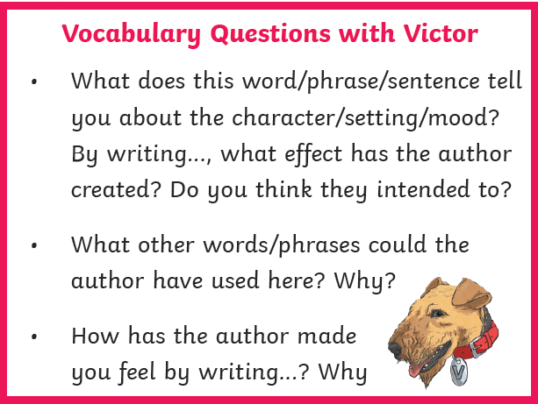
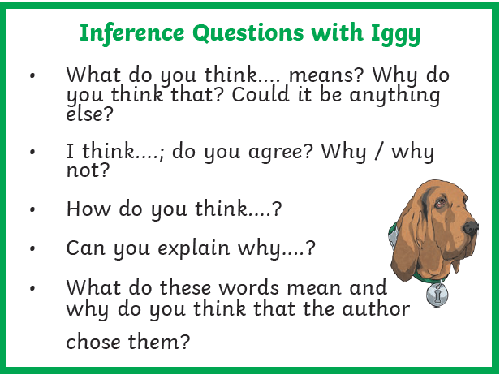

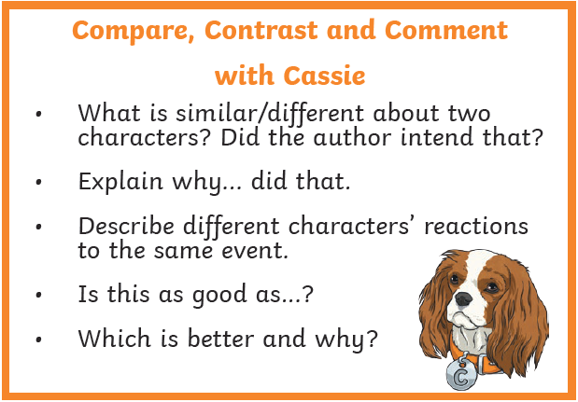

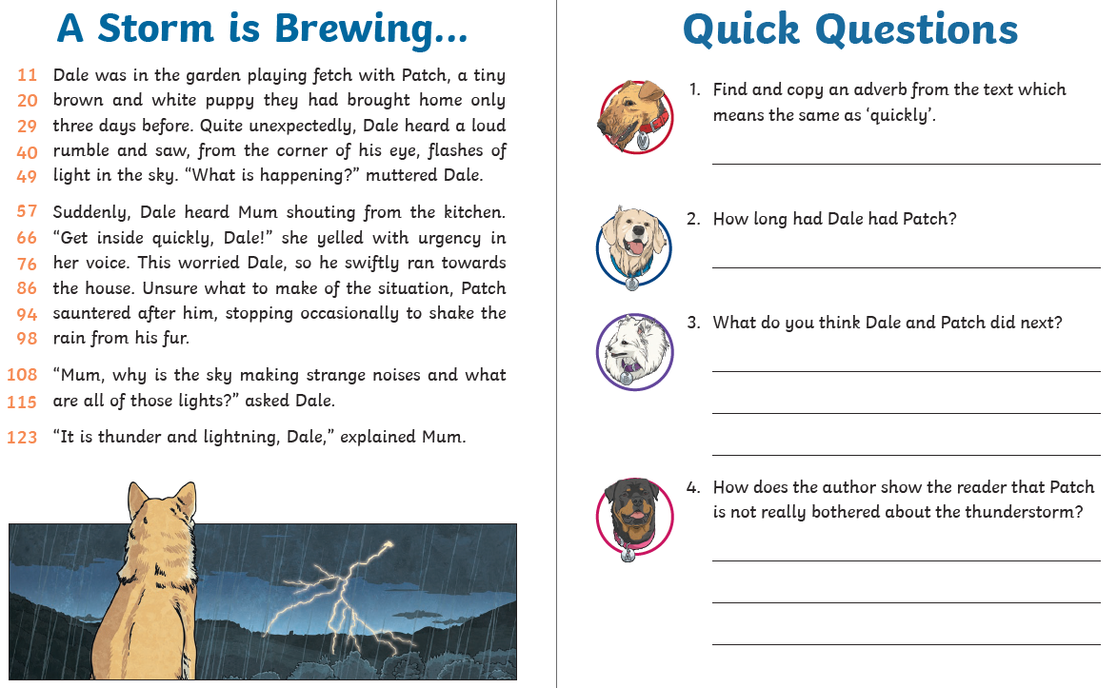
Comprehension Activity 1 Week 5
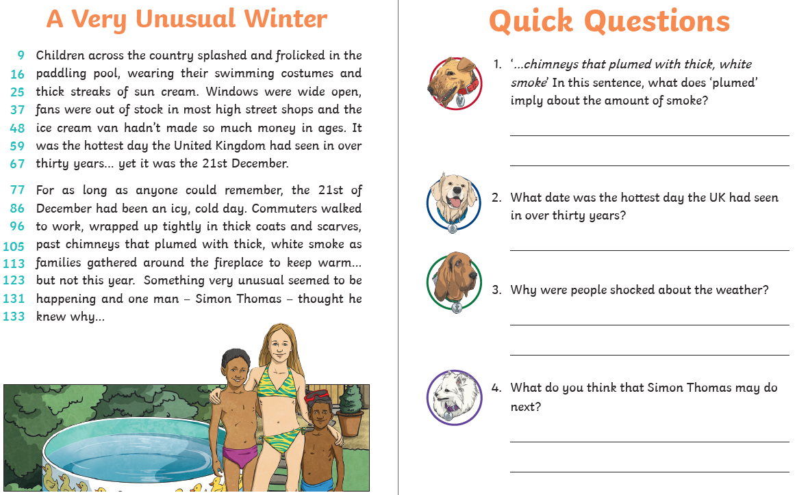
Comprehension Activity 2 Week 5
Spelling – Some of the children are in Group 1 and some are in
Group 2, your child will know which group they’re in.
 | Group 1 – Possessive apostrophe Group 2 – Prefix ‘non’
DAY 1 | Look, Say, Cover, Write, Check
DAY 2 | Word search
DAY 3 | Handwriting sheet | Word chart
DAY 4 | ‘behind’ word mat | ‘decide’ word mat
DAY 5 | ‘child’ word mat | ‘describe’ word mat

NOTE FOR PARENTS AND CHILDREN:
If you’re unable to print any of the sheets off, they can all be adapted. If you can just see the sheet on the screen, all you need is pencil and paper to practice the spellings for Day 1 and Day 3 and the same for Day 4 and Day 5. For the word searches, can you just find the words in order on the screen?
Group 1 – Day 1

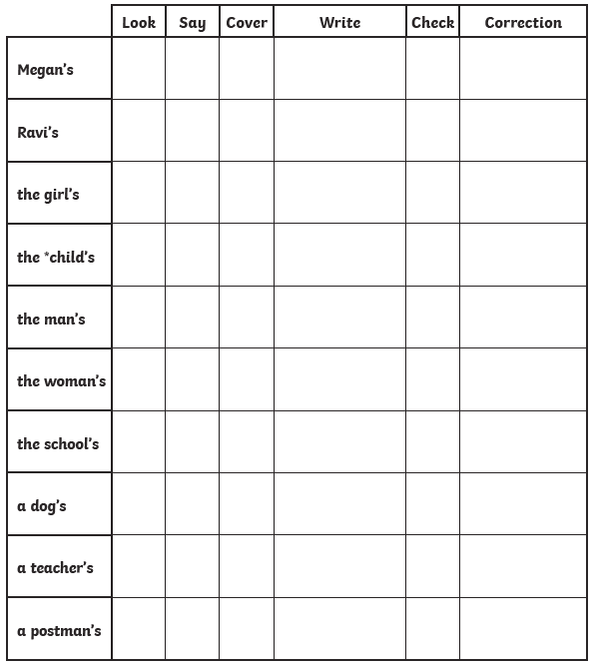

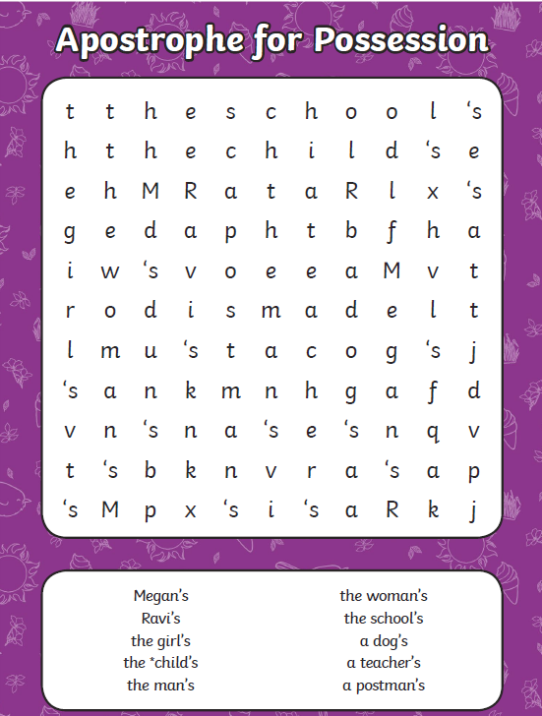
Group 1 – Day 2

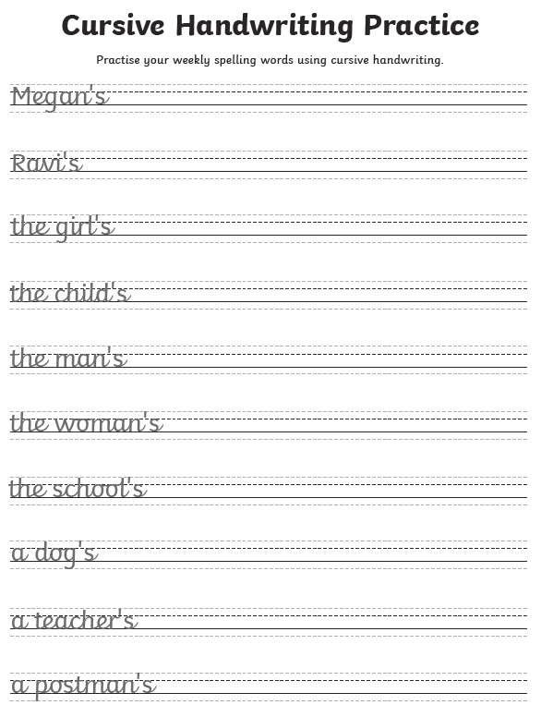
Group 1 – Day 3

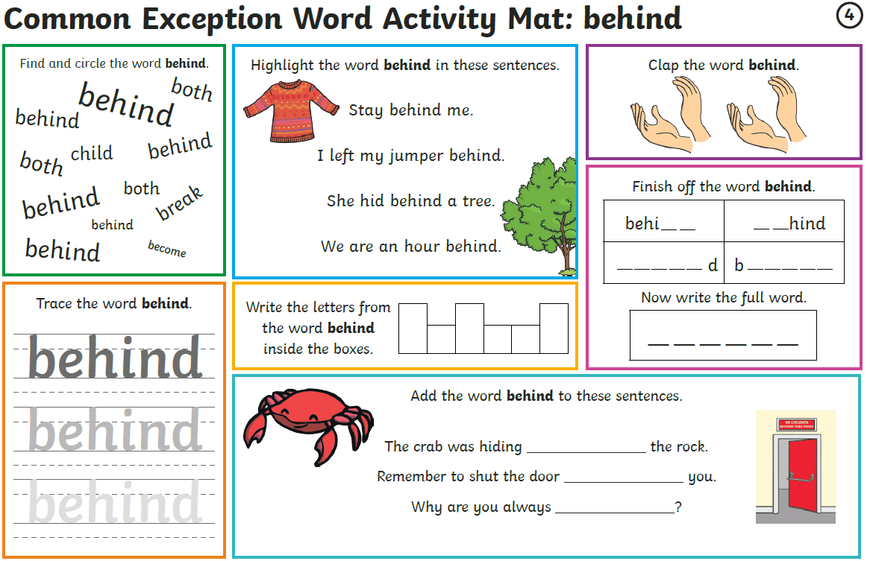
Group 1 – Day 4
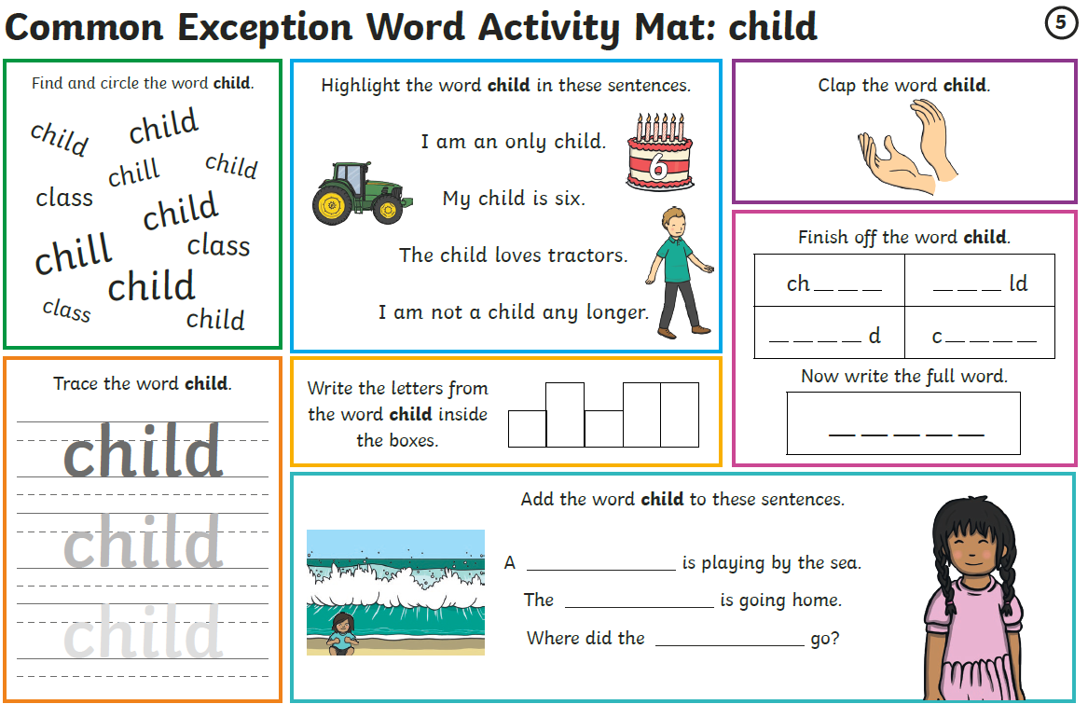
Group 1 – Day 5

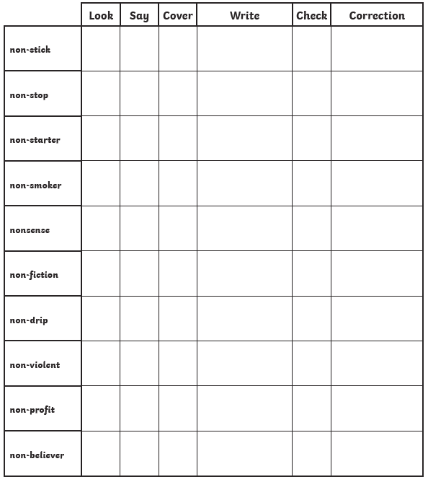
Group 2 – Day 1

Group 2 – Day 2
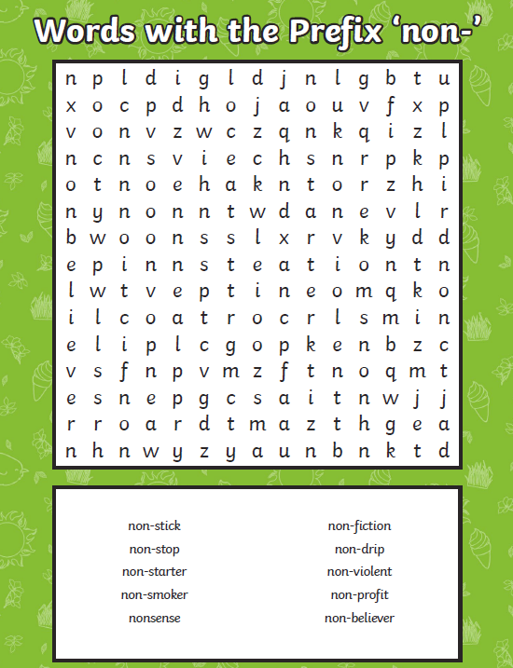
Group 2 – Day 3
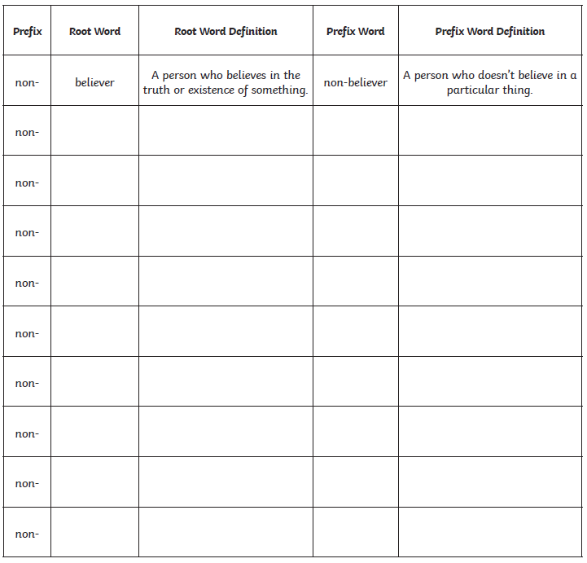

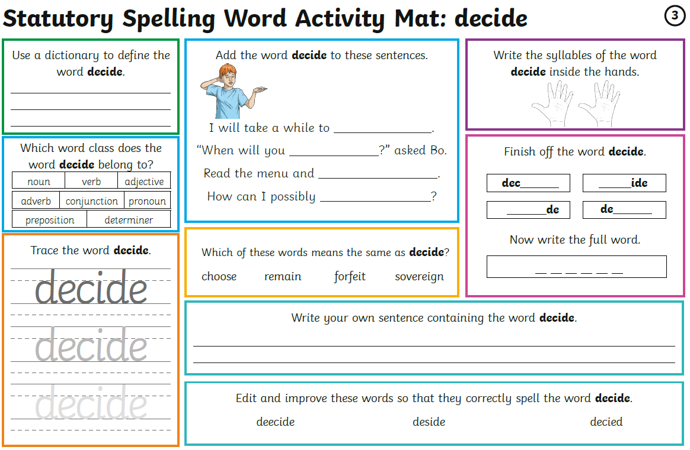
Group 2 – Day 4

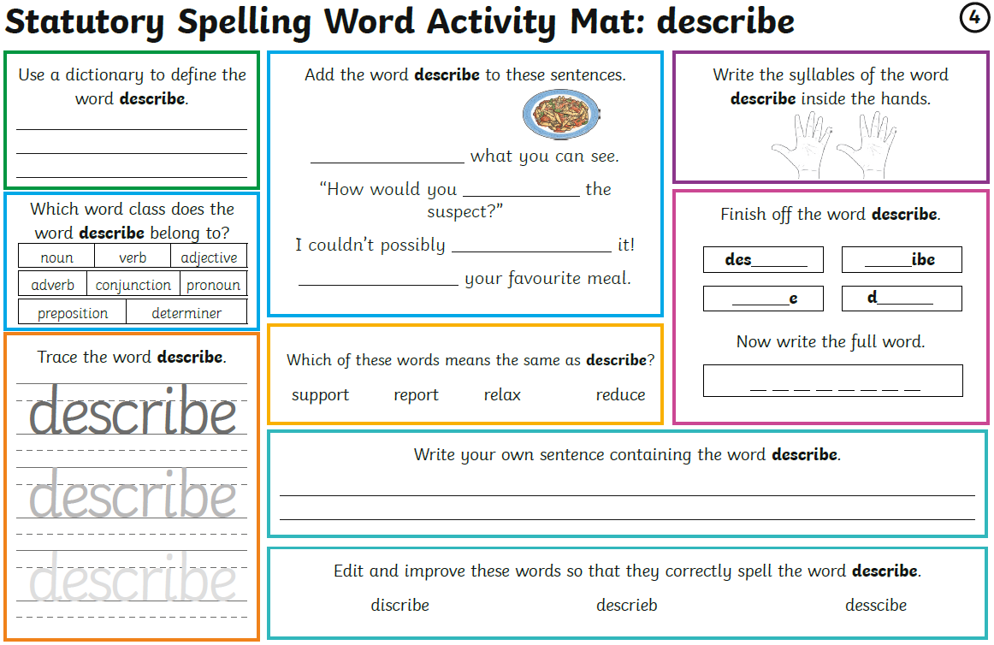
Group 2 – Day 5

Maths – Times Tables Rockstars logins – Please ensure your child is only logging in using their own login details.
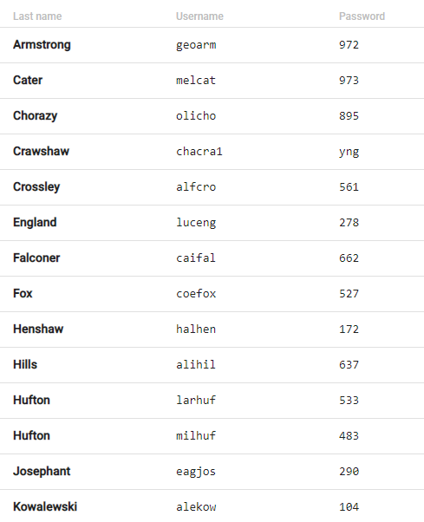
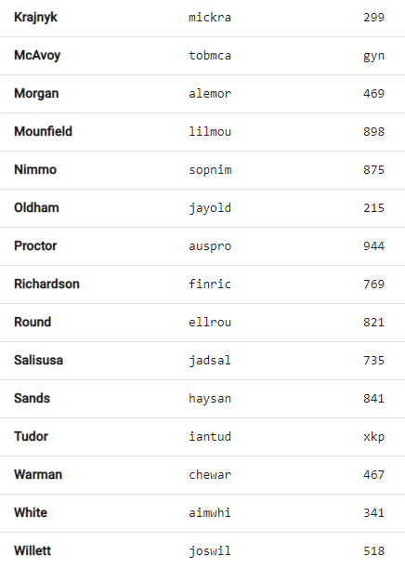
Maths – Week 5 – Place Value

Monday | Tuesday | Wednesday | Thursday | Friday
Go on the BBC link.  Watch the two videos and complete the four activities.  Answers provided on a link at the bottom of the webpage. | Applying yesterday’s learning to reasoning problems.  Answers in the last pages. | Work on Times Tables Rockstars. | Go on the BBC link.  Watch the two videos and complete the two activities.  Try activity 3 if you can!  Answers provided on a link at the bottom of the webpage. | Applying yesterday’s learning to a reasoning problem.  Answers in the last pages.

Week 5 – Day 1 - https://www.bbc.co.uk/bitesize/articles/zjf492p

Week 5 – Day 2

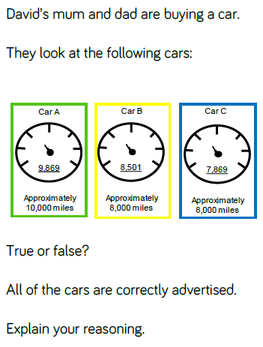
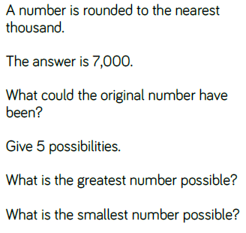

Week 5 – Day 4 - https://www.bbc.co.uk/bitesize/articles/zkmv382

Week 5 – Day 5
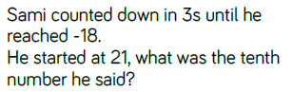
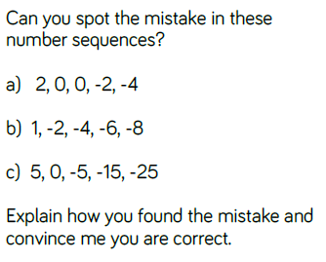

Writing – Day 1
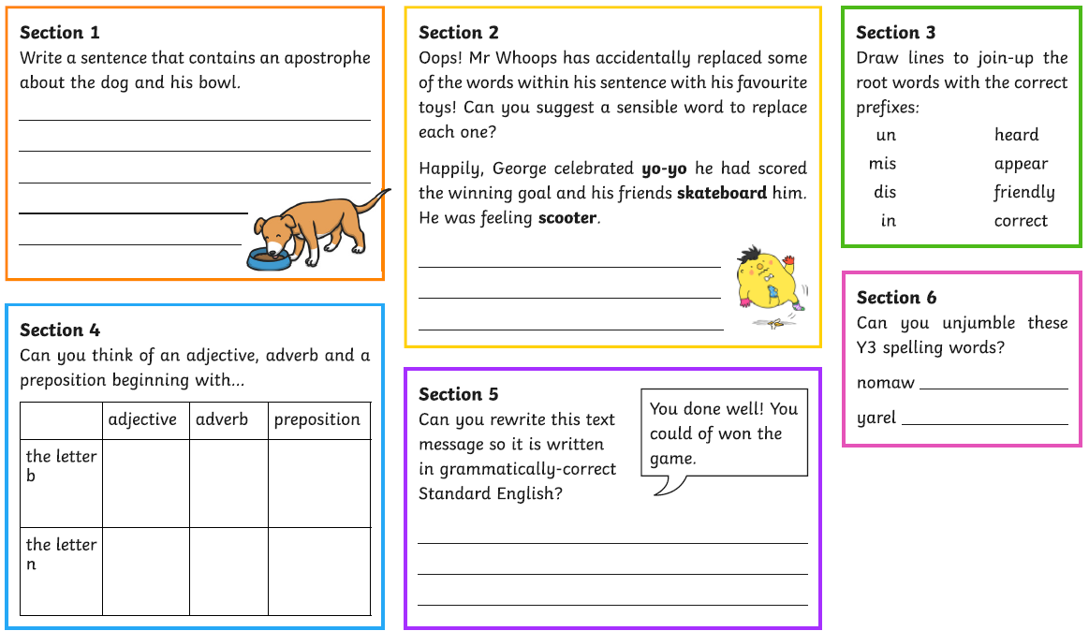
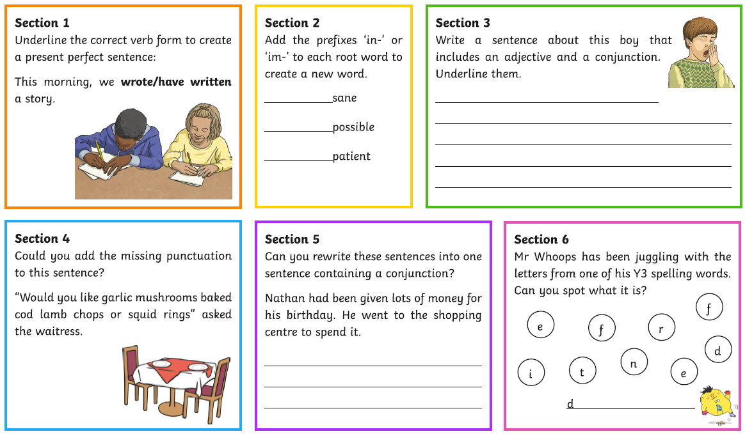
Writing – Day 2
Writing – Day 3
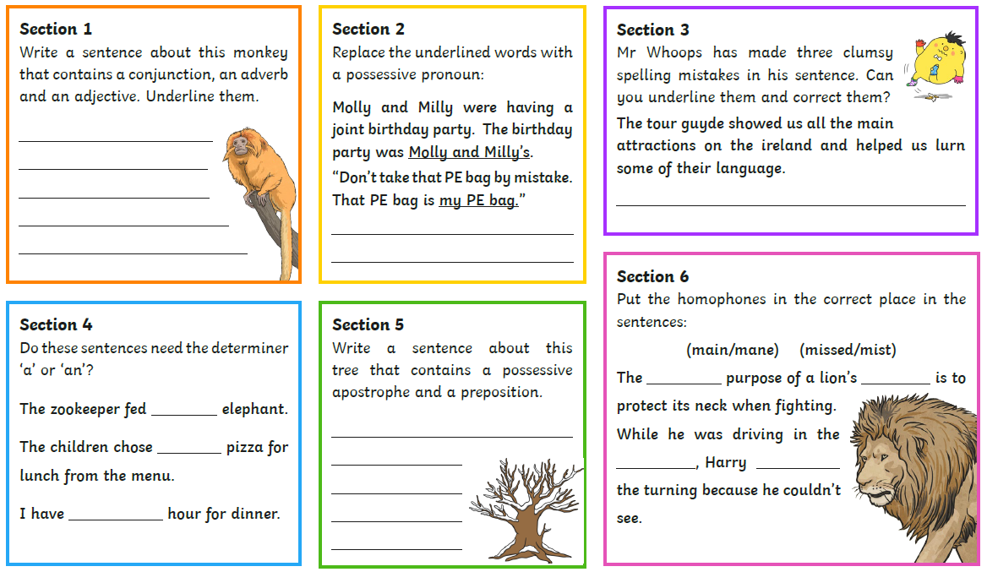

Writing – Day 4
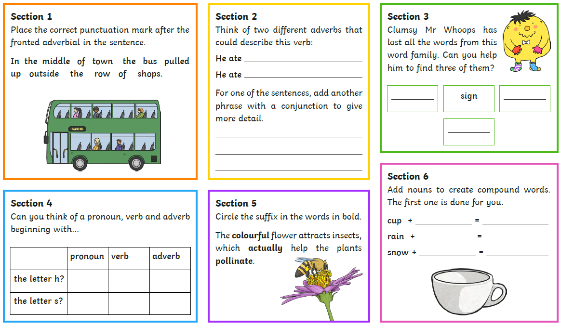
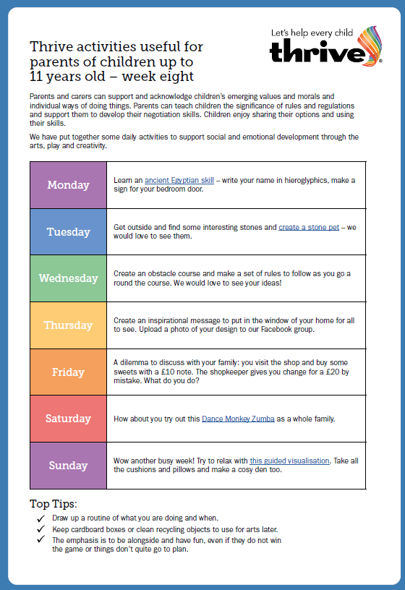
THRIVE

Dancy Monkey Zumba - https://www.youtube.com/watch?v=GRM9h8EQ6Bw
Guided mediation - https://www.youtube.com/watch?v=64QzBuhsyuk
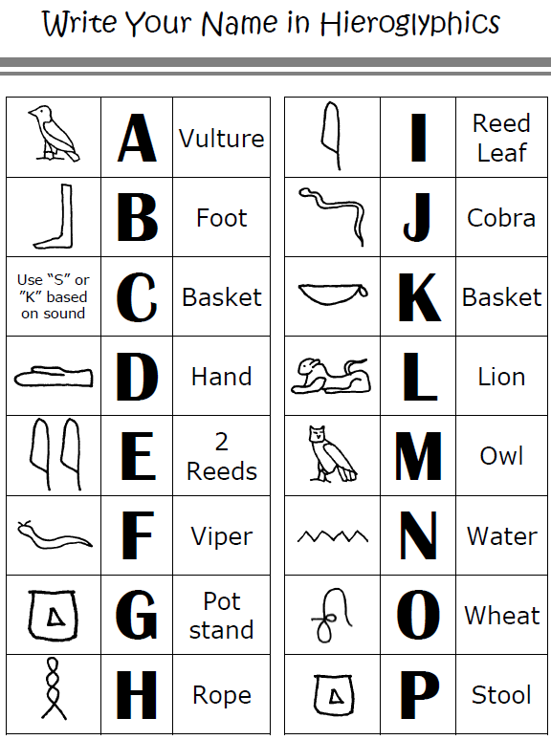

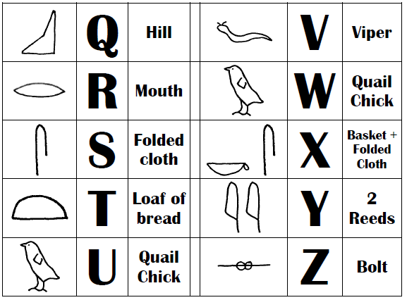
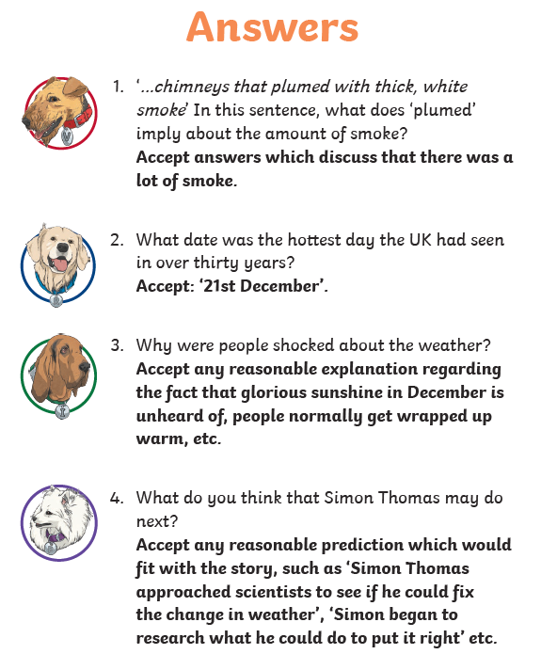
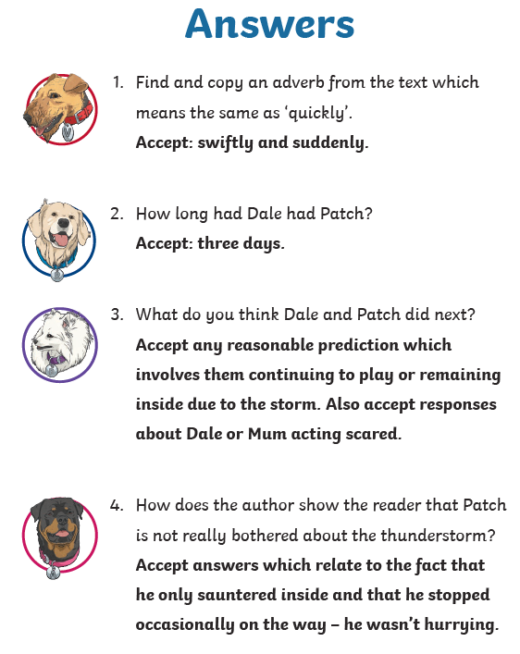
READING ANSWERS

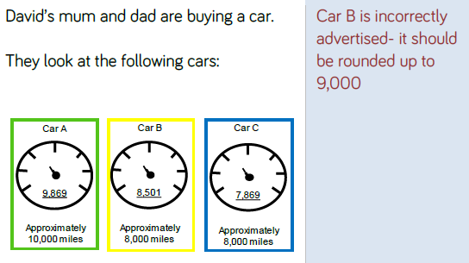
MATHS ANSWERS
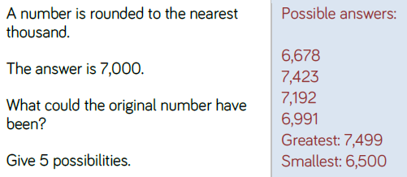

Any number between 6,500 and 7,499 would be correct.

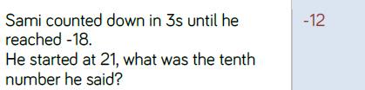
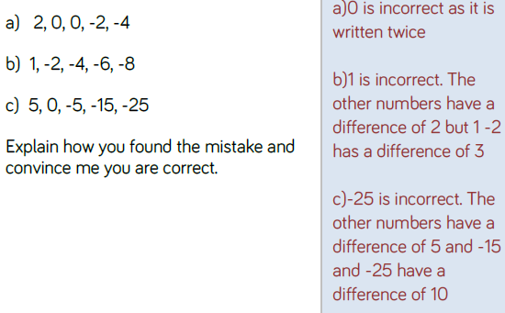

WRITING ANSWERS
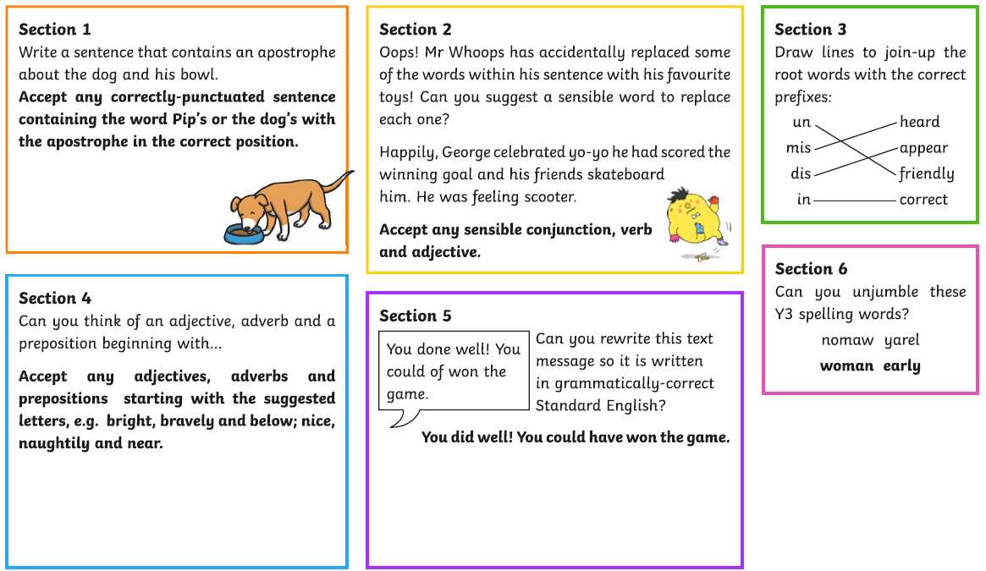
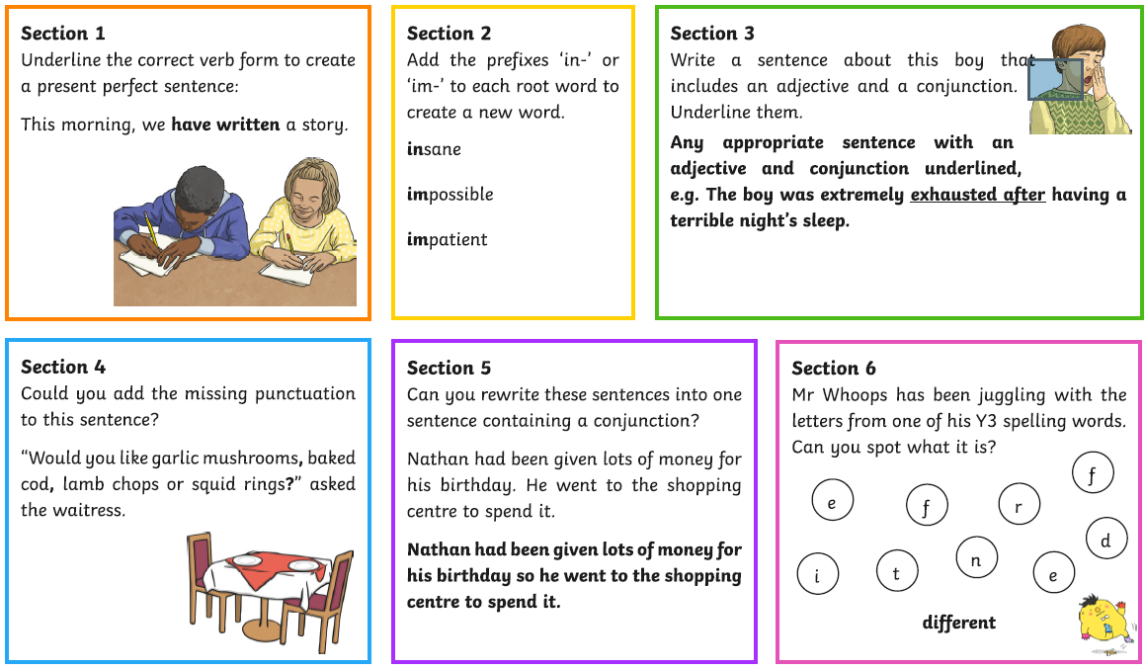
Day 1
Day 2

WRITING ANSWERS
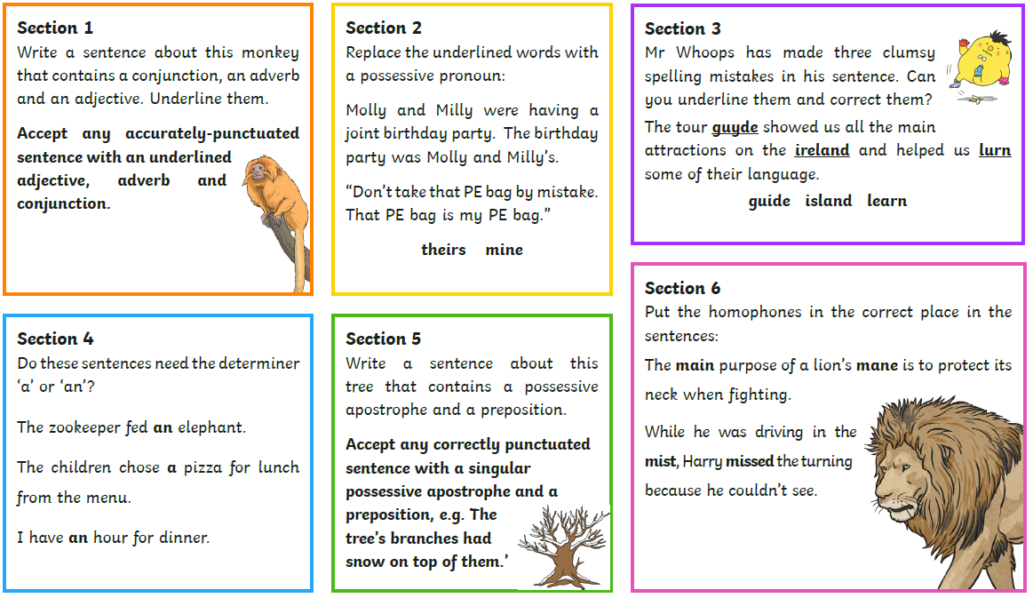
Day 3
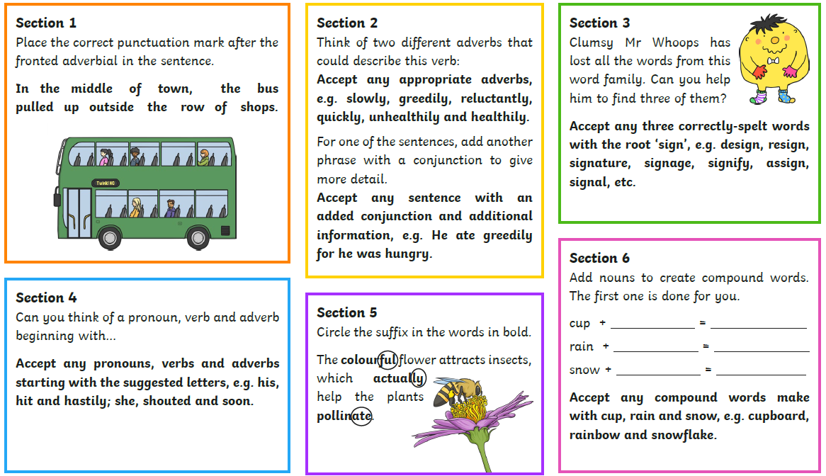
Day 4

