To all our wonderful Y1 Children
I hope you are being good for your grown-ups!
Please stay safe, try to do a little bit of work but most of all stay healthy and happy.
If you want to contact us you can
contact your teacher for when you return - Miss Shah you can contact her here:
mrsgeaney@newvillage.doncaster.sch.uk

If you don’t have a printer, it’s fine, read it on the screen and just pop your answer on a piece of paper.
Creative ideas:
- Spellings – write them in sand, in the garden using twigs and leaves, with pasta or flour (get permission first though)
- Maths – use real things (fruit n veg, pasta, crayons, toys) to help you with calculations
- Reading – Act it out with your family or toys!
- Comprehension – make it into a TV interview. Your parent can pretend to hold a Mic and ask questions and you can be someone famous answering them.
- Writing – write in the air, with your finger near the wall, on a tiny piece of paper. Write a letter or a postcard to someone you can’t see a the moment.
From Miss Shah
Year 1 (Mrs Geaney’s)
Home Learning

 | Activity | Week 4
Activity 1  9.00am | PE with Joe Wickes | Each day: Login to you tube and search for Joe Wickes PE – it will be live that morning. This is good for all children to take part in.
Break
Activity 2 | Reading and spellings | Each day: Complete reading and comprehension.  Spelling Activity 1-5
Break
Activity 3 | Maths | Practise your 2x table with the times table song on here:  https://www.bbc.co.uk/bitesize/topics/zqbg87h/articles/zc7ygdm  Parents - there are other things on BBC Bitesize you might want your child to have a go at.
Break
Activity 4 | English | Writing tasks 1-5
Lunch
Activity 5 | Topic project | Make things from the 3 Billy Goats Gruff story.  Include at least one character and one setting (place).  Or create a collage of the story.
Break
Activity 6 | Craft / Life skills | Write a letter to Mrs Geaney now that you have seen a picture of the baby! Art/making/jobs around the house/cooking/baking/board games/nature pictures/singing/making music/make videos/play outdoors etc.

Reading – choose a book they want to read.
Day 1 | Listen to your child read and ask 5 questions from the Rex Retriever mat. Ask your child to say some of the answers and possibly write some of them down too.
Day 2 | Listen to your child read and ask 5 questions from the Rex Retriever mat. Ask your child to say some of the answers and possibly write some of them down too.
Day 3 | Listen to your child read and ask 5 questions from the Inference Iggy mat. Ask your child to say some of the answers and possibly write some of them down too.
Day 4 | Week 1 Complete Comprehension 1 activity
Day 5 | Week 1 Complete Comprehension 2 activity

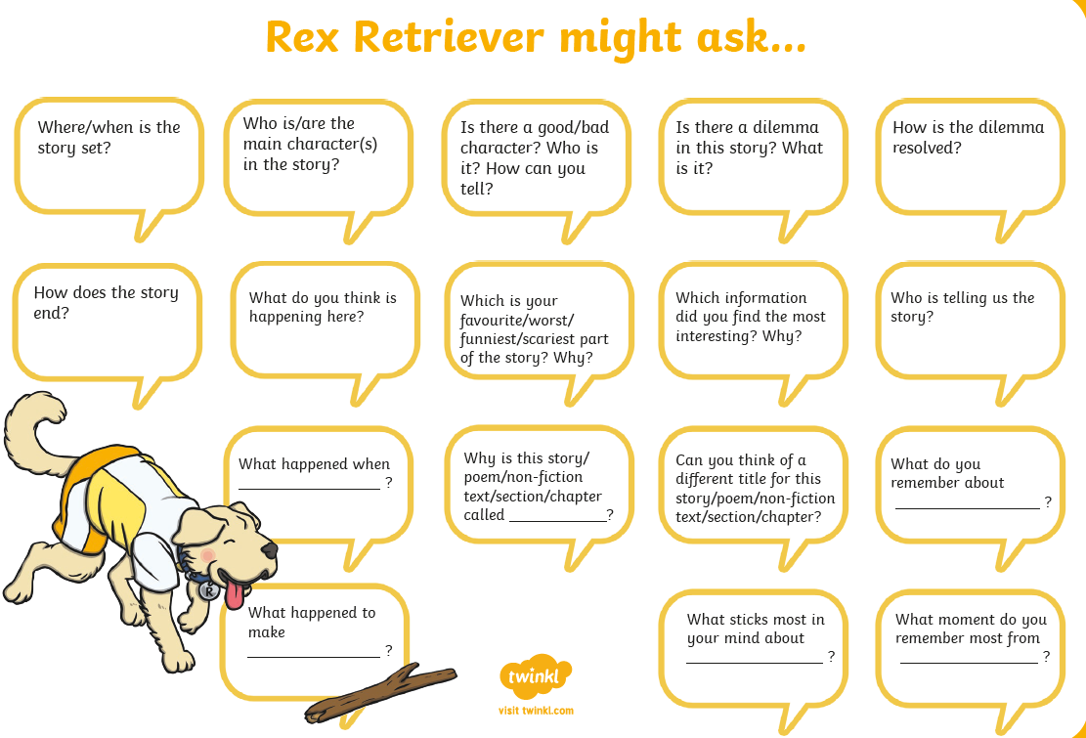
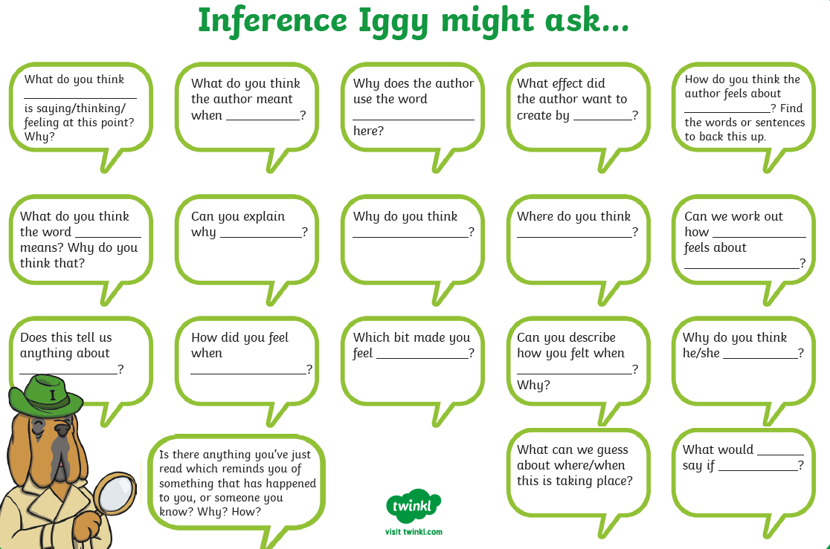

Comprehension Activity 1 Week 5 Act out this story…
Comprehension Activity 2 Week 5 – Can you spot these birds in the sky or in the garden?

Spellings – If you can’t download the spellings, don’t worry, the words are here.
 | Week 3
DAY 1 | Common exception word mat - no
DAY 2 | Common exception word mat – go
DAY 3 | Common exception word mat – so
DAY 4 | Common exception word mat – by
Day 5 | Common exception word mat - my

You can clap the words, find the word in books and newspapers or on screen, spell the words in sand, the garden, using twigs or even using pasta (get permission first). That’s it!

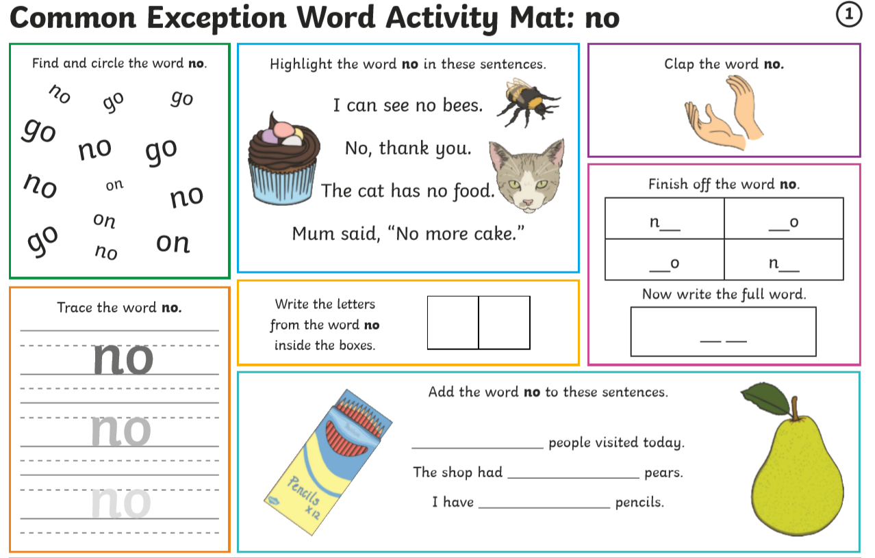

Multiplication – Week 5
Monday | Tuesday | Wednesday | Thursday | Friday
Worksheet for week 5 day 1.  Making doubles. Can your child double a number with you?  Can your child put things into equal groups? You might want to put items you have at home into equal groups. | Information for week 5 day 2.  Can your child write the numbers between 1 and 10?  Now can they double each number using items to help them count? | Your child is to create a picture made up from groups of 2 (animals) groups of 5 (friends) and groups of 10 (ants).  Extra: can your child create their own picture using their own groups of things rule? | Can your child fill in the missing number?  As a piece of extra maths, can your child create their own sentence about groups of numbers? | Can your child work through the word problem with you?  You might want to read it a few times and work through one part at a time.
Week 5 – Day 1 Making doubles
If you don’t have a printer, just read the question on the screen and write the answer on a piece of paper - that’s it.

Week 5 – Day 2 Adding Equal Group
Write each number from 1 to 10. Then double the number. That’s all you have to do.
Week 5 – Day 3 Create a picture that has groups of two (animal), groups of 5 (friends) and groups of 10 (ants).

Week 5 – Day 4 Making groups.

Take 20 items (crayons, or grapes or something else you have at home) Use them to help you complete the sentences.
- I can make ____ equal groups of 2
- I can make ____ equal groups of 5
- I can make ____ equal groups of 10

Week 5 Day 5 – A word problem
Read the problem with your grown up. Then answer the questions.

I am thinking of a number between 20 and 30
I can only make equal groups of 5
What must my number be?
What happens when I try to make groups of 2 with it?
What happens when I try to make groups of 10 with it?

Writing: Use the picture to help you answer the questions.
Monday: Tuesday:
Wednesday: Create your own picture and write sentences for it.

Thursday:
Write a letter to someone you miss and tell them what you have been doing. You might want to write to a relative you can’t see or a friend. You might want to write to Miss Geaney and tell her you’ve seen a picture of the baby.
Friday: Check back through all your writing for the features.
Remember I am looking for your –

- Capital Letters
- Full Stops
- Finger Spaces
- Handwriting
- Spelling

Once you’ve done all that, you might want to draw your own picture about the favourite thing you like to do at home. Then you can write a few sentences to explain it.

