Y3S - Home Learning
Dear Y3S, since we are not able to be together at school at the moment, I have put together some more learning activities that you can complete with your adults at home. Some activities can be printed and there are also some on-line links that may be helpful. I hope that you are all well and look forward to being back together as soon as we can. Miss Shaw
Daily Activities:
 | Activity
9.00 | PE | Take a look at the NETFLEX powerpoint, open it up and choose a link to an exercise of your choice……..superhero….frozen…….Joe Wickes…….anything you like!
Activity 1 | Maths  (30 mins) | Follow the link below to find daily BBC bitesize Maths activities  https://www.bbc.co.uk/bitesize/tags/zmyxxyc/year-3-and-p4-lessons/1
Activity 2 | Times tables  (15 mins) | Log in to Splat 100 square and splat your counting patterns.  https://www.primarygames.co.uk/pg2/splat/splatsq100.html  Monday 2’s  Tuesday 4’s  Wednesday 8’s  Thursday 3’s  Friday 6’s  For each daily pattern count it forwards and backwards….as a challenge, can you count them forwards then backwards with your eyes closed?  If you want to extend your learning, why not make up your own rhyme for the 9’s pattern.  Then log into TTRS and complete 10 minutes practice on the studio section
Activity 3 | Spelling  (10 mins) | Write the spellings for this week just like we do every day in the classroom. Remember LOOK / COVER / WRITE / CHECK  LOOK at the word carefully  COVER the word  WRITE it from memory  CHECK your spelling  Then use the words in a sentence – if you are not sure of the meaning you can ask an adult / check it in a dictionary / check using an on-line dictionary.  The words that I have selected this week all belong to word families.  instruct  structure  construction  instruction  instructor  unit  union  united  universe  university
Activity 4 | Handwriting  (5 mins) | Use the prepared line guide or just a piece of paper to write the joins used in our selected spellings.  un struct
Activity 5 | English  (30 mins) | Follow the link below to find daily BBC bitesize English activities  https://www.bbc.co.uk/bitesize/tags/zmyxxyc/year-3-and-p4-lessons/1
Activity 6 | (30 mins) | Look at the other learning opportunities listed below and select one to do each day!

Other learning opportunities
Choose an activity each day

Music | https://www.outoftheark.co.uk/ootam-at-home/?utm_source=homepage&utm_campaign=ootamathome2&utm_medium=banner  Log on to the above website. Here you will find lovely songs to sing, just like the ones that we use every week in singing assembly.  Choose a song  Listen to it all the way through and spot any repetition  Join in with the song the 2nd time through, following the words on screen.  Make up your own actions or even dance moves, and don’t forget to follow the links for other activities related to each song  This week, I’ve been singing “Join the song” from the week 8 pack because I fancied a challenge. Once you know the basic song, there are challenges that you can do as you sing……have a go!
French | Take a look at the days of the week in French below. Why not keep a diary this week of the things that you do and label the days in French. All you need is some paper and a pencil or a pen
Art | I hope that you enjoyed the workshops last week, provided by local Sheffield Artist Pete McKee. Have a go at drawing more animal friends … all you need is a pencil and paper. Mrs Charlesworth and I had a go and it was really good fun. Don’t forget to look out for little Eric and keep watching until the end for a top tip!  https://www.youtube.com/watch?v=RnNcIZLi9Fs
ICT | Send me an email to the address below and include an emoji to let me know how you feel.  MissShaw@newvillage.doncaster.sch.uk
PSHE | Think about ways that you can enjoy yourself after the lockdown ends.  Think about places that you would like to visit, like the “The Butterfly House” in Anston. Follow the link below to see a lovely video celebrating all that the butterfly house has to offer.  https://www.butterflyhouse.co.uk/  After watching the video clip you might want to draw a butterfly with symmetrical wings.
History | We have just celebrated VE day, follow the clip below to find out why VE day was so important.  https://www.bbc.co.uk/teach/class-clips-video/history-ks2-ve-day/z7xtmfr
DT | In science we are learning all about the body, digestion and how to keep healthy. For your DT homework, why not have a go at making your own leek and potato soup using the recipe below.
Science | In science we learning all about our bodies and keeping healthy. Learn more by looking at the attached links.  https://www.bbc.co.uk/bitesize/topics/zrffr82/articles/zppvv4j  https://www.bbc.co.uk/bitesize/topics/zrffr82/articles/ztsqfcw  After watching these clips, try the DT recipe for this week.
Follow a recipe. Bake a cake or help prepare a meal for your family. Make sure there is an adult who can help you. |  | A big night in!  Have a big night in with your family – get dressed up, have a meal and watch something great on the TV!

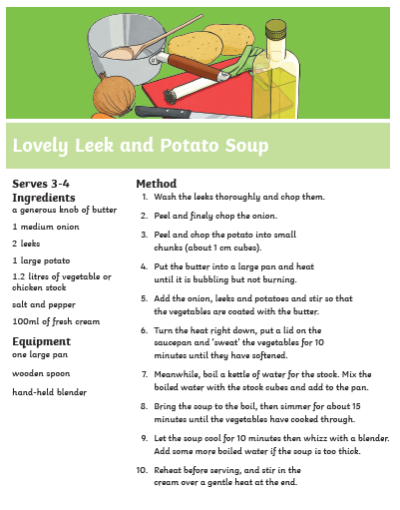

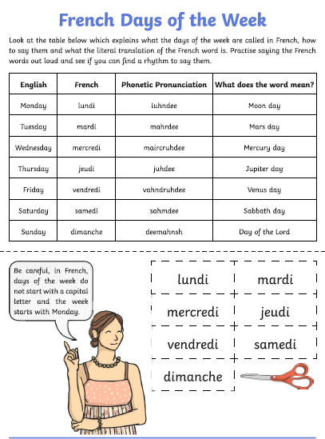

Use the lines below to write a sentence using each of these words – remember to use

your joined handwriting

