Arithmetic practise
- Column subtraction, ensure the biggest number is first
- If the denominator is the same, the answers will be too
- Column addition
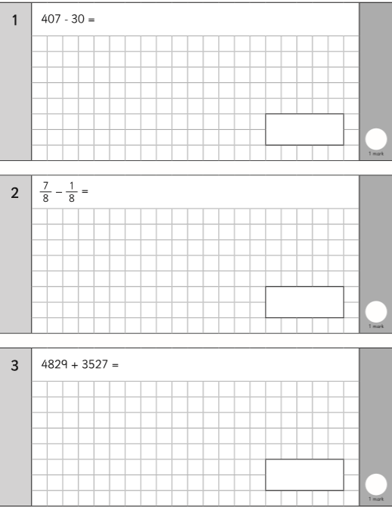
- Put brackets around the first calculation and solve that before moving onto the second part

- Short multiplication

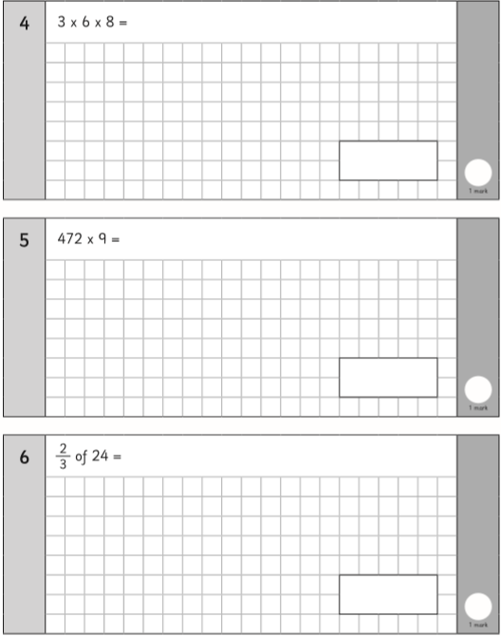
- Remember: divide the whole number by the denominator, multiply your answer by the numerator

- Put a decimal point after your whole number, when dividing you move your number to the left depending on how many zeros

- Column addition, biggest number first

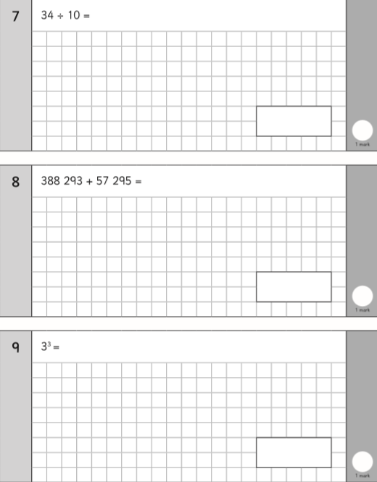
- Square = multiply it by itself
- Short multiplication
- Change them into a common denominator, whatever you do to the bottom, you must do to the top
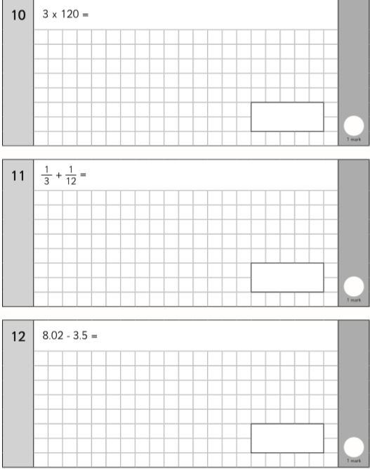
- Column subtraction, ensure decimals are lined up and your biggest number is first

