WALT: using commas to clarify meaning or avoid ambiguity in writing

Watch this video to help you
https://www.bbc.co.uk/bitesize/topics/zvwwxnb/articles/zc773k7

Add commas for clarity. | Explain your reasons fully.
The Rabbit had long sharp pointy teeth.

As the campers sat round the fire eating the bear stayed in the bushes.

David who was 10 wore glasses.

There was lots to do at the fair including face painting and a raffle.

While the onions were cooking soup was brought from the shop
.

If you have everything you need then we are ready to go!

If you have everything you need then we are ready to go!

- I need to add two commas between long and sharp for commas in a list
- There needs to be a comma to make it clear the campers are not eating the bear! Where should it go?
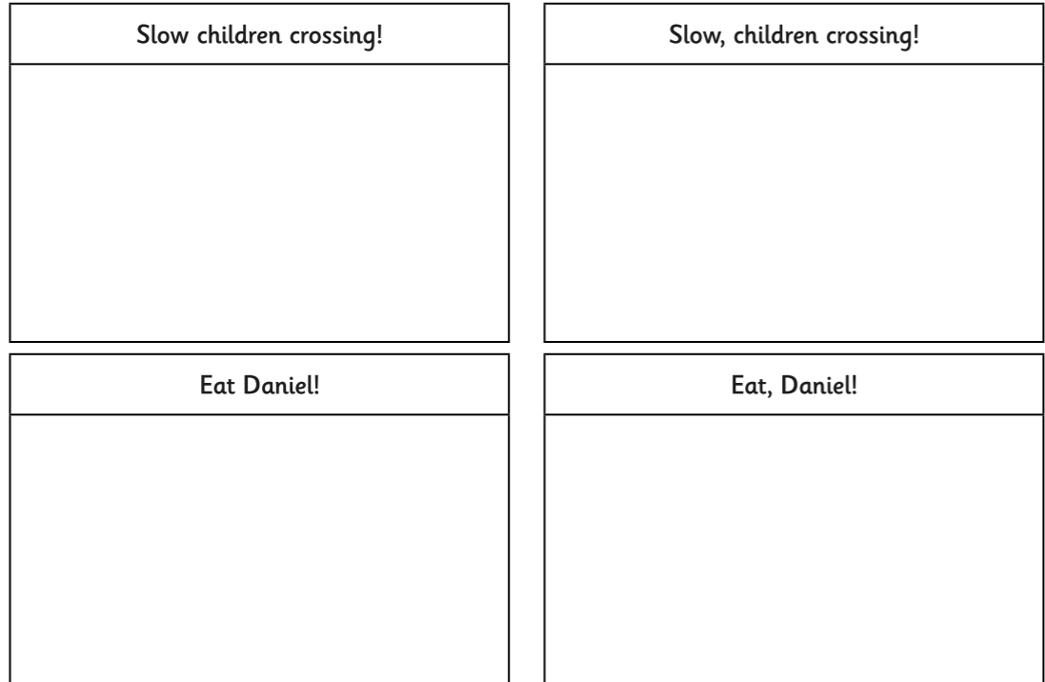
Draw the different meanings.
Example:
- Slow children crossing means there are children being slow crossing the road
The second sentence, slow, children crossing indicates someone or something needs to slow down because there are children crossing the road.

