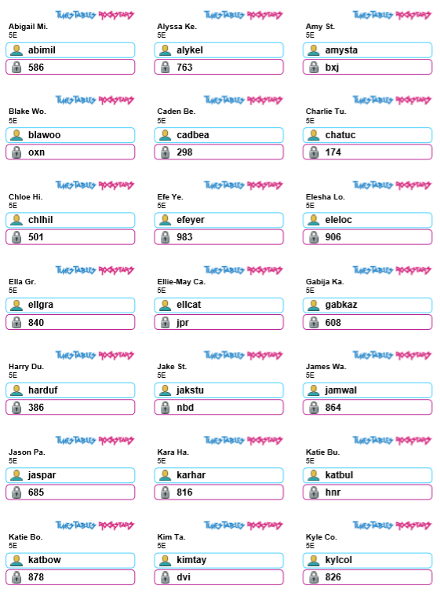
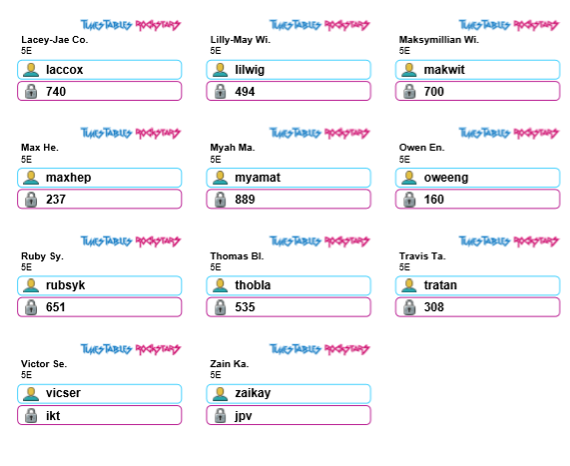
TTR logins- Please ensure your child is only logging in using their own login details.

Watch these videos to help you
https://www.bbc.co.uk/bitesize/topics/znwj6sg/resources/1
Enjoy playing these games
https://primarygamesarena.com/Play/Minus-Numbers-In-Outer-Space-409
https://www.math-salamanders.com/image-files/3rd-grade-math-games-pit-of-doom-minus-20-to-5.gif
To interpret negative numbers in context
WILF:
- Draw a number line
- Place zero in the middle
- Place your negative number on the left of zero
- Place your positive number on the right of zero

- Jump from the negative to zero- make a jotting
- Jump from zero to the positive- make a jotting
- Add your two numbers together
Example:
What is the difference between -16 and 24.

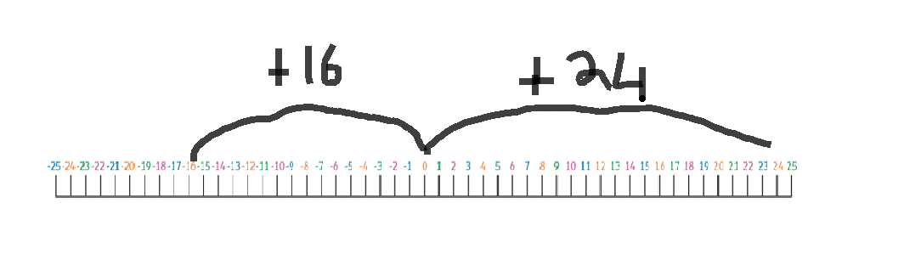
24
+16
40

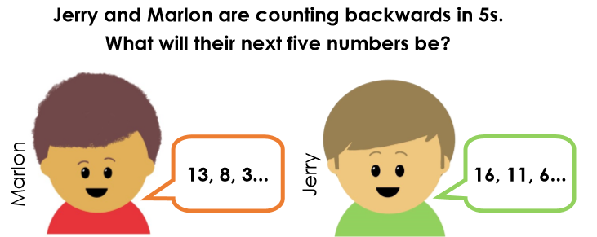
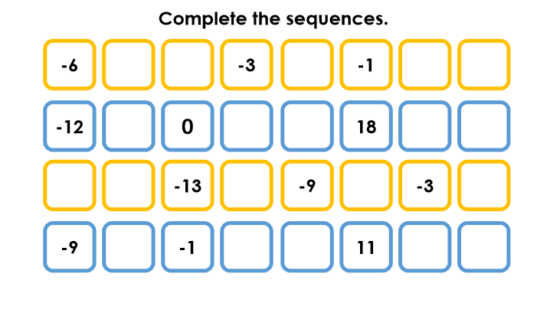
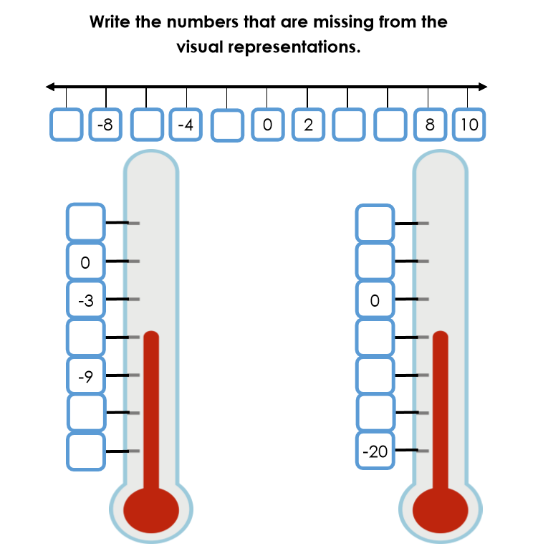
Tasks
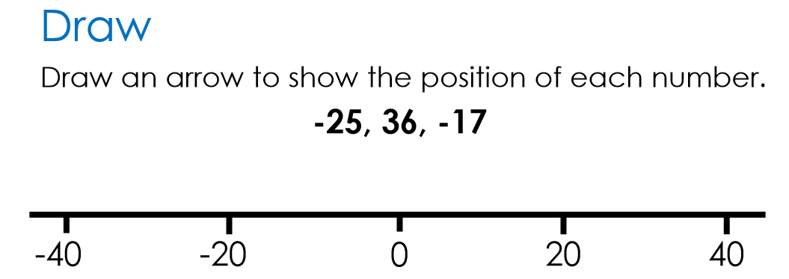

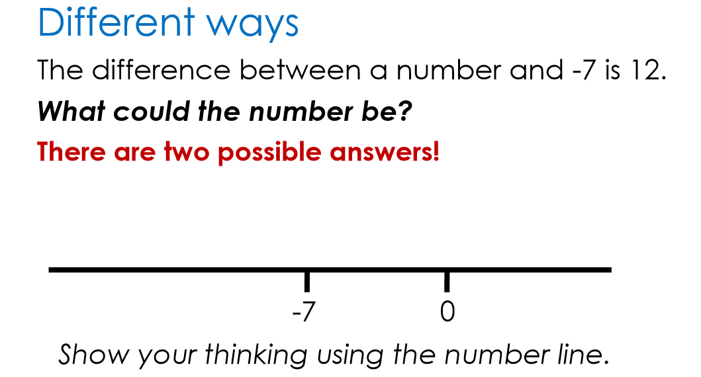

Game
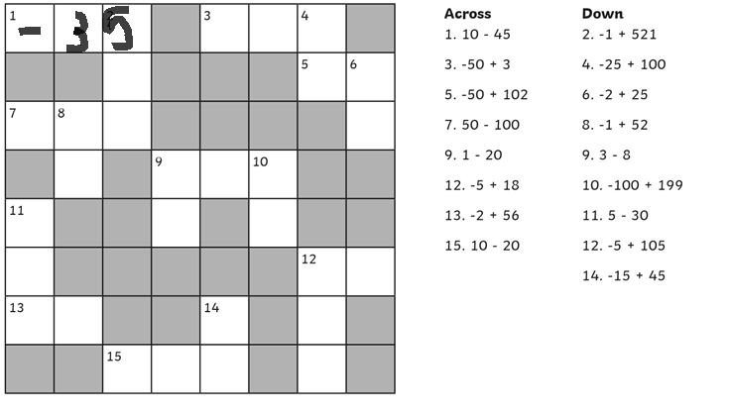

1 across= 10-10= 0. 0-35= -35

Challenge
