Geography-
Think back to our last topic lesson when we explored the arctic and Antarctic looking at globes.
This week’s focus is on The Antarctic, this carries on from last week’s learning
Watch these clips to help you
- https://www.bbc.co.uk/teach/class-clips-video/what-adaptations-do-penguins-have-to-survive-in-antarctica/z6rtscw
- https://www.bbc.co.uk/teach/class-clips-video/science--geography-ks2-how-climate-change-is-affecting-penguins-and-their-habitats/zb2rkmn

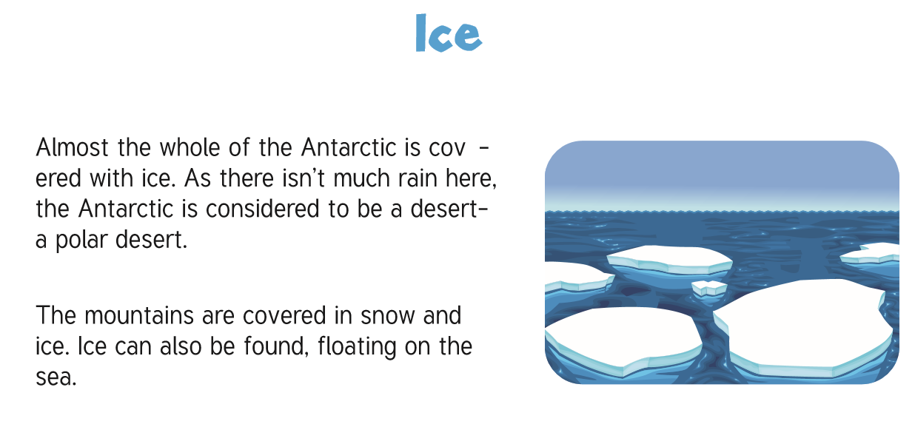

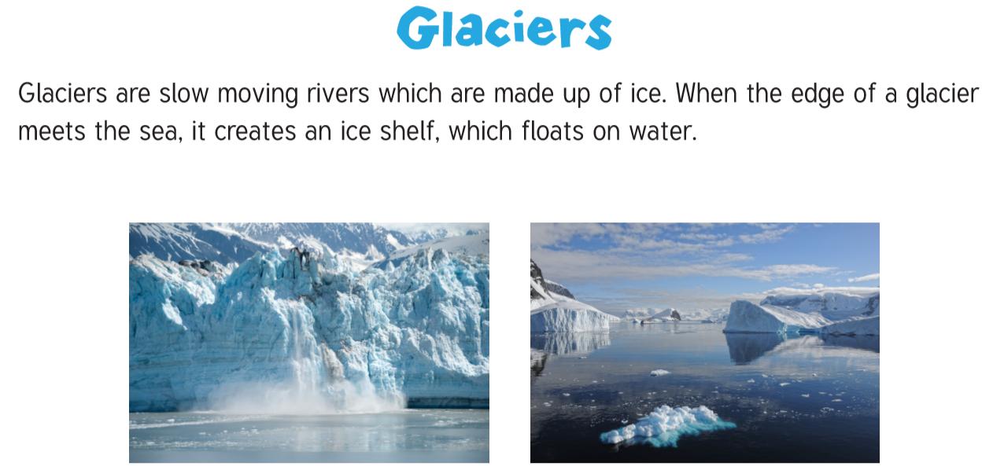

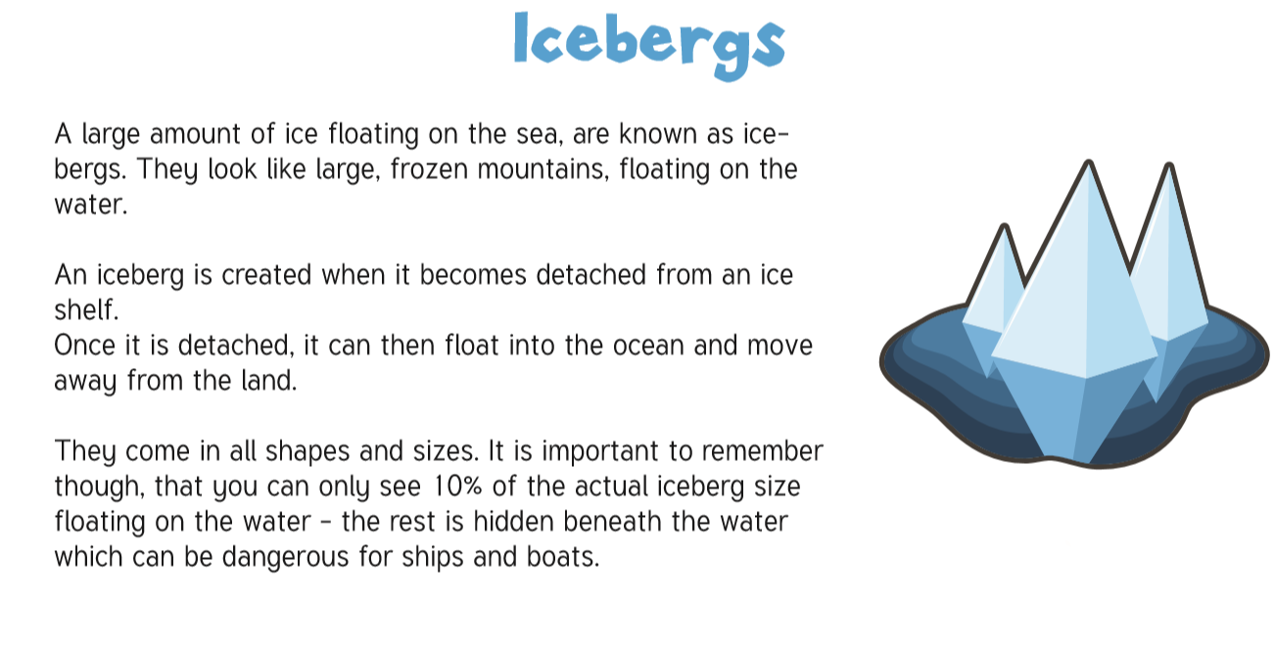

Your task:
Create a description, one paragraph describing the top of the Iceberg, one paragraph focussing on the bottom part. The sense you are using is what you can see-sight.
Remember to include:
Fronted adverbials
Prepositional phrases
Adverbs to say how
Expanded noun phrases
Relative clauses/parenthesis
Modal verbs
Send your completed ones to:
missemery@newvillage.doncaster.sch.uk

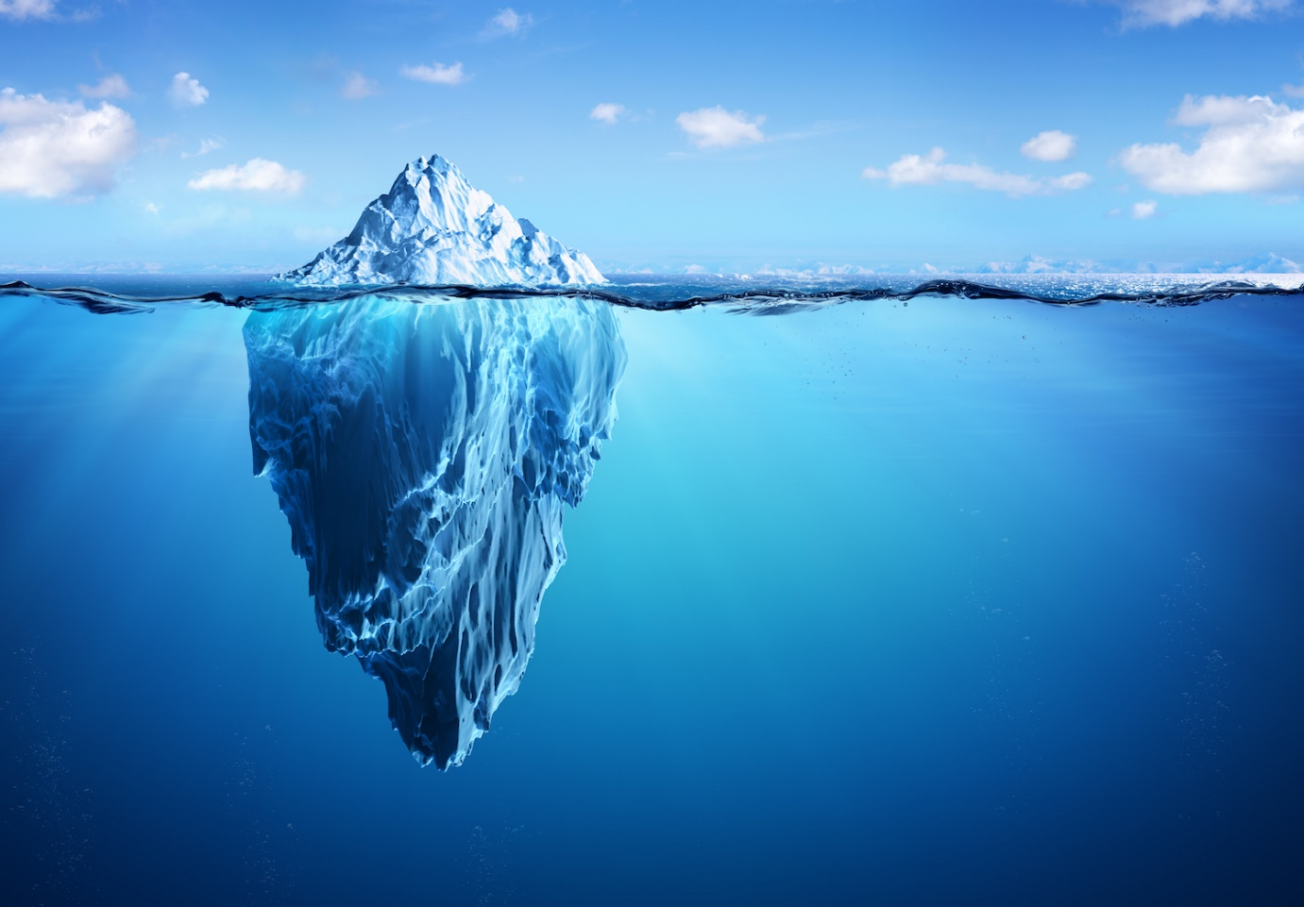
Paragraph one- The top of the Iceberg
Intrusively, the large, delicately-carved iceberg juts through the top of the clear, blue water with a calming ripple…

Paragraph two- The bottom of the Iceberg
Lurking dangerously and silently underneath the calm water, …

