To my class,
I really enjoyed speaking to many of you on the phone last week, it was so nice to hear what some of you have been up to and that plenty of you are missing school! If I didn’t get chance to speak to you on the phone then I’ll be trying again soon but if there’s anything you want to share with me, remember you can email me and I will reply!

MrStallard@newvillage.doncaster.sch.uk
Last week, I went to play a round of FootGolf with a friend. It’s exactly the same as golf, except you have to kick a football and see how many kicks it takes you to get it into a big hole in the ground!
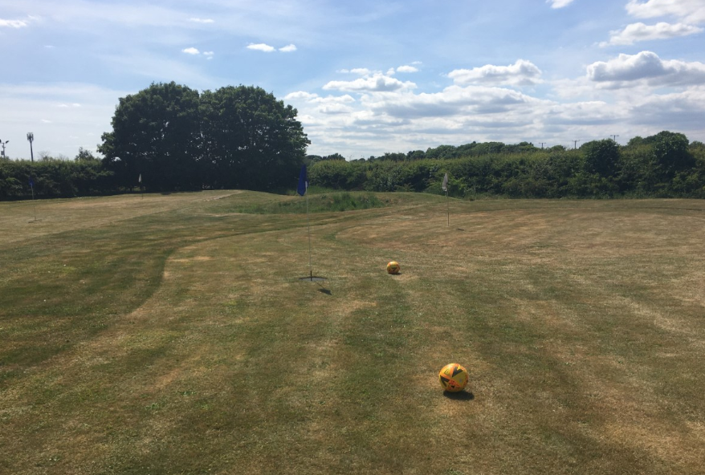
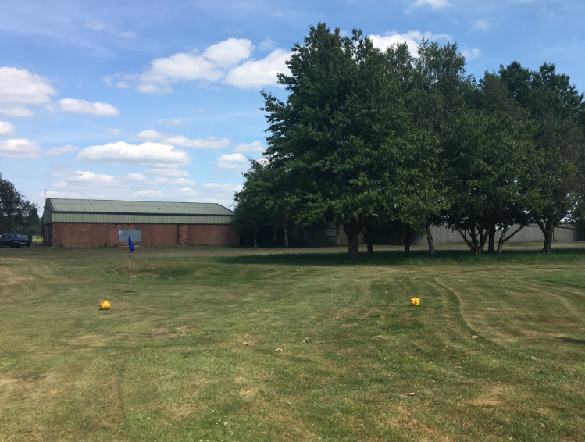
 |  | Week 4
1 | PE | Youth Sport Trust Activity Bingo
2 | Reading and spellings | One for each day  Complete reading activities 1-5  Spelling activities 1-5
3 | Maths | Times Tables Rockstars logins provided and daily learning tasks. I’ll be updating the TTRS website and setting individual Times Tables for those of you who want to use Garage.
4 | English | SPaG mats
Lunch
5 | History and Geography | Learn about Prehistoric Britain!  https://www.bbc.co.uk/bitesize/articles/z7t72sg  Improve your map-reading skills:  hhttps://www.bbc.co.uk/bitesize/articles/zjdm6v4
6 | Thrive and THE LION KING | I’m attaching a list of Thrive activities – one for each day. I’ll also write the links for the websites to go to on the page!  The final task is all about the Lion King! Go down to the page and I’ll write all of the information there!

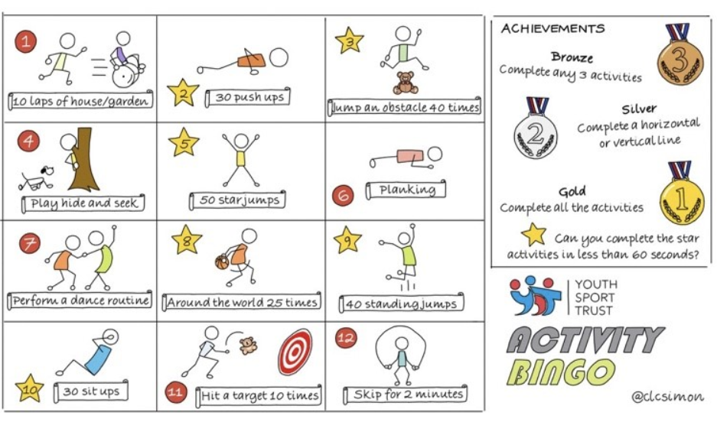

NETFLEX
If you go on our class area on the website and click on ‘Try Mr Stallard’s Exercises’, you can download NETFLEX!

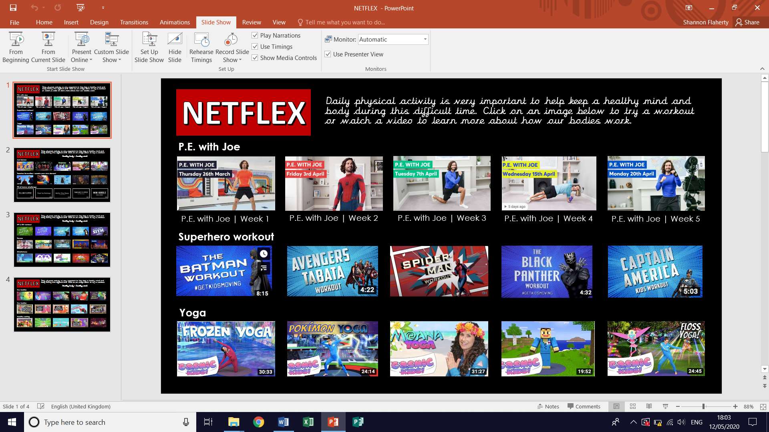
- Scroll through just like you would on Netflix and look at the different exercise activities by clicking on them after it’s gone full screen!
- Click on ‘Slide Show’
- Click on ‘From Beginning’

Reading – choose a book they want to read for Days 1-3

Day 1 | Listen to your child read and ask the questions from the Compare, Contrast and Comment with Cassie mat.  Ask your child to say some of the answers and possibly write some of them down too.
Day 2 | Listen to your child read and ask 5 questions from the Inference with Iggy mat.
Day 3 | Listen to your child read and ask 5 questions from the Prediction with Pip mat
Day 4 | One Tiny Mistake reading comprehension activity.
Day 5 | Ozma and the Little Wizard reading comprehension activity
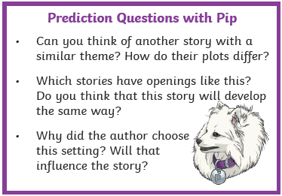
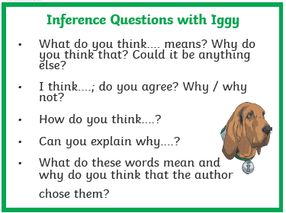
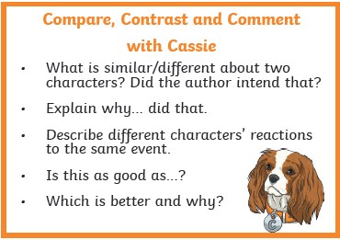

Comprehension Activity 1 Week 7
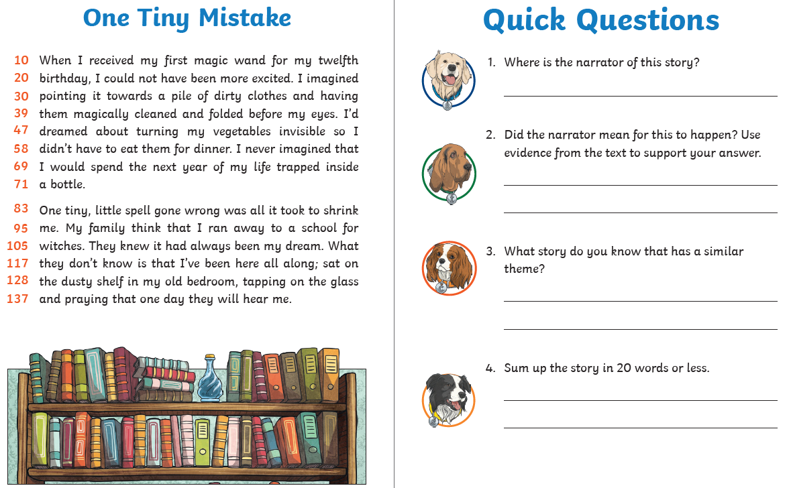
Comprehension Activity 2 Week 7
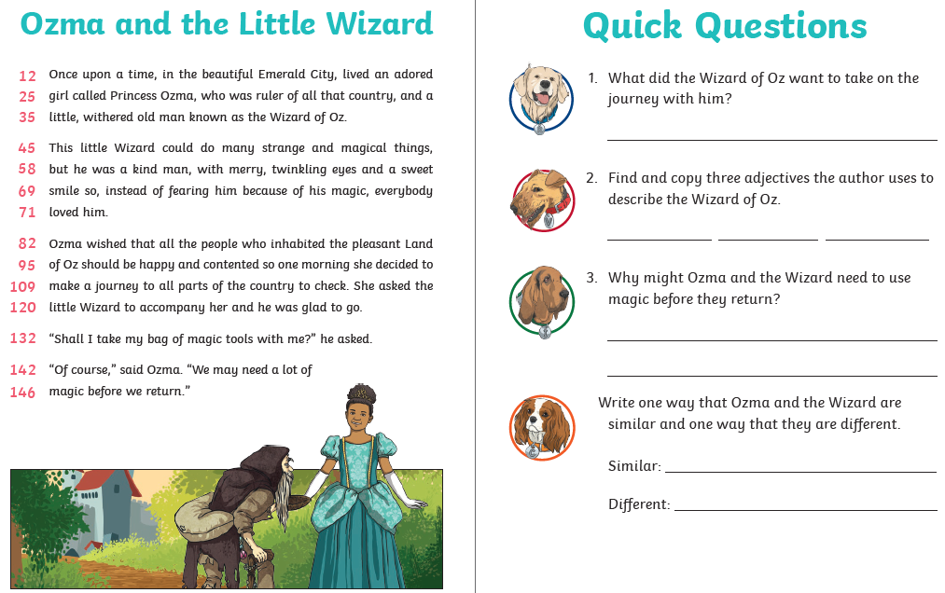
Spelling – Some of the children are in Group 1 and some are in
Group 2, your child will know which group they’re in.
 | Group 1 – Homophones/near homophones Group 2 – Suffix ‘-ous’
DAY 1 | Look, Say, Cover, Write, Check
DAY 2 | Word search
DAY 3 | Matching pairs | Word chart
DAY 4 | ‘should’ word mat | ‘disappear’ word mat
DAY 5 | ‘bath’ word mat | ‘enough’ word mat

NOTE FOR PARENTS AND CHILDREN:
If you’re unable to print any of the sheets off, they can all be adapted. If you can just see the sheet on the screen, all you need is pencil and paper to practice the spellings for Day 1 and Day 3 and the same for Day 4 and Day 5. For the word searches, can you just find the words in order on the screen?
Group 1 – Day 1

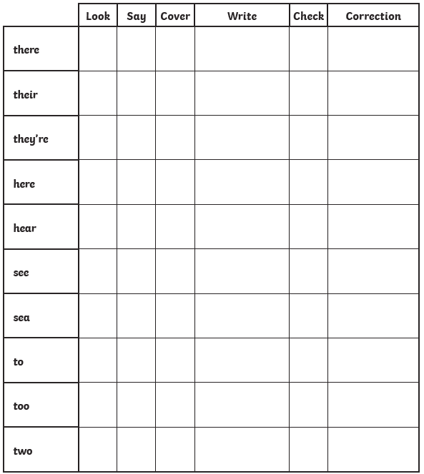

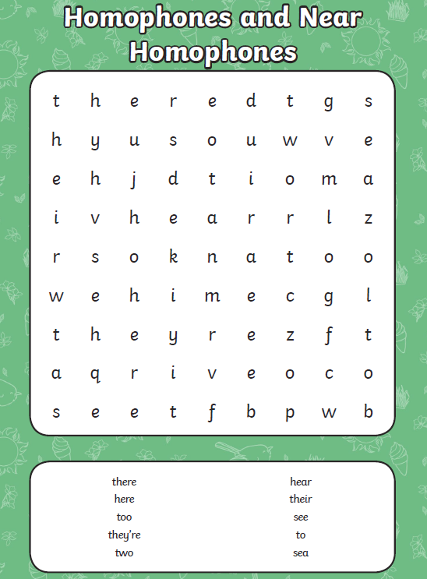
Group 1 – Day 2

Group 1 – Day 3

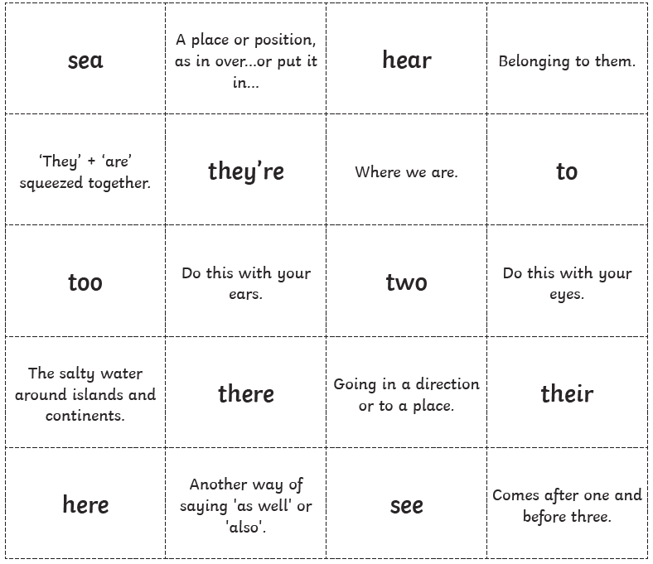
Match the correct spelling to its meaning. You can either draw a line if you can print this sheet off or you can just write down the word and then write down which meaning it matches to on a piece of paper! The answers will be at the end.
Group 1 – Day 4
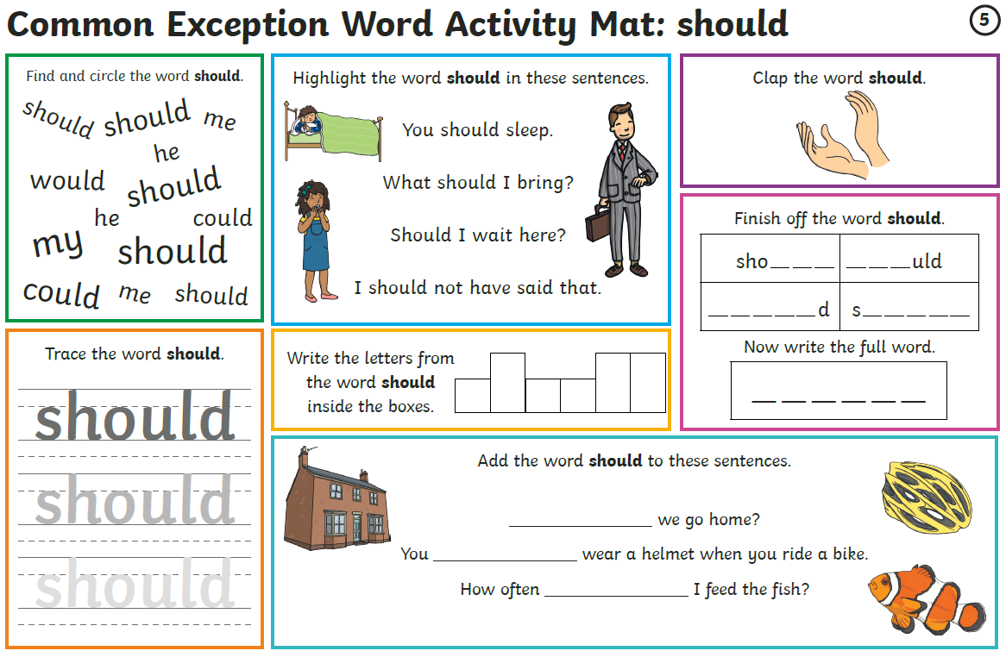
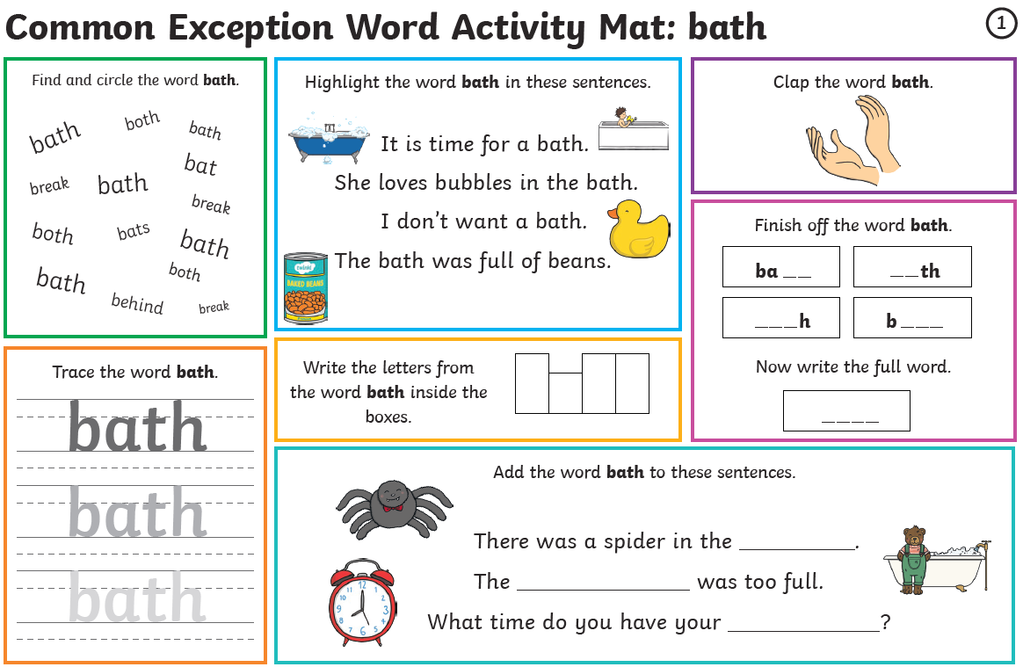
Group 1 – Day 5

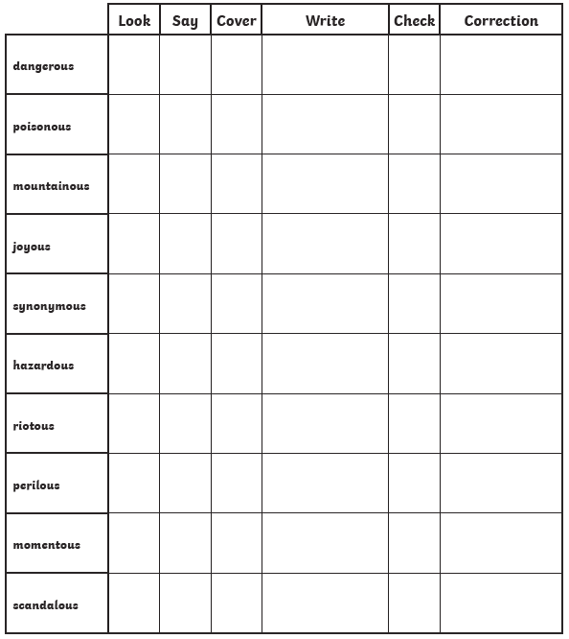
Group 2 – Day 1

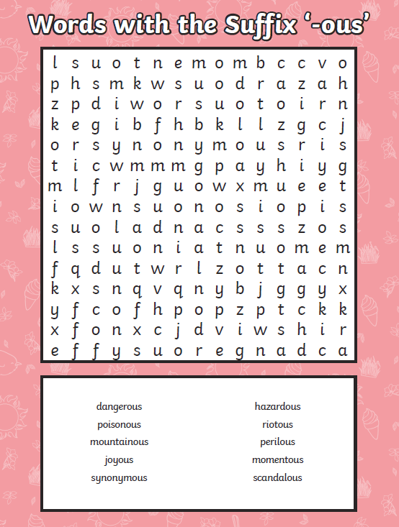
Group 2 – Day 2

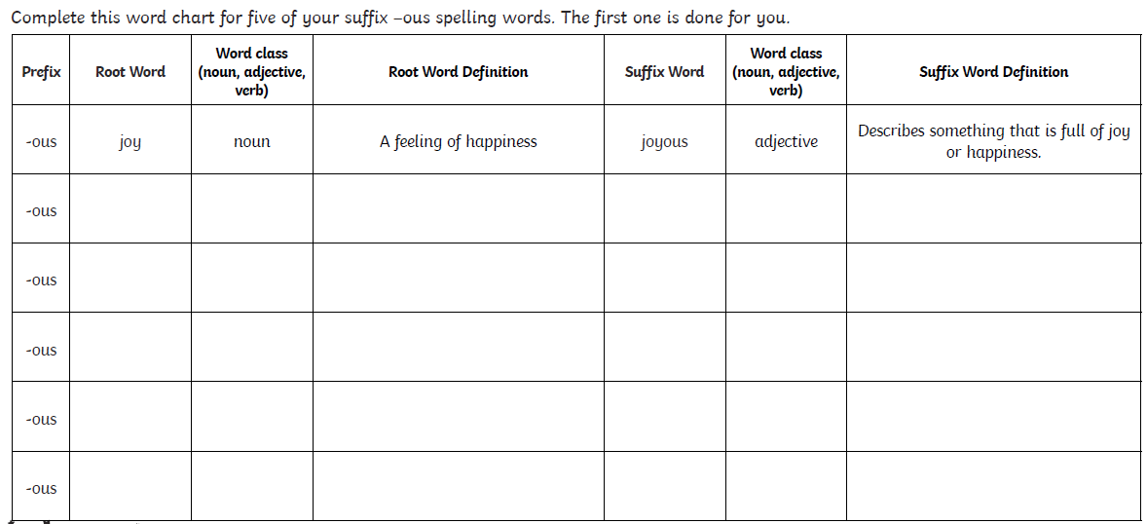
Group 2 – Day 3

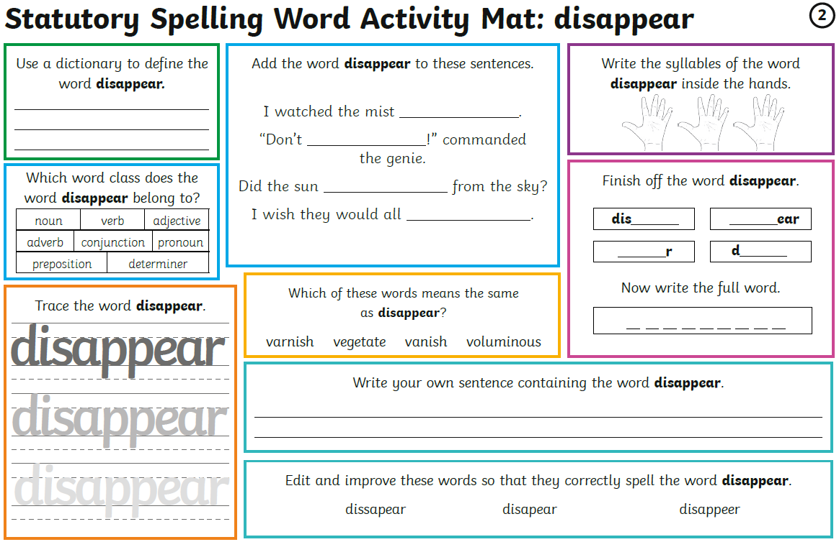
Group 2 – Day 4

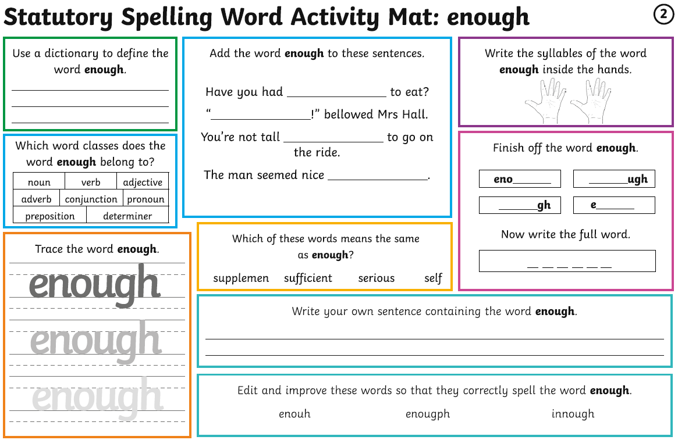
Group 2 – Day 5

Maths – Times Tables Rockstars logins – Please ensure your child is only logging in using their own login details.
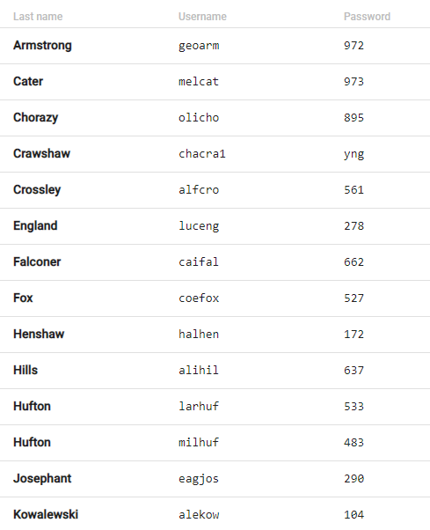
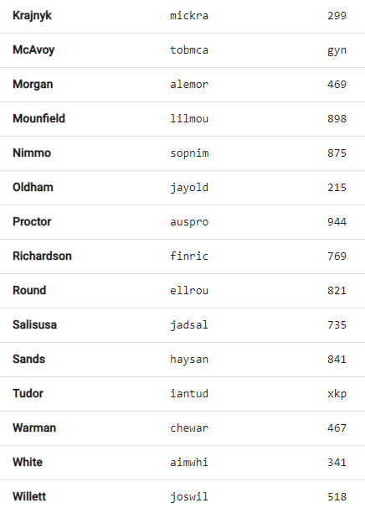
Times Tables Rockstars
WELL DONE to Lucy England who has also improved her Studio time over the last week!

Maths

Monday | Tuesday | Wednesday | Thursday | Friday
Go on the BBC link.  Watch the videos and complete the activities.  Answers provided on a link at the bottom of the webpage. | Applying yesterday’s learning to reasoning problems.  Answers in the last pages. | Work on Times Tables Rockstars. | Go on the BBC link.  Watch the videos and complete the activities.  Answers provided on a link at the bottom of the webpage. | Applying yesterday’s learning to a reasoning problem.  Answers in the last pages.

Day 1 - https://www.bbc.co.uk/bitesize/articles/zf3r47h

Day 2
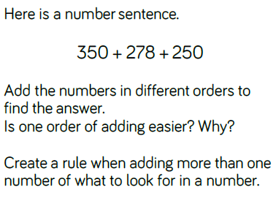
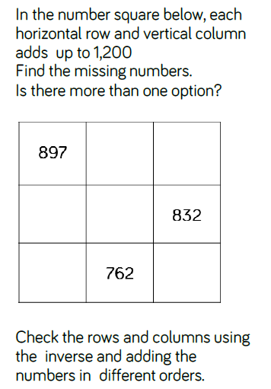

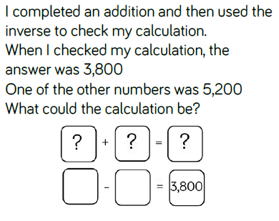

Day 4 - https://www.bbc.co.uk/bitesize/articles/zfgm6v4

Day 5
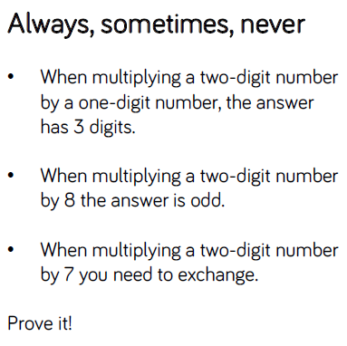
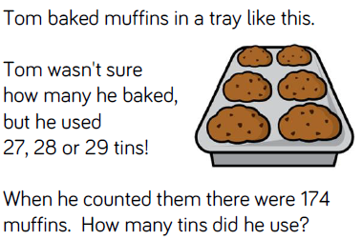
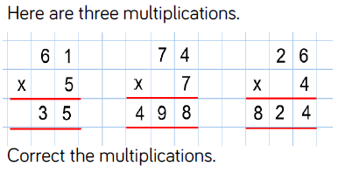

Writing – Day 1
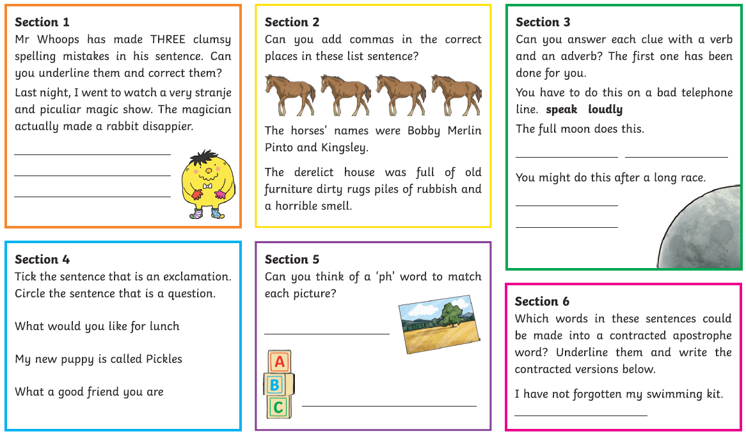

Writing – Day 2
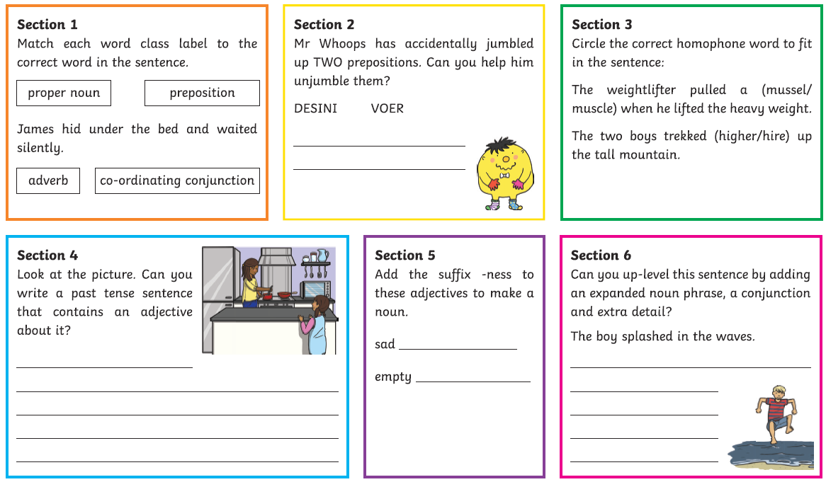
Writing – Day 3
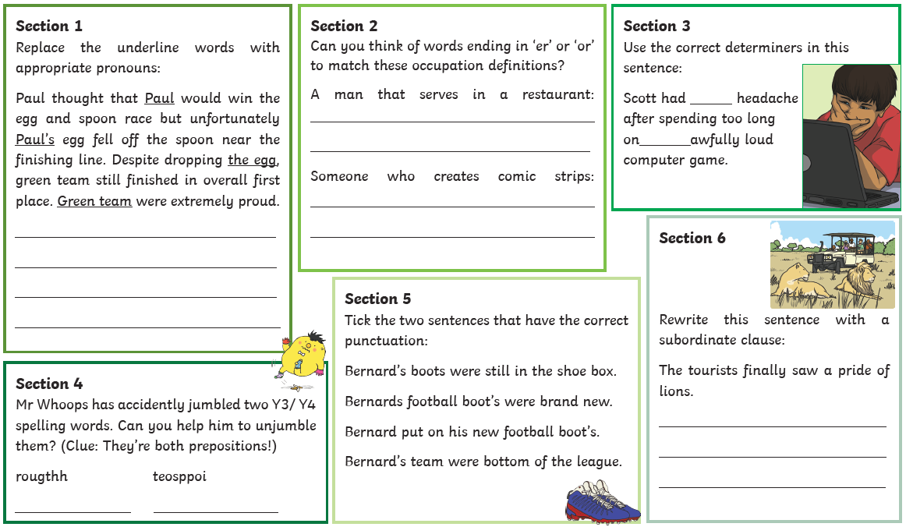

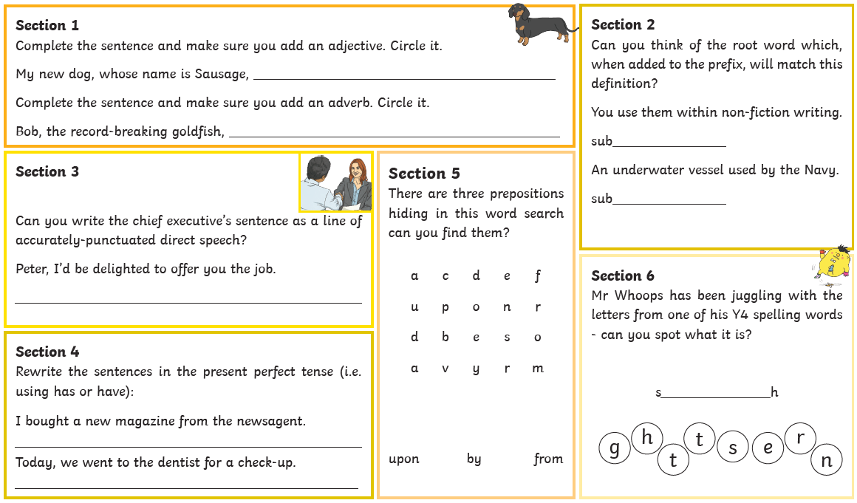
Writing – Day 4

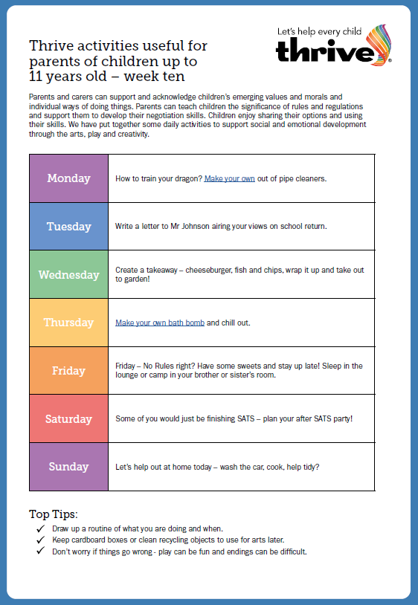
Dragon - https://frugalfun4boys.com/felt-pipe-cleaner-dragon-craft/
Bath Bomb - https://www.bbcgoodfood.com/howto/guide/how-make-bath-bomb

THE LION KING
I was supposed to go and see the Lion King on stage at a theatre in Bradford this week, but unfortunately they had to cancel the show because of everything going on in the world right now. I got an email from Disney with lots of learning activities all to do with the Lion King, so I’m going to pass them onto you guys!

The Lion King has something called ‘The Circle of Life’. For us, the Earth gives us food, light and air and this is our Circle of Life. I want you to think about what you can give back to the Earth! For example, we can respect the Earth by not damaging things and taking care of animals. The Circle of Life is not just about looking after the Earth, but also about looking after each other.
I’d like you to complete the sheet and email me with some of your ideas! I then want you to research some African masks and create your own.
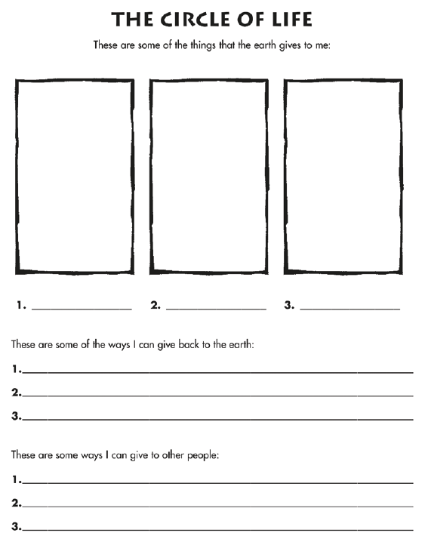

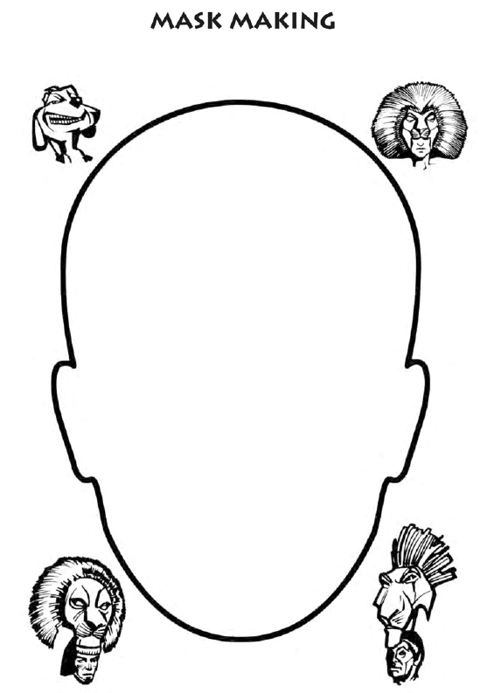

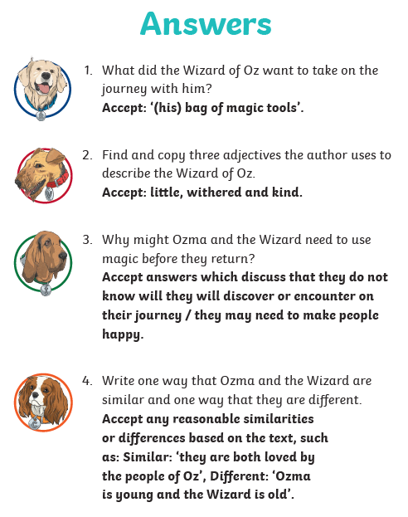
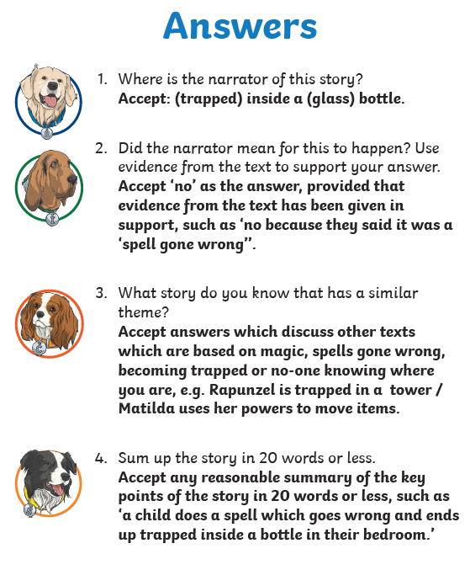
READING ANSWERS
SPELLING ANSWERS
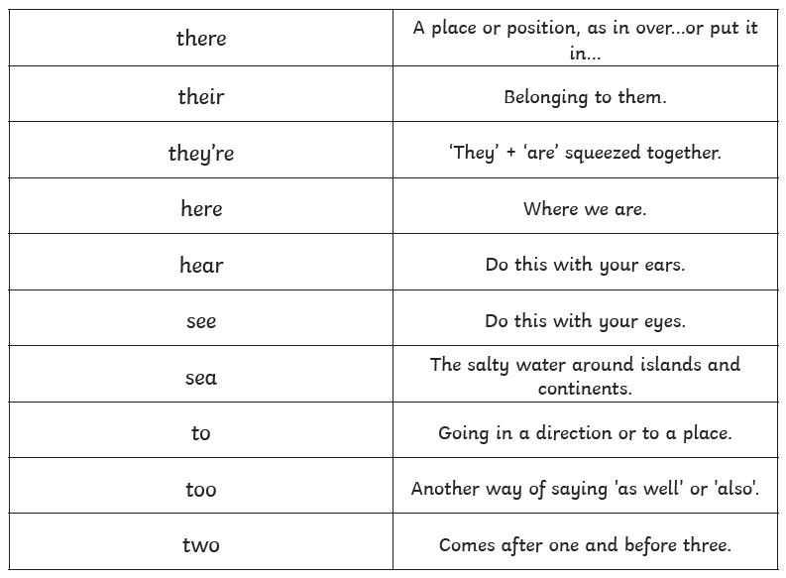

MATHS ANSWERS
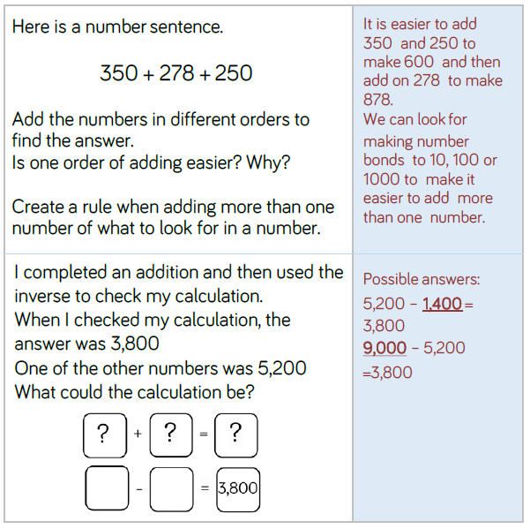

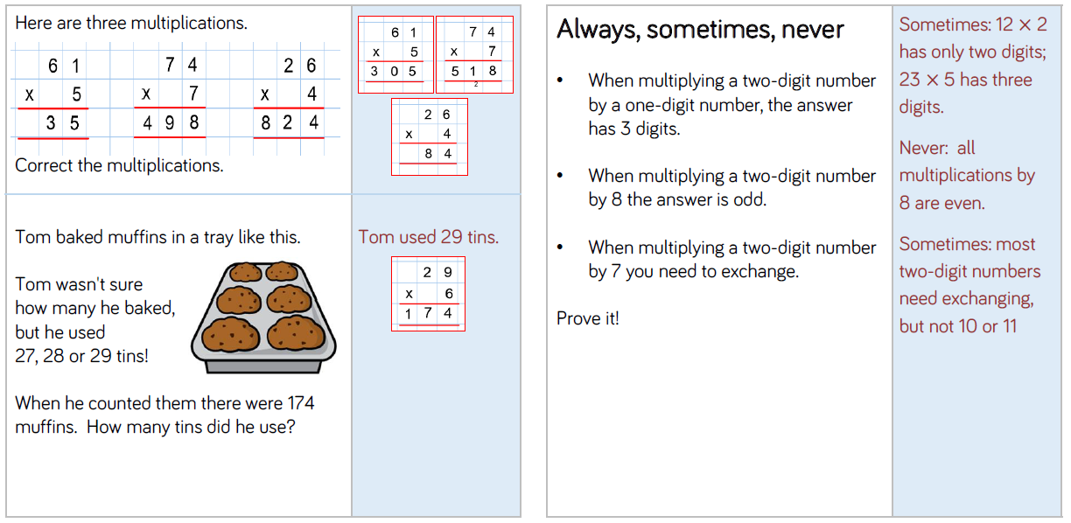
MATHS ANSWERS

WRITING ANSWERS
Day 1
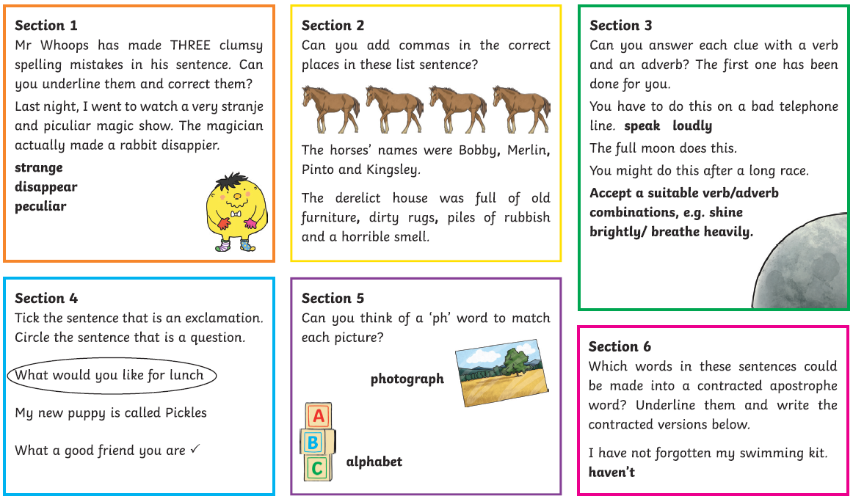
Day 2
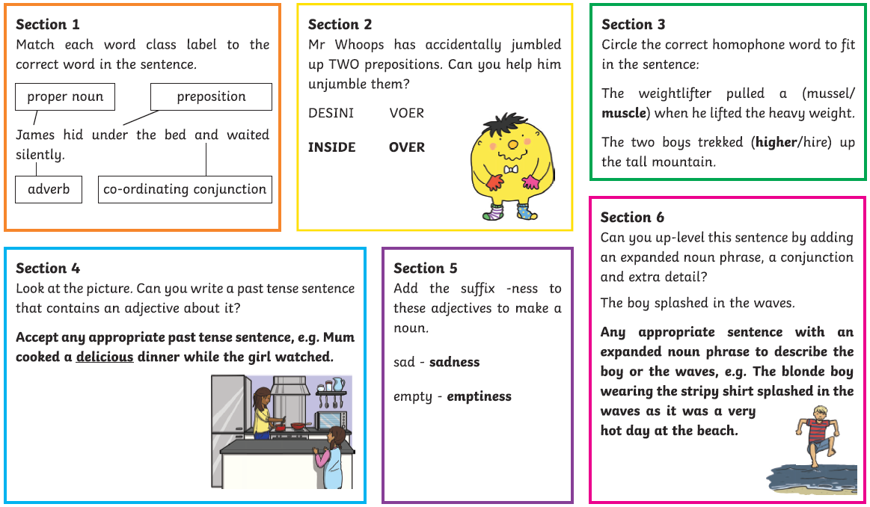
WRITING ANSWERS
Day 3
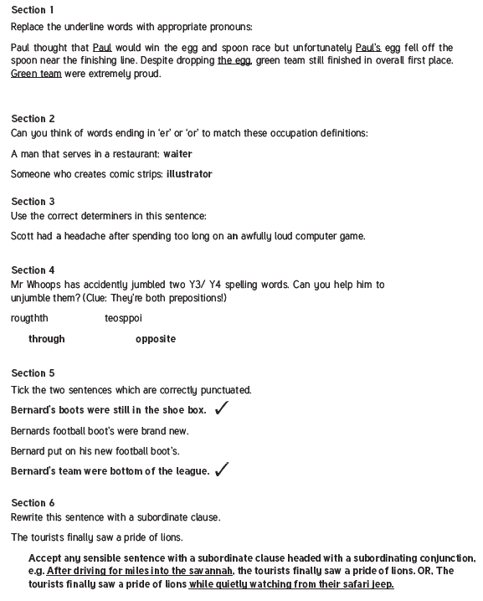

WRITING ANSWERS
Day 4
