Y3S - Home Learning
Dear Y3S, since we are not able to be together at school at the moment, I have put together some more learning activities that you can complete with your adults at home. Some activities can be printed and there are also some on-line links that may be helpful. I hope that you are all well and look forward to being back together as soon as we can. Miss Shaw
Daily Activities:
 | Activity
9.00 – 9.30 | PE with Joe Wickes | Login to you tube and search for Joe Wickes PE – it will be live that morning. This is good for all children to take part in.
Activity 1 | Maths  (30 mins) | Monday  Cut out the roman numeral petals below and place them around a clock at home like this……...  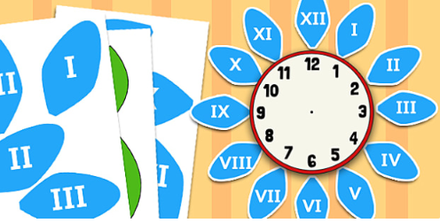  Tuesday - Thursday  Look at the attached Year 3 Maths Mastery Pack and complete Pack 4 sessions A, B, C and D. The section is all about addition and subtraction. This will give you opportunities to use your number bonds that we learn in maths meetings  There are some notes for adults about how to help you.
Activity 2 | Times tables  (15 mins) | Log in to Splat 100 square and splat your counting patterns.  https://www.primarygames.co.uk/pg2/splat/splatsq100.html  Monday 2’s  Tuesday 4’s  Wednesday 8’s  Thursday 3’s  Friday 6’s  For each daily pattern count it forwards and backwards….as a challenge, can you count them forwards then backwards with your eyes closed?  If you want to extend your learning, why not make up your own rhyme for the 7’s pattern.  Then log into TTRS and complete 10 minutes practice on the studio section
Activity 3 | Spelling  (10 mins) | Write the spellings for this week just like we do every day in the classroom. Remember LOOK / COVER / WRITE / CHECK  LOOK at the word carefully  COVER the word  WRITE it from memory  CHECK your spelling  Then use the words in a sentence – if you are not sure of the meaning you can ask an adult / check it in a dictionary / check using an on-line dictionary.  The words that I have selected this week all contain the sound “u” but it is made with an “ou” such as “young.”
Activity 4 | Handwriting  (5 mins) | Use the prepared line guide to write the joins used in our selected spellings.  ou oug ough
Activity 5 | English  (30 mins) | Reading, writing and grammar  Look at the attached Year 3 English Mastery Pack and complete Week 4.  Over the next 5 days you will be able to read a non-fiction text about a world record attempt, and you will be able to answer questions, write your own factual record and use your knowledge of grammar to complete some written activities.  All you need is a pencil / pen and some paper
Activity 6 | (30 mins) | Look at the other learning opportunities listed below and select one to do each day!

Other learning opportunities
Choose an activity each day

Music | https://www.outoftheark.co.uk/ootam-at-home/?utm_source=homepage&utm_campaign=ootamathome2&utm_medium=banner  Log on to the above website. Here you will find lovely songs to sing, just like the ones that we use every week in singing assembly.  Choose a song  Listen to it all the way through and spot any repetition  Join in with the song the 2nd time through, following the words on screen.  Make up your own actions or even dance moves, and don’t forget to follow the links for other activities related to each song  This week, I’ve been singing “Sing of a rainbow!” from the week 7 pack because last week there was a double rainbow during the clap for carers. Don’t forget to check out the related activities,  Can you learn the colours of the rainbow  in order, either by learning the song off by  heart or using a mnemonic like: Richard  Of York Gave Battle In Vain? Or you could  use the name ROY G. BIV to remind you  of the order. Can you now make up  your own mnemonic?
French | Take a look at the activity below. Can you write the days of the week in french?
Art | I hope that you enjoyed the workshops last week, provided by local Sheffield Artist Pete McKee. Have a go at drawing cartoon animals from the side … all you need is a pencil and paper.  https://www.youtube.com/watch?v=LlszMS_8njw
ICT | Send me an email to the address below and include an emoji to let me know how you feel.  MissShaw@newvillage.doncaster.sch.uk
PSHE | Think about ways that you can enjoys yourself after the lockdown ends.  Think about places that you would like to visit, like the Yorkshire Wildlife Park in Doncaster. Follow the link below to see a lovely video of 2 polar bears meeting for the first time.  https://www.yorkshirewildlifepark.com/animals/polar-bears/  After watching the polar bear clip you might want to colour the mindfulness picture of a polar bear below.
RE | At the moment Muslims in our community are observing Ramadan. Find out more about Ramadan by following the links below.  https://www.bbc.co.uk/bitesize/topics/zpdtsbk/articles/zrxxgwx  https://www.bbc.co.uk/bitesize/topics/zpdtsbk/articles/zjc2bdm
DT | In science we are learning all about the body and digestion. For your DT homework, why not have a go at making your own carrot and apple muffins using the recipe below from Joe Wickes.
Science | In science we learning all about the skeletons and muscles. Learn more about the skeletons and muscles by looking at the attached links.  https://www.bbc.co.uk/bitesize/topics/z9339j6/articles/zqfdpbk  https://www.bbc.co.uk/bitesize/topics/z9339j6/articles/zpbxb82  https://www.bbc.co.uk/bitesize/clips/ztfnvcw  After watching these clips, have a go at completing crossword below – I have included the answers so that you can check your own learning.
Follow a recipe. Bake a cake or help prepare a meal for your family. Make sure there is an adult who can help you. |  | A big night in!  Have a big night in with your family – get dressed up, have a meal and watch something great on the TV!

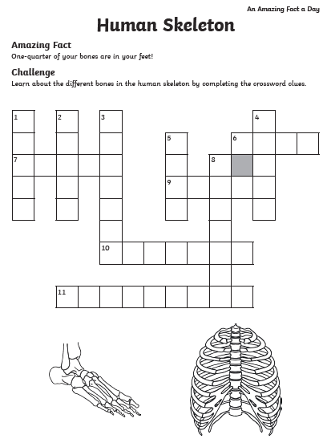

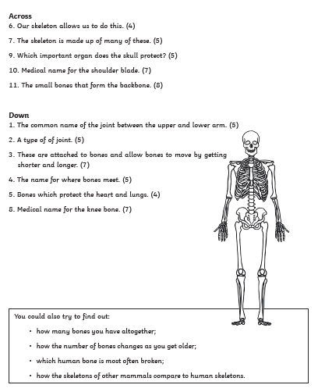

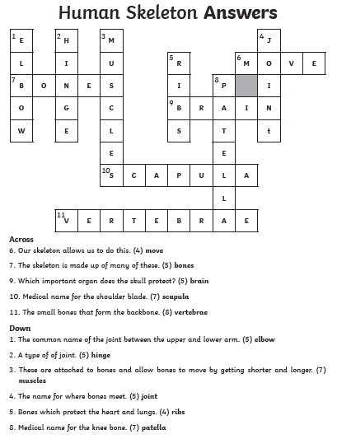

French challenge
We have the days of the week in french on display in our classroom. Can you remember them?
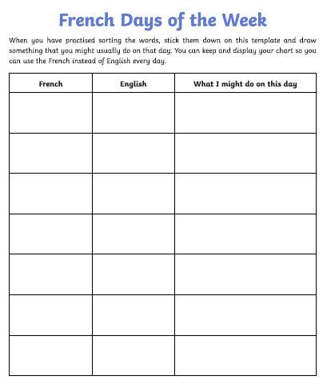
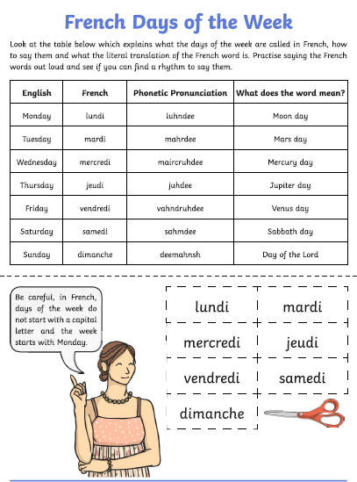

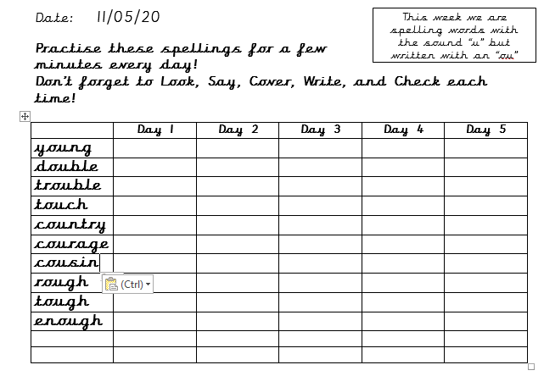

Use the lines below to write a sentence using each of these words – remember to use

your joined handwriting

