To all our wonderful Y1 Children

I hope you are being good for your grown-ups!

Please stay safe, try to do a little bit of work but most of all stay healthy and happy.

If you want to contact us you can
contact your teacher for when you return - Mrs Shah
mrsgeaney@newvillage.doncaster.sch.uk

Year 1 (Mrs Geaney’s)
Home Learning

 | Activity | Week 4
Activity 1  9.00am | PE with Joe Wickes | Each day: Login to you tube and search for Joe Wickes PE – it will be live that morning. This is good for all children to take part in.
Break
Activity 2 | Reading and spellings | Each day: Complete reading and comprehension.  Spelling Activity 1-5
Break
Activity 3 | Maths | Log in to - https://play.prodigygame.com
Break
Activity 4 | English | Writing tasks 1-5
Lunch
Activity 5 | Topic project | Make a solar system.  Include at least one of the planets, the moon and sun. You may do this however you choose.  Or create a collage of the seasons and the things you need in different seasons.
Break
Activity 6 | Craft / Life skills | Art/making/jobs around the house/cooking/baking/board games/nature pictures/singing/making music/make videos/play outdoors etc.

Reading – choose a book they want to read.
Day 1 | Listen to your child read and ask 5 questions from the Rex Retriever mat. Ask your child to say some of the answers and possibly write some of them down too.
Day 2 | Listen to your child read and ask 5 questions from the Rex Retriever mat. Ask your child to say some of the answers and possibly write some of them down too.
Day 3 | Listen to your child read and ask 5 questions from the Inference Iggy mat. Ask your child to say some of the answers and possibly write some of them down too.
Day 4 | Week 1 Complete Comprehension 1 activity
Day 5 | Week 1 Complete Comprehension 2 activity

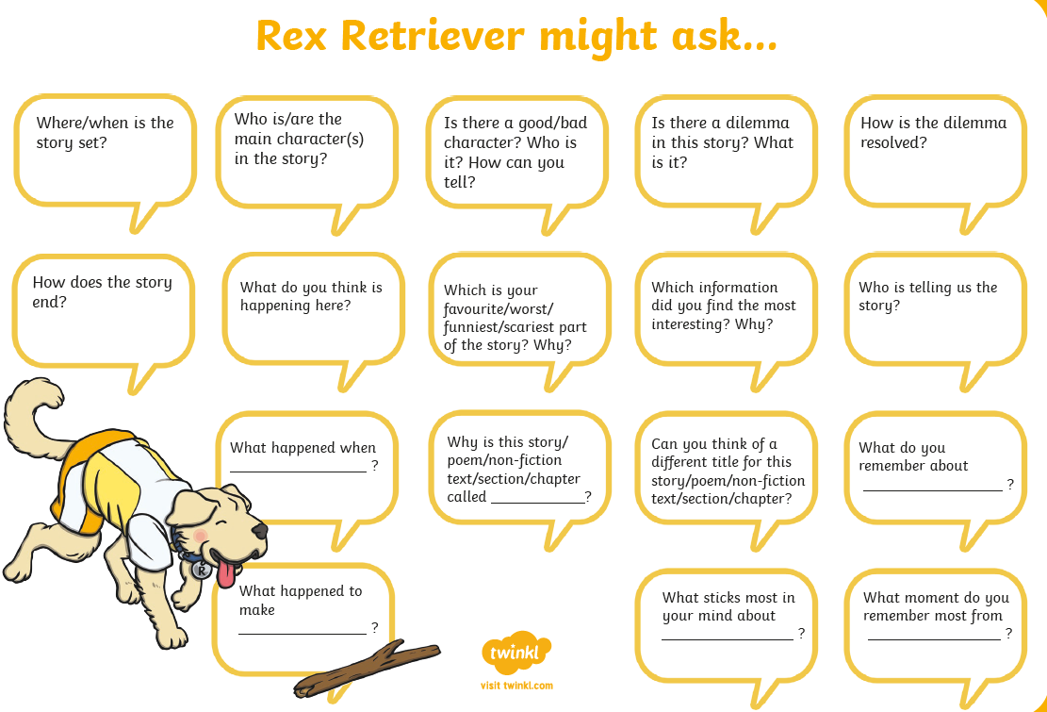
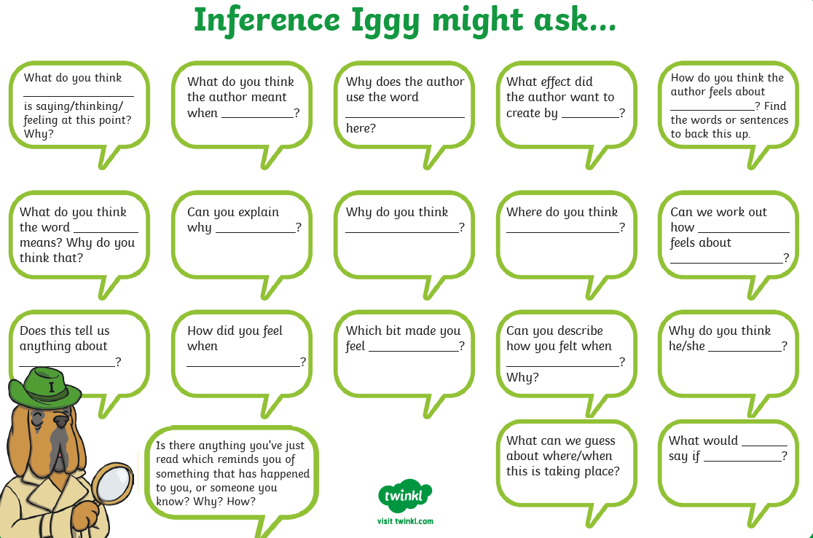

Comprehension Activity 1 Week 3
Comprehension Activity 2 Week 2

Spelling
 | Week 3
DAY 1 | Common exception word mat - be
DAY 2 | Common exception word mat – he
DAY 3 | Common exception word mat – me
DAY 4 | Common exception word mat – she
Day 5 | Common exception word mat - we

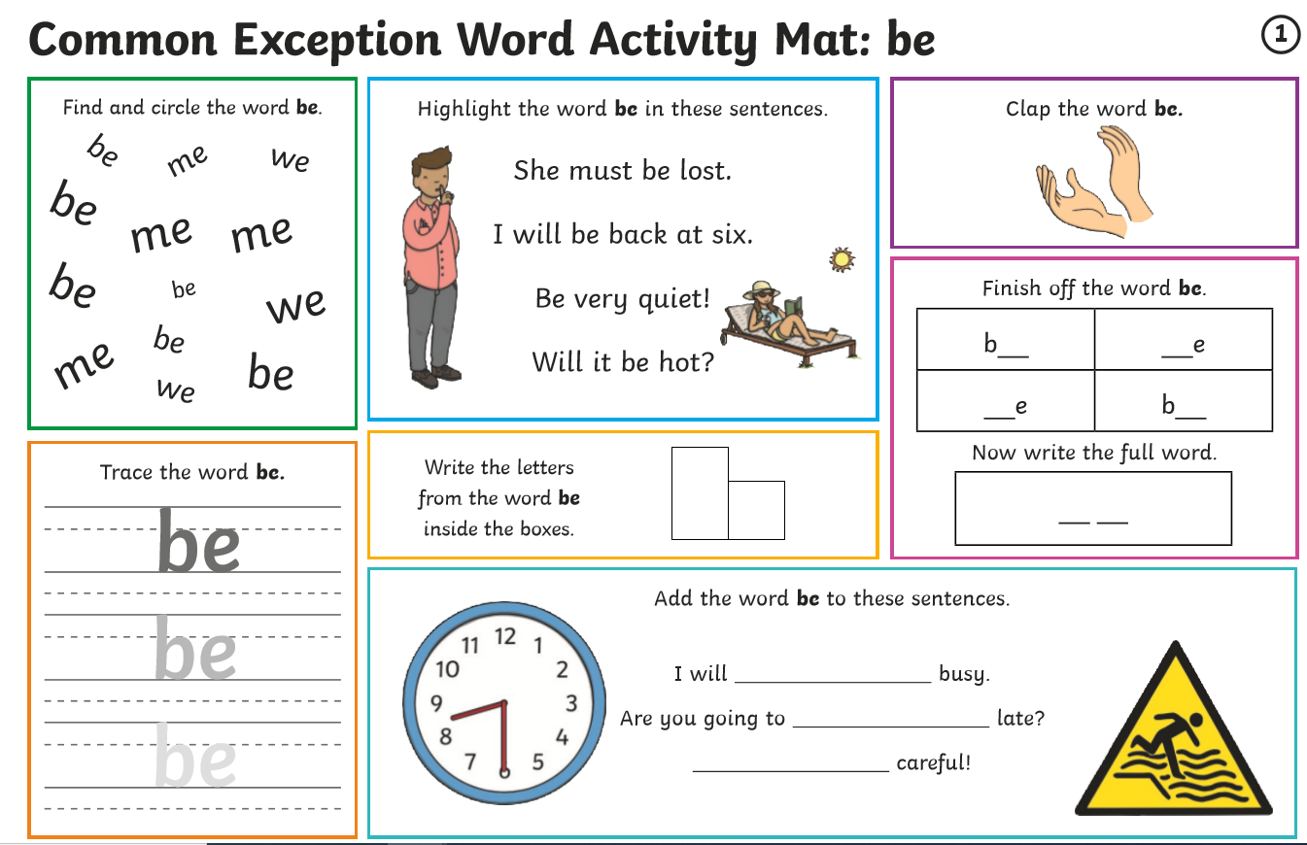

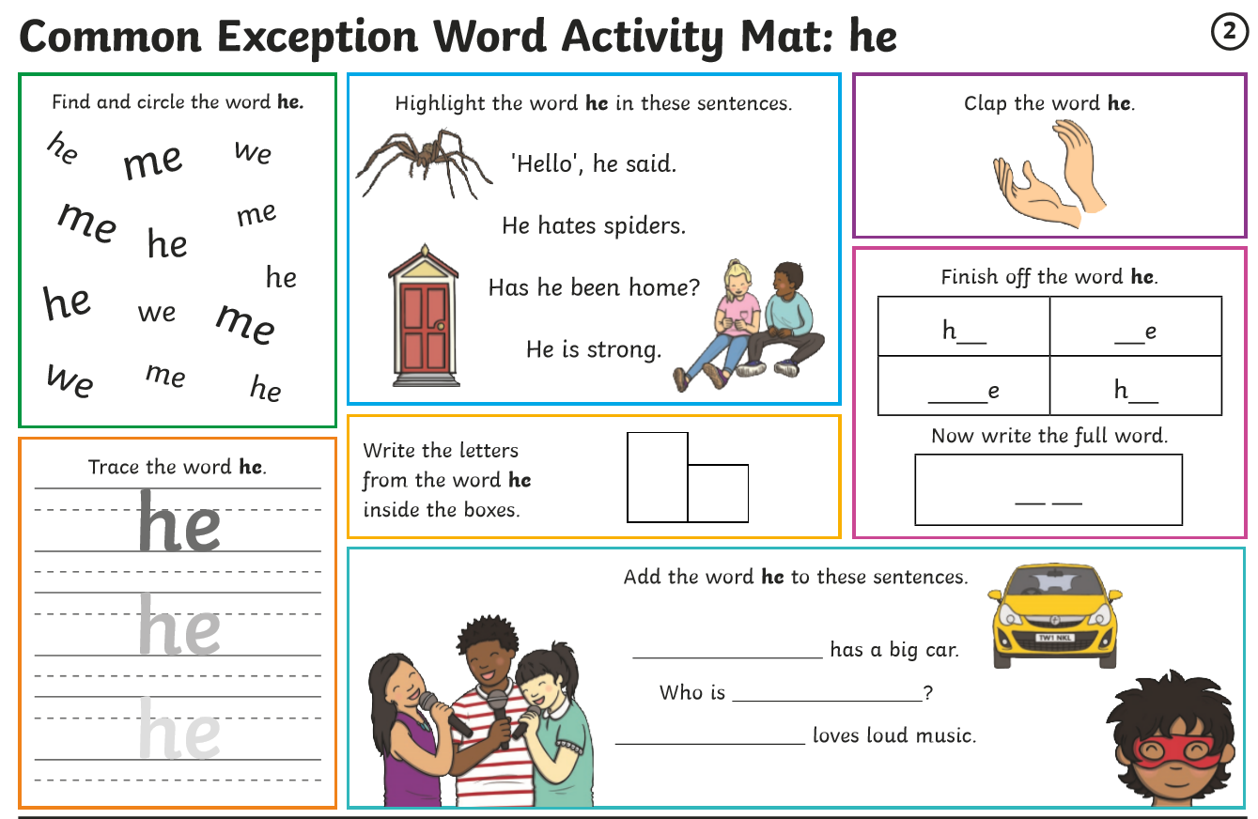

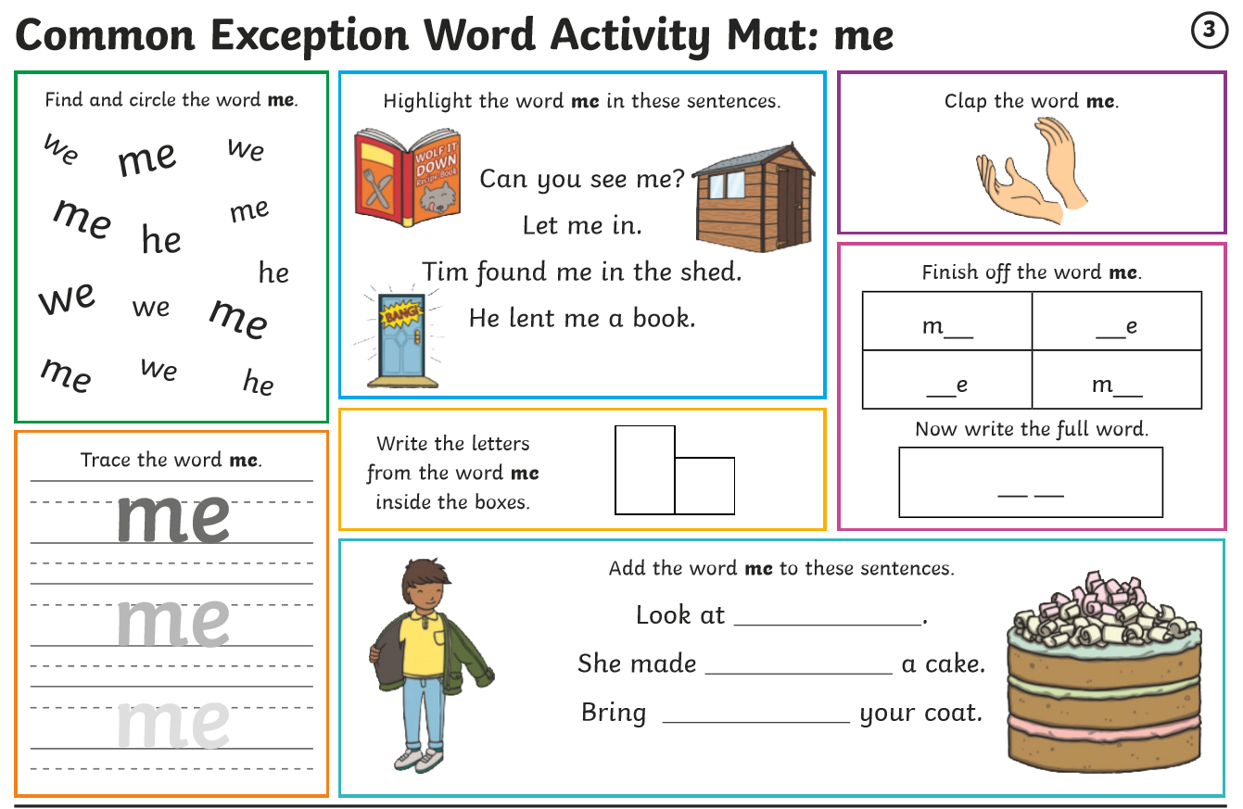

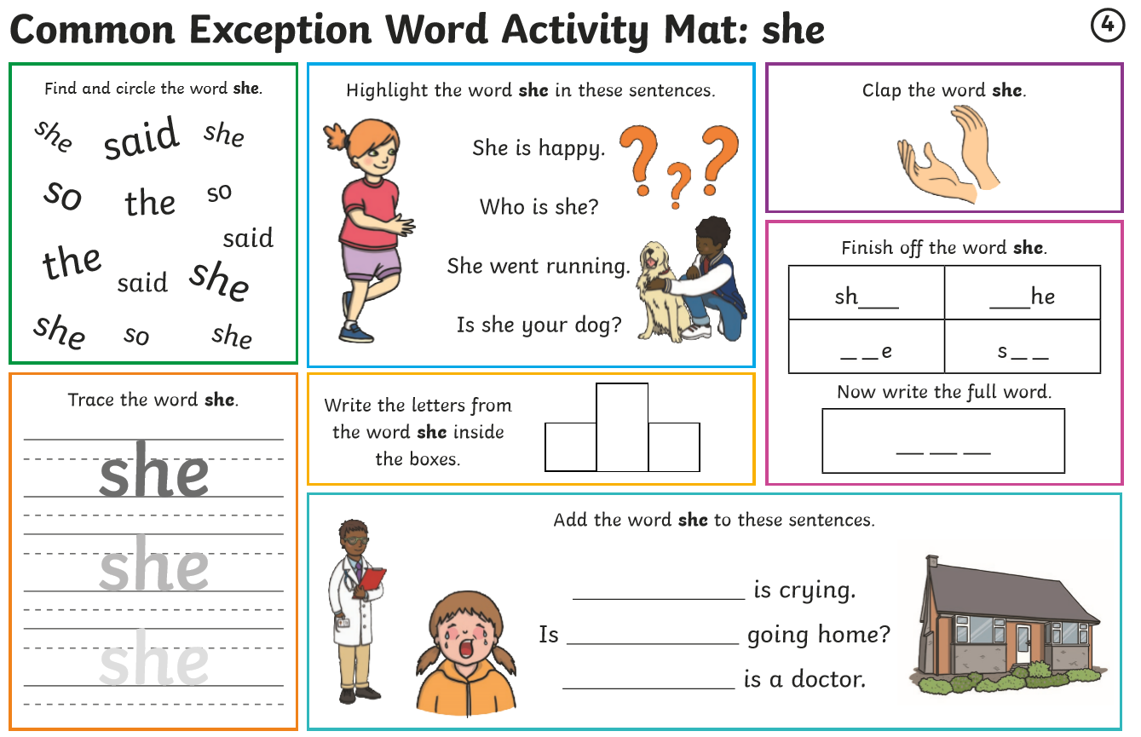
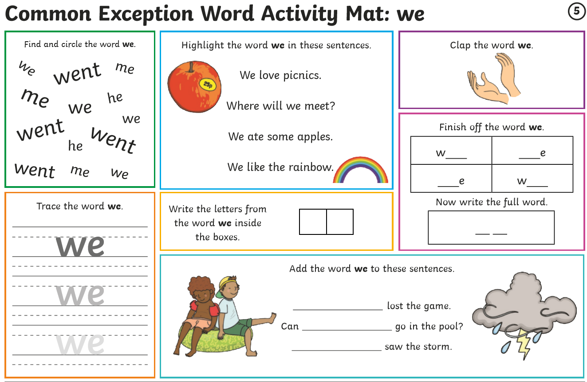

Multiplication – Week 4
Monday | Tuesday | Wednesday | Thursday | Friday
Worksheet for week 3 day 1.  Counting in equal groups. Can your child count in equal groups with you?  Can your child put things into equal groups? You might want to put items you have at home into equal groups. | Worksheet for week 3 day 2.  Can your child say who they agree with?  Can your child explain to you their reasons why they agree or disagree? | Your child is to create a picture made up from a range of different food items grouped in equal numbers eg five bunches of grapes with 7grapes in each bunch  OR 3piles of cookies with 6 cookies in each pile etc. | Can your child recognize arrays? You could let them create arrays in the garden using chalk or crayons. | Can your child recognize the mistake and say why?  Yur child might want to complete the array using sweetcorn!

Week 3 – Day 1 Adding Equal Groups

Week 3 – Day 2 Adding Equal Group
Week 3 – Day 4 Making Arrays
Week 3 – Day 5 Making Arrays

You could complete the array using sweetcorn if you want to- and if it’s ok with your parent/carer !

Writing: Unscramble the sentence.
Monday: Tuesday:
Wednesday: Thursday:
Friday Check back through all your writing for the features.
Remember I am looking for your –

- Capital Letters
- Full Stops
- Finger Spaces
- Handwriting
- Spelling

Once you’ve done all that, you might want to draw your own picture and write words about it that are scrambled up. Then you can unscramble your own sentence!

