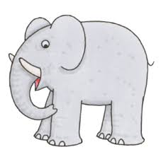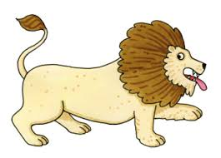
Dear Zoo
- What did the writer want from the zoo?
- Why was the elephant sent back?
- What does fragile mean?
- Why is a lion dangerous?
- Which animal was scary?
- What colour box is the monkey sent in?
- What other animal could be described as jumpy?
- Which animal do you think would make the most perfect pet?
