Week Four
Maths Activities

Hello Everyone! I hope you enjoyed watching the video.
Here are some activities you can now do to practise maths at home.

Sayings number names to 20 in order.
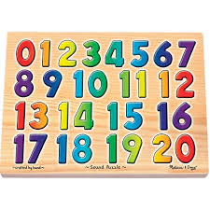
Can you say the numbers in order from 1 to 20?

Counting game
Can you count in 1s to 20?
2s to 20?
5s to 20?

Count by listening.
How many claps can you hear?
Can you show that number using your fingers?
How many stamps can you hear?
Can you show that number using your fingers?

Finding and talking about size and weight

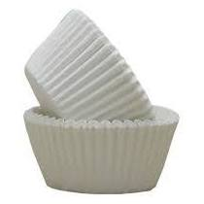
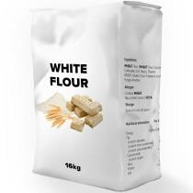
Have a go at finding things around your house that are big and small. Heavy and light. Long and short.
