Week 4 - Craft Activity
This week we are asking you to use nature to get creative.
Below you will find lots of creative ideas that you can make and do using the things we find outdoors. Please remember to only use leaves, petals and sticks that have naturally fallen off the trees and plants. Nature is art and I hope you enjoy being creative with nature.

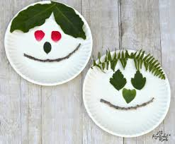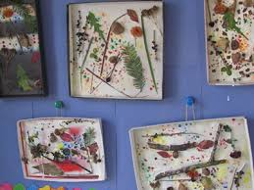
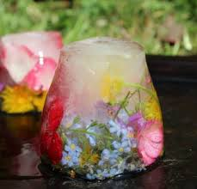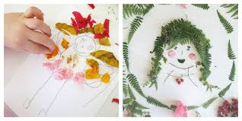

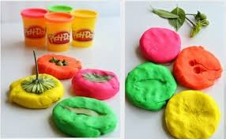
Remember, always find time to connect with nature.

