Y3S - Home Learning
Dear Y3S, since we are not able to be together at school at the moment, I have put together some learning activities that you can complete with your adults at home. Some activities can be printed and there are also some on-line links that may be helpful. I hope that you are all well and look forward to being back together as soon as we can. Miss Shaw
Daily Activities:
 | Activity
9.00 – 9.30 | PE with Joe Wickes | Login to you tube and search for Joe Wickes PE – it will be live that morning. This is good for all children to take part in.
Activity 1 | Maths  (30 mins) | Monday  Complete the clock below using Roman Numerals and then tell the time with an adult (hours / half past / quarter past)  Tuesday - Thursday  Look at the attached Year 3 Maths Mastery Pack and complete Pack 1 sessions A,B,C and D.  There are some notes for adults about how to help you.
Activity 2 | Times tables  (15 mins) | Log in to Splat 100 square and splat your counting patterns.  https://www.primarygames.co.uk/pg2/splat/splatsq100.html  Monday 2’s  Tuesday 4’s  Wednesday 8’s  Thursday 3’s  Friday 6’s  For each daily pattern count it forwards and backwards….as a challenge, can you count them forwards then backwards with your eyes closed?  Why not impress your family with our silly rhymes for the 4, 6 and 8 patterns?  Then log into TTRS and complete 10 minutes practice on the studio section
Activity 3 | Spelling  (10 mins) | Write the spellings for this week just like we do every day in the classroom. Remember LOOK / COVER / WRITE / CHECK  LOOK at the word carefully  COVER the word  WRITE it from memory  CHECK your spelling  Then use the words in a sentence – if you are not sure of the meaning you can ask an adult / check it in a dictionary / check using an on-line dictionary.  The words that I have selected this week are the ones that we had just begun before the holidays…..can you remember what they all mean?
Activity 4 | Handwriting  (5 mins) | Use the prepared line guide to write the joins used in our selected spellings.  gue que
Activity 5 | English  (30 mins) | Reading, writing and grammar  Look at the attached Year 3 English Mastery Pack and complete Week 1  Over the next 5 days you will be able to read Chapter 1 of a wonderful story entitled “Mr Majeika” by Humphrey Carpenter, and you will be able to answer questions, write a diary entry and use your knowledge of grammar to complete some written activities.  All you need is a pencil / pen and some paper
Activity 6 | (30 mins) | Look at the other learning opportunities listed below and select one to do each day!

Other learning opportunities
Choose an activity each day

Music | https://www.outoftheark.co.uk/ootam-at-home/?utm_source=homepage&utm_campaign=ootamathome2&utm_medium=banner  Log on to the above website. Here you will find lovely songs to sing, just like the ones that we use every week in singing assembly.  Choose a song  Listen to it all the way through and spot any repetition  Join in with the song the 2nd time through, following the words on screen.  Make up your own actions or even dance moves, and don’t forget to follow the links for other activities related to each song  This week, I’ve been singing “The chocolate song” from the week 3 pack, because I had some delicious Easter eggs for Easter…..one was even filled with mini bunnies, but there are none left now!!!!!!!!!!!!!!!!!!!!!!!!!!!!!
French | Colour a rainbow using the colours written in French. You can then cut this out and place it in your window. I have done this at home and my neighbours thought that it looked good.
Art | Local Sheffield Artist Pete McKee has provided some lovely learning opportunities on-line to help you to draw cartoons. Have a go at the first 2 sessions…all you need is a pencil and paper.  https://www.youtube.com/watch?v=q8f8ag58jDs  https://www.youtube.com/watch?v=N_25Cxc0RcE
ICT | Learn to send an e-mail with the help of an adult.  You can send an e-mail to a friend or relative so that you can keep in touch. You can even send one to me!
PSHE | Think about ways that you can relax.  As a way to relax, listen to the sound of a robin singing using the link below.  https://www.youtube.com/watch?v=Nrw9xPCFtYw  Then. when you listen to the birds outside, see if you can hear a robin. The best time for this is first thing in the morning when the birds wake up – this is called the dawn chorus. When you are listening to the birds you might want to colour the picture below.  Over the weekend. I took my laptop outside and played the clip in my garden. To my amazement, a little robin that lives in my garden joined in with the singing! Try it and see what happens!
DT | In science we are going to be learning all about the body and digestion. Why not have a go at making your own yogurt……with the help of an adult of course! Just follow the link to NG kids.  https://www.natgeokids.com/uk/primary-resource/make-yummy-yoghurt-primary-resource/
Science | In science we are going to be learning all about the teeth and digestion. Take a look at the diagram below and see if you can label the teeth.
Follow a recipe. Bake a cake or help prepare a meal for your family. Make sure there is an adult who can help you. |  | Quiz night!  Make up your own quiz about the Stone Age using facts the we learned last term in school and…….. test your family!

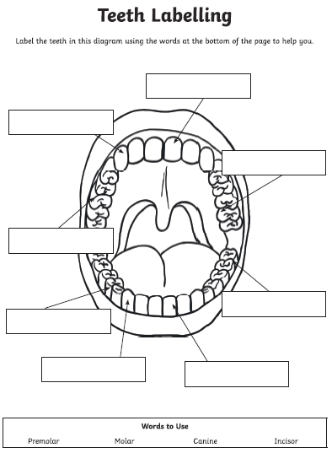

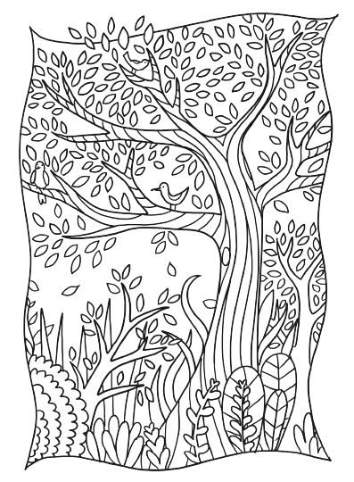

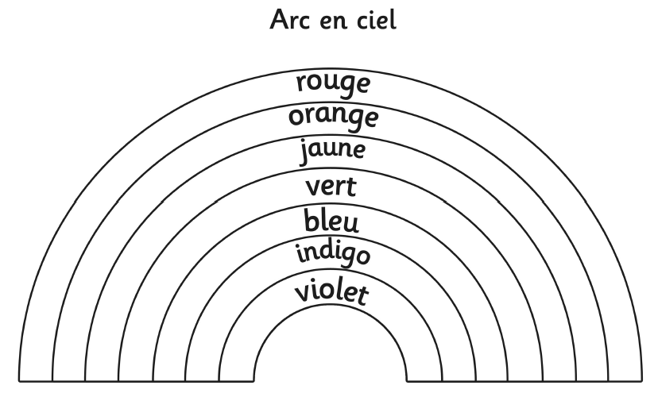

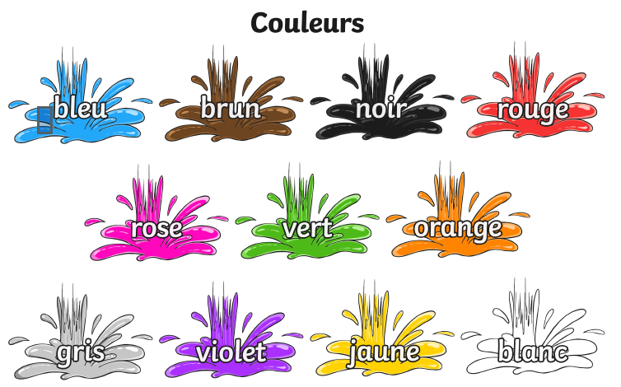
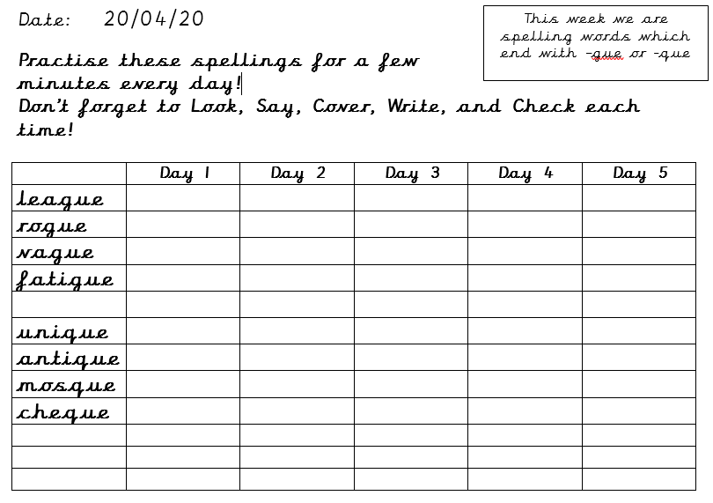

Use the lines below to write a sentence using each of these words – remember to use your joined handwriting

