Y3S - Home Learning
Dear Y3S, since we are not able to be together at school at the moment, I have put together some more learning activities that you can complete with your adults at home. Some activities can be printed and there are also some on-line links that may be helpful. I hope that you are all well and look forward to being back together as soon as we can. Miss Shaw
Daily Activities:
 | Activity
9.00 – 9.30 | PE with Joe Wickes | Login to you tube and search for Joe Wickes PE – it will be live that morning. This is good for all children to take part in.
Activity 1 | Maths  (30 mins) | Monday  Complete the clock below using Roman Numerals or use the one that you made last week and then tell the time with an adult (think this week about quarter to the hour.)  Tuesday - Thursday  Look at the attached Year 3 Maths Mastery Pack and complete Pack 2 sessions A,B,C and D. The section is all about application of multiplication and division. You are all really brilliant at your times tables, so just think about what you already know.  There are some notes for adults about how to help you.
Activity 2 | Times tables  (15 mins) | Log in to Splat 100 square and splat your counting patterns.  https://www.primarygames.co.uk/pg2/splat/splatsq100.html  Monday 2’s  Tuesday 4’s  Wednesday 8’s  Thursday 3’s  Friday 6’s  For each daily pattern count it forwards and backwards….as a challenge, can you count them forwards then backwards with your eyes closed?  If you want to extend your learning, mark out the pattern of 7’s.  Then log into TTRS and complete 10 minutes practice on the studio section
Activity 3 | Spelling  (10 mins) | Write the spellings for this week just like we do every day in the classroom. Remember LOOK / COVER / WRITE / CHECK  LOOK at the word carefully  COVER the word  WRITE it from memory  CHECK your spelling  Then use the words in a sentence – if you are not sure of the meaning you can ask an adult / check it in a dictionary / check using an on-line dictionary.  The words that I have selected this week all end in the sound – ary. There are a couple of tricky ones….. February and necessary. It is probably best to start with these 2 as they are more difficult to remember.
Activity 4 | Handwriting  (5 mins) | Use the prepared line guide to write the joins used in our selected spellings.  ary
Activity 5 | English  (30 mins) | Reading, writing and grammar  Look at the attached Year 3 English Mastery Pack and complete Week 2.  Over the next 5 days you will be able to read Chapter 1 and 2 of a wonderful story entitled “Mr Majeika” by Humphrey Carpenter, and you will be able to answer questions, write your own version of chapter one and use your knowledge of grammar to complete some written activities.  All you need is a pencil / pen and some paper
Activity 6 | (30 mins) | Look at the other learning opportunities listed below and select one to do each day!

Other learning opportunities
Choose an activity each day

Music | https://www.outoftheark.co.uk/ootam-at-home/?utm_source=homepage&utm_campaign=ootamathome2&utm_medium=banner  Log on to the above website. Here you will find lovely songs to sing, just like the ones that we use every week in singing assembly.  Choose a song  Listen to it all the way through and spot any repetition  Join in with the song the 2nd time through, following the words on screen.  Make up your own actions or even dance moves, and don’t forget to follow the links for other activities related to each song  This week, I’ve been singing “As one” and “Wake up!” from the week 5 pack. The “Wake up!” song helps keep you active and there are also some dance moves that you can access. You may remember this one from singing assemblies.
French | Take a look at the activity below. Can you match the numbers with the number words in French?
Art | I hope that you enjoyed the workshops last week, provided by local Sheffield Artist Pete McKee. Have a go at adding bodies to the faces that you can now draw …all you need is a pencil and paper.  https://www.youtube.com/watch?v=UOTMtsYtyOY
ICT | Learn to send an e-mail with the help of an adult.  Don’t forget that you can send an e-mail to me using the e-mail address that your parents can access. It would be lovely to hear from you and I will send you a message back.
PSHE | Think about ways that you can relax.  As a way to relax, listen to the sound of a blackbird singing using the link below.  https://www.youtube.com/watch?v=WmpEWlmgRxQ  Then. when you listen to the birds outside, see if you can hear a balckbird. The best time for this is first thing in the morning when the birds wake up – this is called the dawn chorus. When you are listening to the birds you might want to colour the picture below.  One of my friends has a blackbird that nests every year in her garden, and she loves to watch them feeding their babies.
DT | In science we are learning all about the body and digestion. For your DT homework, why not have a go at making your own fruit kebabs using the recipe below.
Science | In science we learning all about the teeth and digestion. On the diagram last week, you had to label the different teeth. (molar, premolar, incisor and canine.) Learn more about what these teeth do be looking at the attached links.  https://www.bbc.co.uk/bitesize/topics/z27kng8/articles/zsp76yc  https://www.bbc.co.uk/bitesize/topics/z27kng8/articles/z2rxb82  After learning about incisors and molars why not take my challenge below?  Think back to the shape of the woolly mammoth tooth that we had in our classroom last half term. What type of tooth do you think that it was, and what does that tell you about the diet of a woolly mammoth?  Send your answer by e-mail if you like.  Now have a go at the crossword below…  all about teeth!
Follow a recipe. Bake a cake or help prepare a meal for your family. Make sure there is an adult who can help you. |  | A big night in!  Have a big night in with your family – get dressed up, have a meal and watch something great on the TV!

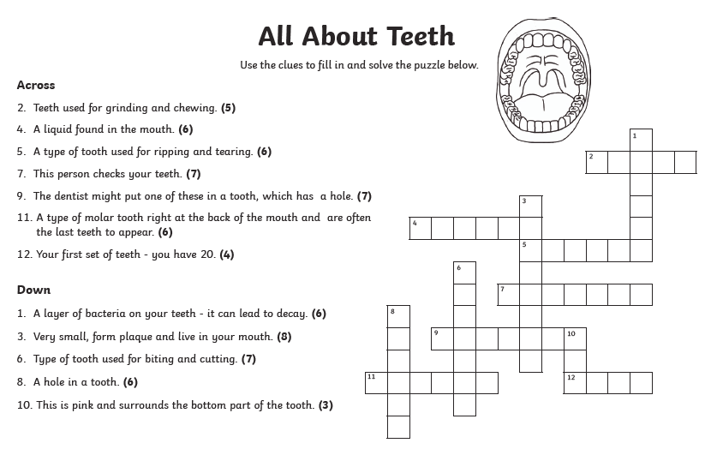

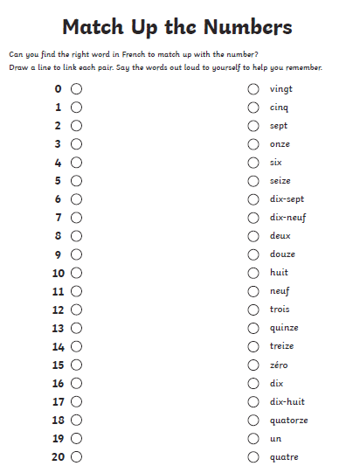

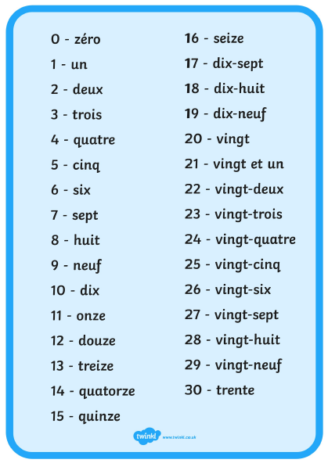

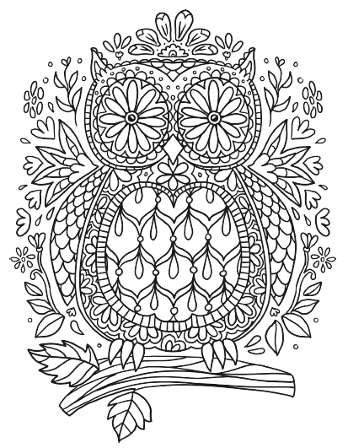

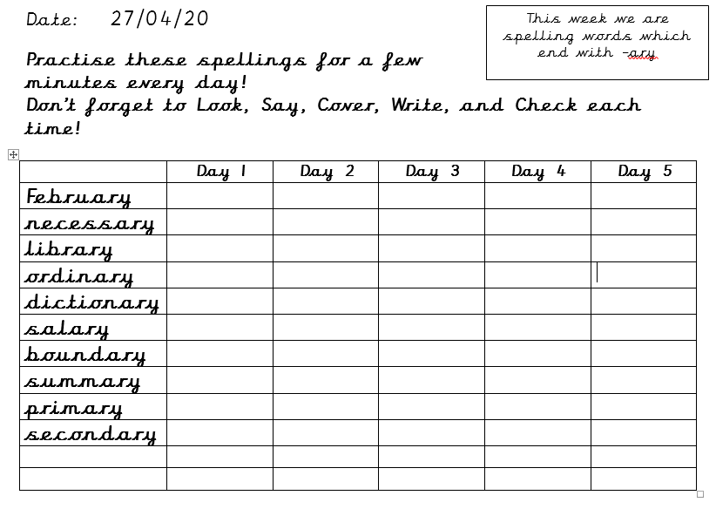

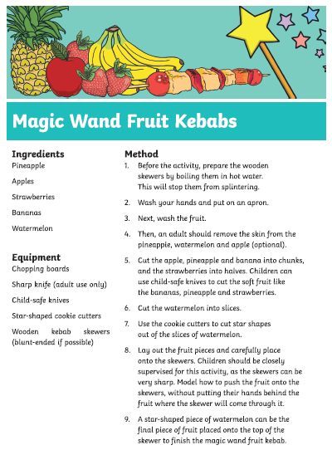

Use the lines below to write a sentence using each of these words – remember to use

your joined handwriting

