2Si - Home Learning - Week 2
Daily Activities:
 | Activity
9.00 – 9.30 | PE with Joe Wickes/Oti | Login to you tube and search for Joe Wickes PE or Oti Dance classes https://youtu.be/EJmpCH9p2X8 – have fun
Activity 1 | Maths  (30 mins) | Complete the Maths Meeting revision grid each day  OR Maths task
Activity 2 | Spag  (30 mins) | Complete this weeks Spag revision grid
Activity 3 | TTRS  (10 mins) | Log into TTRS and complete 10 minutes practice on the studio or practice counting in 2, 5, 10 forwards and backwards – get an adult to test you.
Activity 4 | English  (30 mins) | Day 1 – Think about your best day. Plan a piece of writing, why is it your best day.  Day 2/3 – write the recount. Remember to use sentences in your writing, add in the adjectives and adverbs to help me picture it.  Day 4/5 – proof read your writing, check spellings in a dictionary (online dictionary here https://www.collinsdictionary.com/dictionary/english)
Activity 5 | Reading  (30 mins) | Day 1 & 2  Child: Choose a book you would like to read. Read it aloud to an adult  Adults: Listen to the child read and ask 3 questions from the Rex Retriever mat. Ask the child to write/type the answers to at least 2 of them. Then ask the child 3 questions from the Inference Iggy mat. The child should record at least 2 answers in writing  Day 3 & 4 Complete the comprehension activity  Day 5 Work through the answers with the child – can they prove why that answer is correct?
Activity 6 | Science Task (30 mins) | Complete the activities at the end about food chains
Extra Activities
Choose an activity each day
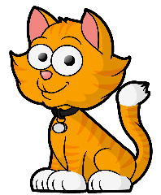
Can you build a tower? Use anything you like! How tall can you make it? See if you can measure it. | Online singing lessons  https://www.bbc.co.uk/bitesize/articles/zr4nscw | Choose a garden project. You can do some weeding or have a try at growing your own plant! | Go on an alphabet Scavenger hunt. Can you find an object that starts with every letter of the alphabet
Sort your toys into 2 groups. See if your adult can guess which sorting rule you used. | Hide some ‘treasure and create a map for someone in your family to follow. | Quiz night!  Make up your own quiz about Space and test your family! | Create a diary of all the different things you have been doing.
 | MATHS REVISION CHALLENGES
Partition this number | 146 | 89 | 21
Add 53 to these numbers | 35 | 23 | 69
Find 3/4 of each number | 48 | 28 | 56
How much is this tally worth? | //// //// // | //// //// //// /// | //// ////
Look at the shape
What is its name?
How many sides does it have?
How many lines of symmetry?
Look at the 2d shape above – how many lines of symmetry does it have?
Multiply these numbers by 3 | 4 | 9 | 12
Complete these calculations | 32 + 63 = | 124 – 63 = | 27 x 5 =
 | 148 + 34 = | 84 – 28 = | 36 ÷ 3 =
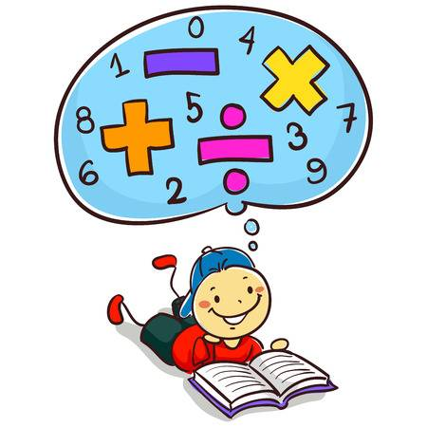
Maths Tasks
Look closely at the picture below. What 2d shapes can you see?
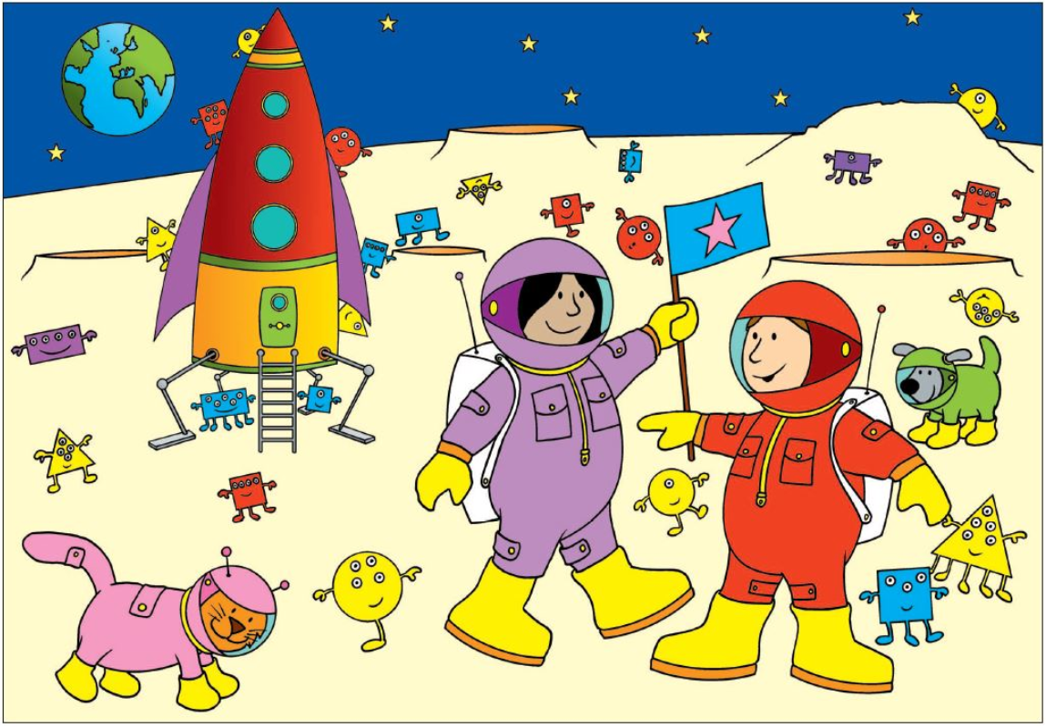

Look at the picture from previous page. Look closely at the aliens and complete the tally chart below. (Remember a tally has / for each and then cross over for 5 ////)
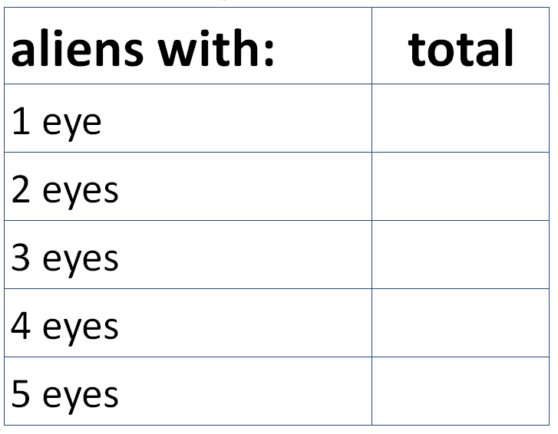

Which is the most common?

Which is the least common?

 | SPAG REVISION CHALLENGES
Write a sentence using this conjunction | because | but | so
Spell this word correctly | 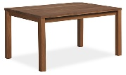  t_ _ _ _ | 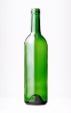  b _ _ _ _ _ | 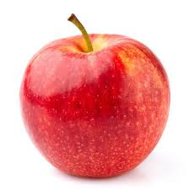  a _ _ _ _
Use suffixes to show comparison (er/est) | quiet | angry | silly
Change these to the past tense – (rewrite the sentence) | Freddie is walking. | Freddie is eating | Rachel is singing.
Circle the verbs | Hastings nearly scored a goal. | Dolphins happily swim with people. | The plane scarily flew very low.
What type of word is the arrow pointing to | The angry dog ran quickly towards the cat. | The angry dog ran quickly towards the cat. | The angry dog ran quickly towards the cat.
Create your own expanded noun phrase for these items | cat | field | monster
Put the apostrophe in the correct place | C a n t | D o n t | W o n t
Writing activity

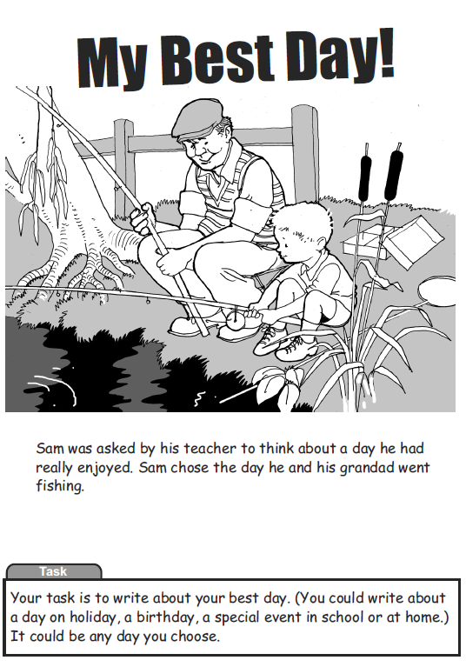

Planning Your writing

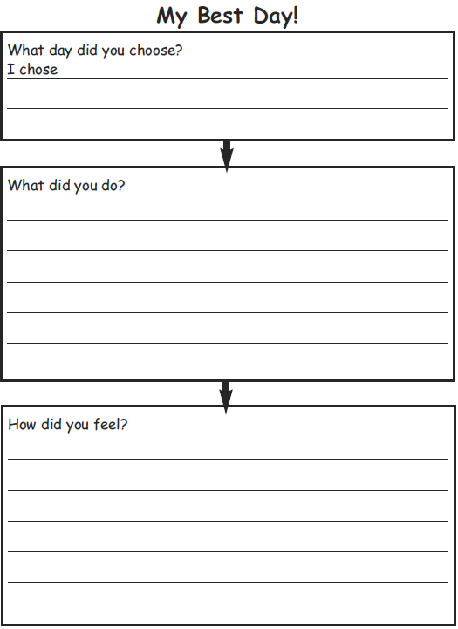

The Best Day

Reading – choose a book they want to read.
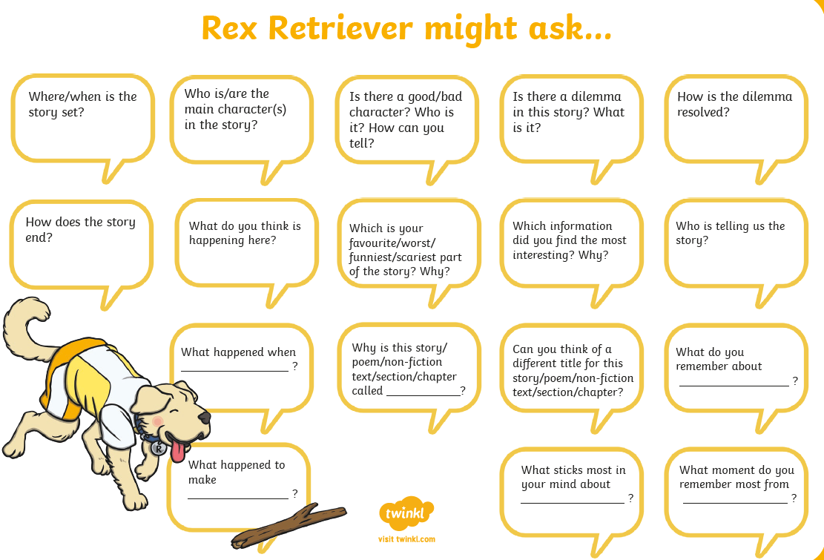

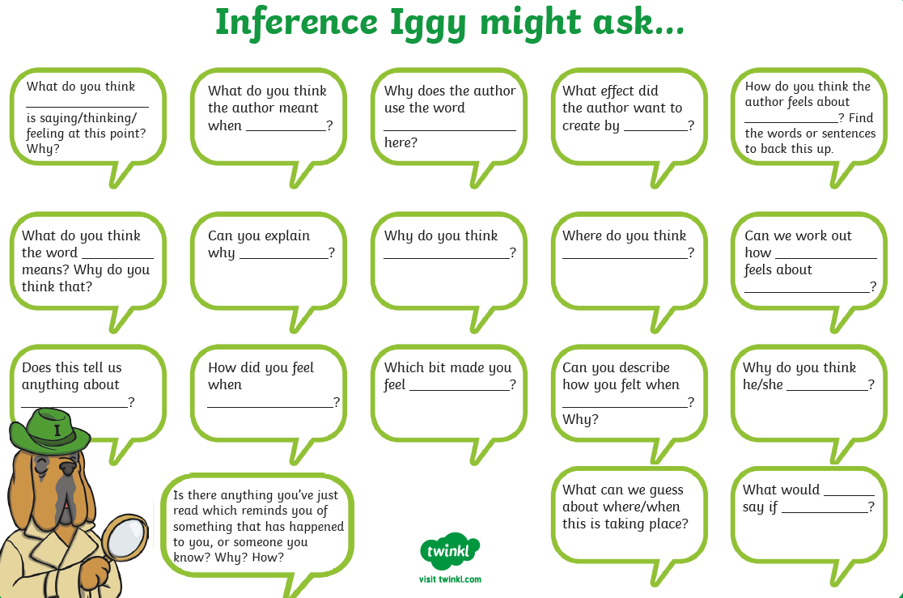
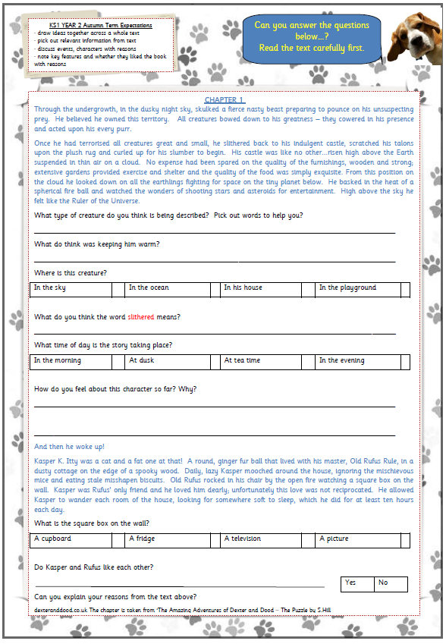
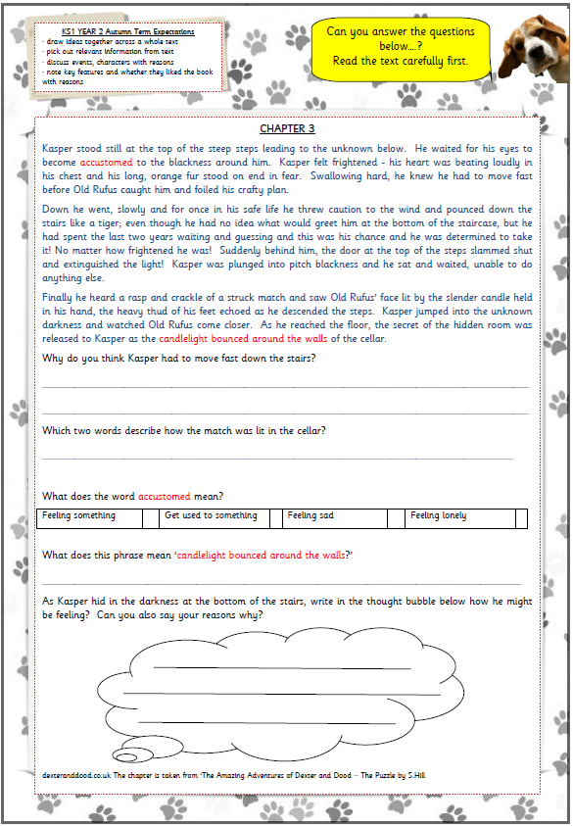
Science Activity
FOODCHAINS
Watch this short video clip:
https://www.bbc.co.uk/bitesize/topics/zx882hv/articles/z3c2xnb
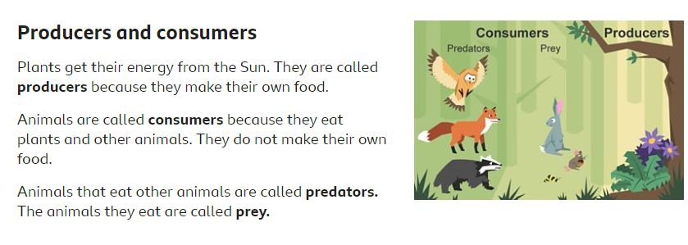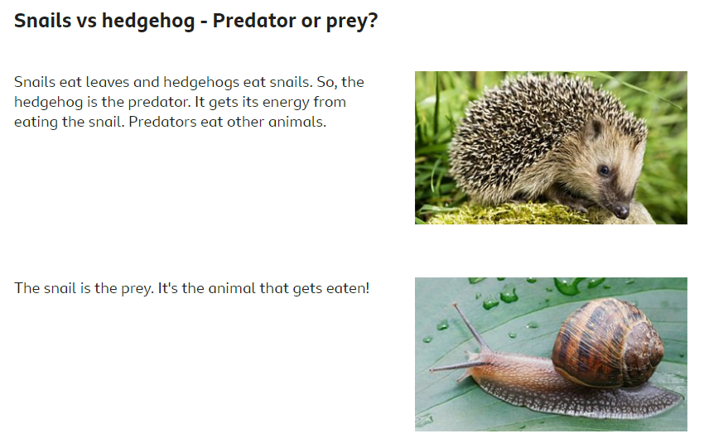
TASK 2: You are going to create 4 food chains for animals from different habitats.
- Pick a habitat (Polar/Ocean/Woodland/Rainforest)
- Research food chains from that habitat
- Draw and label your food chains- be creative in how you create it!
CHALLENGE- Try to present each habitat differently!
Here are some ideas:
