To all our wonderful Y1 Children

I hope you are being good for your grown-ups!

Please stay safe, try to do a little bit of work but most of all stay healthy and happy.

If you want to contact us you can do so at:
Mrshemmingway@newvillage.doncaster.sch.uk
or contact your teacher for when you return - Mrs Shah
mrsgeaney@newvillage.doncaster.sch.uk

Year 1 (Mrs Geaney’s)
Home Learning

 | Activity | Week 1
Activity 1  9.00am | PE with Joe Wickes | Each day: Login to you tube and search for Joe Wickes PE – it will be live that morning. This is good for all children to take part in.
Break
Activity 2 | Reading and spellings | Each day: Complete reading and comprehension.  Spelling Activity 1-5
Break
Activity 3 | Maths | Log in to - https://play.prodigygame.com
Break
Activity 4 | English | Writing tasks 1-5
Lunch
Activity 5 | Topic project | Make a solar system.  Include at least one of the planets, the moon and sun. You may do this however you choose.
Break
Activity 6 | Craft / Life skills | Art/making/jobs around the house/cooking/baking/board games/nature pictures/singing/making music/make videos/play outdoors etc.

Reading – choose a book they want to read.
Day 1 | Listen to your child read and ask 5 questions from the Rex Retriever mat. Ask your child to say some of the answers and possibly write some of them down too.
Day 2 | Listen to your child read and ask 5 questions from the Rex Retriever mat. Ask your child to say some of the answers and possibly write some of them down too.
Day 3 | Listen to your child read and ask 5 questions from the Inference Iggy mat. Ask your child to say some of the answers and possibly write some of them down too.
Day 4 | Week 1 Complete Comprehension 1 activity
Day 5 | Week 1 Complete Comprehension 2 activity

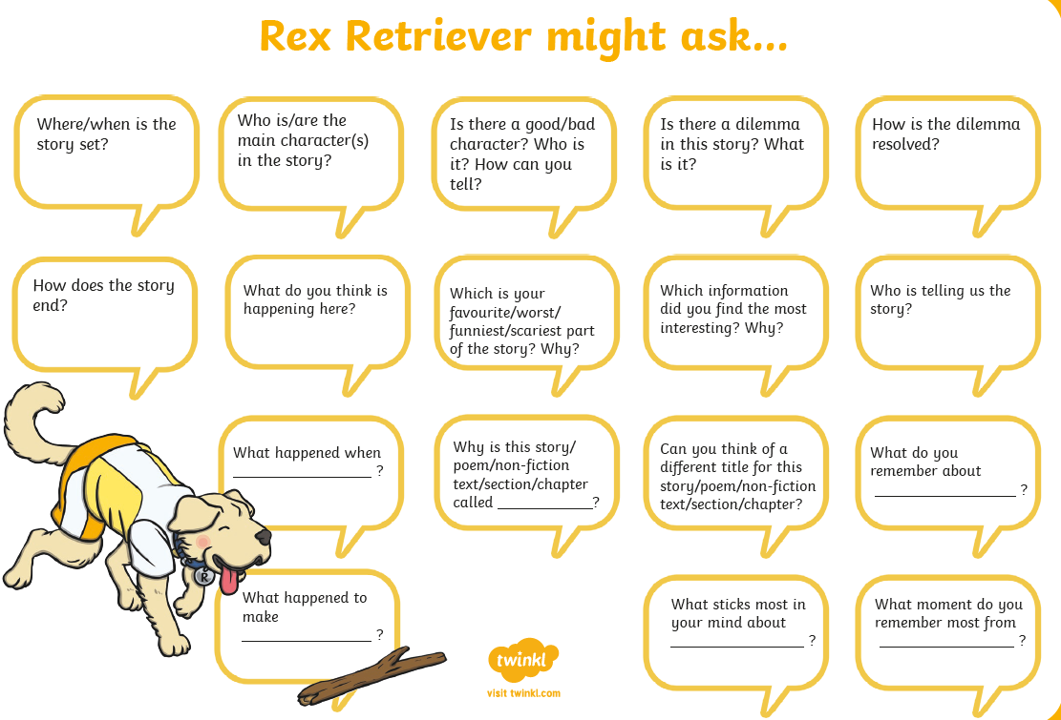
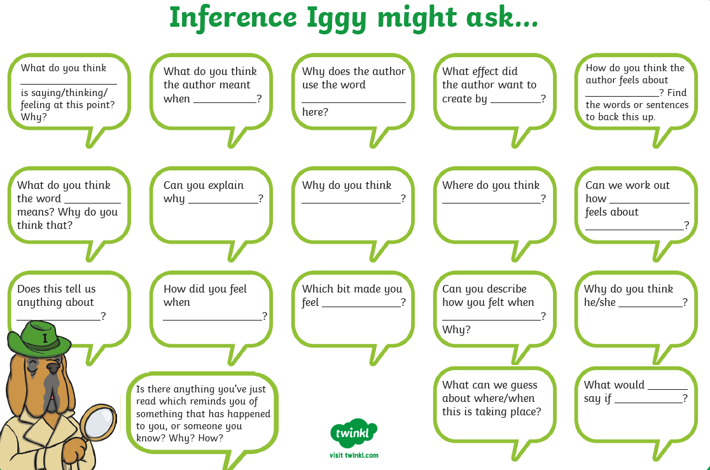

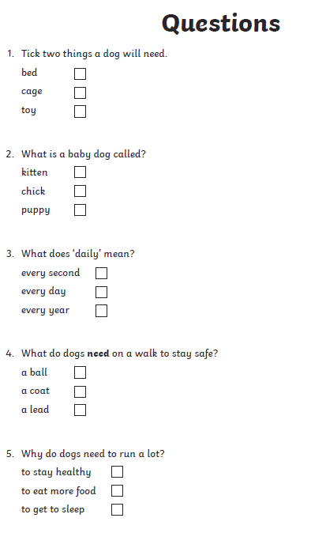
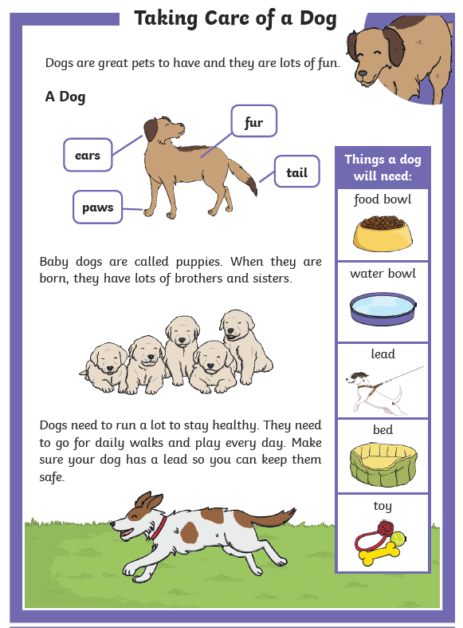
Comprehension Activity 1 Week 1

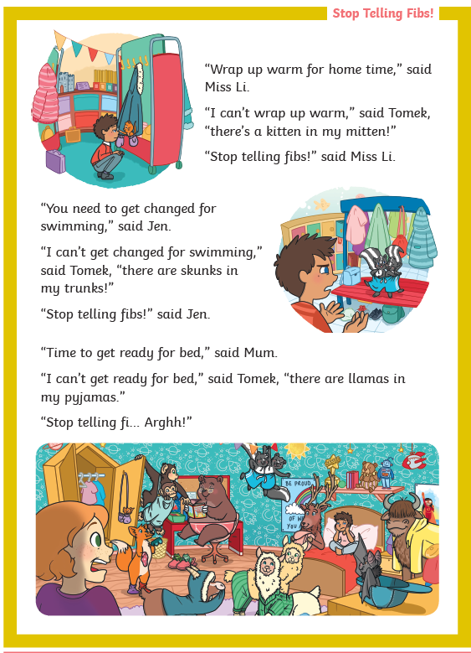
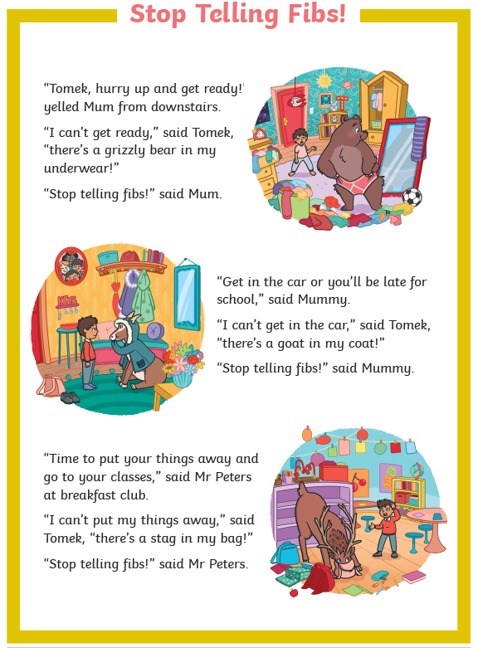
Comprehension Activity 2 Week 1

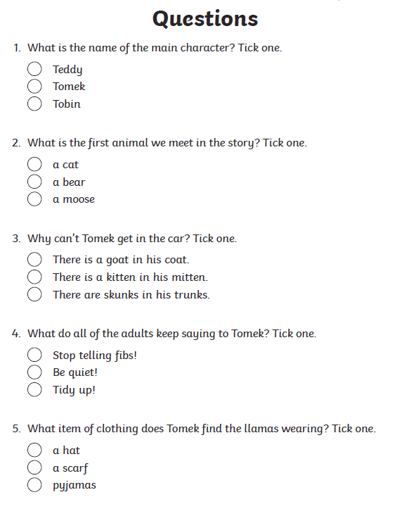

Spelling
 | Week 1
DAY 1 | Common exception word mat - a
DAY 2 | Common exception word mat – the
DAY 3 | Common exception word mat – I
DAY 4 | Common exception word mat – is
Day 5 | Common exception word mat - was

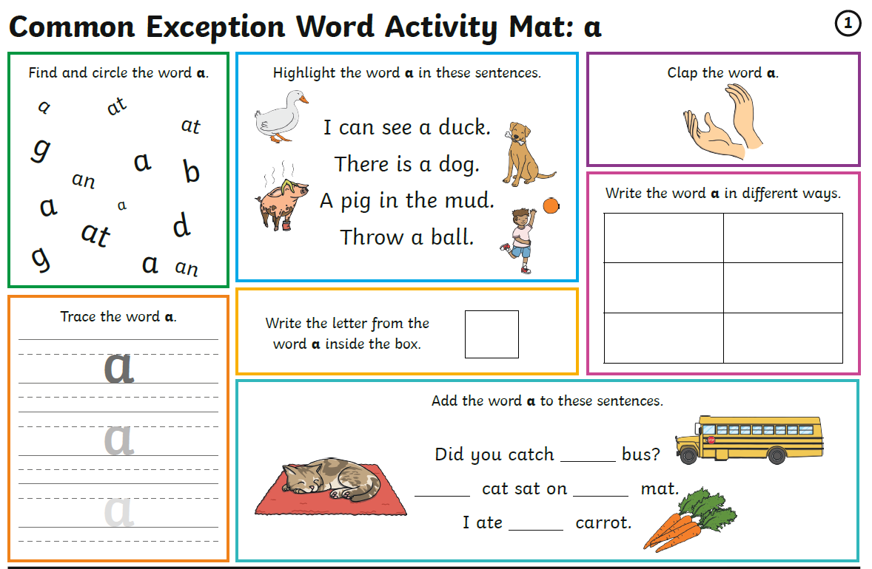

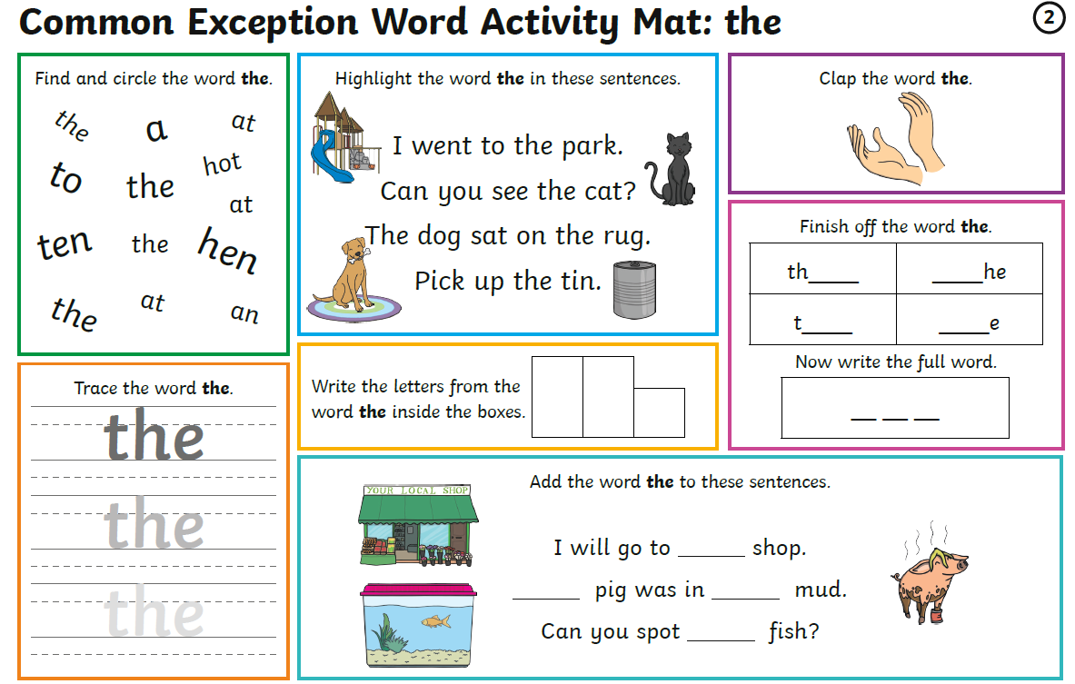

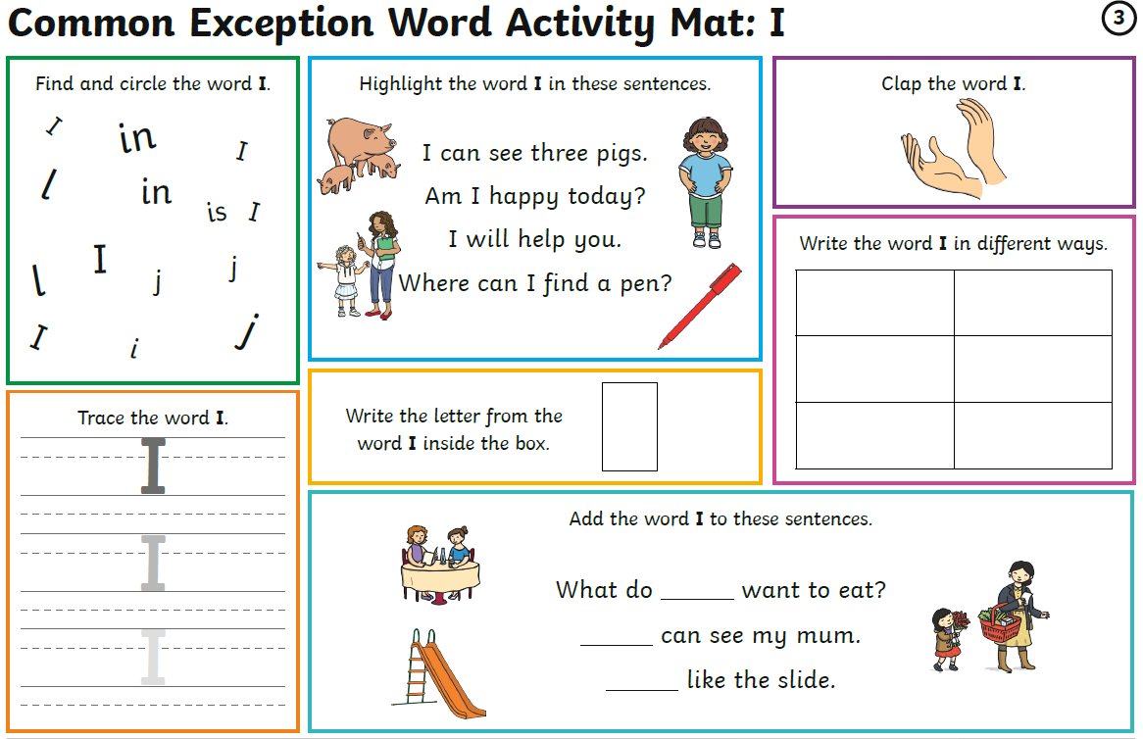
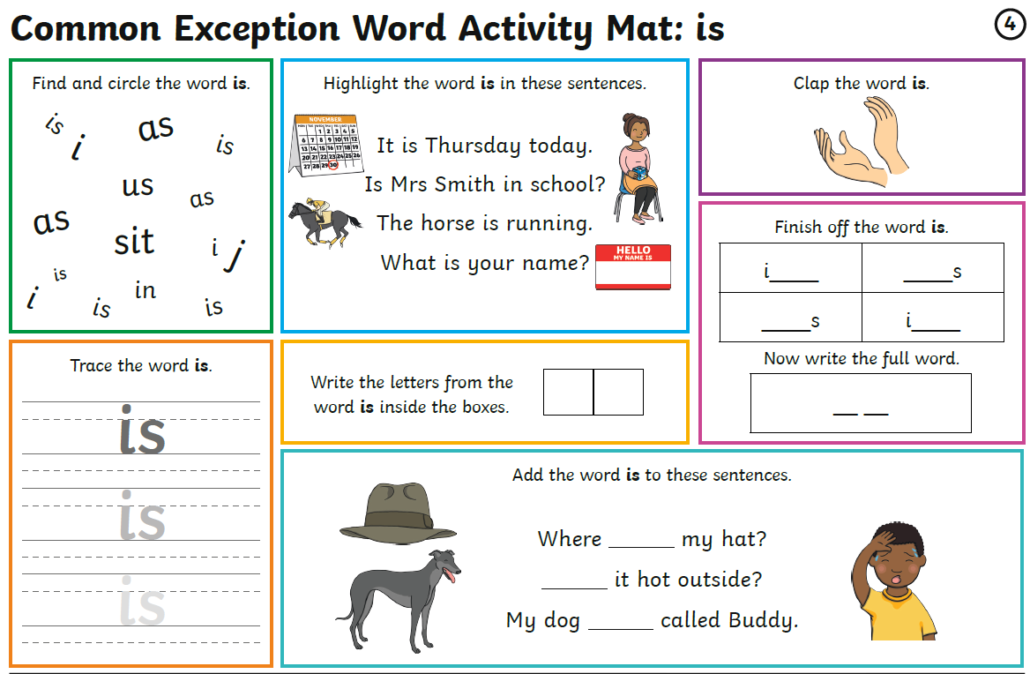

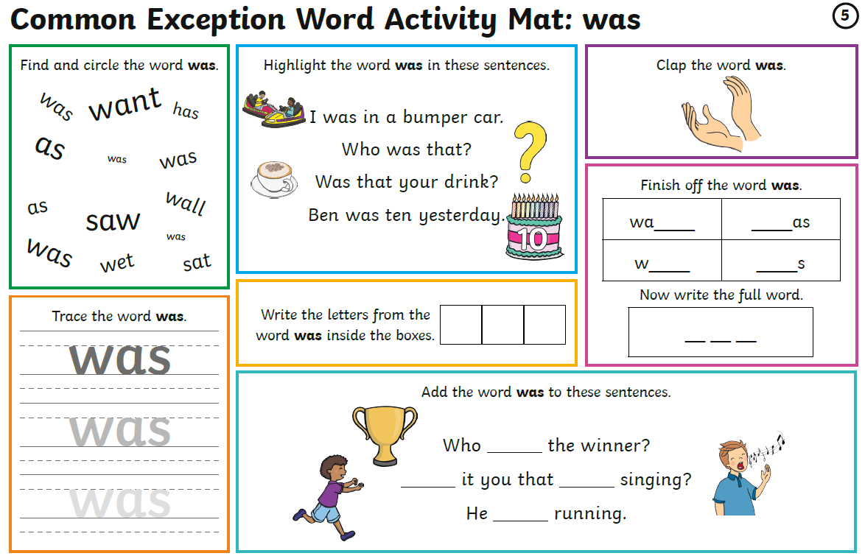
Maths
Log on to https://play.prodigygame.com – let your child log in with the following log in and play the maths games.
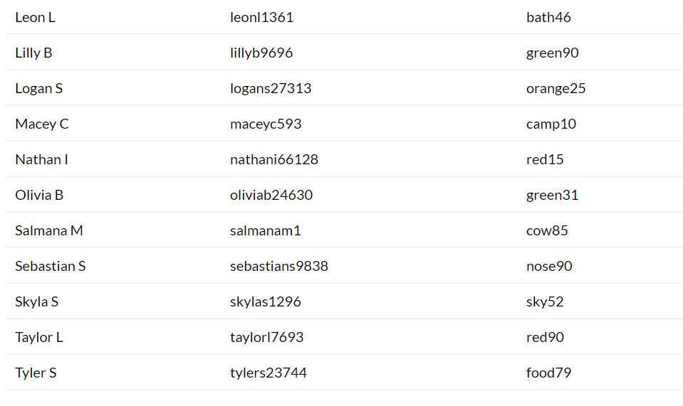
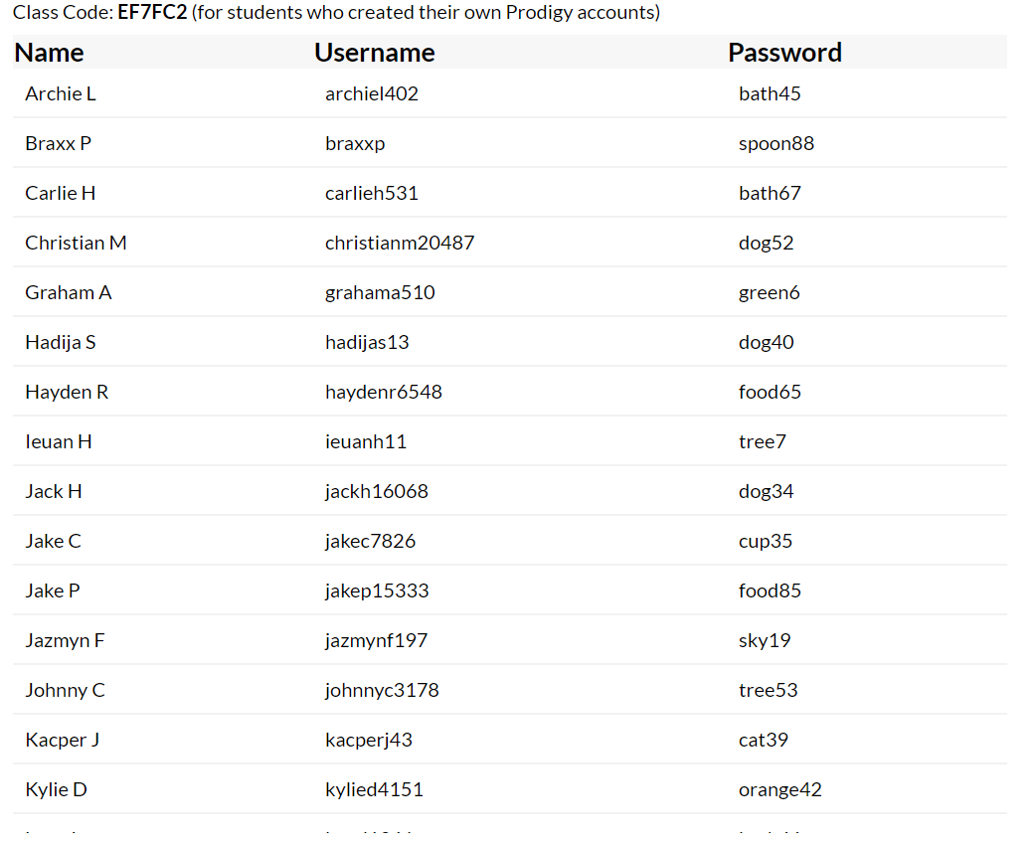

Shape – Week 1
Monday | Tuesday | Wednesday | Thursday | Friday
Worksheet for week 1 day 1.  What shapes does your child know?  Do a shape hunt around the house and garden. Can you find each of the shapes? | Worksheet for week 1 day 2.  Can your child sort the shapes?  Complete the mathematical talk about shape. | Complete a picture of your child’s choice made up from a range of different shapes. | Can your child recognise patterns with shapes? Complete the sheet.  Make own patterns. | Make some biscuits with your parents and make them all different shapes. Talk about how many sides and vertices (points)

Week 1 – Day 1
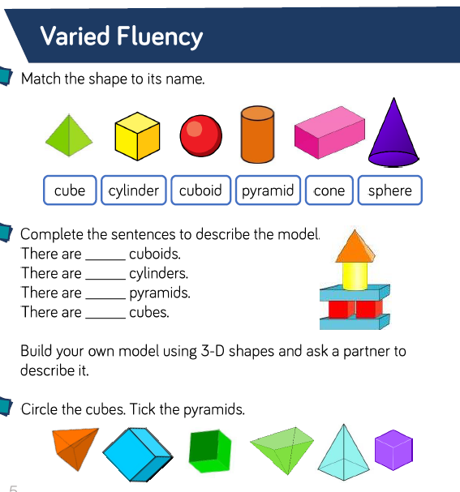
How many of each of the shapes can you see around the house and garden – try to find one of each!

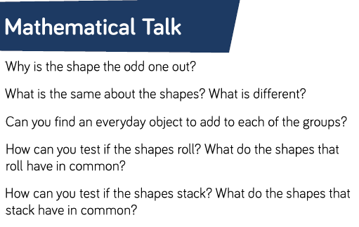
Week 1 – Day 2
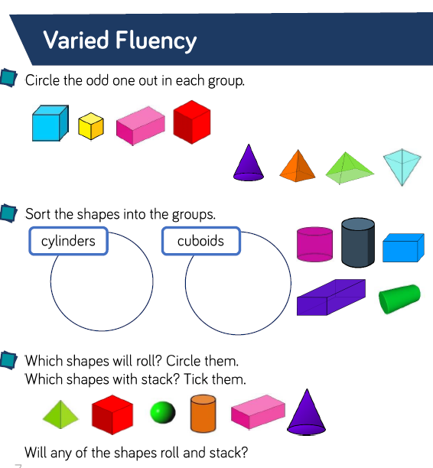

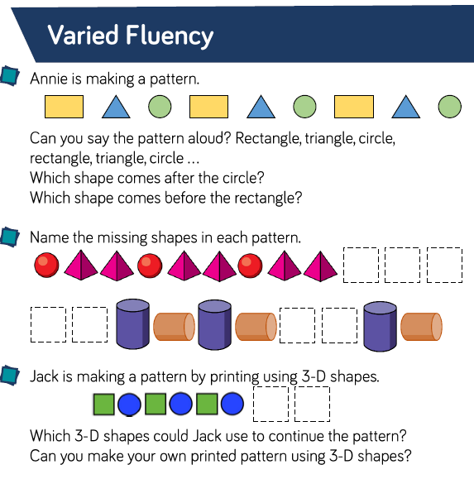
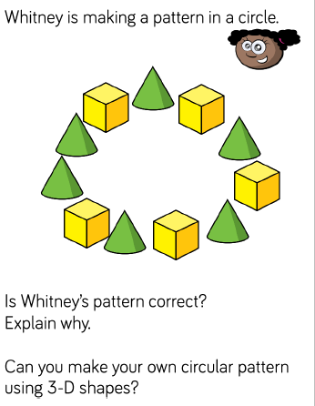
Week 1 – Day 4

Writing
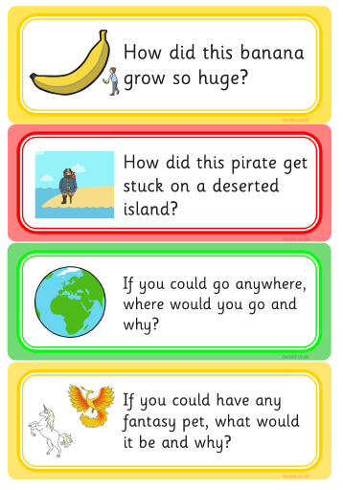
Write a few sentences about each of these prompts.
Remember I am looking for your –

- Capital Letters
- Full Stops
- Finger Spaces
- Handwriting
- Spelling
Monday

Tuesday

Wednesday

Thursday

Friday Check back through all your writing for the features

