Week 2
Maths Activities

Hello Everyone! I hope you enjoyed watching the video.
Here are some activities you can now do to practise maths at home.

Days of the week.
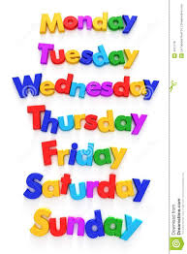
Can you sing the days of the week song?
What day is it today?
What day will it be tomorrow?
What days are on the weekend?

Sayings number names to 20 in order.
Can you say the numbers in order from 1 to 20?
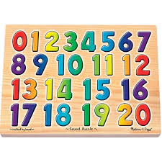
Try whispering the numbers.
Try singing the numbers.
Try saying the numbers in a deep voice.

Recognising shapes
How many sides does a square have?
What shape has 3 sides?
Why is a square and a rectangle different?
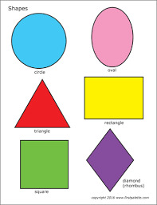
Which shape has one side that goes all the way round?

The Shape Hunt
There are shapes everywhere!
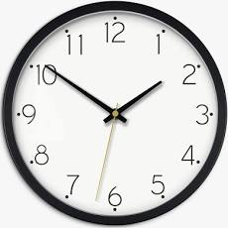
Enjoy looking for different shapes around your home.

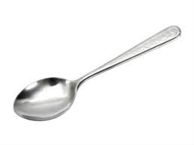

DON’T FORGET TO SEND US SOME PHOTOS OF WHAT YOU FIND

