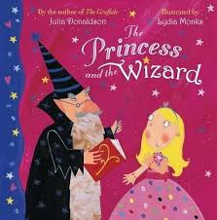
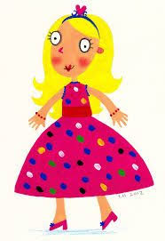
The Princess and the Wizard
- How many candles did Eliza have on her birthday cake? Why?
- What did the wizard do to the party guests?
- How many times will Princess Eliza try to escape according to the Fairy Godmother?
- Where does the wizard live?
- What number did the wizard count to each time?
- What colour was she when she was the following;
A fish? A chick? A grass hopper? A fox? A butterfly? A cat? A gull?
- How did the wizard find her each time?
- What happened when the wizards book fell into the moat?
- Where the party guests happy to see her? How do you know?
10. What did they all eat at the end?
