Week 1
Maths Activities

Hello Everyone! I hope you enjoyed watching the video.
Here are some activities you can now do to practise maths at home.

Days of the week.
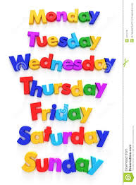
Can you sing the days of the week song?
What day is it today?
What day will it be tomorrow?
What days are on the weekend?

Sayings number names to 20 in order.
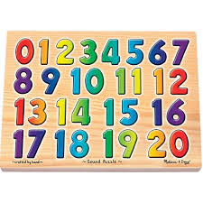
Can you say the numbers in order from 1 to 20?
Try whispering the numbers.
Try singing the numbers.
Try saying the numbers in a deep voice.

Counting a set of objects.
Can you make a set of 6 objects?
Can you put the 6 objects in a line?
Can you put the 6 objects in a triangle shape?
Can you arrange your 6 objects in a different pattern?

The number hunt
There are numbers everywhere! Enjoy looking for different numerals around your home.
