2Si - Home Learning
Daily Activities:
 | Activity
9.00 – 9.30 | PE with Joe Wickes | Login to you tube and search for Joe Wickes PE – it will be live that morning. This is good for all children to take part in.
Activity 1 | Maths  (30 mins) | Complete the Maths Meeting revision grid each day
Activity 2 | Spag  (30 mins) | Complete the Spag revision grid
Activity 3 | TTRS  (10 mins) | Log into TTRS and complete 10 minutes practice on the studio
Activity 4 | English  (30 mins) | Day 1 – look at the picture, write down 5 nouns you can see from the picture, then write down 5 adjectives you could use to describe it (think of all senses),  Day 2 – turn the adjectives and nouns into adjective noun phrases – if possible have adjective, adjective noun e.g. emerald, green leaves  Day 3 – use your adjective noun phrases to create a description of the setting  Day 4 & 5 – use this setting to write a story – remember to spell common exception words correctly
Activity 5 | Reading  (30 mins) | Day 1 & 2  Child: Choose a book you would like to read. Read it aloud to an adult  Adults: Listen to the child read and ask 3 questions from the Rex Retriever mat. Ask the child to write/type the answers to at least 2 of them. Then ask the child 3 questions from the Inference Iggy mat. The child should record at least 2 answers in writing  Day 3 & 4 Complete the comprehension activity  Day 5 Work through the answers with the child – can they prove why that answer is correct?

Topic/Life Skills Activities
Choose an activity each day

Make a solar system.  Include all the planets, moon and sun.  You may do this however you choose. | Complete the Science investigation | Follow a recipe. Bake a cake or help prepare a meal for your family. Make sure there is an adult who can help you.  Take a phot and email to me | Mindfulness  Put on some relaxing music or nature sounds and complete some mindfulness colouring or create your own.
Can you turn your hands into animals?  Search ‘draw animals with your hand’ on YouTube for inspiration! | Make your own playdough (recipe is online)  What 3D shapes can you make? | Quiz night!  Make up your own quiz about Space and test your family! | Create a poster of a country you have visited or a country you would like to visit. What facts can you find?

 | MATHS REVISION CHALLENGES
Partition this number | 96 | 47 | 64
Add 26 to these numbers | 54 | 19 | 43
Find half and a quarter of each number | 36 | 28 | 96
Name the 3d shape
Name the 2d shape
Look at the 2d shape above – how many lines of symmetry does it have?
Multiply these numbers by 5 | 4 | 9 | 12
Complete these calculations | 54 + 32 = | 94 – 53 = | 16 x 5 =
 | 48 + 34 = | 82 – 31 = | 40 ÷ 5 =

 | SPAG REVISION CHALLENGES
Write a sentence using this conjunction | when | if | that
Add a suffix to these roots to form an adjective | beauty | happy | plenty
Use suffixes to show comparison (er/est) | soft | easy | happy
Change these to the past tense – (rewrite the sentence) | The dog is wagging his tail. | The cat is eating her food. | Matthew is enjoying his new x box game.
Circle the verbs | Lilly danced for her exam. | Fish swim in deep and shallow waters. | The sun shone brightly.
Change these statements into questions. (remember punctuation) | It is raining. | The dog is barking. | The girl is reading.
Write the contraction of these words. (Use apostrophe) | Do not | Should not | Can not
Punctuate this sentence correctly. | charlotte said the puppies bark when you leave them | can you see the kittens | amazing work william

Writing activity

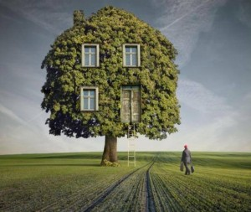

Day 1
Nouns Adjectives

Day 2
Adjective, adjective noun

Day 3
Write a description

Day 4 & 5 – Write a story using this picture as the setting

Reading – choose a book they want to read.
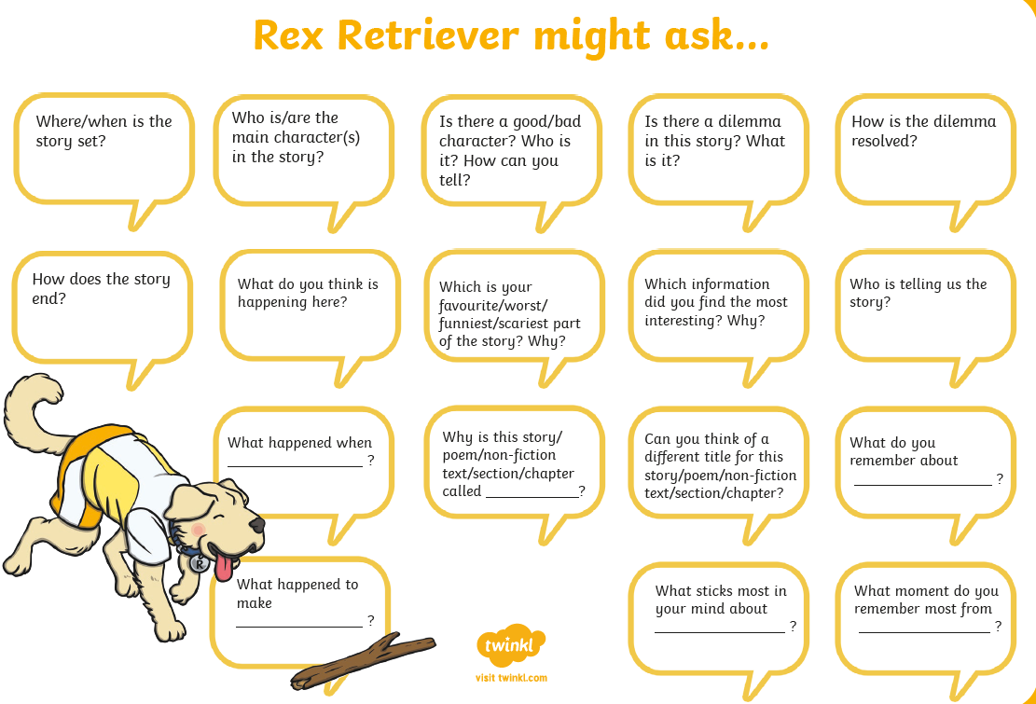

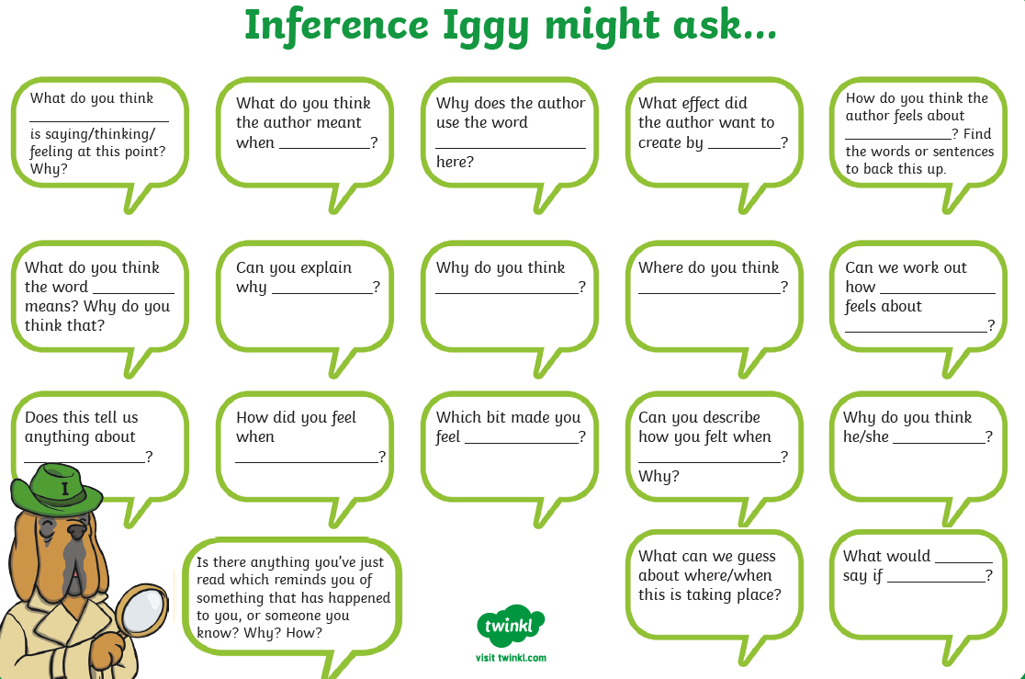

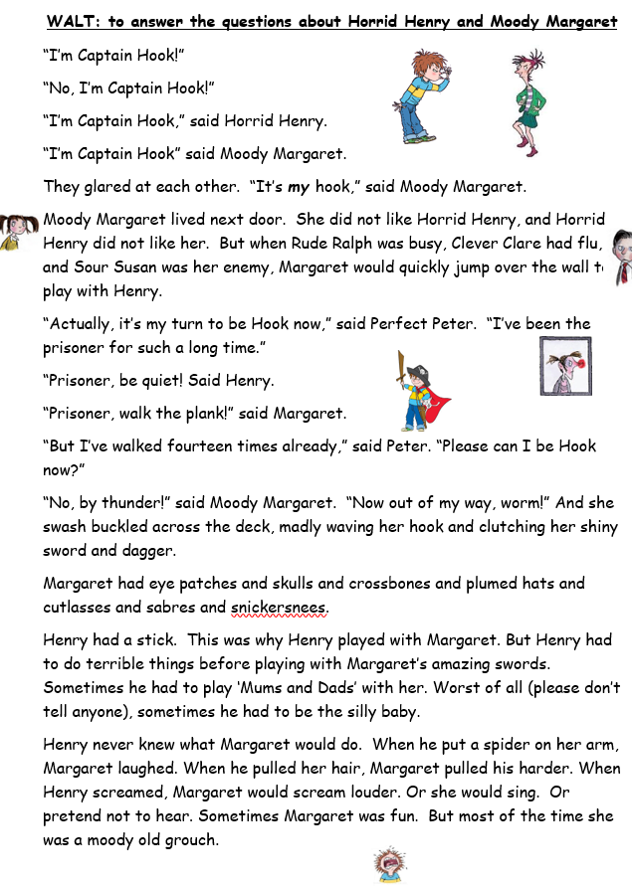
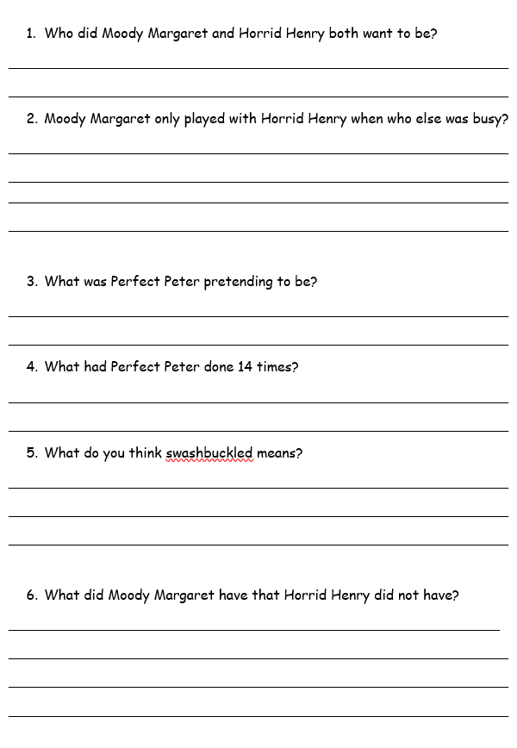
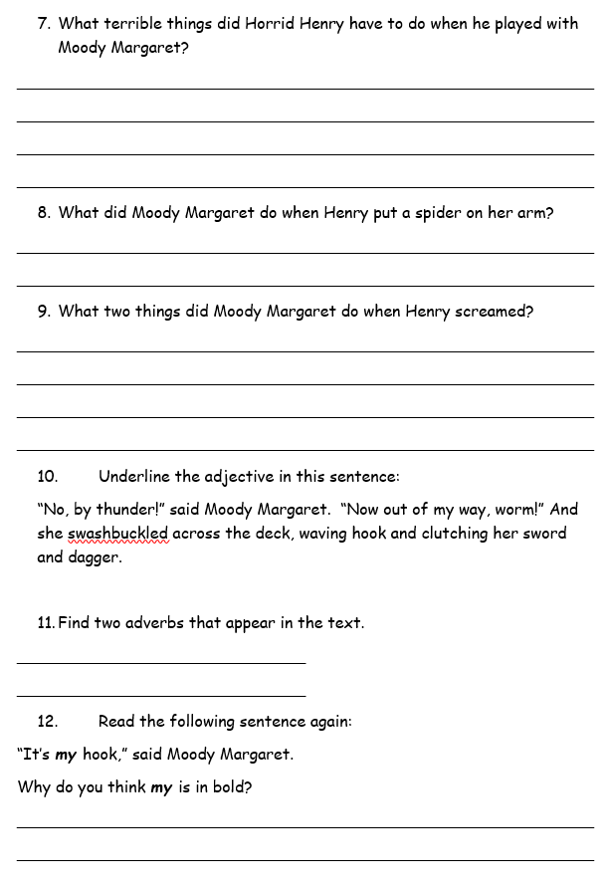
Science Activity

You are going to create a poster about HABITATS!
Watch this you tube clip: https://www.youtube.com/watch?v=ZrSWYE37MJs
Now watch it again and think about:
- What is a habitat?
- What must a habitat provide for the animals?
Explore these 4 habitats:
Polar Habitat: https://www.bbc.co.uk/bitesize/topics/zx882hv/articles/z3sr4wx
Ocean Habitat: https://www.bbc.co.uk/bitesize/topics/zx882hv/articles/zsfkd2p
Woodland Habitat: https://www.bbc.co.uk/bitesize/topics/zx882hv/articles/zc42xnb
Rainforest Habitat: https://www.bbc.co.uk/bitesize/topics/zx882hv/articles/zxdsvcw
You may use the internet to explore habitats further.

Make sure your poster has:
- An eye catching bold title
- Use neat, cursive writing
- Include 4 different types of habitat
- Use punctuation (Capital letters, full stops, ?, !)
- Include drawings/diagrams
- Tell the reader what a habitat is and what it needs to provide.

