To all my wonderful Y2 Children

I am missing you so, so much. I hope you are being good for your grown-ups!

Please stay safe, try to do a little bit of work but most of all stay healthy and happy.

If you want to contact me you can do at:
Mrshemmingway@newvillage.doncaster.sch.uk

Mrs H xx
Year 2 (Mrs Hemmingway’s)
Home Learning

 | Activity | Week 1
Activity 1  9.00am | PE with Joe Wickes | Each day: Login to you tube and search for Joe Wickes PE – it will be live that morning. This is good for all children to take part in.
Break
Activity 2 | Reading and spellings | Each day: Complete reading and comprehension 1-5  Spelling Activity 1-5
Break
Activity 3 | Maths | Log in to - https://play.prodigygame.com  Money activities (see below)
Break
Activity 4 | English | Writing tasks 1-5
Lunch
Activity 5 | Topic project | Make a solar system.  Include all the planets, moon and sun. You may do this however you choose.
Break
Activity 6 | Craft / Life skills | Art/making/jobs around the house/cooking/baking/board games/nature pictures/singing/making music/make videos/play outdoors etc.

Reading – choose a book they want to read.
Day 1 | Listen to your child read and ask 5 questions from the Rex Retriever mat. Ask your child to say some of the answers and possibly write some of them down too.
Day 2 | Listen to your child read and ask 5 questions from the Rex Retriever mat. Ask your child to say some of the answers and possibly write some of them down too.
Day 3 | Listen to your child read and ask 5 questions from the Inference Iggy mat. Ask your child to say some of the answers and possibly write some of them down too.
Day 4 | Week 1 Complete Comprehension 1 activity | Week 2 Activity 3 | Week 3 Activity 5
Day 5 | Week 1 Complete Comprehension 2 activity | Week 2 Activity 4 | Week 3 Activity 6

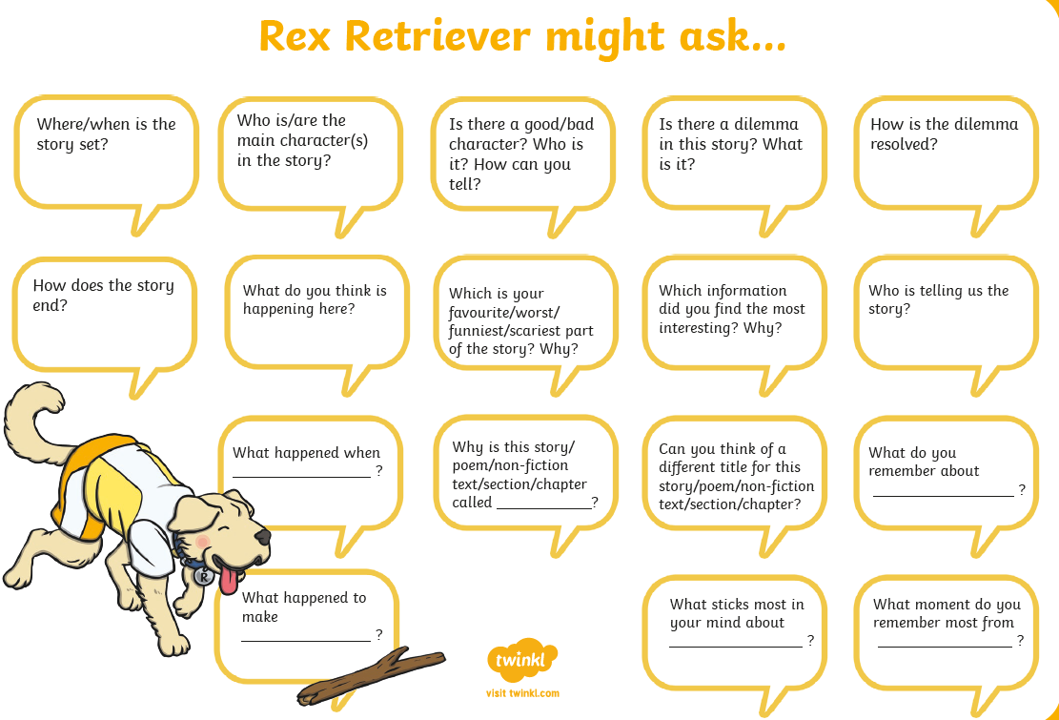
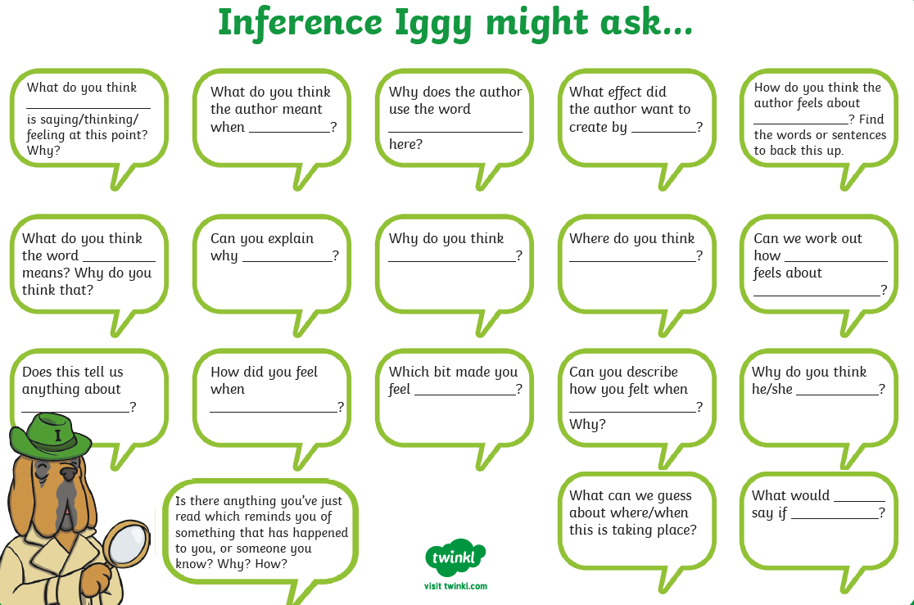

Comprehension Activity 1 Week 1
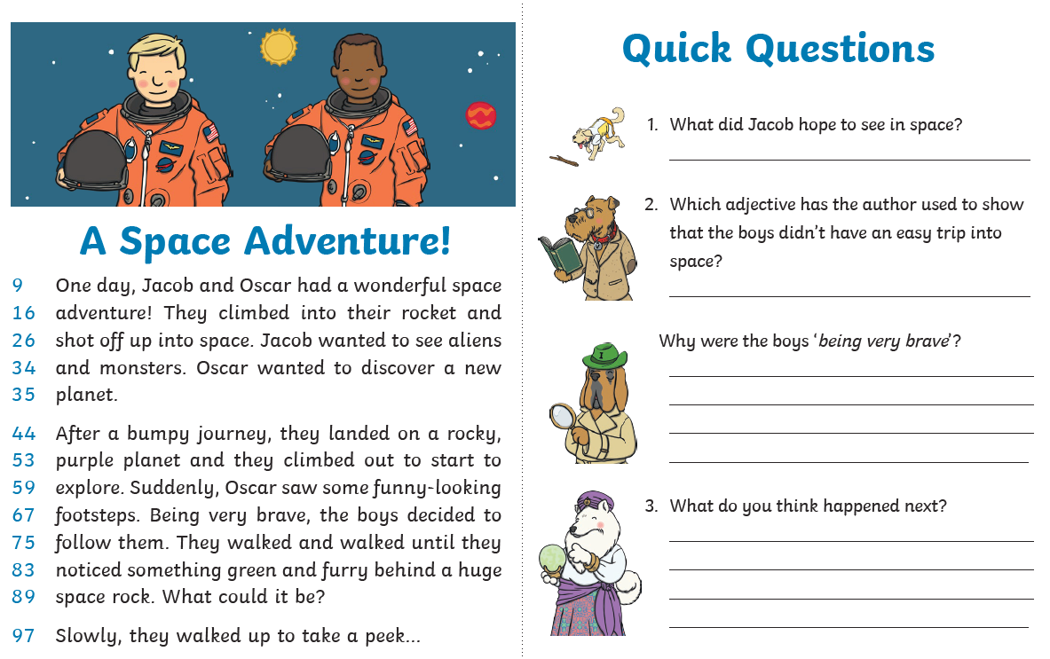
Comprehension Activity 2 Week 1
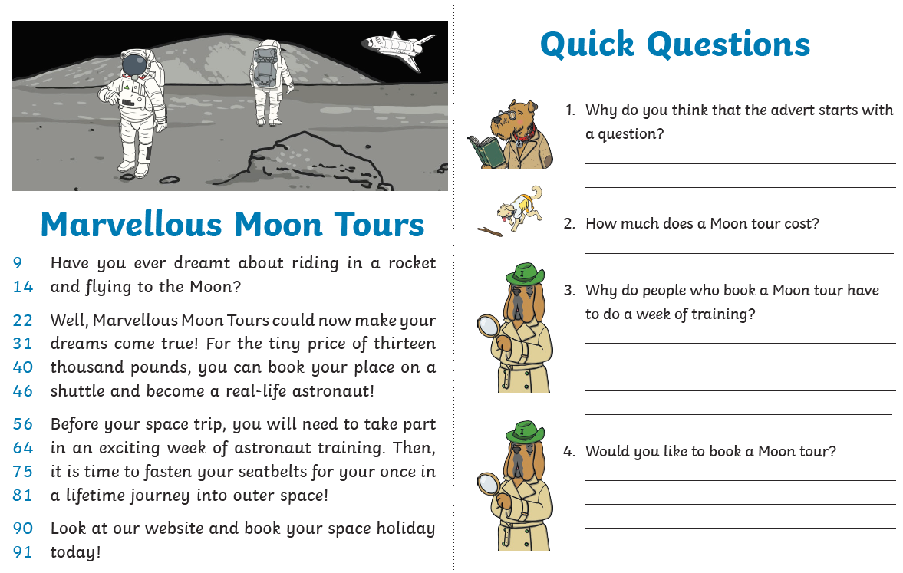
Spelling
 | Week 1
DAY 1 | Common exception word mat - door
DAY 2 | Common exception word mat – floor
DAY 3 | Common exception word mat – poor
DAY 4 | Common exception word mat – because
Day 5 | Common exception word mat - hold

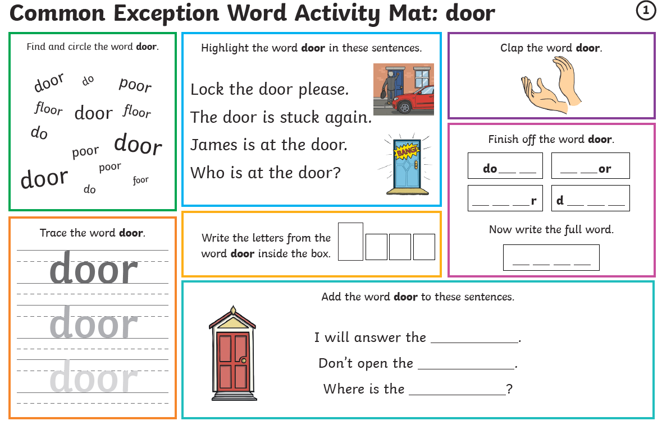

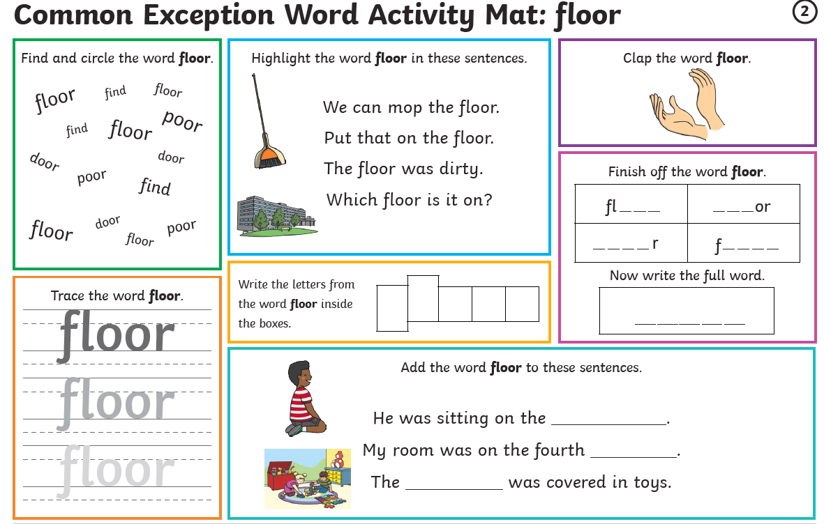

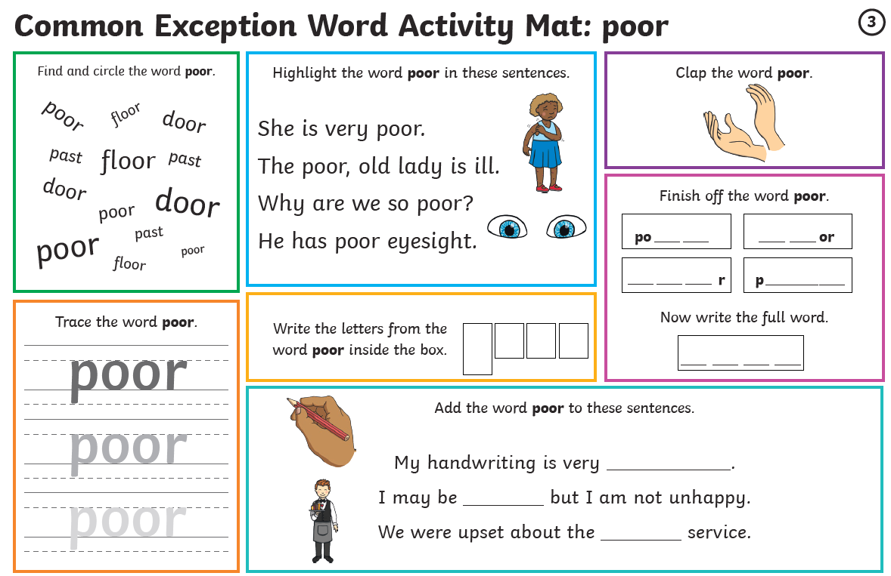

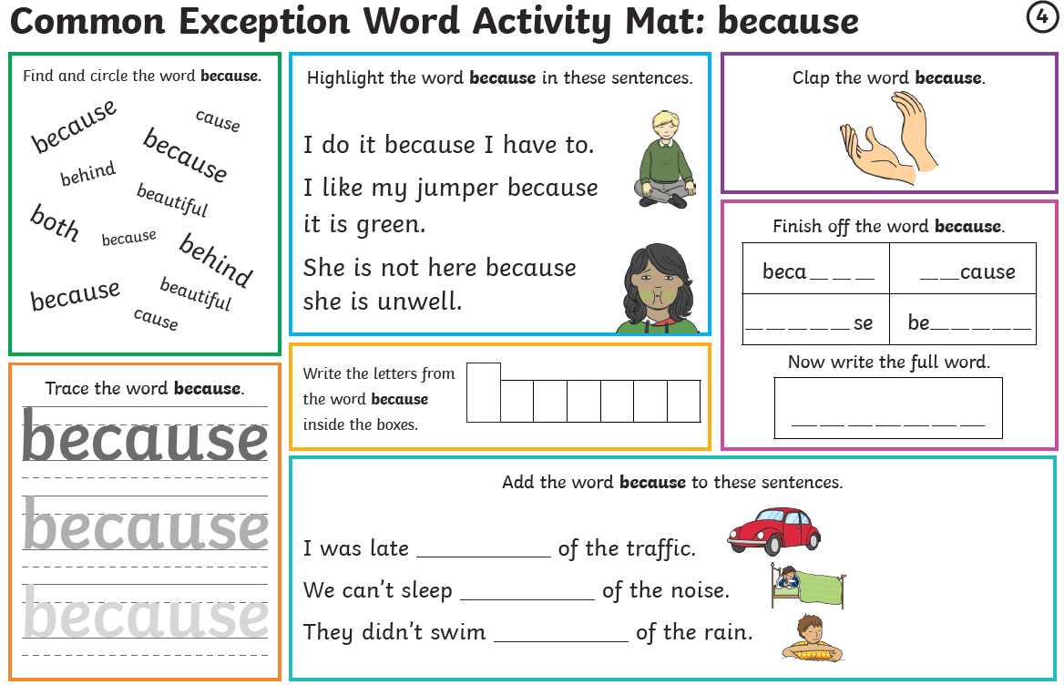

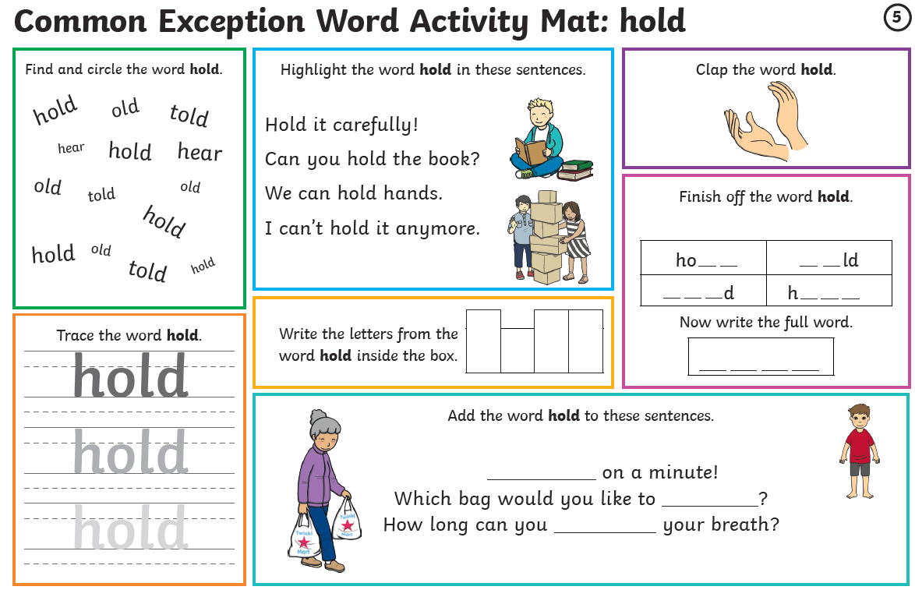

Maths
Log on to https://play.prodigygame.com – let your child log in with the following log in and play the maths games.
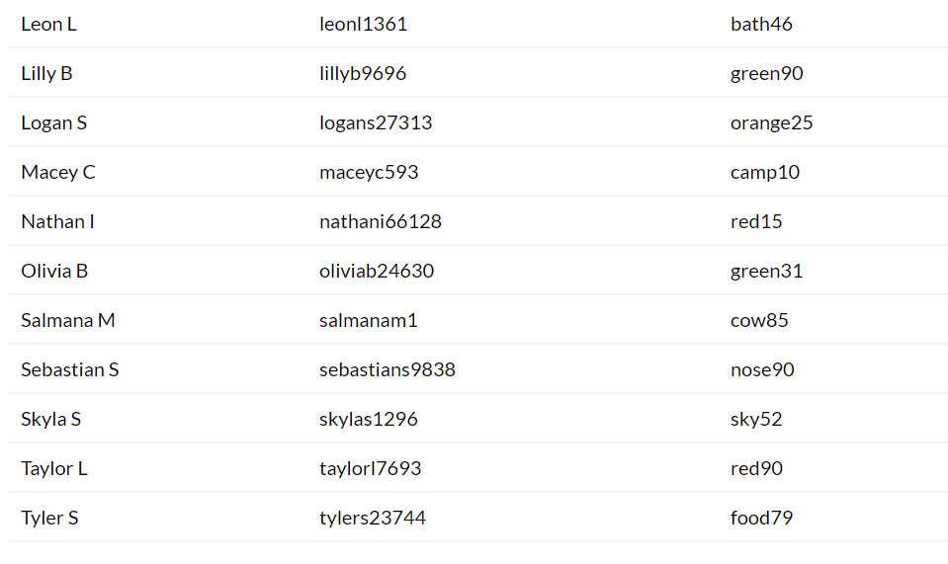
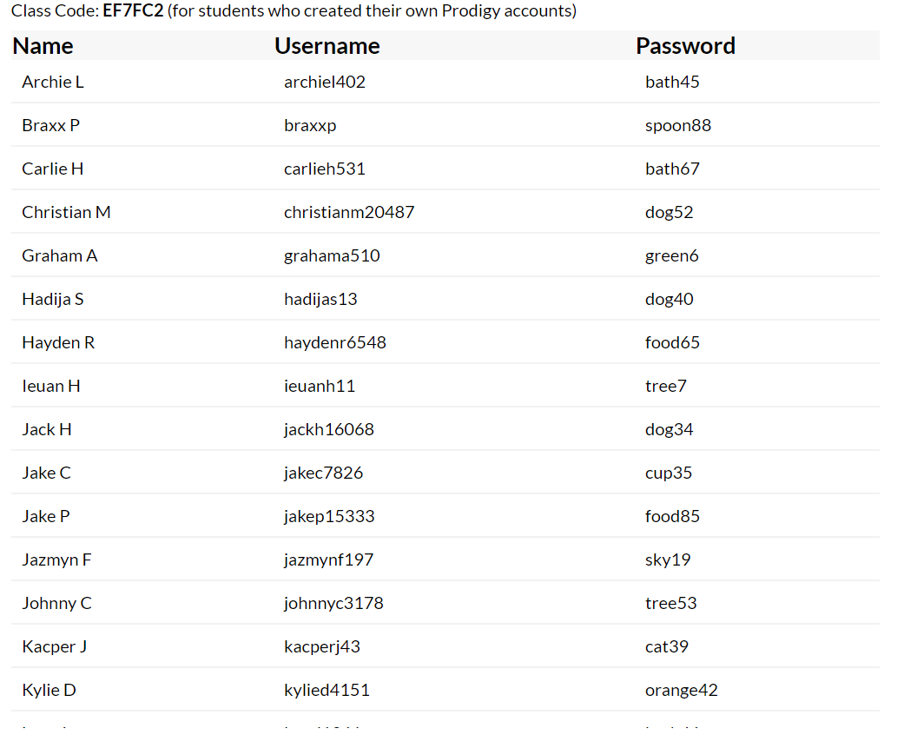

Money – Week 1
Monday | Tuesday | Wednesday | Thursday | Friday
Make some 1p, 2p, 5p and 10p roughly on paper. Get your child to have piles and count them – the should recognise they are counting in their times tables.  Make 2 piles, which has more? Is it the bigger pile or the bigger amount?  Complete the sheets for Day 1  Keep the coins for tomorrow. | Play shop  Make a shop at home – Label items with prices below 20p.  Then get your child to go to the shop and buy 2 items and then buy 3 etc – ask them to add up the total cost. | Play shop  Repeat yesterday’s activity – increase the prices to below 50p. If your child is finding this easy please increase the money to your child’s addition ability. | Play shop  Repeating yesterday’s activity at your child’s level. Today concentrate on teaching your child about change.  I have £…. how much will I have left if I buy the beans at …p. | Complete the sheets for Week 1 day 5 – help your child with this.
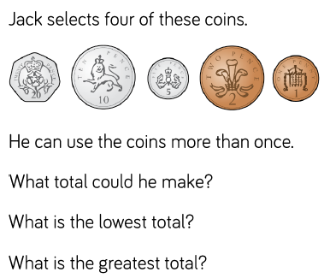
Week 1 – Day 1
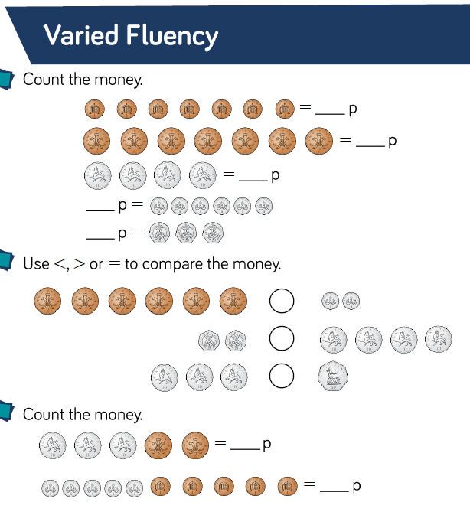

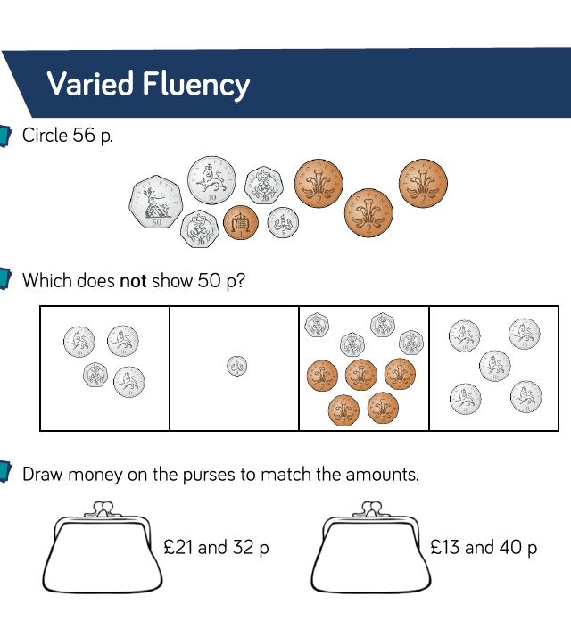
Week 2 – Day 5

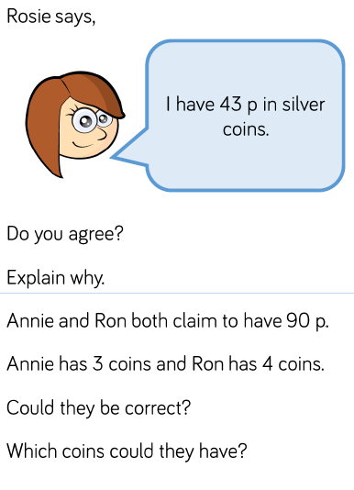

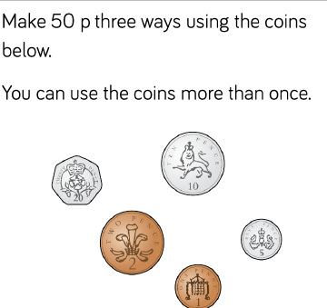
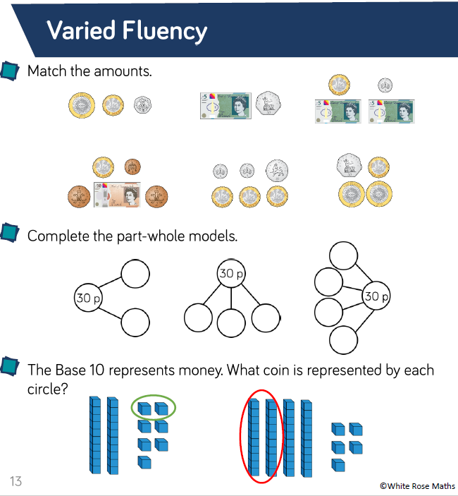
Writing
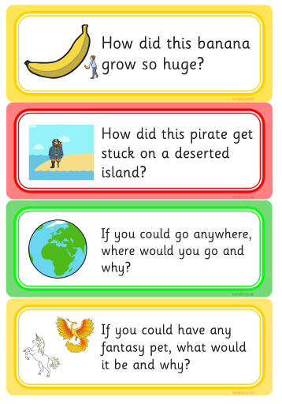
Write a few sentences about each of these prompts.

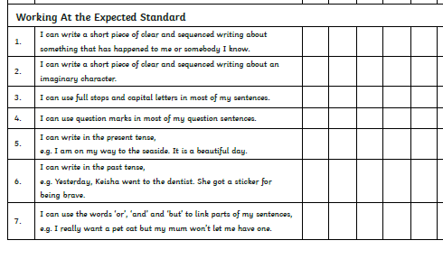
Monday

Tuesday

Wednesday

Thursday

Friday Check back through all your writing for the features

