To all my wonderful Y2 Children

The weeks are passing by so quickly and I hope we are back to school soon!

Please stay safe, try to do a little bit of work but most of all stay healthy and happy.

If you want to contact me you can do at:
Mrshemmingway@newvillage.doncaster.sch.uk

Mrs H xx
Year 2 (Mrs Hemmingway’s)
Home Learning

 | Activity | Week 2
Activity 1  9.00am | PE with Joe Wickes | Login to you tube and search for Joe Wickes PE – it will be live that morning. This is good for all children to take part in.
Break
Activity 2 | Reading and spellings | Complete reading and comprehension 6-10  Spelling Activity 6-10
Break
Activity 3 | Maths | https://play.prodigygame.com  Multiplication
Break
Activity 4 | English | Writing tasks 6-10
Lunch
Activity 5 | Topic project | Make a solar system.  Include all the planets, moon and sun. You may do this however you choose.
Break
Activity 6 | Craft / Life skills | Art/making/jobs around the house/cooking/baking/board games/nature pictures/singing/making music/make videos/play outdoors etc.

Reading – choose a book they want to read.
Day 1 | Listen to your child read and ask 5 questions from the Rex Retriever mat. Ask your child to say some of the answers and possibly write some of them down too.
Day 2 | Listen to your child read and ask 5 questions from the Rex Retriever mat. Ask your child to say some of the answers and possibly write some of them down too.
Day 3 | Listen to your child read and ask 5 questions from the Inference Iggy mat. Ask your child to say some of the answers and possibly write some of them down too.
Day 4 | Week 2 Activity 3
Day 5 | Week 2 Activity 4

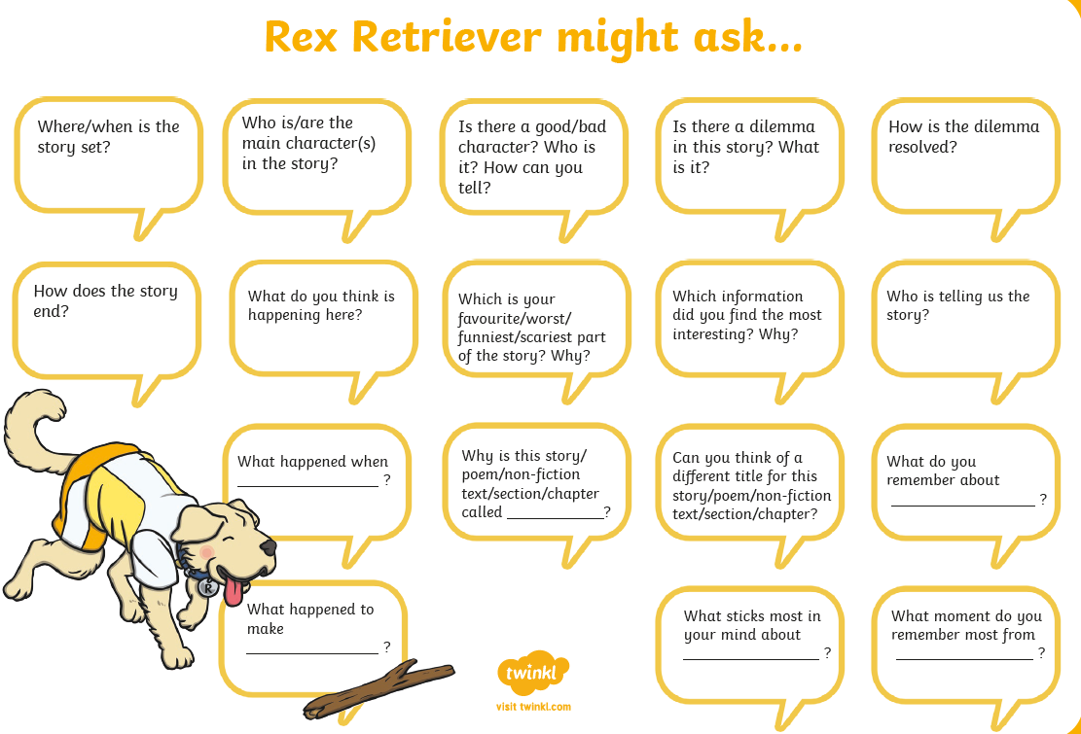
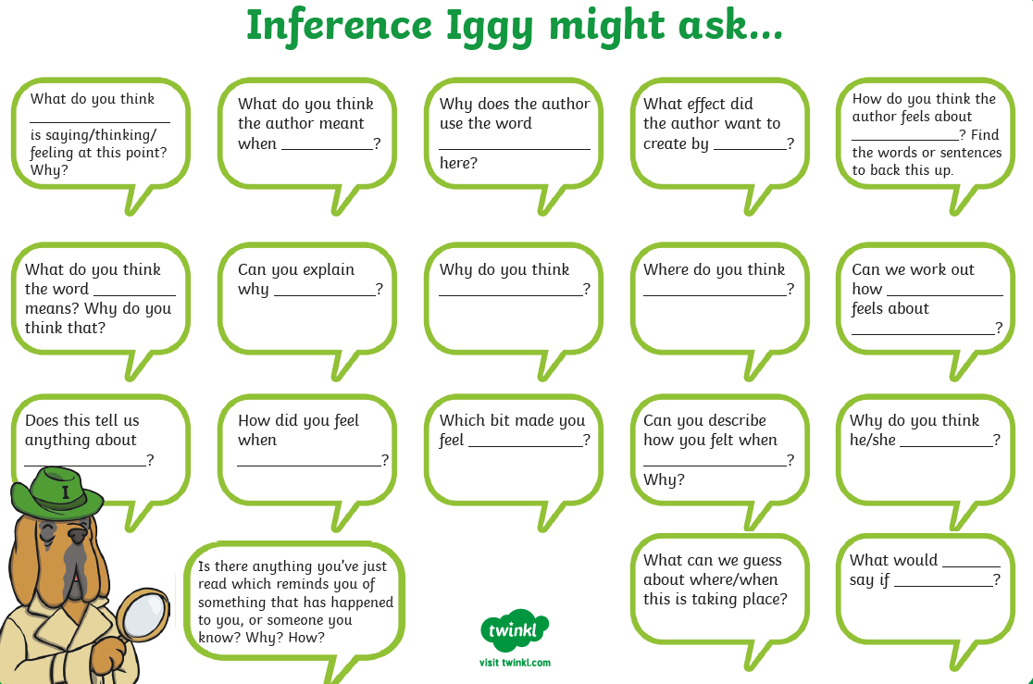

Comprehension Activity 3 Week 2
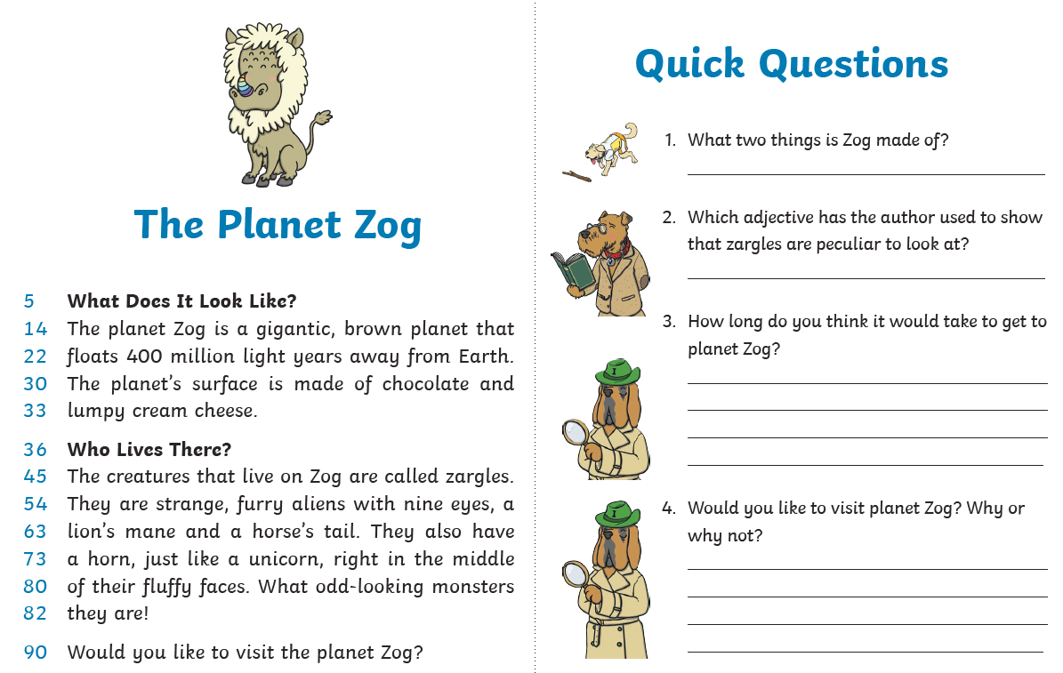
Comprehension Activity 4 Week 2
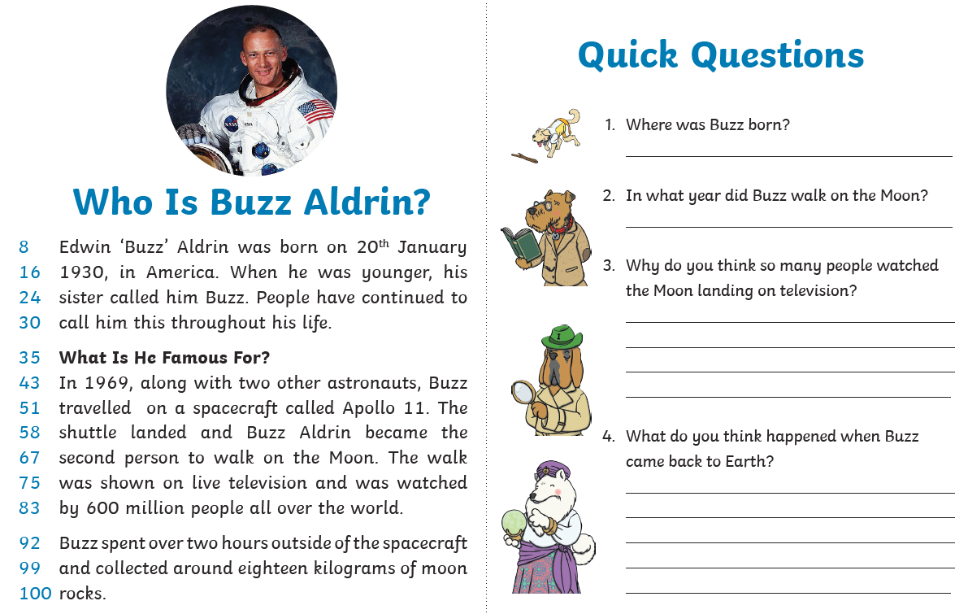
Spelling
 | Week 2
DAY 1 | Common exception word mat - told
DAY 2 | Common exception word mat – both
DAY 3 | Common exception word mat – old
DAY 4 | Common exception word mat – cold
Day 5 | Common exception word mat - gold

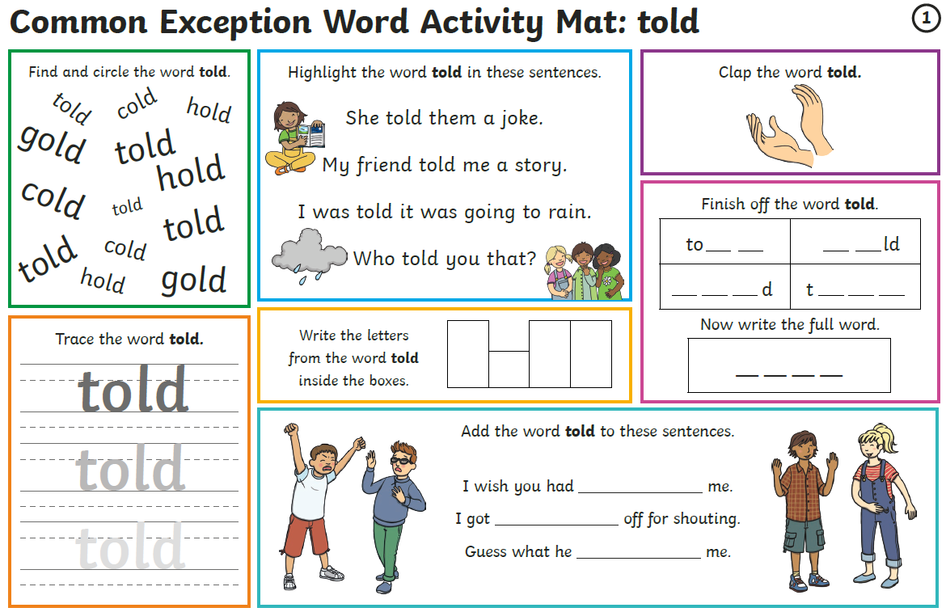

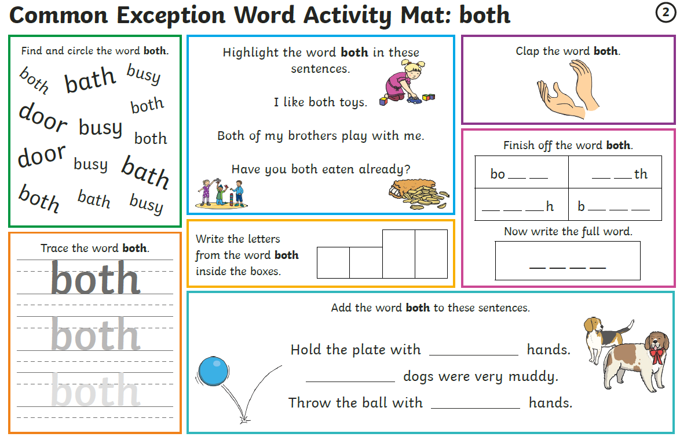

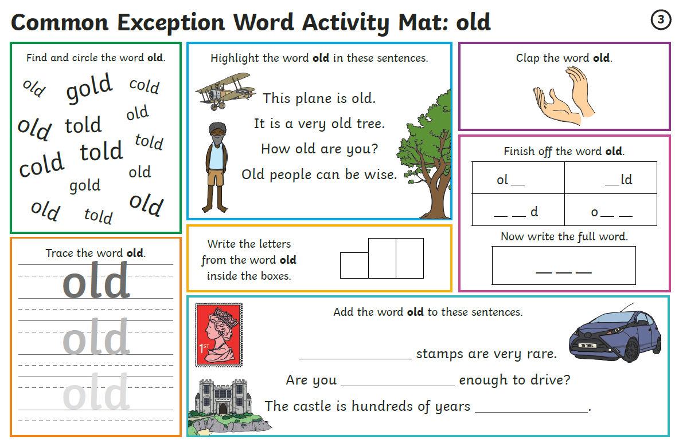

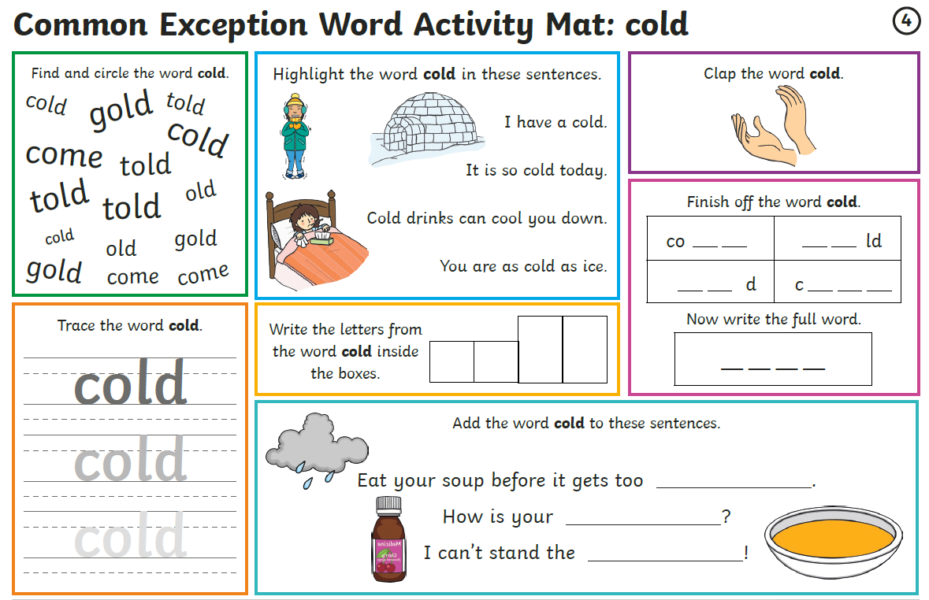

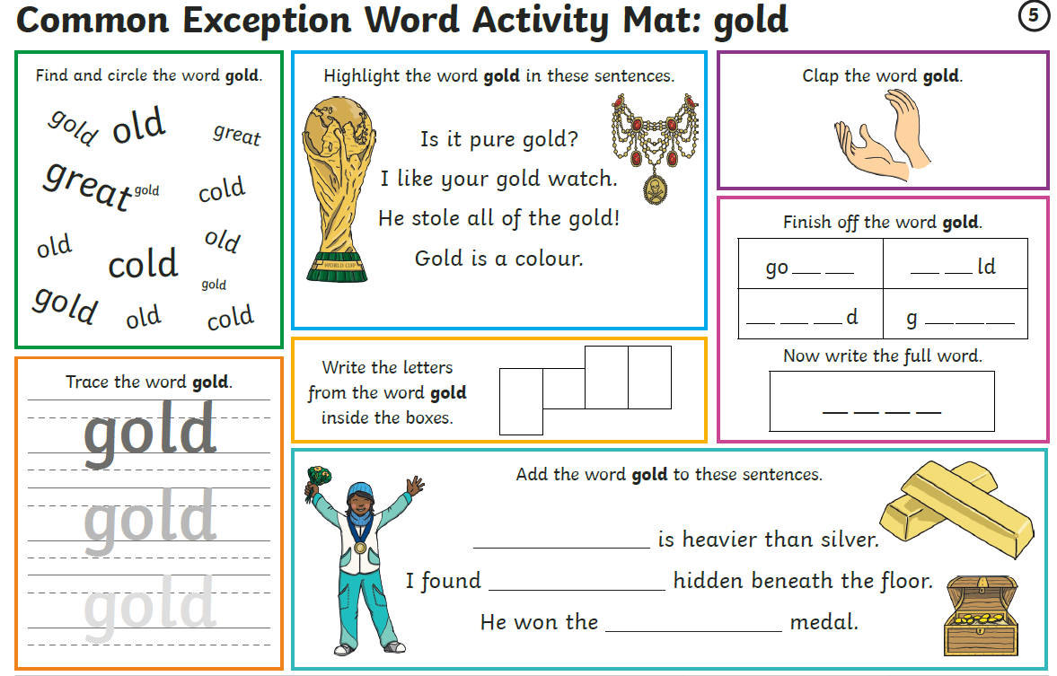
Maths
Log on to https://play.prodigygame.com – let your child log in with the following log in and play the maths games.
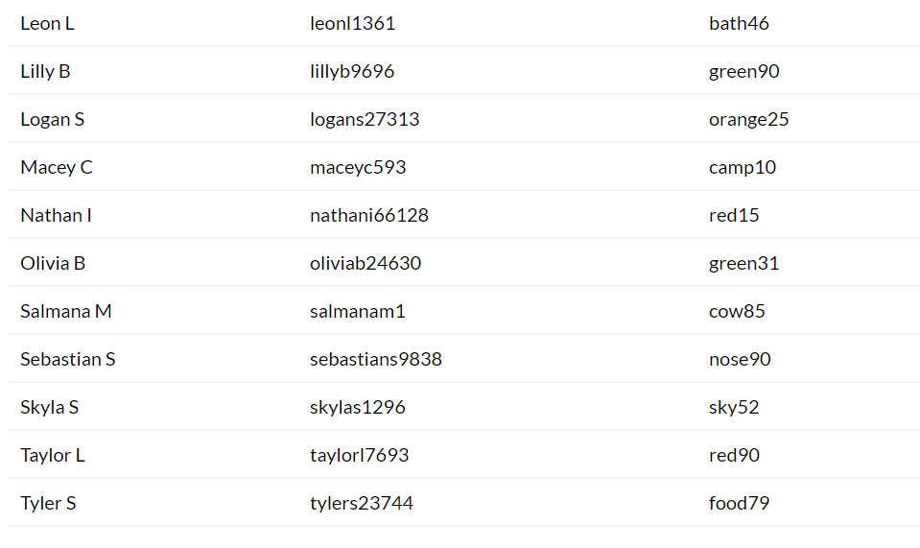
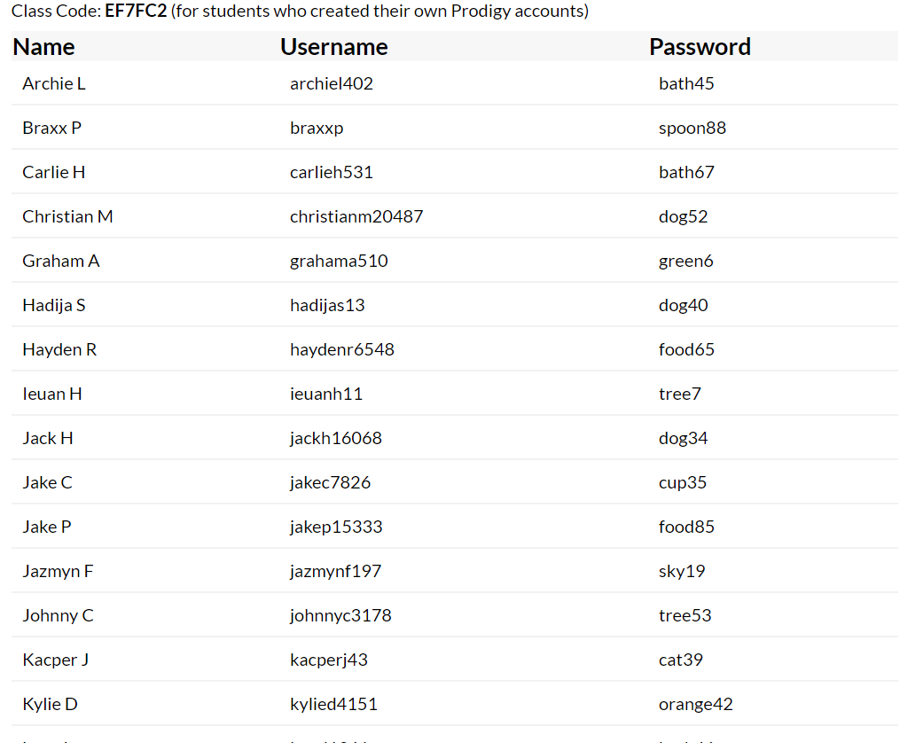

Multiplication – Week 2
Monday | Tuesday | Wednesday | Thursday | Friday
Practise counting in 2 times tables. Quick recall questions.  Discuss the robots. How many are there in a group? 4  How many groups are there? 3  What is the number sentence? 4 x 3 = ____  Work through more examples. | Practise counting in 2 times tables. Quick recall questions.  Using what they completed yesterday, children are to complete examples on their own.  Please go through them afterwards with them. | Practise counting in 5 times tables. Quick recall questions.  Discuss that in a multiplication sentence, the numbers can be either way arranged.  2 x 5 = 10  5 x 2 = 10  Work through examples on array sheet with children. | Practise counting in 5 times tables. Quick recall questions.  Find objects in the house and children are to make x sentences. They are to record them on paper and draw the arrays.  Eg – 12 bananas in the house, split into equal groups.  4 groups of 3 = 12 | Practise counting in 10 times tables. Quick recall questions.  Give children the number sentence 6 x 3  Draw the arrays  ******  ******  ******  How many?  Complete the sheet asking them to draw the arrays to find the answer.
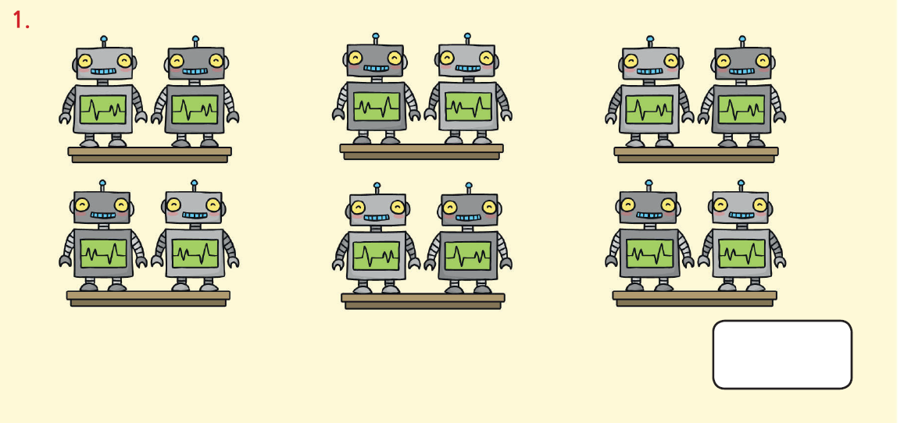
Monday

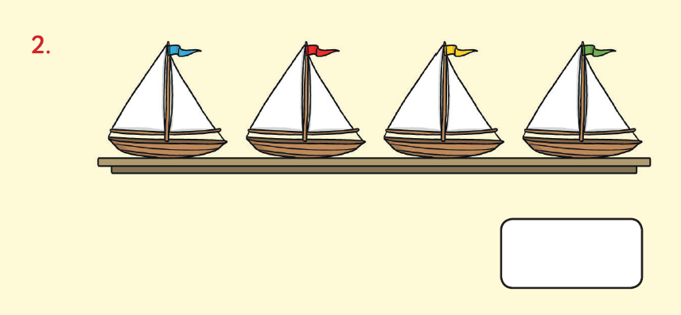
4 x ____ = ____

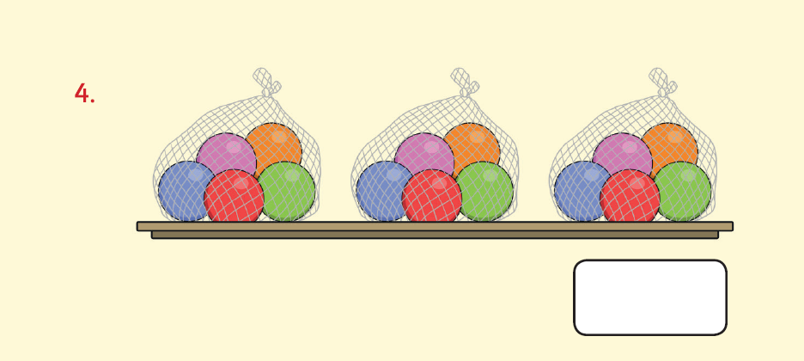
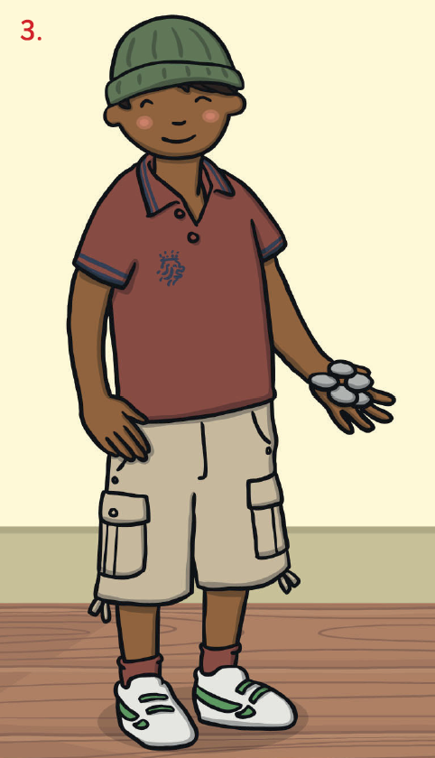

Tuesday
How many dots on the space ships? How many green balls?
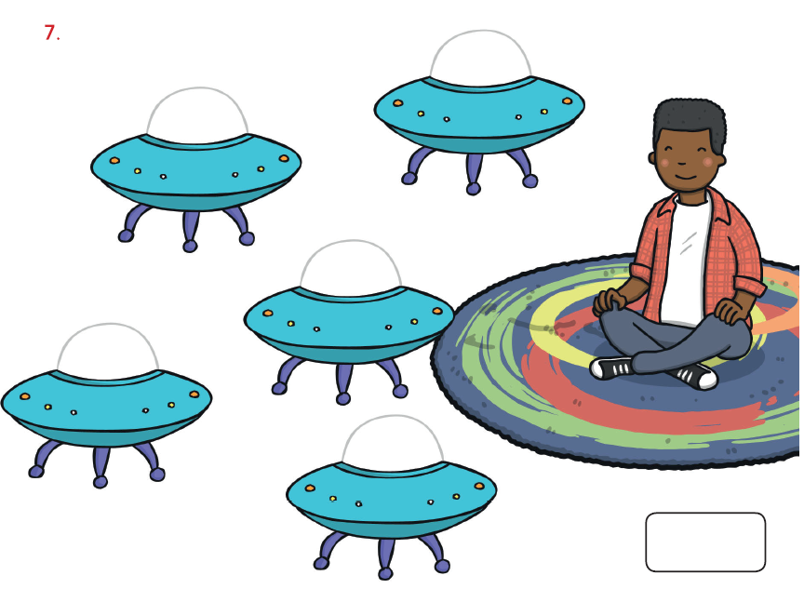
Use a multiplication sentence. How many blue balls?
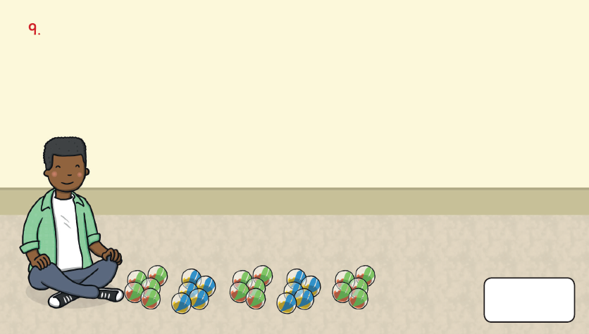
Use number sentences.

Green __________ x __________ = ____________
Blue
__________ x __________ = ______________________ x ____________ = _______________

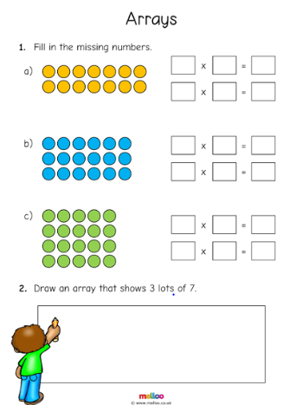
Wednesday

Friday
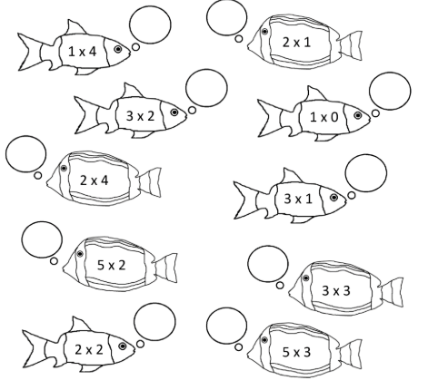

Writing
Write a few sentences about each of these prompts.

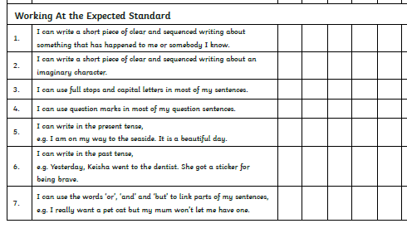
Monday and Tuesday
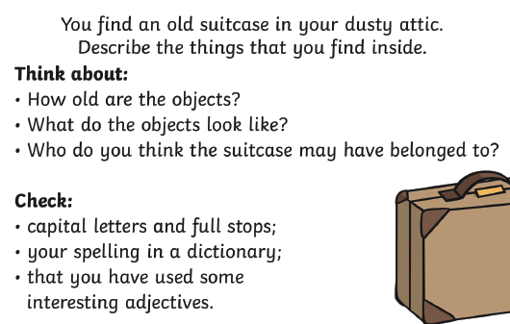
Wednesday and Thursday
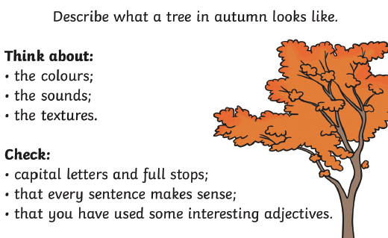
Friday: Check back through all your writing for the features

