To all my wonderful Y1 Children

The weeks are passing by so quickly and I hope we are back to school soon!

Please stay safe, try to do a little bit of work but most of all stay healthy and happy.

If you want to contact me you can do at:
Mrshemmingway@newvillage.doncaster.sch.uk
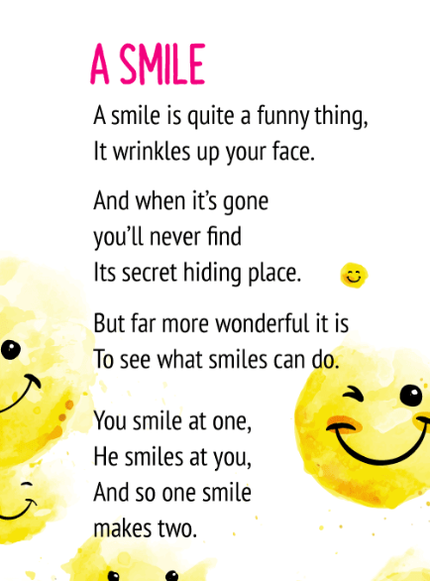

Mrs H xx
Year 1 (Mrs Hemmingway’s)
Home Learning

 | Activity | Week 2
Activity 1  9.00am | PE with Joe Wickes | Login to you tube and search for Joe Wickes PE – it will be live that morning. This is good for all children to take part in.
Break
Activity 2 | Reading and spellings | Complete reading and comprehension 6-10  Spelling Activity 6-10
Break
Activity 3 | Maths | https://play.prodigygame.com  Height and Length, Weight and Mass
Break
Activity 4 | English | Writing tasks 6-10
Lunch
Activity 5 | Topic project | Make a solar system.  Include at least one of the planets, the moon and the sun. You may do this however you choose.
Break
Activity 6 | Craft / Life skills | Art/making/jobs around the house/cooking/baking/board games/nature pictures/singing/making music/make videos/play outdoors etc.

Reading – choose a book they want to read.
Day 1 | Listen to your child read and ask 5 questions from the Rex Retriever mat. Ask your child to say some of the answers and possibly write some of them down too.
Day 2 | Listen to your child read and ask 5 questions from the Rex Retriever mat. Ask your child to say some of the answers and possibly write some of them down too.
Day 3 | Listen to your child read and ask 5 questions from the Inference Iggy mat. Ask your child to say some of the answers and possibly write some of them down too.
Day 4 | Week 2 Activity 3
Day 5 | Week 2 Activity 4

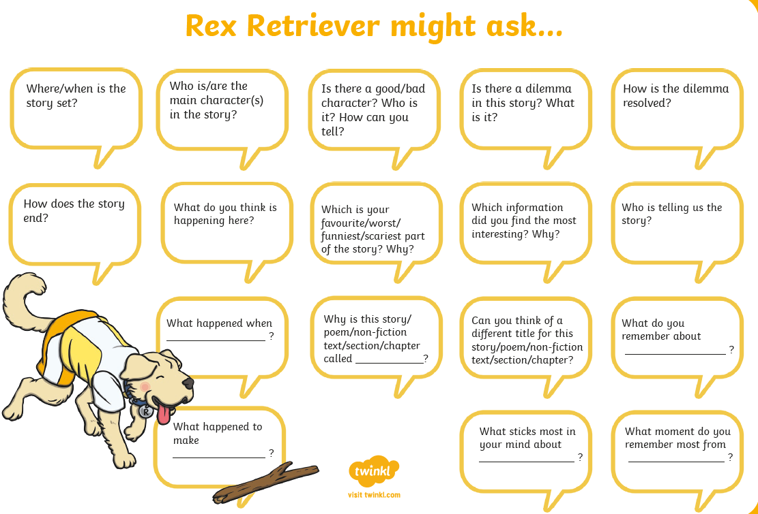
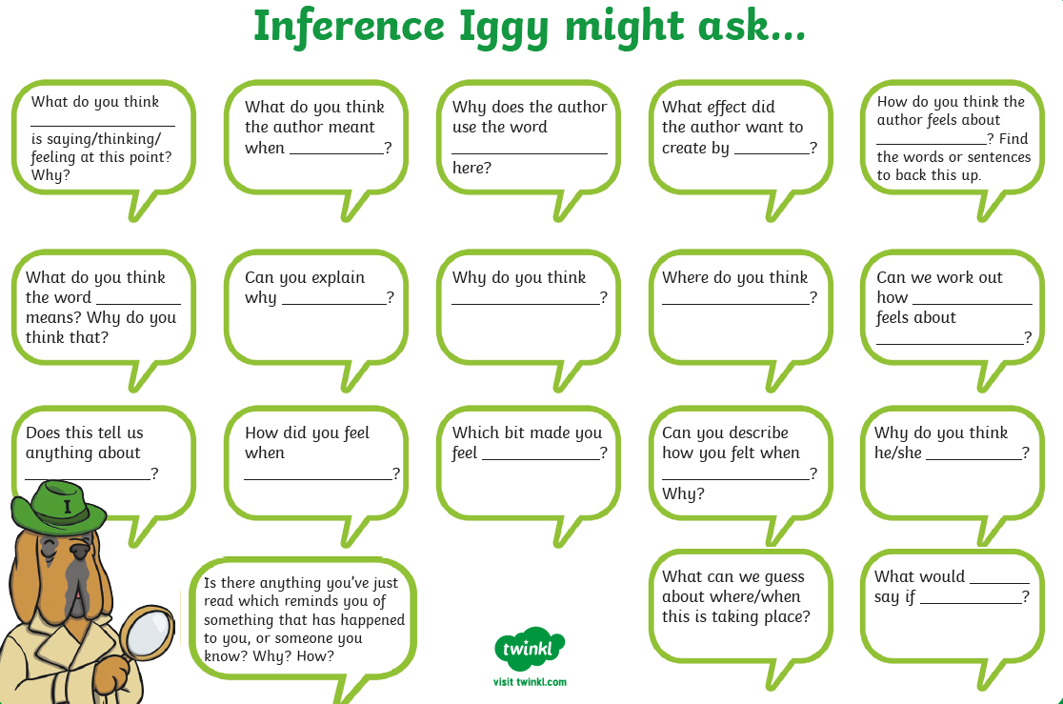

Comprehension Activity 3 Week 2
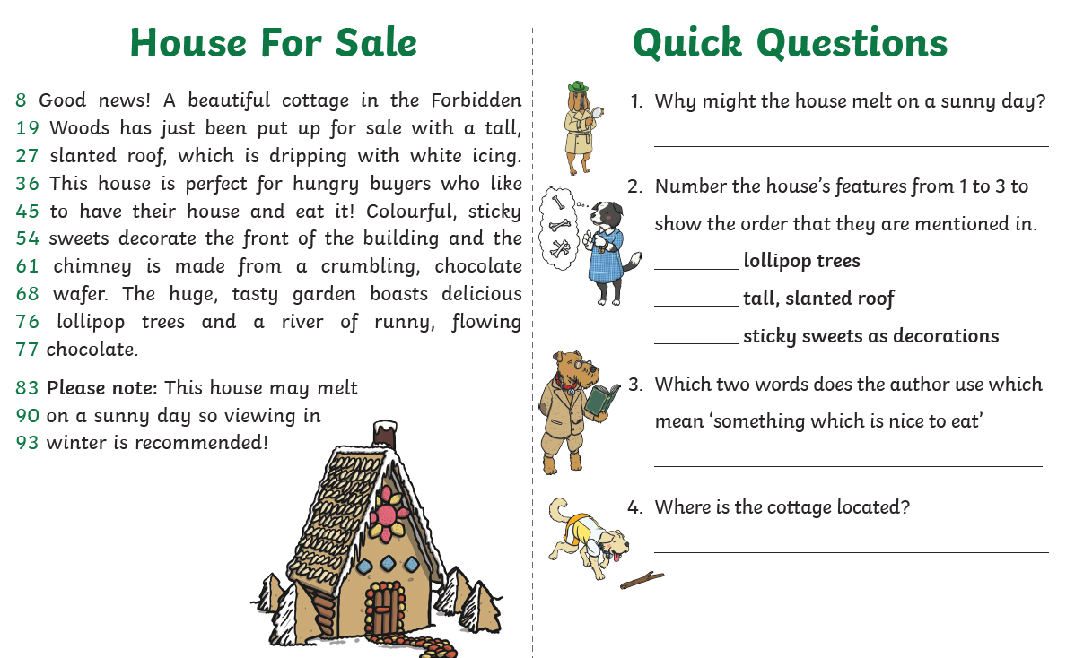
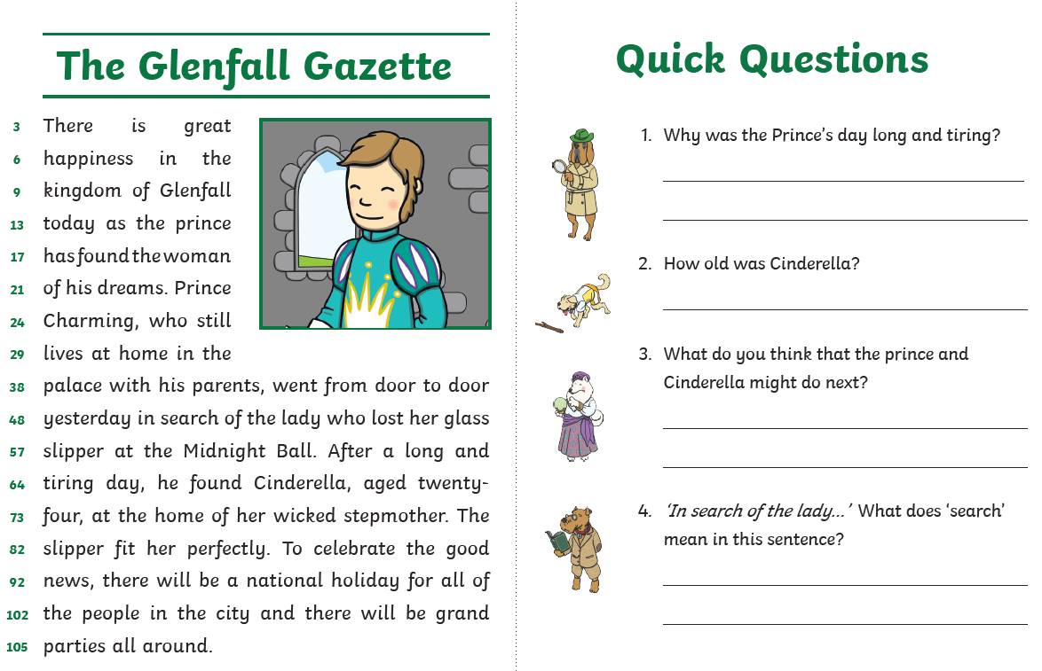
Comprehension Activity 4 Week 2
Spelling
 | Week 2
DAY 1 | Common exception word mat - here
DAY 2 | Common exception word mat – there
DAY 3 | Common exception word mat – where
DAY 4 | Common exception word mat – says
Day 5 | Common exception word mat - push

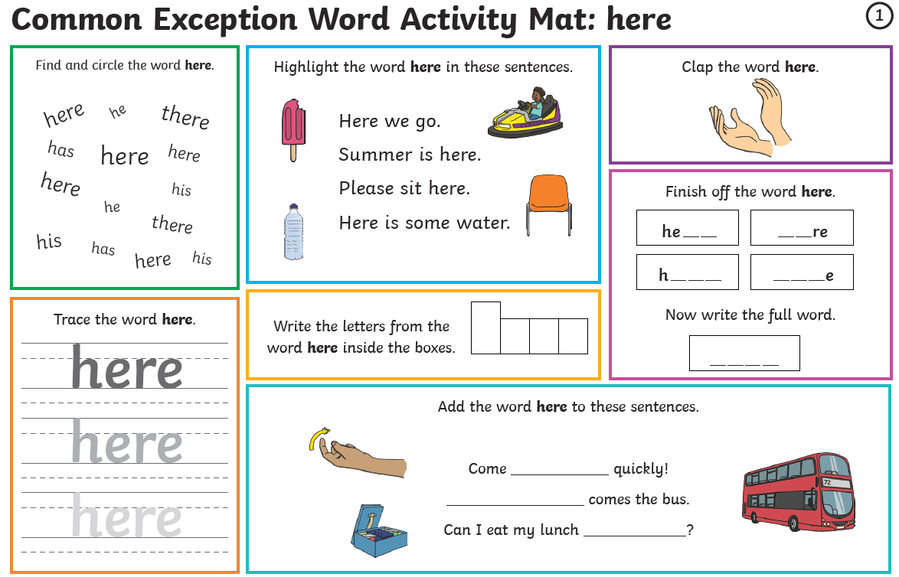
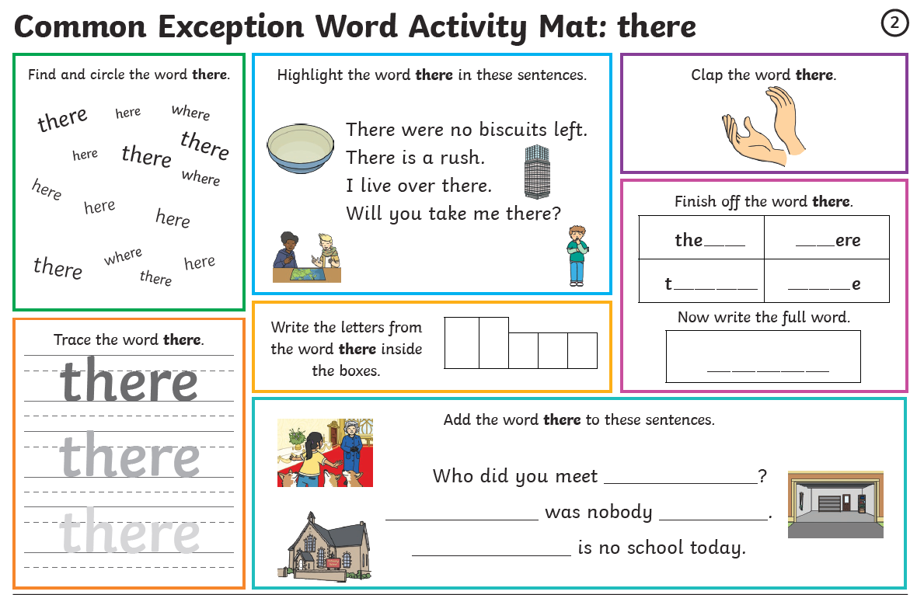

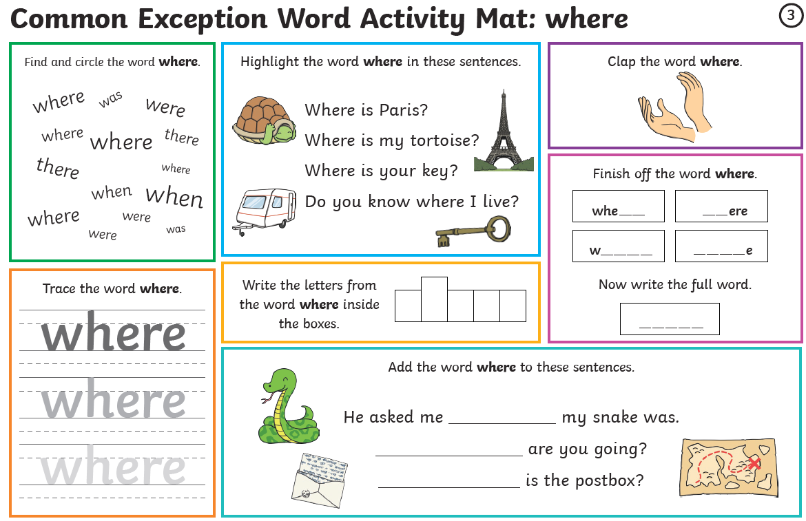

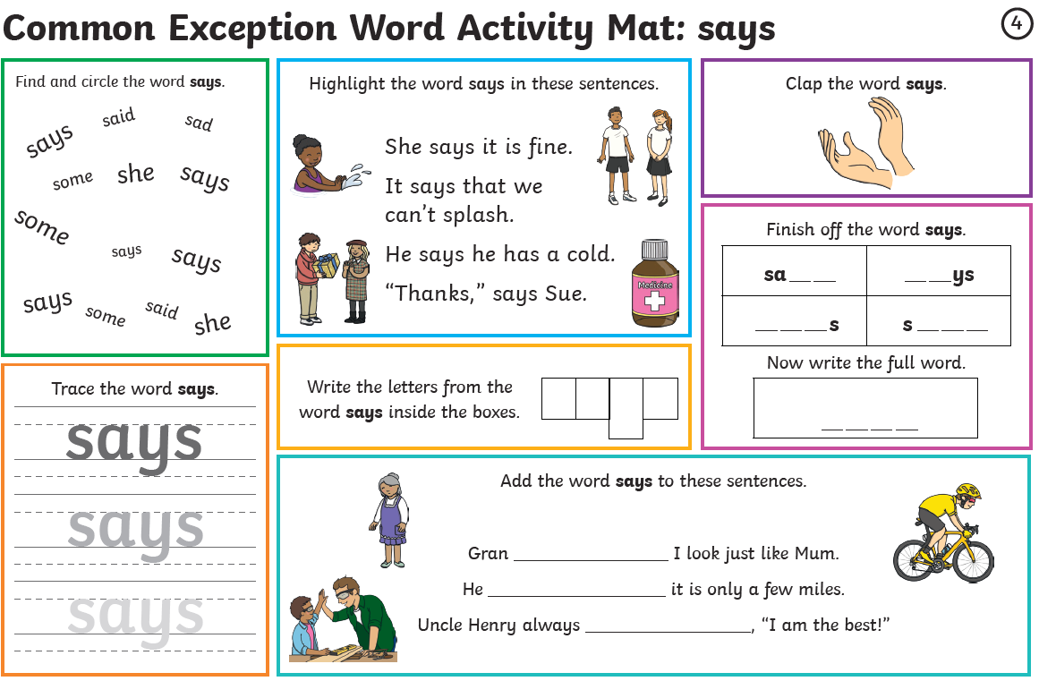
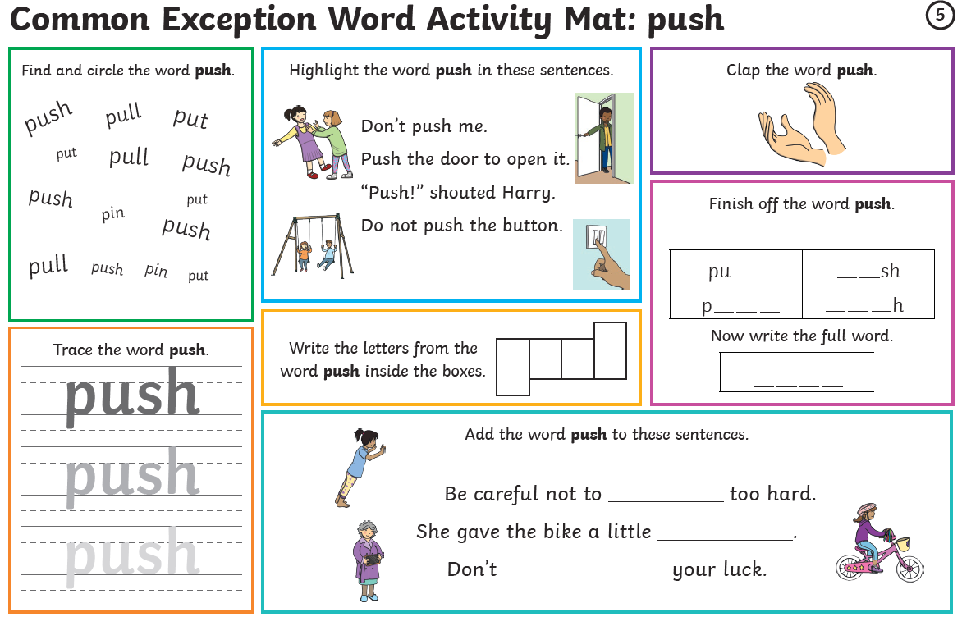

Maths
Log on to https://play.prodigygame.com – let your child log in with the following log in and play the maths games.
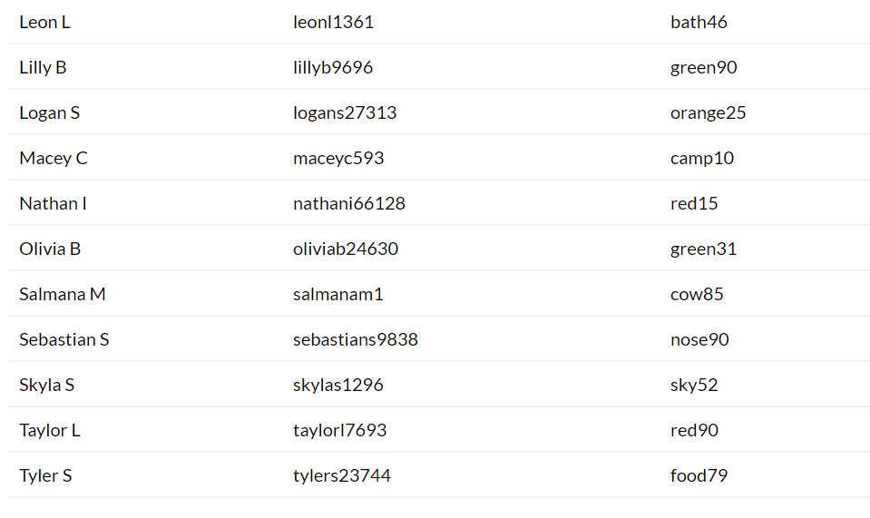
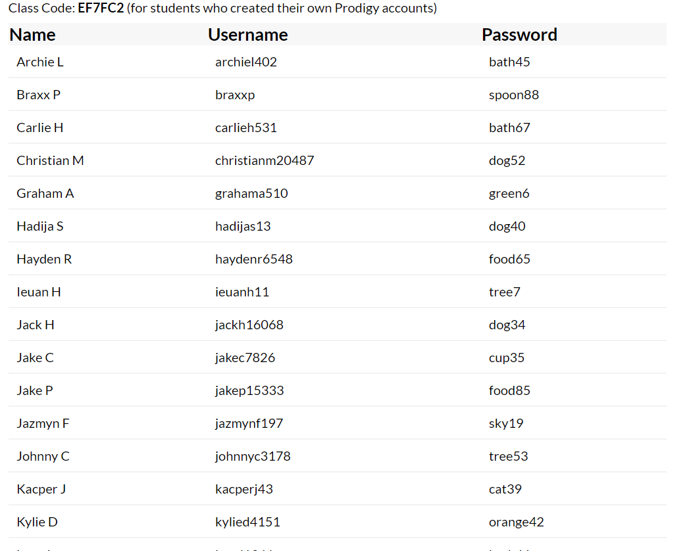

Length and Height, Weight and Mass – Week 2
Monday | Tuesday | Wednesday | Thursday | Friday
Discuss shorter and longer, taller and shorter, bigger and smaller. Find things in the house to compare.  Complete worksheet 1 | Using a ruler, on the page, measure the lengths of the objects.  Measure objects around the home – write 3 sentences. | Discuss heavier and lighter. Find things in the house to compare.  Complete worksheet 3 | Complete the worksheet | Use weighing scales – write the object you are weighing and then write the correct weight.  Then write 3 sentences to say which is heavier and lighter etc.

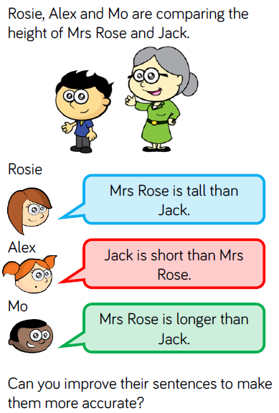
Week 2 Day 1
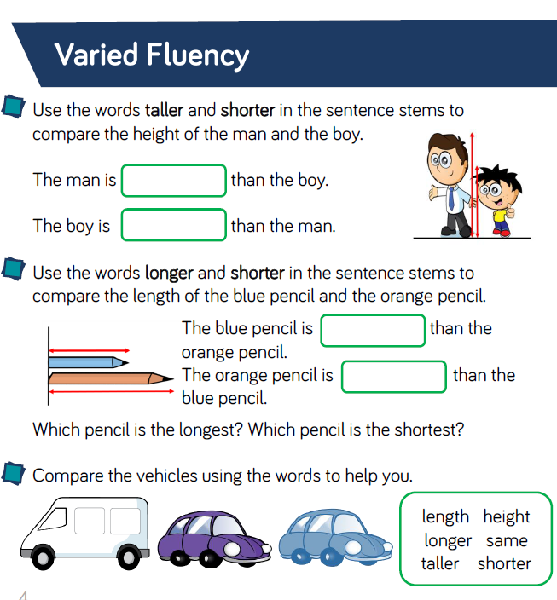
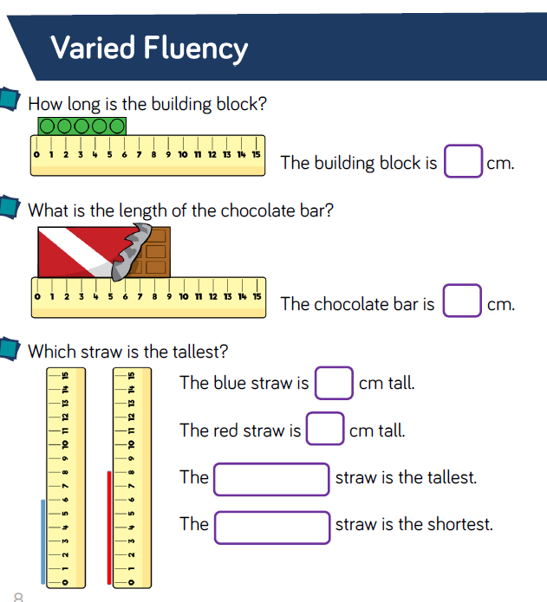
Week 2 – Day 2

Can you use a ruler to measure things around the house?

Then write 3 sentences to explain which are taller, smaller, bigger, longer, shorter etc.

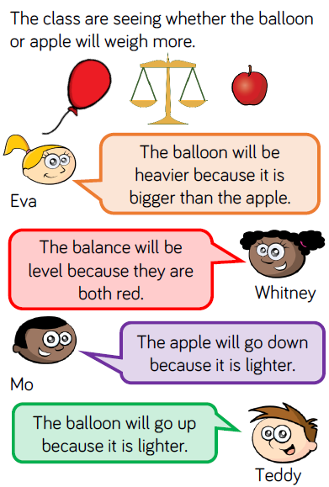
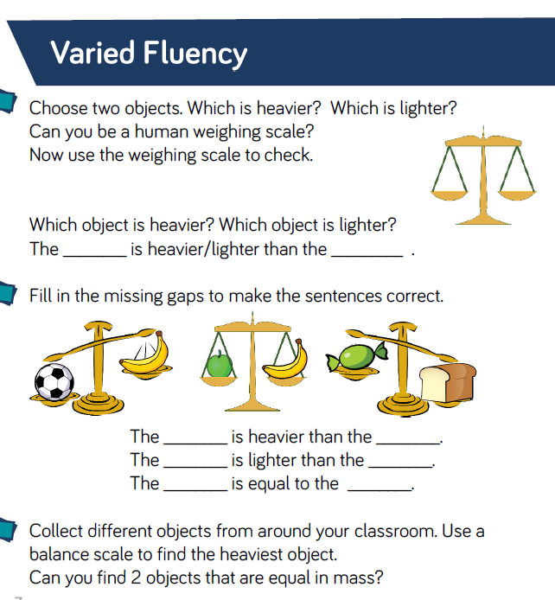
Week 2 – Day 3
Tell your parent who is correct and why.

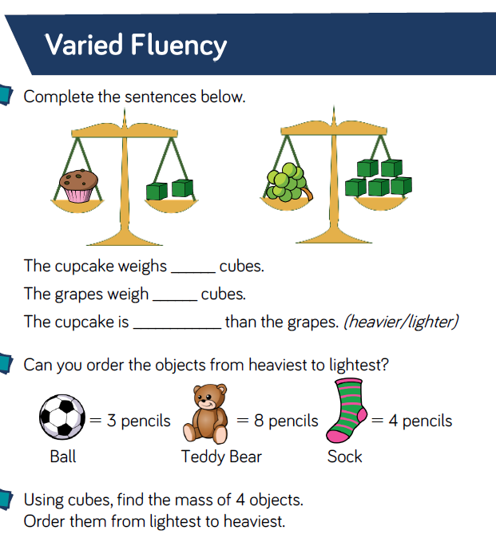
Week 2 – Day 4
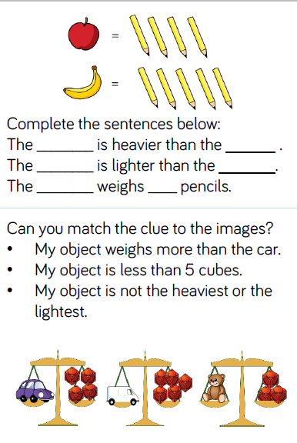
Talk to your parent

Writing
Write a few sentences about each of these prompts.
Remember I am looking for your –

- Capital Letters
- Full Stops
- Finger Spaces
- Handwriting
- Spelling
Monday and Tuesday
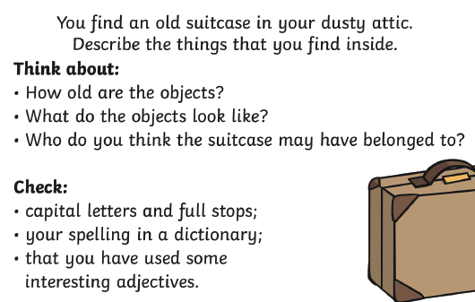

Wednesday and Thursday
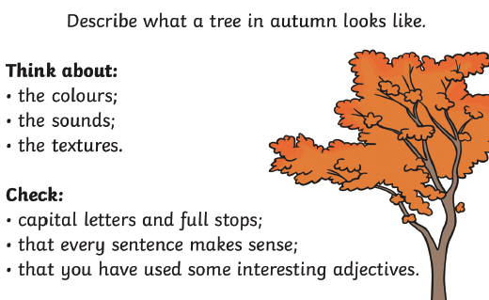
Friday: Check
back through all your writing for the features

