Wonder by R.J Palacio
Chapter one
I know I’m not an ordinary ten-year-old kid. I mean, sure, I do ordinary things. I eat ice cream. I ride my bike. I play ball. I have an Xbox. Stuff like that makes me ordinary. I guess. And I feel ordinary. Inside. But I know ordinary kids don’t make other ordinary kids run away screaming in playgrounds. I know ordinary kids don’t get stared at wherever they go. If I found a magic lamp and I could have one wish, I would wish that I had a normal face that no one ever noticed at all. I would wish that I could walk down the street without people seeing me and then doing that look-away thing. Here’s what I think: the only reason I’m not ordinary is that no one else sees me that way. But I’m kind of used to how I look by now. I know how to pretend I don’t see the faces people make. We’ve all gotten pretty good at that sort of thing: me, Mom and Dad, Via. Actually, I take that back: Via’s not so good at it. She can get really annoyed when people do something rude. Like, for instance, one time in the playground some older kids made some noises. I don’t even know what the noises were exactly because I didn’t hear them myself, but Via heard and she just started yelling at the kids. That’s the way she is. I’m not that way. Via doesn’t see me as ordinary. She says she does, but if I were ordinary, she wouldn’t feel like she needs to protect me as much. And Mom and Dad don’t see me as ordinary, either. They see me as extraordinary. I think the only person in the world who realizes how ordinary I am is me. My name is August, by the way. I won’t describe what I look like. Whatever you’re thinking, it’s probably worse.

Listen to chapter 2 by the author-
https://www.youtube.com/watch?v=8NiP1FIhJbw

Task one- Retrieval
Who is August Pullman?
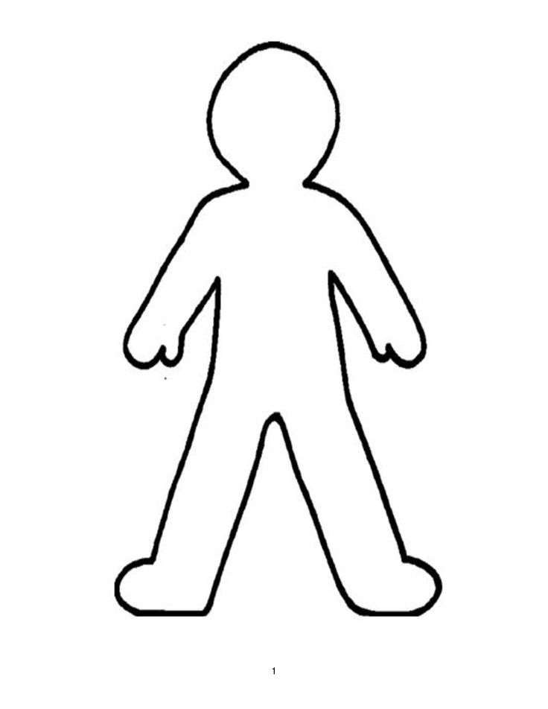
Retrieve facts from the two chapters you have read and write them onto his body map.
He is ten years old
Task two- Infer
Read this passage which is much later on in the book, describing what August Pullman looks like.
His head is pinched in on the sides where the ears should be, like someone used giant pliers and crushed the middle part of his face. He doesn’t have cheekbones. There are deep creases running down both sides of his nose to his mouth, which gives him a waxy appearance. Sometimes people assume he’s been burned in a fire; his features look like they’ve been melted, like drippings on the side of a candle. Several surgeries to correct his lip have left a few scars around his mouth, the most noticeable one being a jagged gash running from the middle of his upper lip to his nose. His teeth are small and splay out.

Using this extract to help you, can you draw how you think August Pullman would look? Use this space below.

Task three-
Your task is to design an animal, which like August is normal on the inside but different on the outside. You then need to write a paragraph describing the sense sight (what can be seen) like the paragraph above.
Remember to include some of your year five features like:
-prepositions/ prepositional phrases
-Relative clause using the relative pronoun, ‘which’
- Expanded noun phrase

