WALT: To complete, read and interpret information in tables- including timetables.
WILF:
- Read the information carefully
- Decide what the question is asking you to do
- If it is asking for the time difference:
- Draw a number-line
- Place your beginning time to the left of the number-line
- Place your end time at the right of the number-line
- Jump in appropriate steps
- Calculate the difference
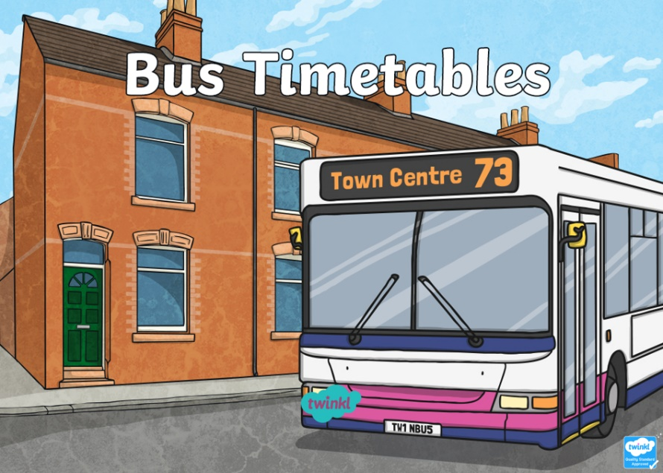

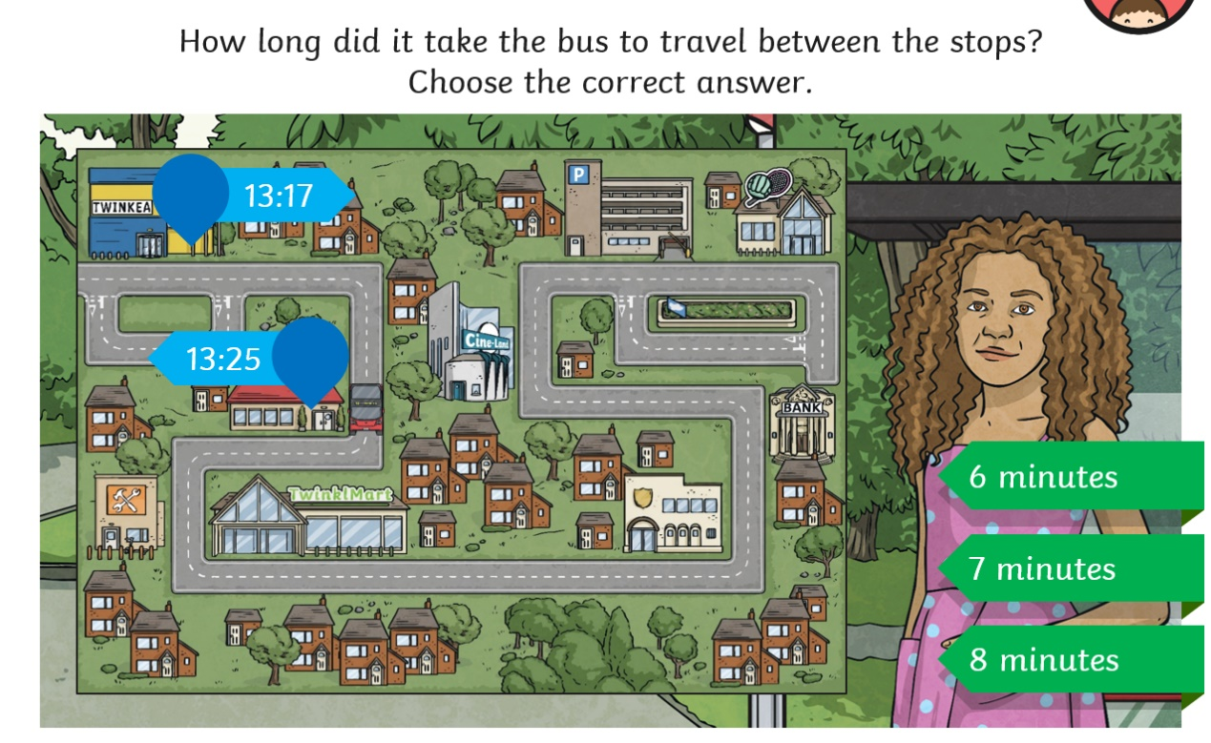
Example

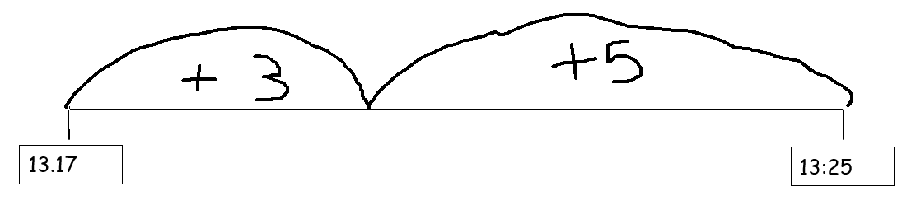
13.20
3+5= 8 minutes
Practise
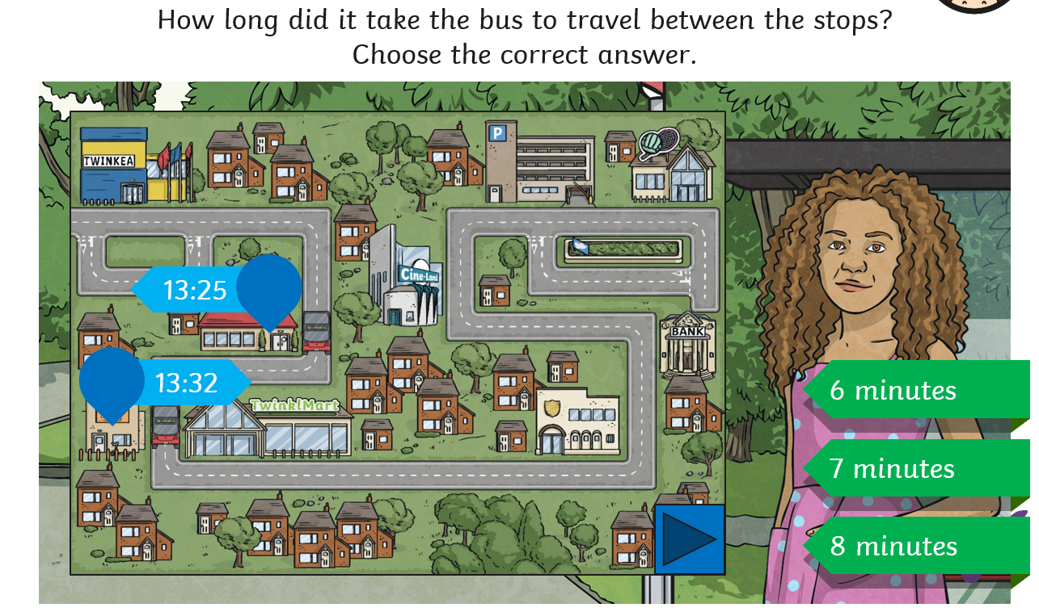

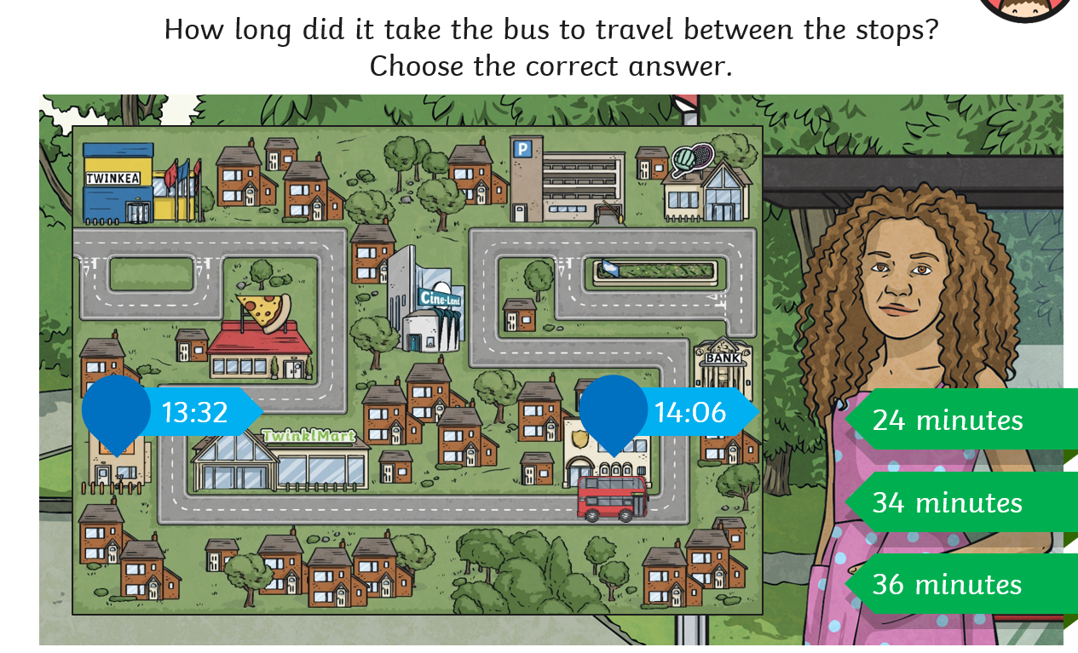

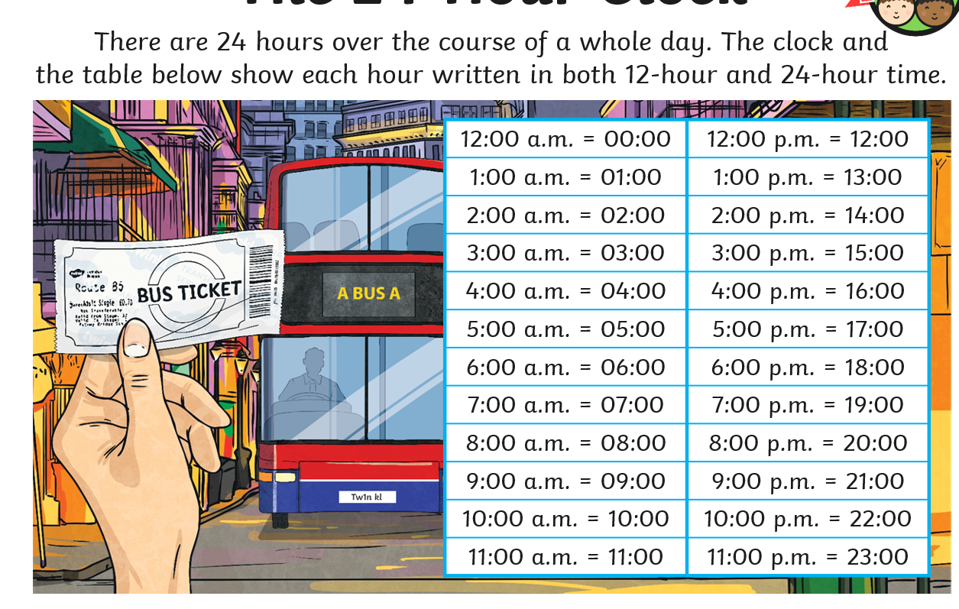
Activities
Remember the WILF!

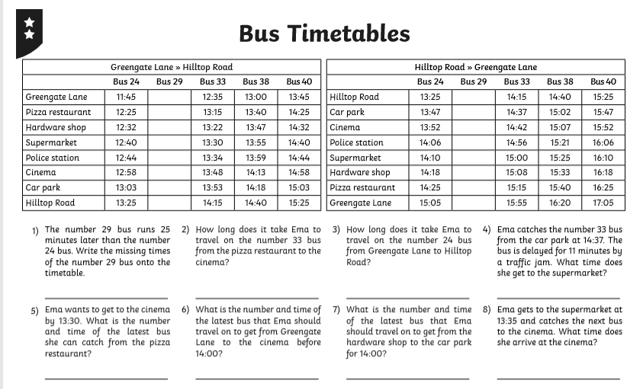

Challenge
