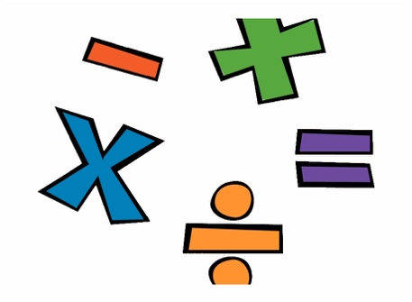

HOME LEARNING PACK
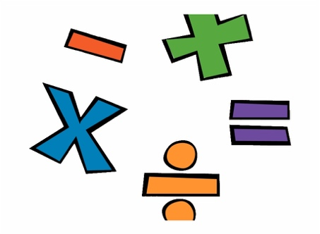

KEY STAGE ONE

YEAR ONE

Maths Activity: Counting in twos.

W.A.L.T: To be able to count in 2s up to the number 10.

Steps to Success:
- I can count in twos up to the number ten.
- I can work out how many twos are in the number ten.
- I can use my knowledge of counting in twos to work out the missing number in a sequence.

Starter:

Can you write numbers up to 10?

If you finish this really quickly, can you write numbers up to 20?

Today’s Learning:

When we count in 2s, we add 2 to each number before.

Smelly Socks!

Can you go and get 10 socks?

Once you have the socks can you count them out loud to make sure there are 10?

Now, put your socks into pairs, give them a friend and draw me a picture of your socks underneath.

Draw me your smelly socks in their pairs!

Example – Here are mine! Check yours to make sure they are the same!

Think and Answer:

- How many pairs of socks do we have?

- How many socks have we got in each pair?

- Can you count the socks in their pairs?

- What are we counting in each time?

- We have 10 socks altogether and we have 5 pairs. Using this to help you can you tell me how many 2s there are in 10?

Have a go at these questions using the number line:

0 2 4 6 8 10
+2
+2
+2
+2
+2

Answer the questions, use this number line to help!

- What is 2 more than 2?

- What is 2 more than 4?

- What is two more than 6?

- What is 2 more than 8?

Missing Numbers:

You are now all superstars at counting in 2s! Can you use this to help work out the missing number in these sequences.

0 __ 4 6 8 10

0 2 4 __ 8 10

0 2 __ 6 __ 10

0 __ 4 __ 8 __

How do you feel about counting in twos?
Parents: Please could you take a photograph of this worksheet and post it on our class page!

Music Activity: Create a song about your family and friends.

W.A.L.T: To compose a chant about our family and/or friends.

Steps to Success:
- I can identify and use adjectives to describe my family and friends.
- I can use these adjectives to write a chant about my family and friends.
- I can perform my chant to an audience if I feel comfortable.

Warm Up:

In school we always use a chant to warm up, so can you sing this chant to warm up your vocals chords at home?

We have been learning this chant in class so make sure you remember that we sing each line twice!!

Everywhere we go

People want to know

Who we are

And where we come from

So we tell them

We’re from Doncaster

Mighty, mighty Doncaster

And if they can’t hear us

We sing a little louder!

If you want to push yourself can you:
- Sing it really fast?
- Sing it really slow?
- Sing it really quiet?
- Sing it really loud?
- Sing it really high (like a squeaky mouse)?
- Sing it really low (like a giant)?

Ideas Storm:

We are going to write a chant about our family and friends. It is very important that we tell people how much we love them, especially right now when we can’t all be together.

So, can you think about: Why are family and friends important?
What makes someone a good friend?
What does it mean to be a family?

Write some words to these answers on the ideas storm!!
I have put some adjectives on to start you off!
If you are struggling, use the adjectives glossary!
Family and Friends
Loving
Helpful

Example Chant:

I have written a chant as an example for you.

We love our family because they are kind

They are there for us when we feel down

They are loving and caring

And we are so lucky to have them

Our friends are helpful

And always make us laugh

Our friends are gentle and funny too.

Use the template and your adjectives to write your chant!

Template

We love our family because they are ___________

They are there for us when we feel down

They are ________ and ___________

And we are so lucky to have them.

Our friends are ___________

And always make us laugh

Our friends are ________ and _________ too.

Adjectives
Glossary

Beautiful

Caring

Helpful

Happy

Kind

Cheerful

Fantastic

Clever

Brave

Gentle

Fun

Friendly

Polite

Honest

Funny

Thoughtful

