To all my wonderful Y2 Children

How are you doing? Have you completed all your work so far?

Please stay safe, try to do a little bit of work but most of all stay healthy and happy.

If you want to contact me you can do at:
Mrshemmingway@newvillage.doncaster.sch.uk
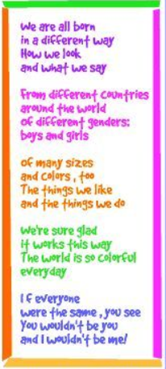

Mrs H xx

Year 2 (Mrs Hemmingway’s)
Home Learning

 | Activity | Week 3
Activity 1  9.00am | PE with Joe Wickes | Login to you tube and search for Joe Wickes PE – it will be live that morning. This is good for all children to take part in.
Break
Activity 2 | Reading and spellings | Complete reading and comprehension 11-15  Spelling Activity 11-15
Break
Activity 3 | Maths | https://play.prodigygame.com  Arithmetic
Break
Activity 4 | English | Writing tasks 11-15
Lunch
Activity 5 | Topic project | Complete a piece of art work that reminds you of the seaside – be as creative as you wish! Use some different materials.
Break
Activity 6 | Craft / Life skills | Art/making/jobs around the house/cooking/baking/board games/nature pictures/singing/making music/make videos/play outdoors etc.

Reading – choose a book they want to read.
Day 1 | Listen to your child read and ask 5 questions from the Rex Retriever mat. Ask your child to say some of the answers and possibly write some of them down too.
Day 2 | Listen to your child read and ask 5 questions from the Rex Retriever mat. Ask your child to say some of the answers and possibly write some of them down too.
Day 3 | Listen to your child read and ask 5 questions from the Inference Iggy mat. Ask your child to say some of the answers and possibly write some of them down too.
Day 4 | Week 2 Activity 5
Day 5 | Week 2 Activity 6

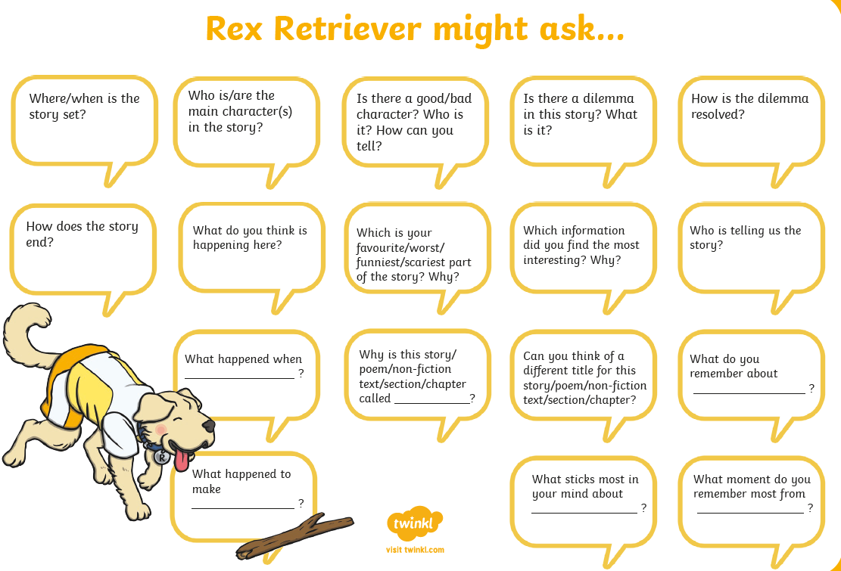
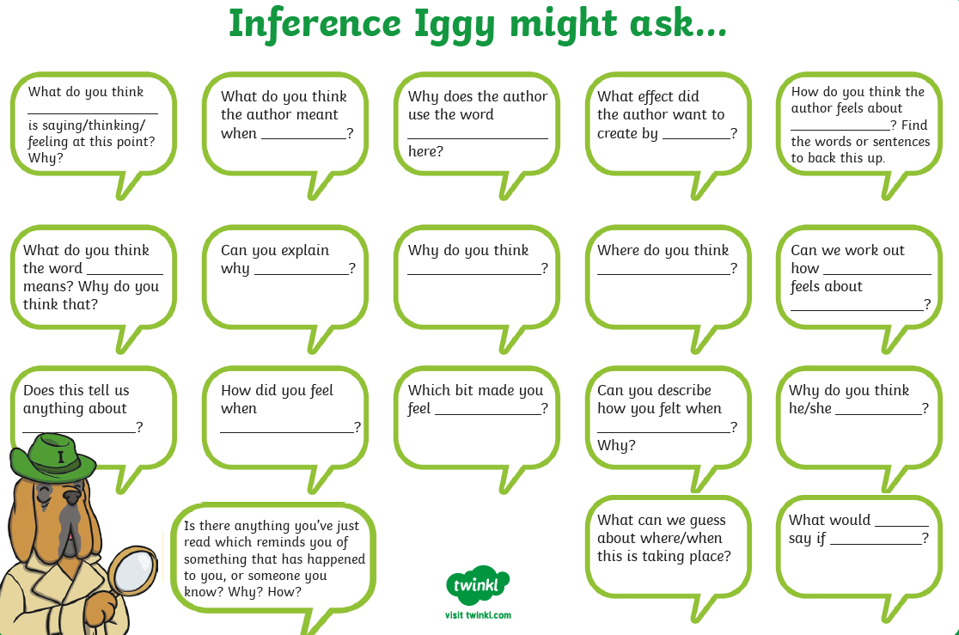

Comprehension Activity 5 Week 3
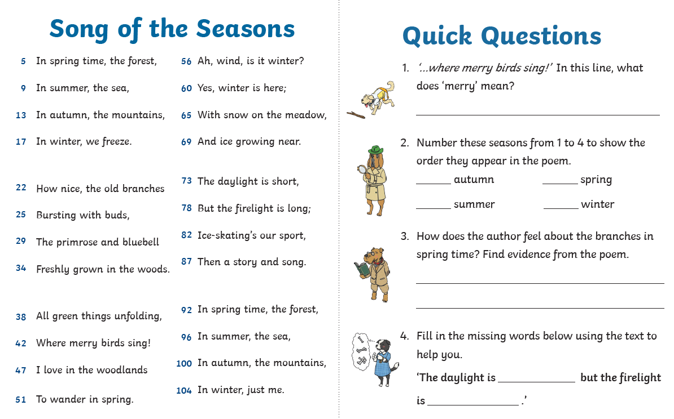
Comprehension Activity 6 Week 3
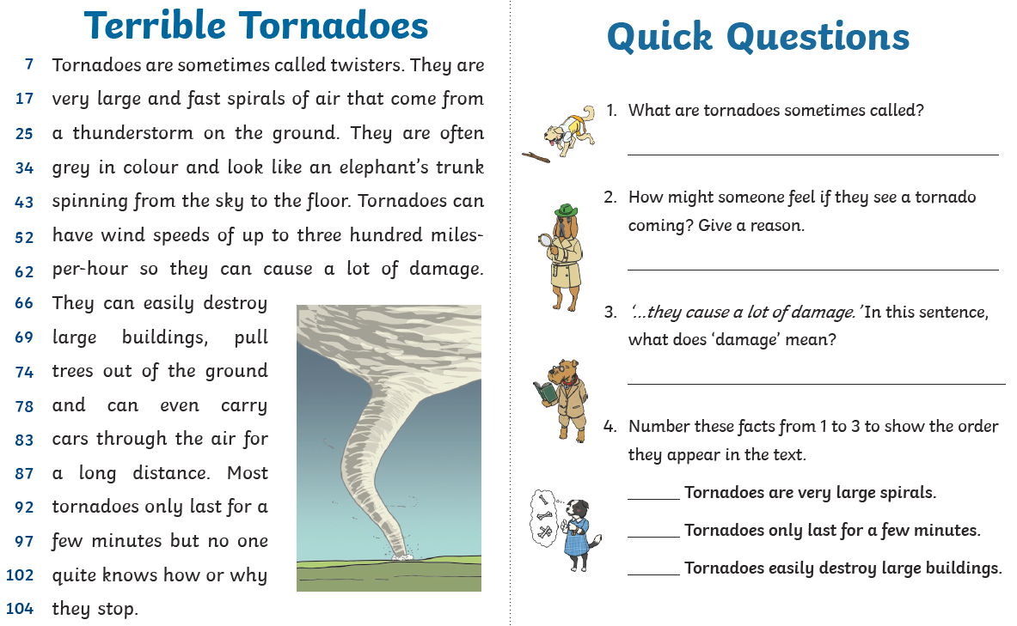
Spelling
 | Week 3
DAY 1 | Common exception word mat - most
DAY 2 | Common exception word mat – only
DAY 3 | Common exception word mat – great
DAY 4 | Common exception word mat – even
Day 5 | Common exception word mat - after

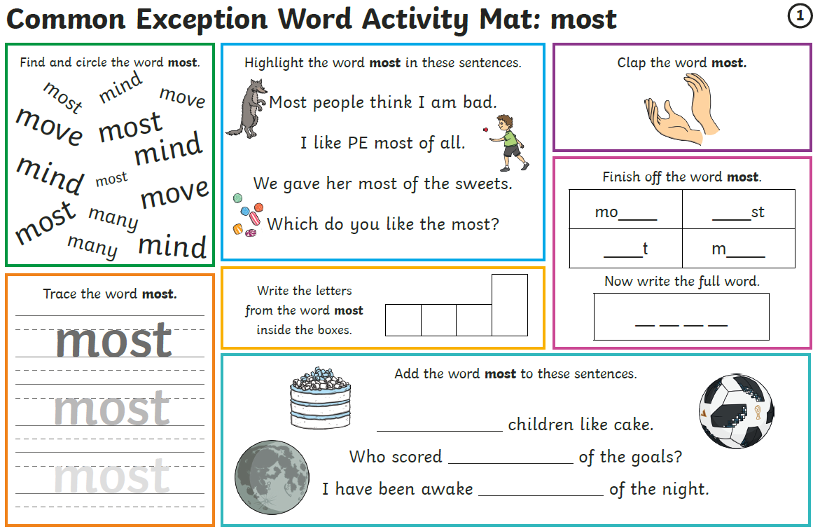

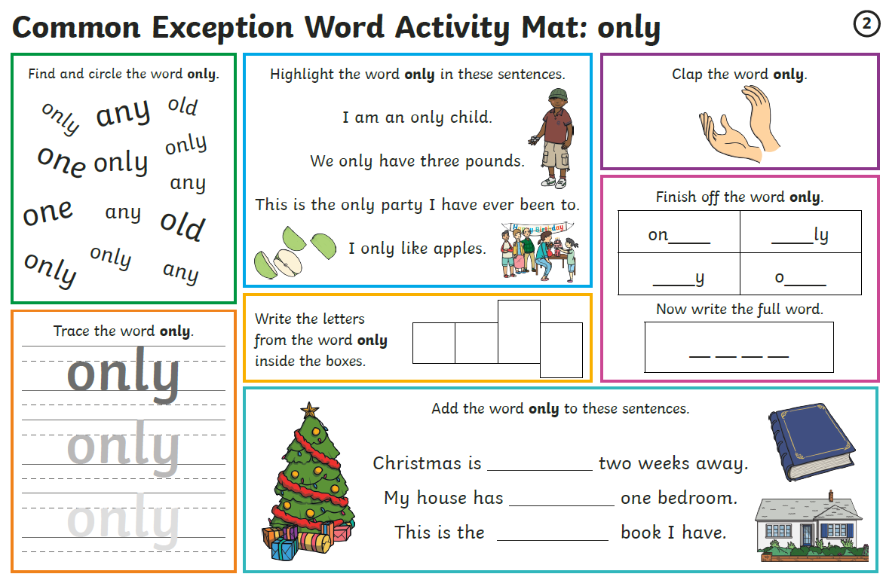

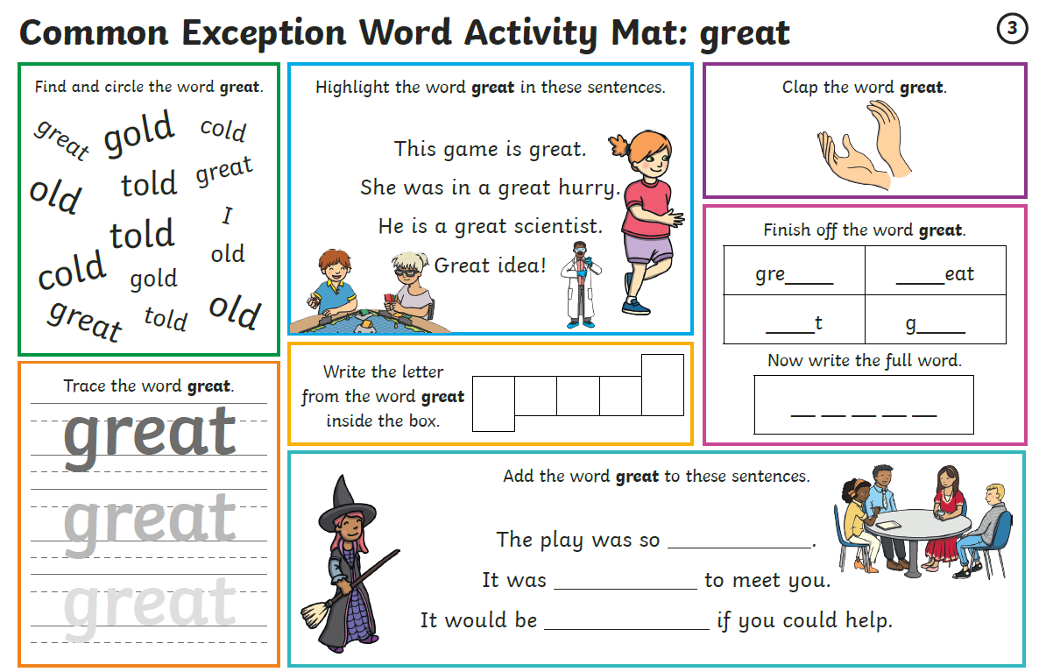
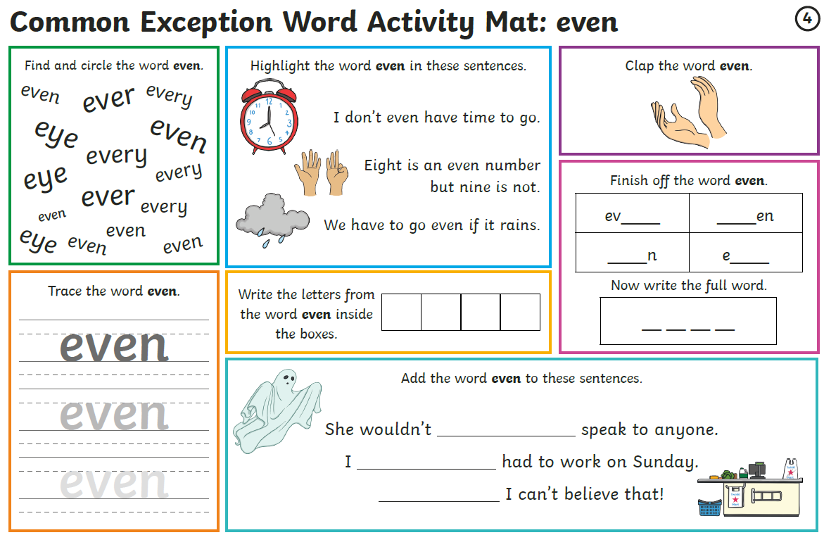

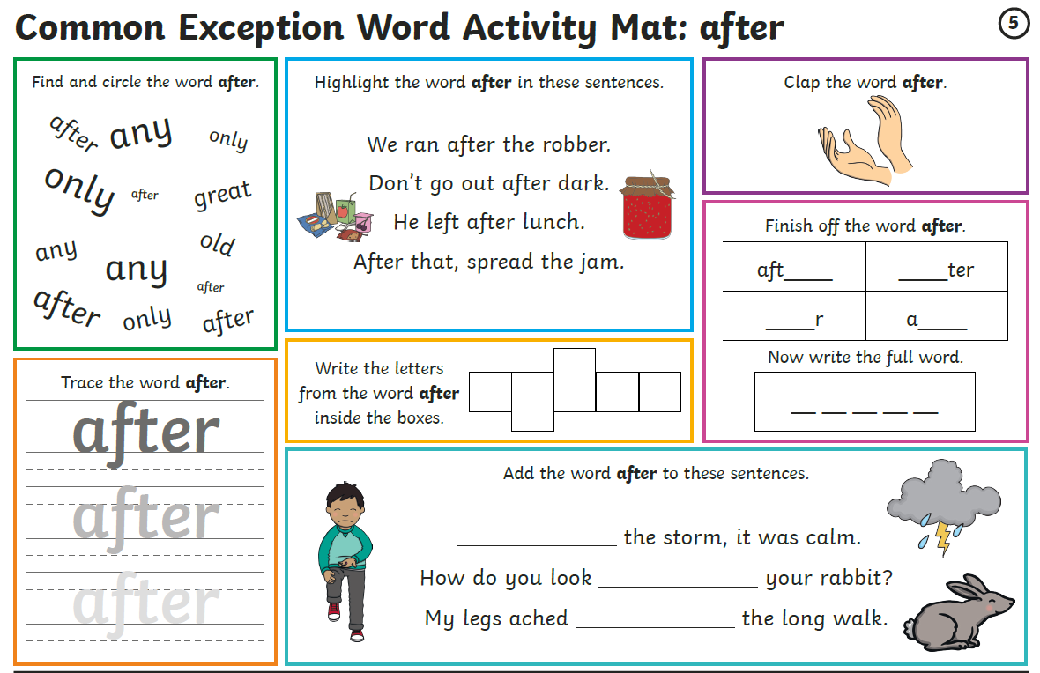
Maths
Log on to https://play.prodigygame.com – let your child log in with the following log in and play the maths games.
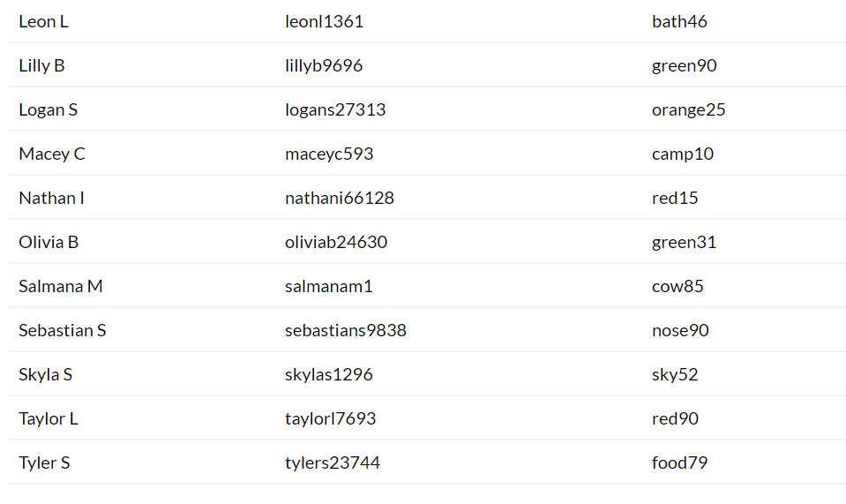
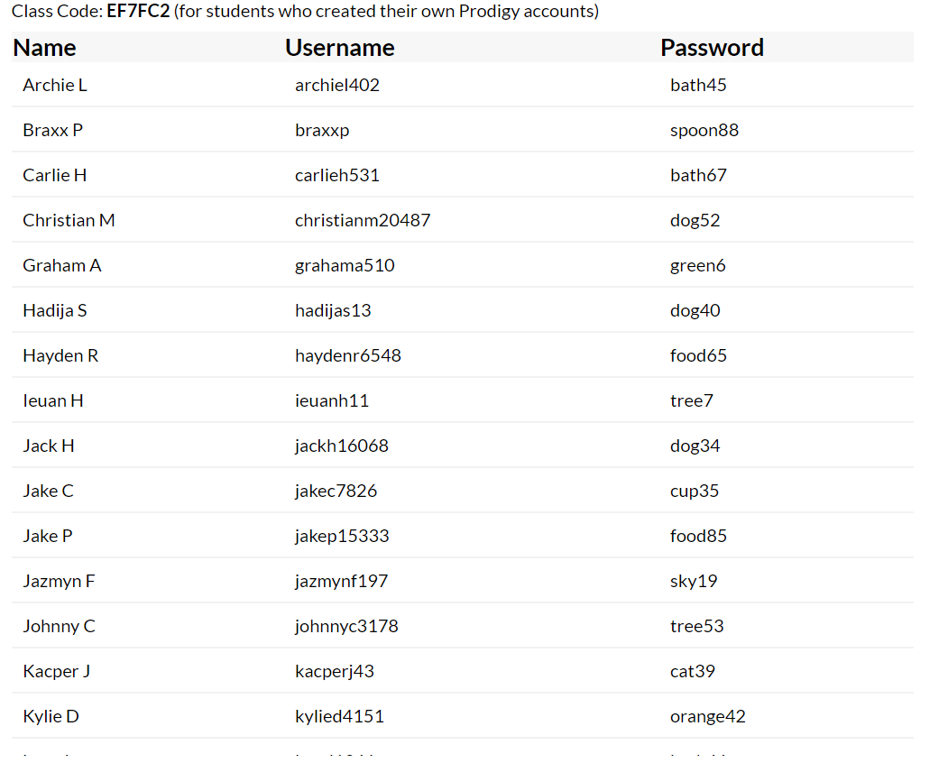

Arithmetic – Week 3
Monday | Tuesday | Wednesday | Thursday | Friday
Arithmetic 1 | Arithmetic 2 | Arithmetic 3 | Arithmetic 4 | Arithmetic 5
1. Complete the number sequence 10, 9, 8, 7 __  2. Write the number that is 1 more than 13.  3. Can you write the number 17 in this box.  4. There are 4 rabbits and 8 parrots for sale. How many animals altogether?  5. On your sheet you can see three shapes. Tick the triangle.  6. Which number do you add to 6 to make 10?  7. Have a look at your sheet – how long is the snake?  8. There were 5 hamsters in the shop. They all had 3 babies. How many now? | 1. Complete the number sequence 5, 6, 7, 8 __  2. Put a ring around the number 1 less than 19.  3. Can you write the number 26 in this box?  4. On your sheet there is a number line. Which number is missing?  5. There are 14 cats and 7 dogs in the pet shop. How many altogether? | Wednesday bookmark – please allow your child to do this and then go through this with them. | Thursday bookmark – please allow your child to do this and then go through this with them. | Friday bookmark – please allow your child to do this and then go through this with them.

Monday
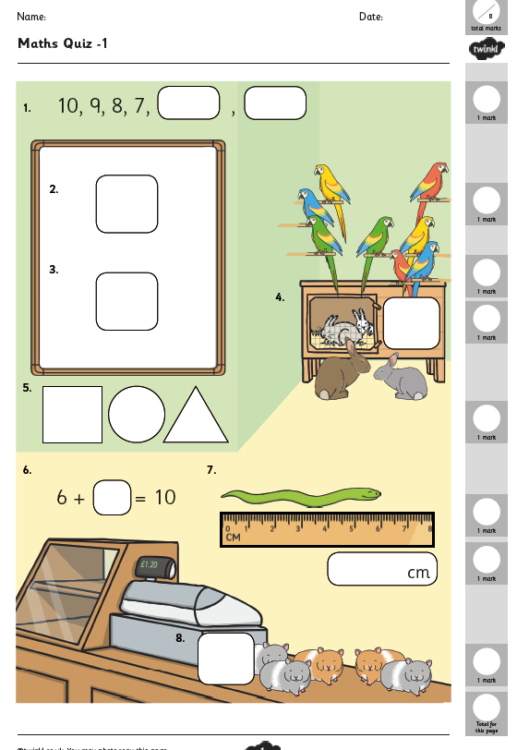
Tuesday
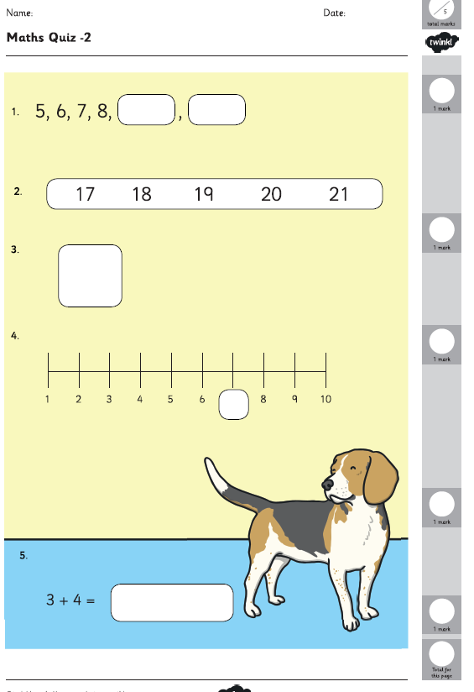

Wednesday Thursday
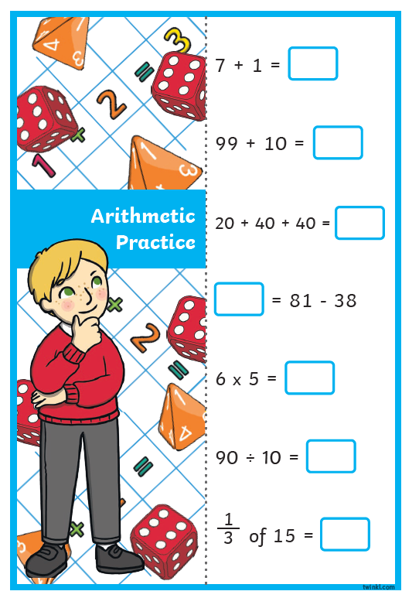
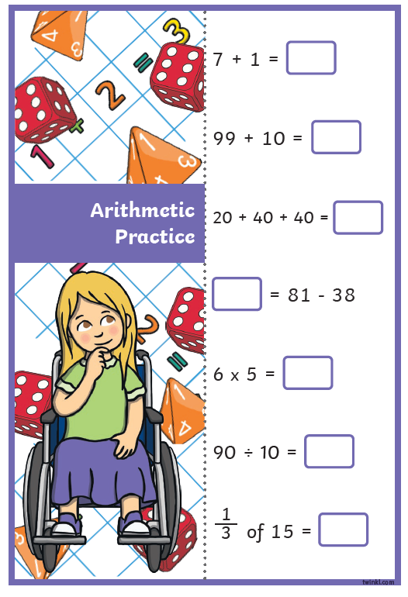
Friday
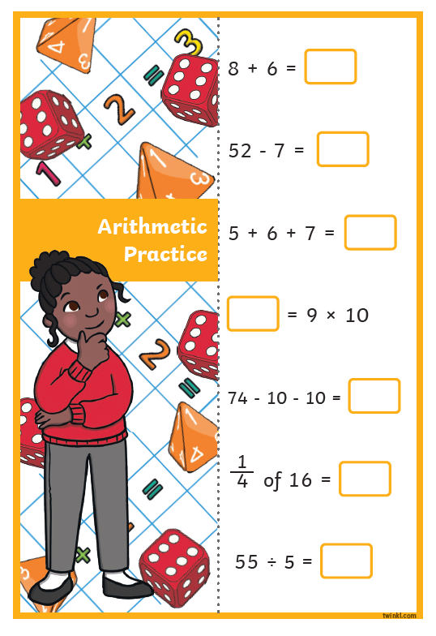

Writing
Write a few sentences about each of these prompts.

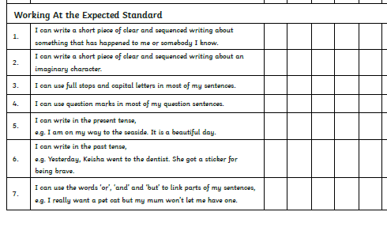
Monday and Tuesday
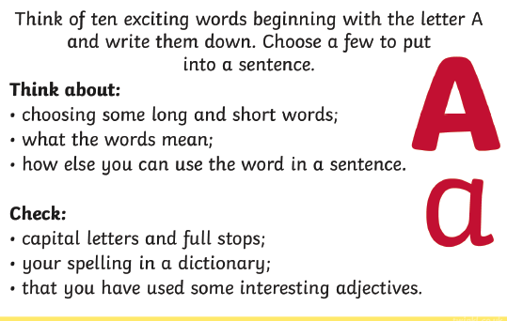
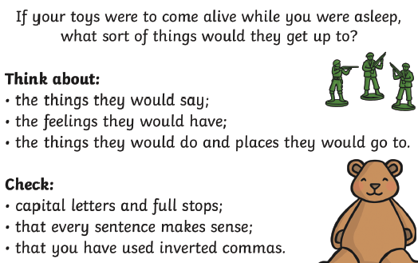
Wednesday and Thursday Friday: Check back through all your writing for the features

