To all my wonderful Y1 Children

How are you doing? Have you completed all your work so far?

Please stay safe, try to do a little bit of work but most of all stay healthy and happy.

If you want to contact me you can do at:
Mrshemmingway@newvillage.doncaster.sch.uk
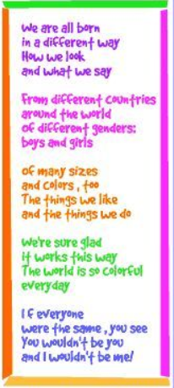

Mrs H xx

Year 1 (Mrs Hemmingway’s)
Home Learning

 | Activity | Week 3
Activity 1  9.00am | PE with Joe Wickes | Login to you tube and search for Joe Wickes PE – it will be live that morning. This is good for all children to take part in.
Break
Activity 2 | Reading and spellings | Complete reading and comprehension 11-15  Spelling Activity 11-15
Break
Activity 3 | Maths | https://play.prodigygame.com  Weight/Mass and Time
Break
Activity 4 | English | Writing tasks 11-15
Lunch
Activity 5 | Topic project | Create a musical instrument that sounds like the sea. Can you decorate it to make it look like the sea/sand/sun/ice-cream.
Break
Activity 6 | Craft / Life skills | Art/making/jobs around the house/cooking/baking/board games/nature pictures/singing/making music/make videos/play outdoors etc.

Reading – choose a book they want to read.
Day 1 | Listen to your child read and ask 5 questions from the Rex Retriever mat. Ask your child to say some of the answers and possibly write some of them down too.
Day 2 | Listen to your child read and ask 5 questions from the Rex Retriever mat. Ask your child to say some of the answers and possibly write some of them down too.
Day 3 | Listen to your child read and ask 5 questions from the Inference Iggy mat. Ask your child to say some of the answers and possibly write some of them down too.
Day 4 | Week 2 Activity 5
Day 5 | Week 2 Activity 6

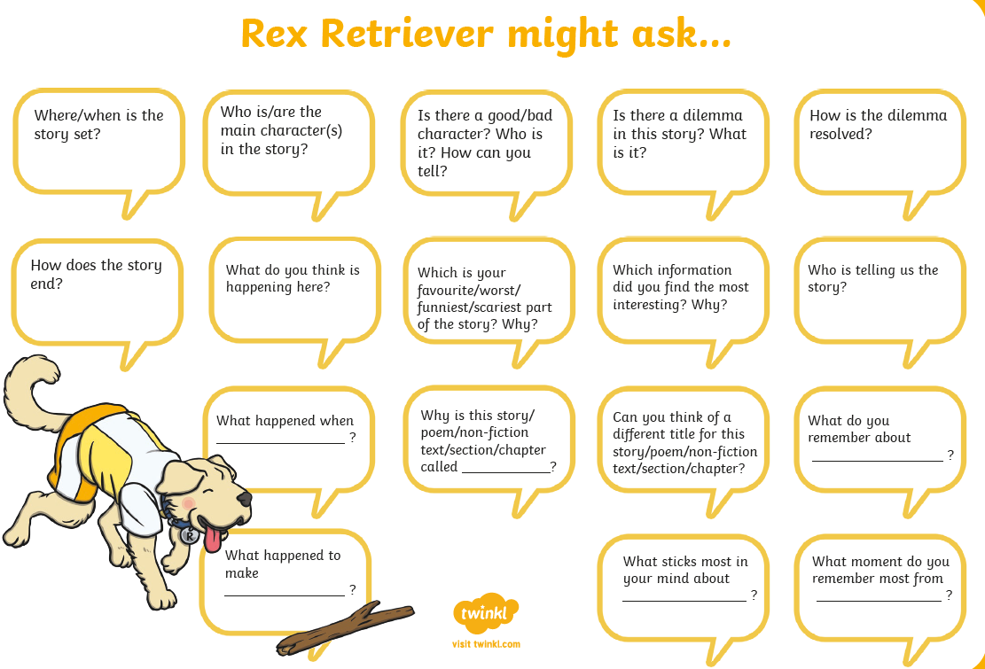
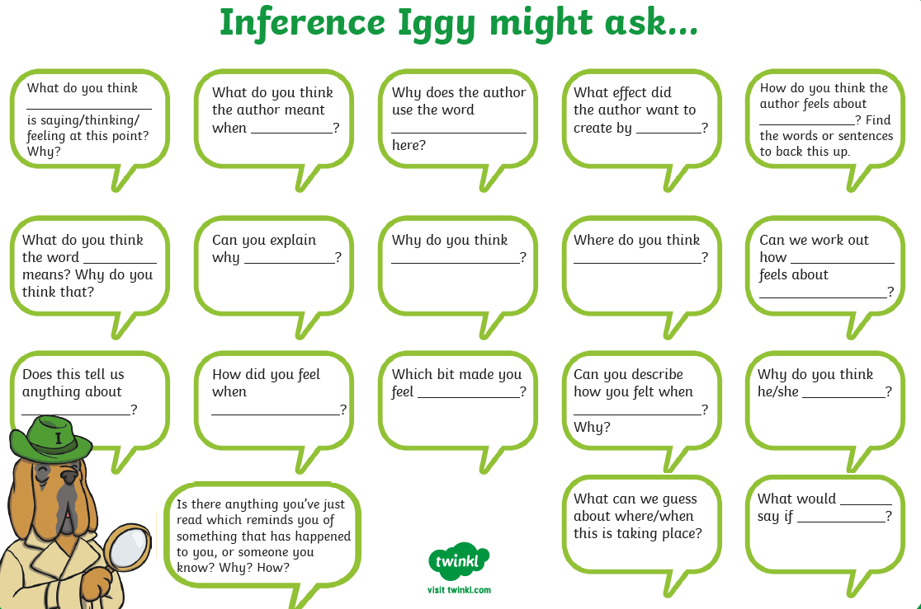

Comprehension Activity 5 Week 3
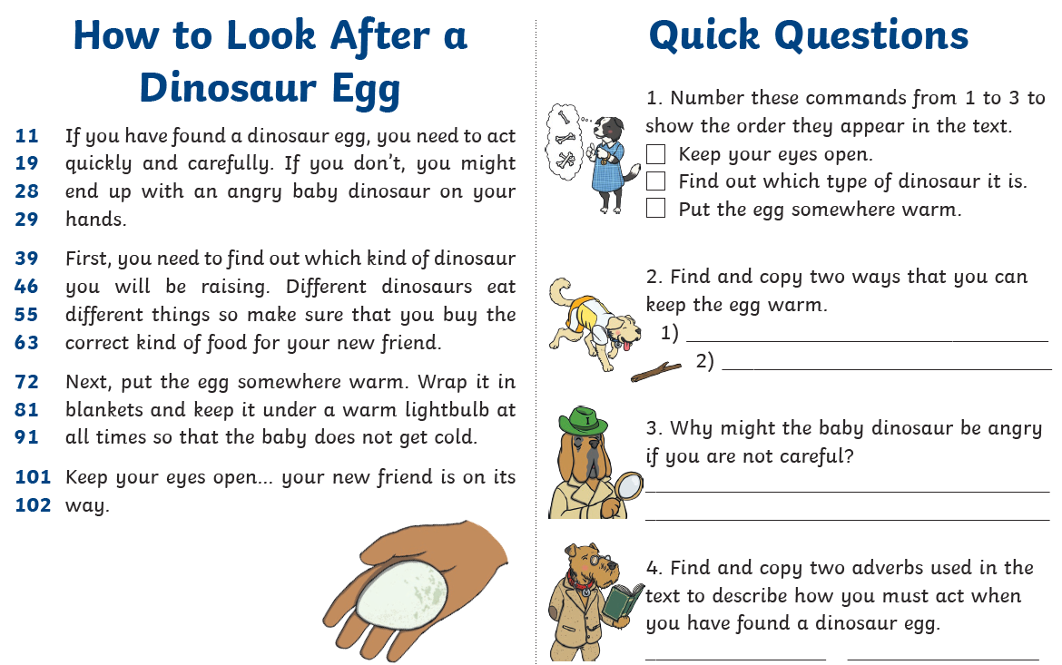
Comprehension Activity 6 Week 3
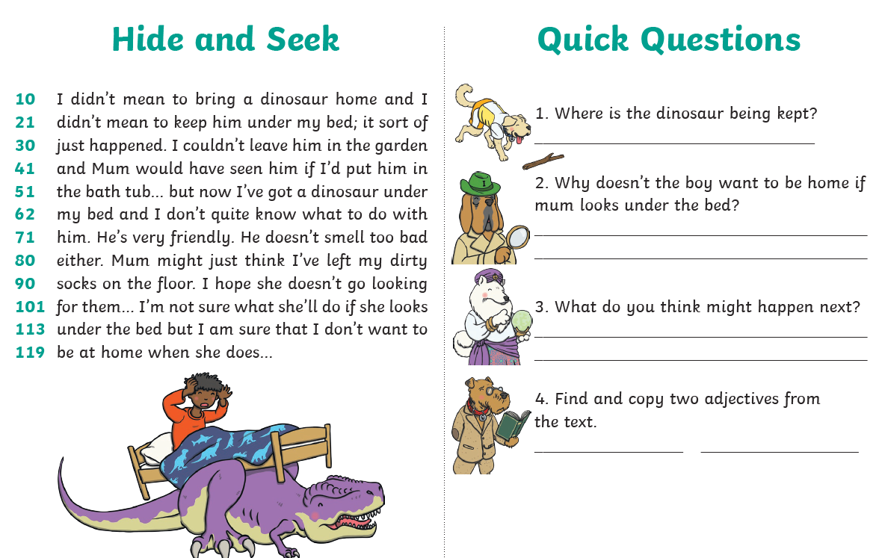
Spelling
 | Week 3
DAY 1 | Common exception word mat - be
DAY 2 | Common exception word mat – he
DAY 3 | Common exception word mat – me
DAY 4 | Common exception word mat – she
Day 5 | Common exception word mat - we

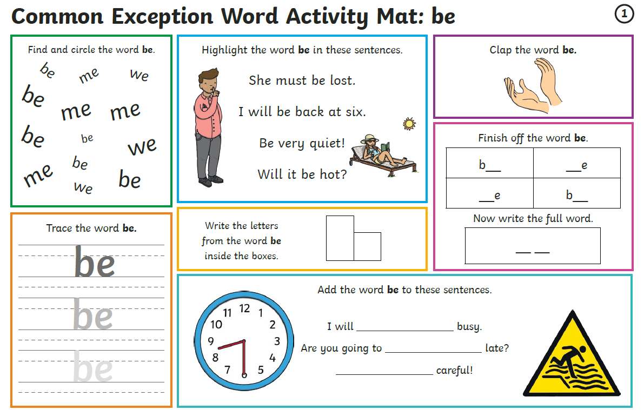

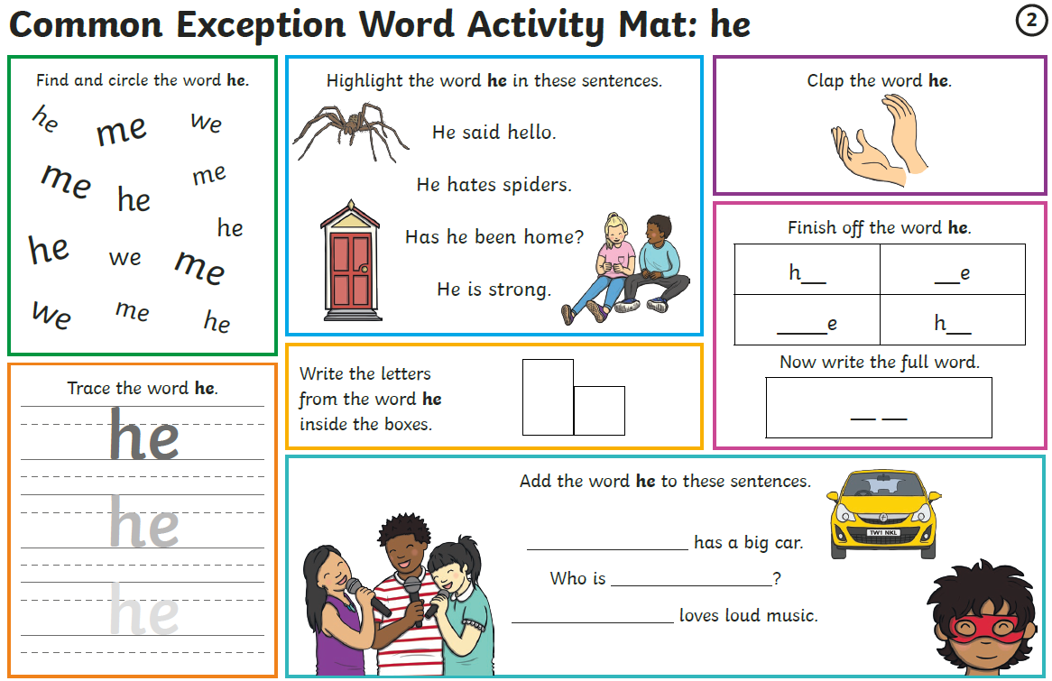

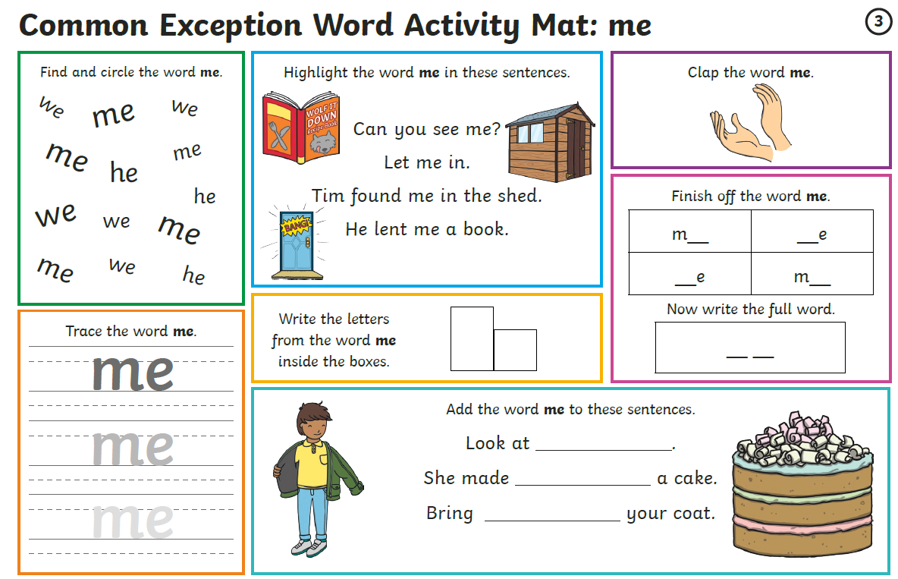
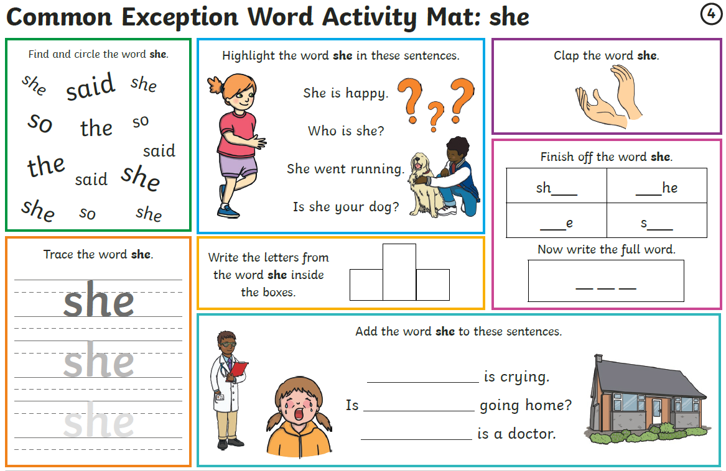

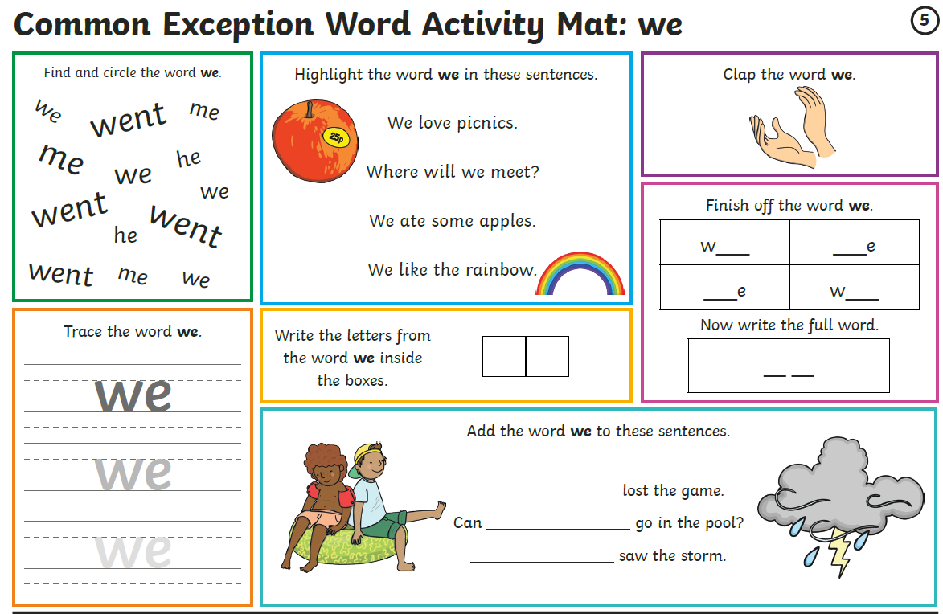
Maths
Log on to https://play.prodigygame.com – let your child log in with the following log in and play the maths games.
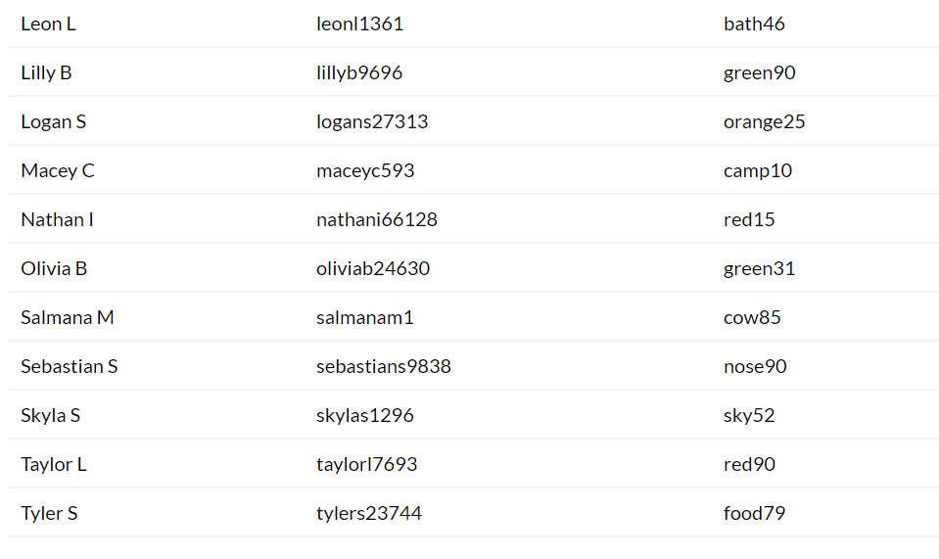
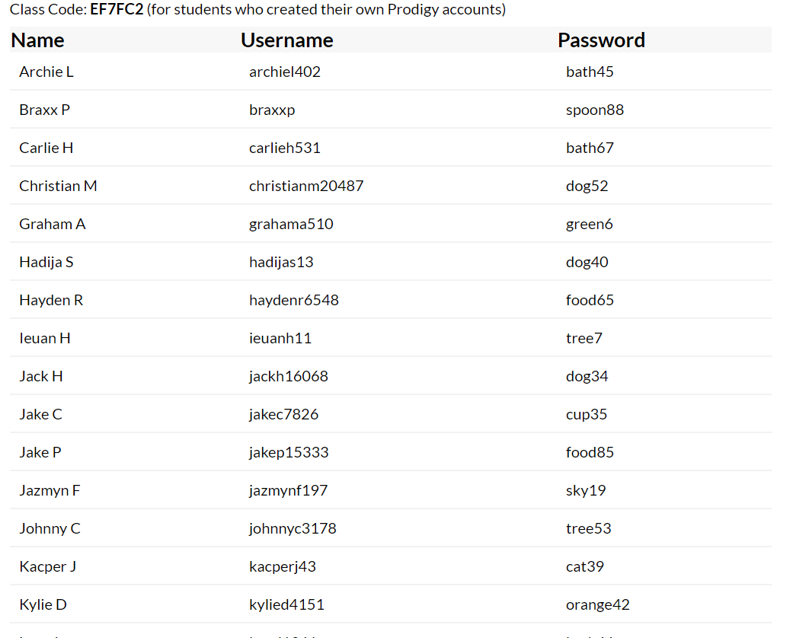

Arithmetic – Week 3
Monday | Tuesday | Wednesday | Thursday | Friday
Arithmetic 1 | Arithmetic 2 | Arithmetic 3 | Arithmetic 4 | Arithmetic 5

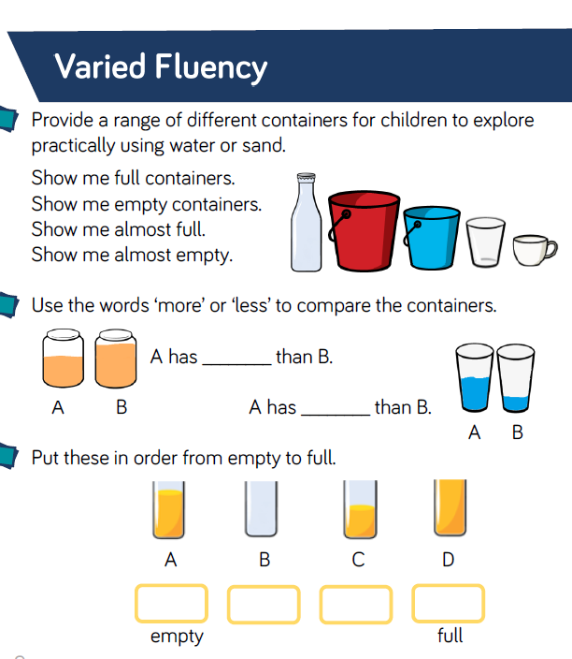
Monday

Get 5 containers out of the kitchen cupboards, can you guess which will hold more and less liquid?

Stack them in order.

Test it out. Were you correct?

Tuesday

Ask your parent to find 5 objects.
Order the 5 objects in the order lightest to heaviest – now weigh them. Were you correct.

Can you find 3 items heavier than an apple?
Can you find 3 items similar in weight to a milk bottle?
Can you find 3 items lighter than a cup?

Take photos of your items.

Wednesday

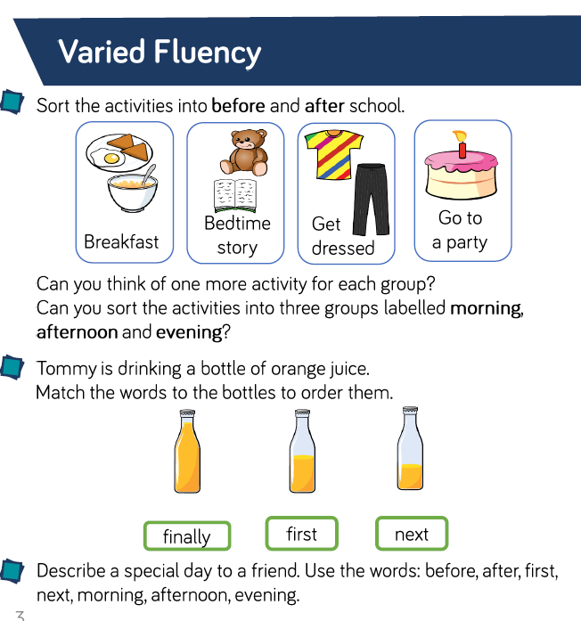

Complete a timetable of your normal day. Write the times in – ask your parent to help.

Thursday
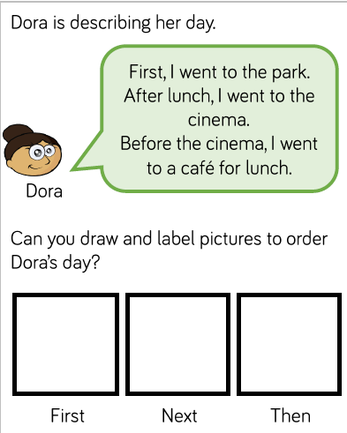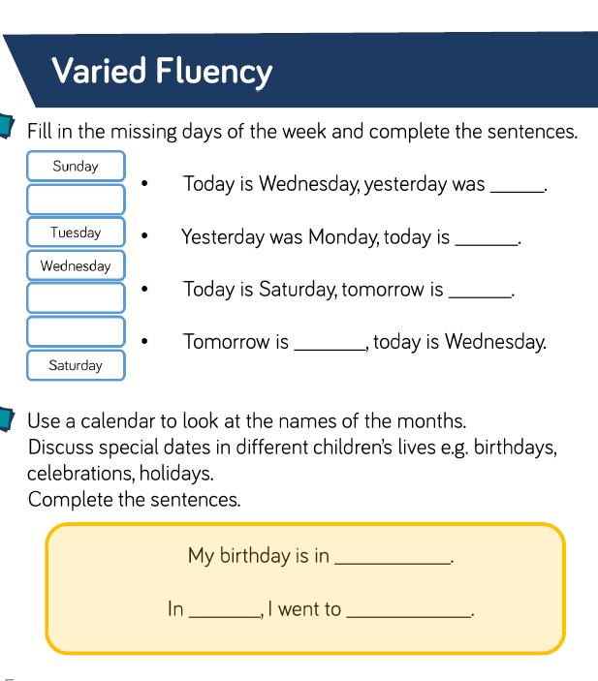
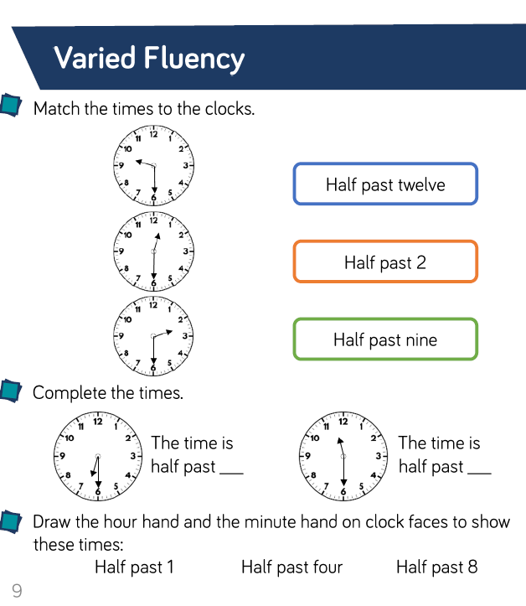
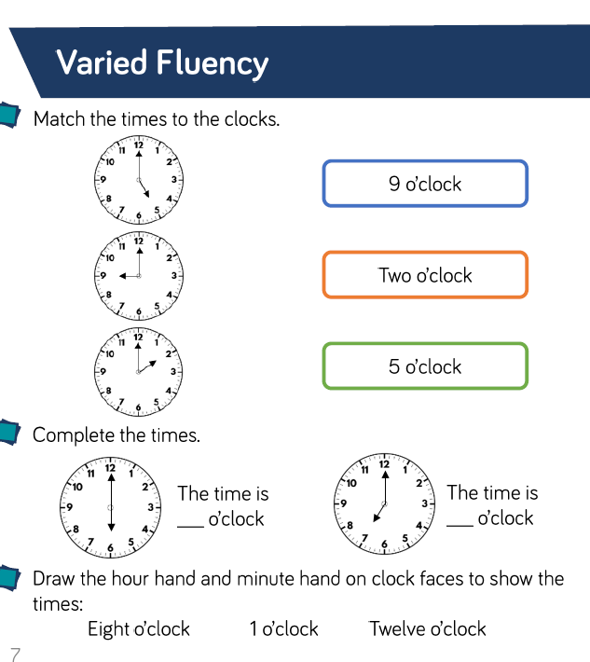
Friday

Writing
Write a few sentences about each of these prompts.
Remember I am looking for your –

- Capital Letters
- Full Stops
- Finger Spaces
- Handwriting
- Spelling
Monday and Tuesday
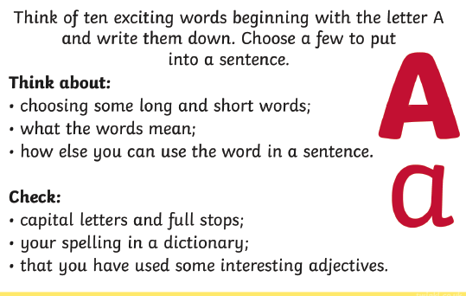
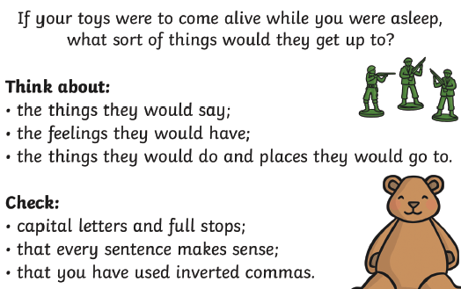
Wednesday and Thursday Friday: Check back through all your writing for the features

