To all my wonderful 2Si children

I’m proud I was your teacher,
I’ve watched you learn and grow.
We worked so hard and had such fun,
And how I miss you so.
We had so many special times,
And now we are apart.
Just to know you will always have
A special place in my heart!

It seems so long since I have seen you and I am missing you so, so much. I hope you are being good for your grown-ups!

Please stay safe, try to do a little bit of work but most of all stay healthy and happy.

If you want to contact me you can do at:
MrsSimmons@newvillage.doncaster.sch.uk

Mrs S xx

2Si - Home Learning - Week 3
Daily Activities:
 | Activity
9.00 – 9.30 | PE with Joe Wickes/Oti | Login to you tube and search for Joe Wickes PE or Oti Dance classes https://youtu.be/EJmpCH9p2X8 – have fun
Activity 1 | Maths  (30 mins) | Complete the daily maths statistics tasks
Activity 2 | Spag  (30 mins) | Complete the spelling activities using the common exception word list
Activity 3 | TTRS  (10 mins) | Log into TTRS and complete 10 minutes practice on the studio or practice counting in 2, 5, 10 forwards and backwards – get an adult to test you.
Activity 4 | English  (30 mins) | Day 1 – Read my model. Pick out all the description  Day 2 - Look at the images, think carefully about the senses and the work we completed for poetry. Imagine you are there in the different pictures, Think about what you can see, hear, smell and touch. Write down the adjectives that come to mind  Day 3/4/5 – write the description. Remember to use sentences in your writing, add in the adjectives and adverbs to help me picture it.  Proof read your writing, check spellings in a dictionary (online dictionary here https://www.collinsdictionary.com/dictionary/english)
Activity 5 | Reading  (30 mins) | Day 1 & 2  Child: Choose another book you would like to read. Read it aloud to an adult  Adults: Listen to the child read and ask 3 questions from the Rex Retriever mat. Ask the child to write/type the answers to at least 2 of them. Then ask the child 3 questions from the Inference Iggy mat. The child should record at least 2 answers in writing  Day 3 & 4 Complete the comprehension activity  Day 5 Work through the answers with the child – can they prove why that answer is correct?

Extra Activities
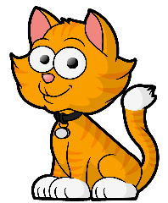
We will be writing instructions on how to travel from place to place. Write instructions on how to travel from one room in your home to another. Use the following language: half turn, quarter turn, clockwise, anti-clockwise, left, right and straight ahead. You could draw a map to help you.  https://www.bbc.co.uk/education/clips/z7kwmp3 | Lots of flowers and plants grow in summer. What can you see growing and changing in your garden/ on the way to school? Complete an observational sketch, using pencils, of 3 things you see. Label each with its name (if you know it) and visible parts e.g. trunk, stem, petal, leaf.  https://artfulparent.com/2016/05/observational-drawing-for-kids.html | We are learning about animals and how they are suited for their home. Pick an animal from the North or South pole. Draw them and label their features that help them to survive in the icy temperatures.  https://www.activewild.com/arctic-animals-list/
Have a go at planting some seeds and watch them grow. You could draw pictures or take photographs to show how they grow over time. What did the seeds need to help them grow into plants? | Have a go at yoga:  https://www.youtube.com/user/CosmicKidsYoga | Learn some scientific vocabulary  https://family.gonoodle.com/activities/think-like-a-scientist
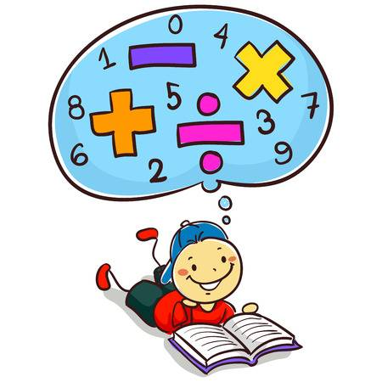
Maths Tasks STATISTICS PRACTICE – Task 1: Tally Charts

Starter: Can you name these charts and diagrams?
Which is a Pictogram, Tally Chart and Block Diagram?
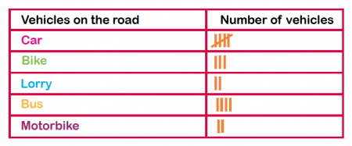
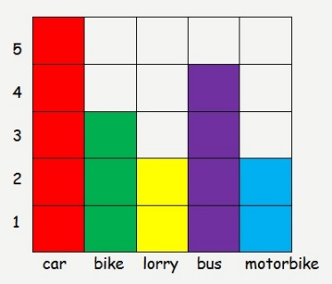
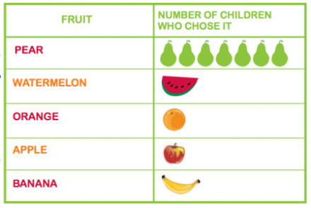

_____________________________
_____________________________
_____________________________

Favourite Colour | Tally | Total
Green
Pink |  | 14
Blue
Orange |  | 17
Purple |  | 9
Yellow |  | 20
This Tally Chart is unfinished. Can you complete it?

Which is the most popular colour?
_____________________________
_____________________________
Which is the least popular colour?

How many more people chose orange over blue?
_____________________________

What else does the Tally Chart show you?

Year 2 STATISTICS PRACTICE – Task 1: Tally Charts
Carefully read the text below. Then read it again, highlighting the key information and numbers. Complete the Tally Chart to show the information you have read.

James asked everyone in his class what their favourite sport was. Ten people chose football and three people chose rugby. Bella and Katy chose dance and eight people said tennis. James’ favourite sport is cricket.

Title – What was James finding out?

 | Tally | Total

What does the data in your Tally Chart show you?
______________________________________________
______________________________________________
______________________________________________
______________________________________________
Year 2 STATISTICS PRACTICE – Task 2: PICTOGRAMS
Look carefully at the Pictograms below and answer the questions.
Key: = 1

Five apples were sold on Sunday. Complete the Pictogram to show this.
How many apples were sold on Friday? ________________
What was the total amount of apples sold on Monday and Tuesday? ________________
The shop sold the most apples on _______________________.
The least amount of apples were sold on _____________________.
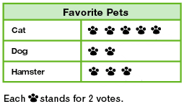

Which pet got the most votes? _____________
Which pet got the smallest amount of votes? ________________
How many people chose cats as their favourite pet? _______
_______ people voted for Hamsters.
Year 2 STATISTICS PRACTICE – Task 2: PICTOGRAMS
Create a Pictogram using the Tally chart below.
Easter Eggs eaten | Tally | Total
Monday |  | 7
Tuesday |  | 10
Wednesday |  | 5
Thursday |  | 3
Friday |  | 4

Pictogram:
Day | Easter Eggs Eaten
Monday
Tuesday

Wednesday

Thursday

Friday

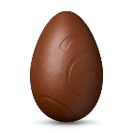
Key: = 1

What was the total amount of Easter Eggs eaten on Monday, Tuesday and Thursday?

Number Sentence: _____ + ______ + _______ = _______
Year 2 STATISTICS PRACTICE – Task 3: Block Diagrams
Look carefully at the Block Diagrams below and fill in the gaps in the sentences.
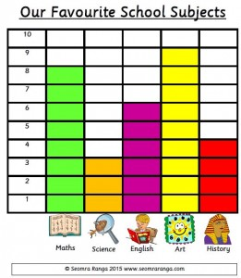

The most popular subject was _____________because it got _______ votes.
The least popular subject is __________________ as it has _______ votes.
Eight people voted for ___________________.
Four people voted for _____________________.
The subject that got 6 votes was _____________________.

Class _____ collected the least house points.

Class ____ have the most house points.

Class 5 have got _____ fewer house points than Class 2.
Year 2 STATISTICS PRACTICE – Task 3: Block Diagrams
Create a Block Diagram using the Tally Chart below.
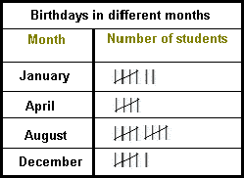

A Block Diagraph to show Birthdays in different months
Year 2 STATISTICS PRACTICE- TABLET FRIENDLY GAMES

All games can be found on the Topmarks website: https://www.topmarks.co.uk/maths-games/5-7-years/data-handling

Block Diagrams/Bar Chart Practice:
https://mathsframe.co.uk/en/resources/resource/51/bar_charts

Pictogram Practice:
http://toytheater.com/fishing/
http://toytheater.com/fruit-fall/
https://www.softschools.com/math/data_analysis/pictograph/games/

Tally Chart Practice:
https://www.softschools.com/math/data_analysis/tally_chart/

Interpreting Data on Block Diagrams, Pictograms and Tally Charts:
http://flash.topmarks.co.uk/4771

Spelling
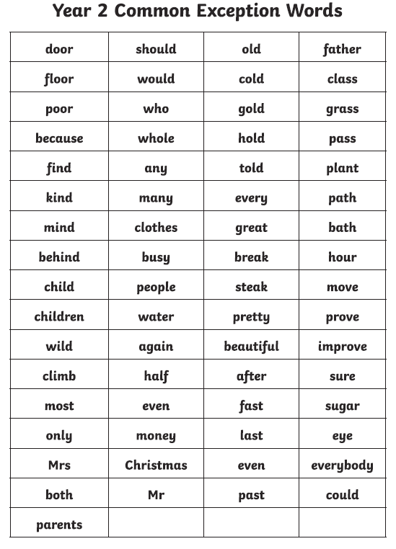
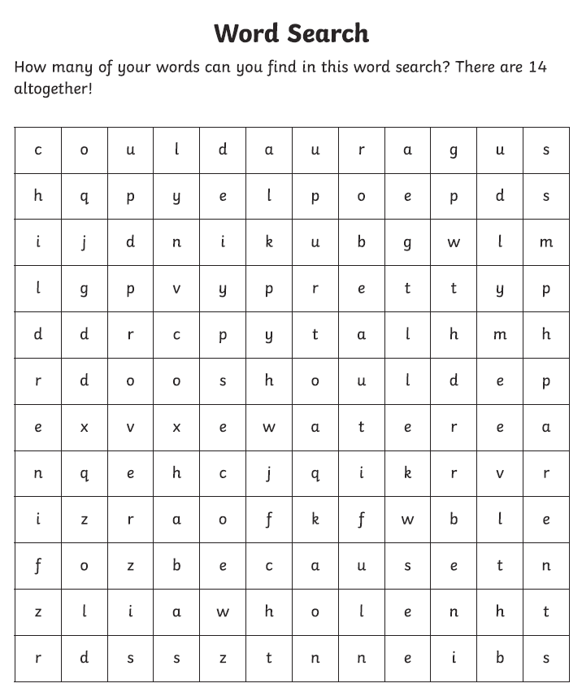

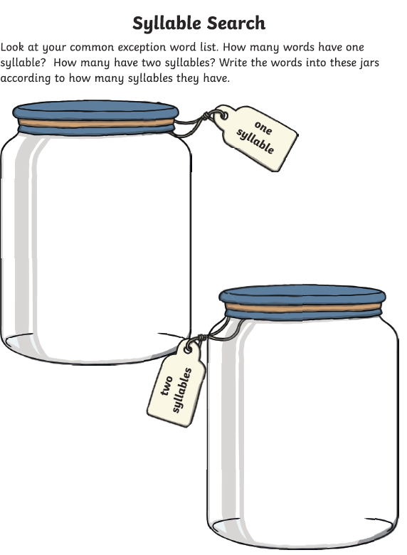

Handwriting
Write some of the common exception words – think carefully about the size of the letters and where they sit on the line.

Writing activity

Mrs Simmons model.
Nestled amongst the trees was a long, winding path that led to the forest of hope. Nervously, I began to tread along the wooden path. With each step the creaks became louder and louder. My hands tightly grabbing onto the rough green rope guiding me along the trail. I looked ahead, surrounded by misty fog and green trees, I really wasn’t sure if I was ever going to make it. I could hear the birds singing in the distance, getting quieter and quieter with every step I took.
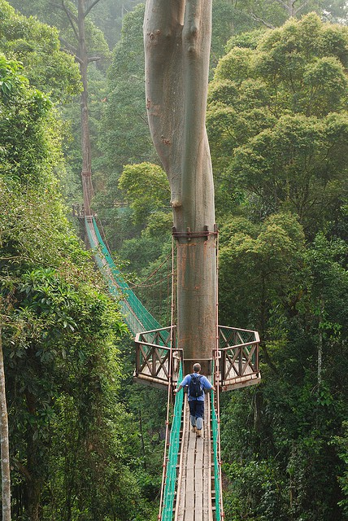

Image 1 to describe.
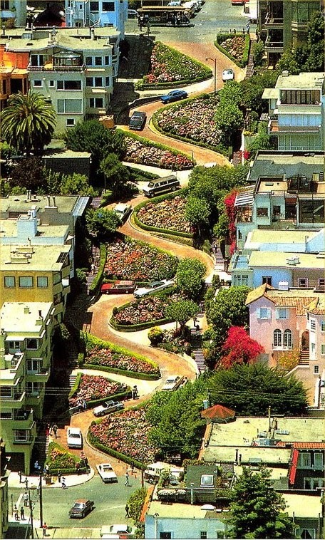
Cars nervously dodging each other
Long, winding roads.

Trees swaying in the wind.

Image 2 to describe.

Slushy

Crunchy
Coldly white and opaque.

Snow dripping down the branches.

Image 3 to describe.

Walls caving in all around me
Mysterious ruins
Rocks crumbled
Vines wrapping around tall, chunky trees.

Reading – choose a book they want to read.
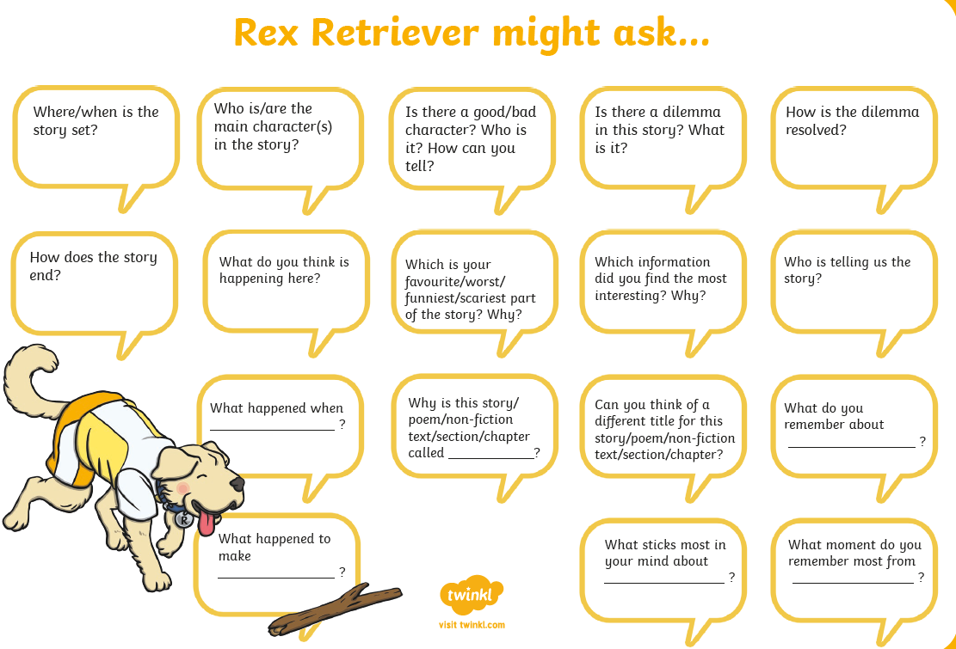

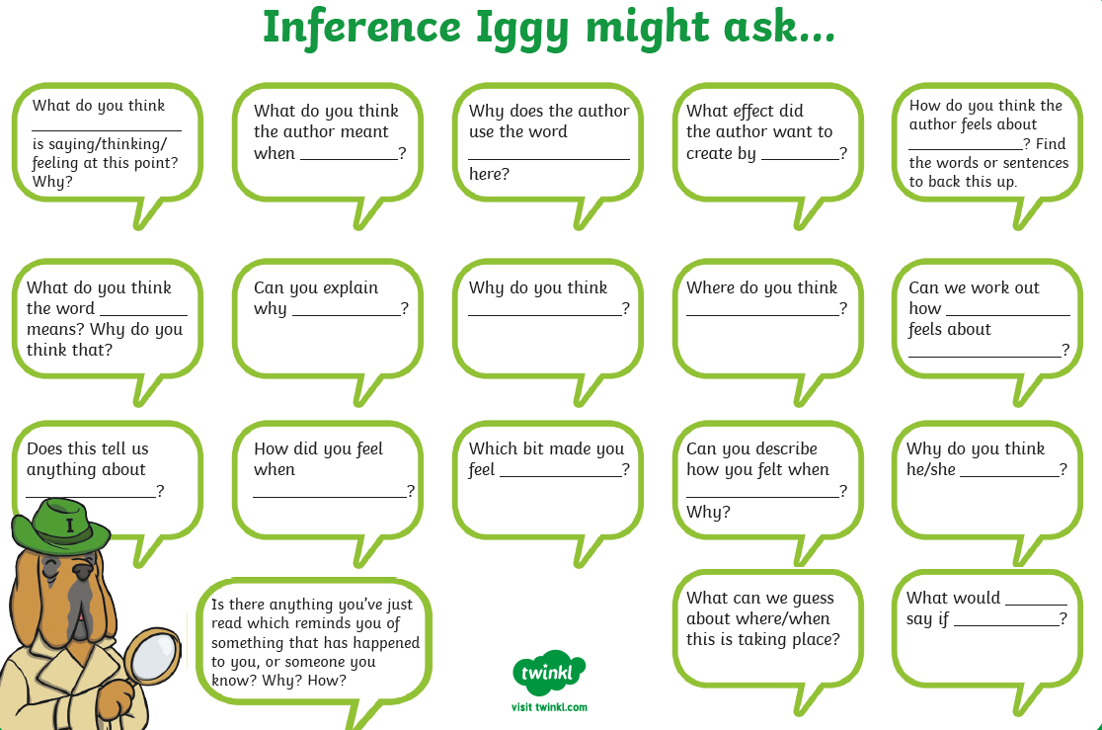

A New Pet

Tom was six. He lived in a flat with his Mum. The flat was on the top floor. It was very high up!
One day, Tom said to his Mum, “Mum, can I have a dog?”
But Mum shook her head and said, “No Tom, you can’t have a dog. There are no dogs allowed in a flat.”
Tom wanted to cry. Then he said, “Mum, can I have a cat?”
But Mum shook her head and said “No Tom, you can’t have a cat. There are no cats allowed in a flat.”
Now Tom did start to cry, “I want my own pet!” he shouted.
Mum patted Tom on the back and gave him a kiss, “Don’t cry Tom, I will see what I can do.”
The next day, when Tom got home from school, there was a small cage on the table. Tom was excited! He ran to look in the cage. In the cage was an orange hamster! Mum put the hamster in Tom’s hands.
Tom smiled and said, “I will call it Rusty. Thank you, Mum!”

Questions.
- How old is Tom?

- Where does Tom live?

- What pets did Tom want?

- How does Tom feel when Mum says “No?” How do you know this?

- How does Mum try to make Tom feel better?

- Why was Tom excited when he saw a cage on the table?

- What was in the cage?

- Why did Tom call his pet, ‘Rusty?’

- How do you know Tom is happy about his new pet?

- Do you have a pet or would you like one? What kind of pet?

