Wonder by RJ Palacio
Chapter Three
How I came to Life
I like it when Mom tells this story because it makes me laugh so much. It’s not funny in the way a joke is funny, but when Mom tells it, Via and I just start cracking up.
So, when I was in my Mom’s stomach, no one had any idea I would come out looking the way I look. Mom had Via four years before, and that had been such a, ‘walk in the park’ (Mom’s expression) that there was no reason to run any special tests. About two months before I was born, the doctors realised there was something wrong with my face, but they didn’t think it was going to be bad. They told Mom and Dad I had a cleft palate and some other stuff going on. They called it small anomalies.
There were two nurses in the delivery room that night I was born. One was nice and sweet. The other one, Mom said, did not seem at all nice and sweet. She had very big arms and (here comes the funny part), she kept farting. Like, she’d bring Mom some ice chips, and then fart. She’d check Mom’s blood pressure, and fart. Mom said it was unbelievable because the nurse never ever said excuse me!
Meanwhile, Mom’s regular doctor wasn’t on duty that night, so Mom got stuck with this cranky kid doctor she and Dad nicknamed Doogie after some old Tv show or something. But Mom says even though everyone in the room was kind of grumpy, Dad kept making her laugh all night long.

Your task
Complete retrieval facts about each character below.

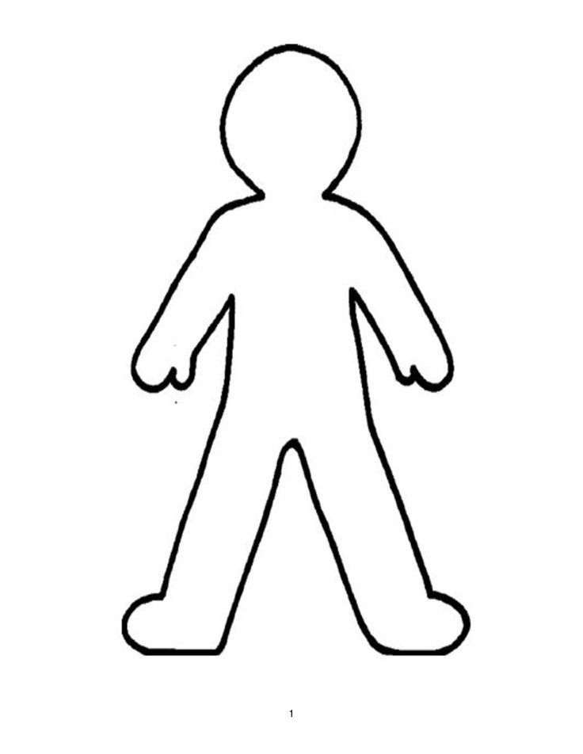
Auggie

Nurse two

