Y3S - Home Learning
Dear Y3S, since we are not able to be together at school at the moment, I have put together some more learning activities that you can complete with your adults at home. Some activities can be printed and there are also some on-line links that may be helpful. I hope that you are all well and look forward to being back together as soon as we can. Miss Shaw
Daily Activities:
 | Activity
9.00 – 9.30 | PE with Joe Wickes | Login to you tube and search for Joe Wickes PE – it will be live that morning. This is good for all children to take part in.
Activity 1 | Maths  (30 mins) | Monday  Have a go at the roman numeral challenge below and then check out the meaning of the phrases on the internet.  Tuesday - Thursday  Look at the attached Year 3 Maths Mastery Pack and complete Pack 4 sessions A, B, C and D. The section is all about application of multiplication. You are all really brilliant at your times tables, so just think about what you already know.  There are some notes for adults about how to help you.
Activity 2 | Times tables  (15 mins) | Log in to Splat 100 square and splat your counting patterns.  https://www.primarygames.co.uk/pg2/splat/splatsq100.html  Monday 2’s  Tuesday 4’s  Wednesday 8’s  Thursday 3’s  Friday 6’s  For each daily pattern count it forwards and backwards….as a challenge, can you count them forwards then backwards with your eyes closed?  If you want to extend your learning, mark out the pattern of 9’s.  Then log into TTRS and complete 10 minutes practice on the studio section
Activity 3 | Spelling  (10 mins) | Write the spellings for this week just like we do every day in the classroom. Remember LOOK / COVER / WRITE / CHECK  LOOK at the word carefully  COVER the word  WRITE it from memory  CHECK your spelling  Then use the words in a sentence – if you are not sure of the meaning you can ask an adult / check it in a dictionary / check using an on-line dictionary.  The words that I have selected this week all contain the sound “u” but it is made with an “o” such as “other.”
Activity 4 | Handwriting  (5 mins) | Use the prepared line guide to write the joins used in our selected spellings.  on ov other
Activity 5 | English  (30 mins) | Reading, writing and grammar  Look at the attached Year 3 English Mastery Pack and complete Week 3.  Over the next 5 days you will be able to read again Chapter 1 and 2 of a wonderful story entitled “Mr Majeika” by Humphrey Carpenter, and you will be able to answer questions, write your own description using lots of adjectives and use your knowledge of grammar to complete some written activities.  All you need is a pencil / pen and some paper
Activity 6 | (30 mins) | Look at the other learning opportunities listed below and select one to do each day!

Other learning opportunities
Choose an activity each day

Music | https://www.outoftheark.co.uk/ootam-at-home/?utm_source=homepage&utm_campaign=ootamathome2&utm_medium=banner  Log on to the above website. Here you will find lovely songs to sing, just like the ones that we use every week in singing assembly.  Choose a song  Listen to it all the way through and spot any repetition  Join in with the song the 2nd time through, following the words on screen.  Make up your own actions or even dance moves, and don’t forget to follow the links for other activities related to each song  This week, I’ve been singing “Dang-a-rang-a-dang-do!” from the week 4 pack and “The bonkers song!” from the week 1 pack. “Dang-a-rang-a-dang-do!” is a tongue twister, and I have tried it – it is almost impossible!!!!!! Don’t forget to check out the related activities, including the shortest tongue twister that you can try with your family.
French | Take a look at the activity below. Can you write the numbers words in French on the birthday cakes below?
Art | I hope that you enjoyed the workshops last week, provided by local Sheffield Artist Pete McKee. Have a go at drawing cartoon animals now … all you need is a pencil and paper.  https://www.youtube.com/watch?v=KdKpPmBbr6s
ICT | Send me an email to the address below and include an emoji to let me know how you feel.  MissShaw@newvillage.doncaster.sch.uk
PSHE | Think about ways that you can relax.  As a way to relax, use the link below to watch the live pictures of penguins at Edinburgh Zoo.  https://www.edinburghzoo.org.uk/webcams/penguin-cam/#penguincam  The rockhopper penguins are sitting on their rocky nests at the moment waiting for their eggs to hatch. After watching the live web-cams you might want to colour the mindfulness picture of a lion below.
DT | In science we are learning all about the body and digestion. For your DT homework, why not have a go at making your own blueberry and banana muffins using the recipe below from Joe Wickes.
Science | In science we learning all about the teeth and digestion. Learn more about the digestive system and what happens to food in your stomach by looking at the attached links.  https://www.bbc.co.uk/bitesize/topics/z27kng8/articles/z9wk7p3  https://www.bbc.co.uk/bitesize/topics/z27kng8/articles/zg2g7p3  After watching these clips, have a go at completing the diagrams below by cutting out the parts of the body and sticking them in the correct places on the diagram.
Follow a recipe. Bake a cake or help prepare a meal for your family. Make sure there is an adult who can help you. |  | A big night in!  Have a big night in with your family – get dressed up, have a meal and watch something great on the TV!

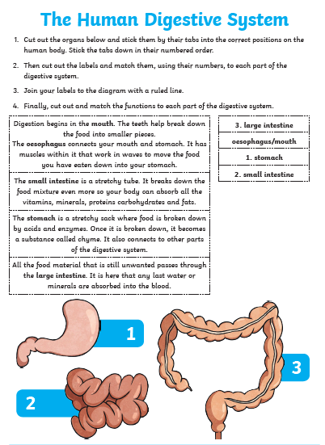

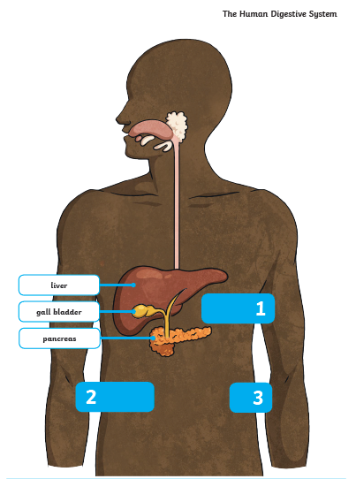

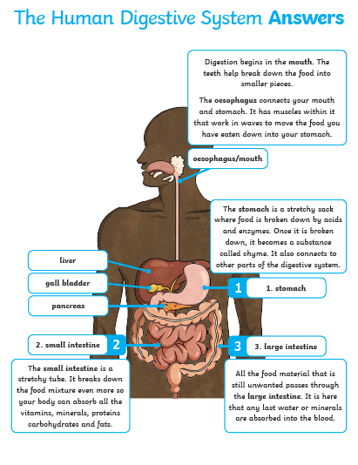

French challenge
Write the correct number on each cake in french. You can find the numbers on the number mat below.

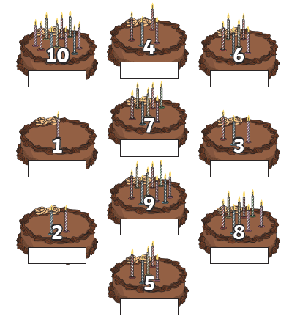
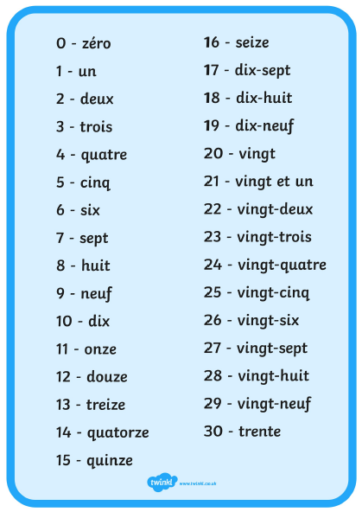

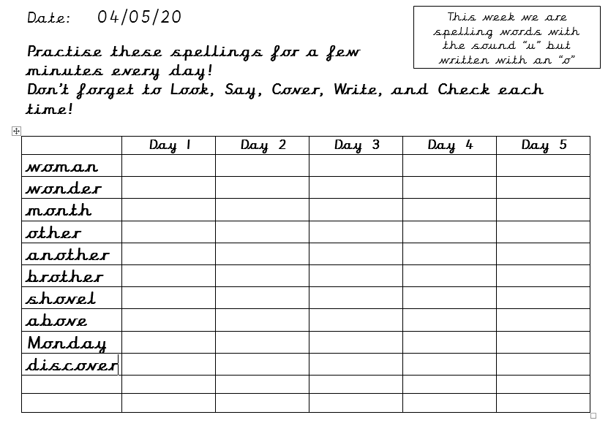

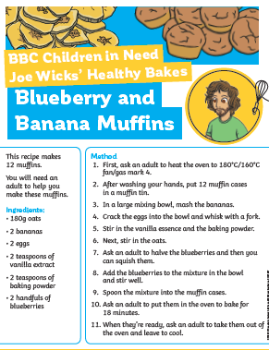

Use the lines below to write a sentence using each of these words – remember to use

your joined handwriting

