Geography-
Think back to our last topic lesson when we explored the arctic and Antarctic looking at globes.
This week’s focus is on The Arctic
Watch these clips to help you
- https://www.bbc.co.uk/programmes/p00mq6j2
- https://www.bbc.co.uk/teach/class-clips-video/science-ks1-ks2-wonders-of-nature-polar-bears-in-their-habitat/z73ygwx
- https://www.bbc.co.uk/bitesize/clips/zpqw2hv

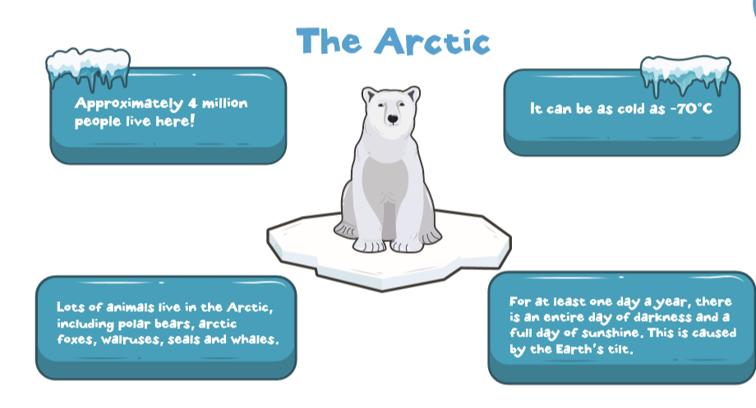
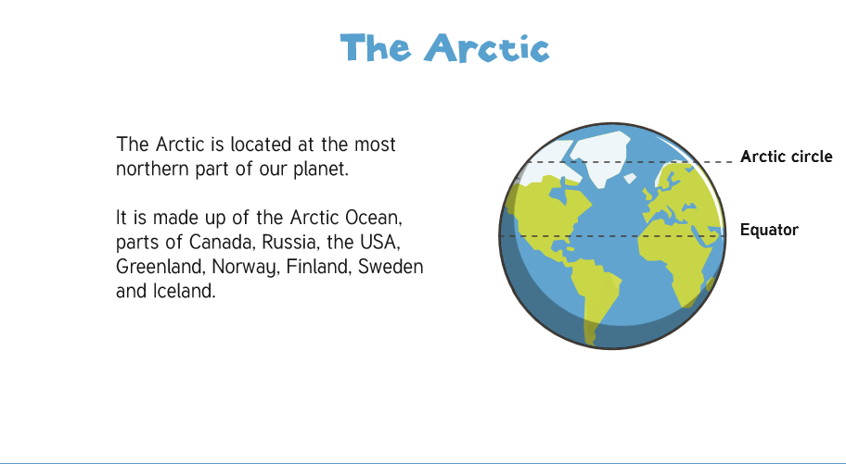

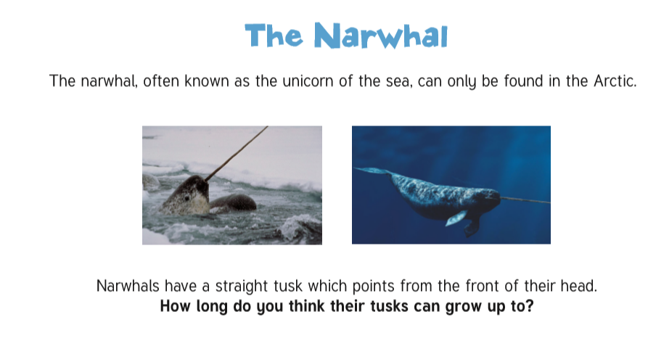
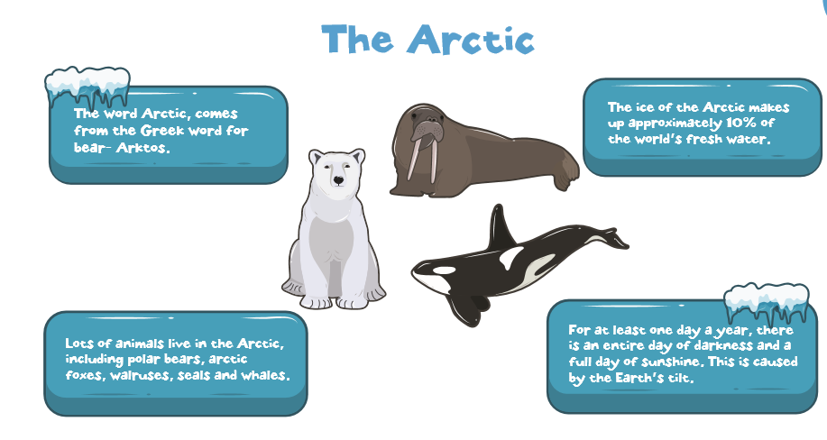
#

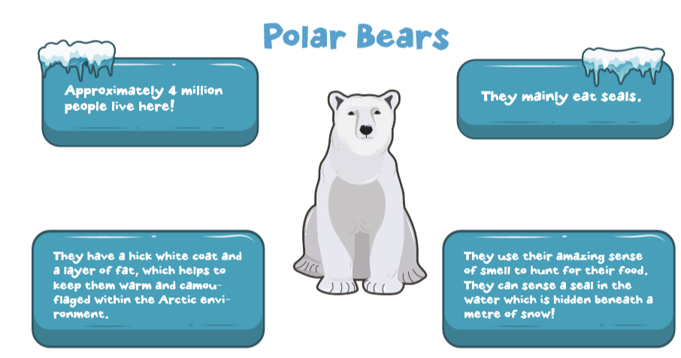
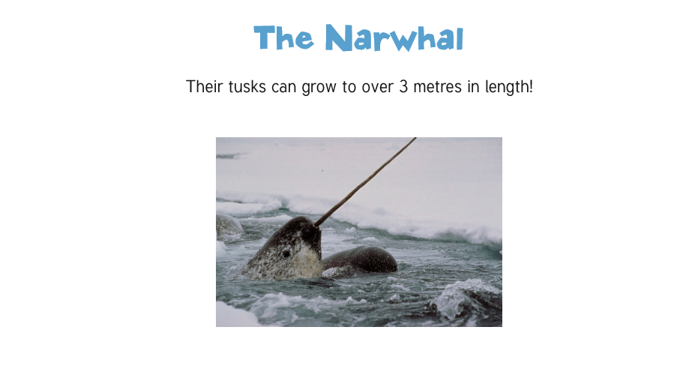

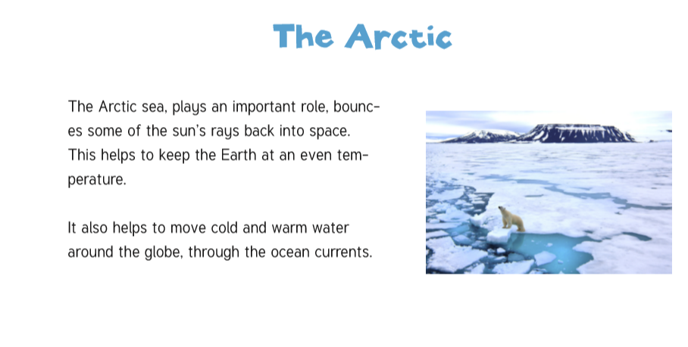
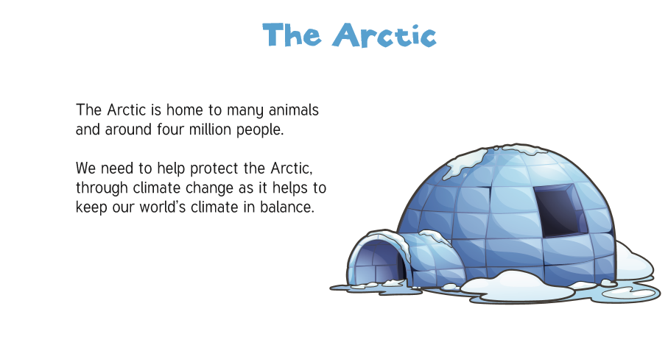

Tasks:
- Choose an acrostic poem to complete
- Choose a fact-file to complete, use the internet to help you

Send a picture of your completed work to:
missemery@newvillage.doncaster.sch.uk

