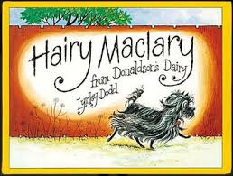
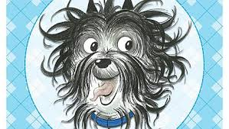

Hairy McClary from Donaldson;’s Dairy
- What type of animal is Hairy McClary?
- Which dog was covered in spots?
- Which animal were all the dogs afraid of?
- Who did Hairy McClary meet first?
- Which dog was like a bundle of hay?
- Who was described as skinny and bony?
- Where did Hairy McClary run to at the end of the story?

