Week Three
Maths Activities

Hello Everyone! I hope you enjoyed watching the video.
Here are some activities you can now do to practise maths at home.

Sayings number names to 20 in order.
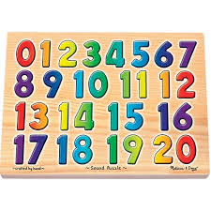
Can you say the numbers in order from 1 to 20?
Counting game
The grown up starts to count and then stops. You have to start from where they stop and carry on all the way to 20.
Take it in turns to start counting and stopping.

Count by listening.
How many claps can you hear?
Can you show that number using your fingers?
How many stamps can you hear?
Can you show that number using your fingers?

Finding and talking about patterns
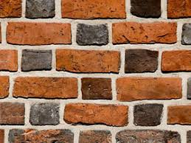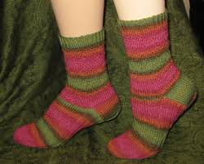
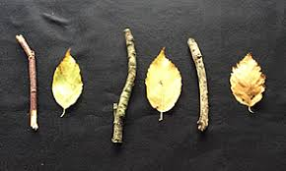
There are patterns everywhere! Enjoy looking for different patterns around your home.

