Week 3 - Craft Activity
This week we are asking you to think about rainbows. This rainbow streamer is made by using half of a paper plate or a semi – circle of cardboard. The children can decorate the semi – circle in any way they like. Next they need to attach different coloured strips of paper or ribbon to the semi – circle. This will make a streamer that can hang in your window.
The pictures below show you examples of rainbow streamers.

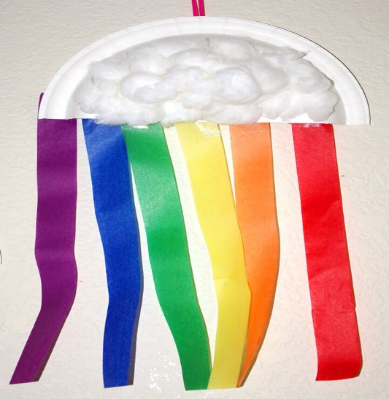
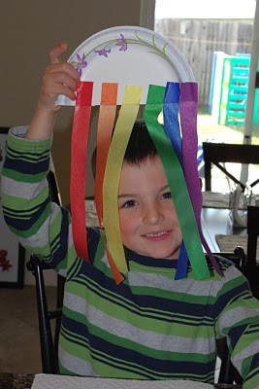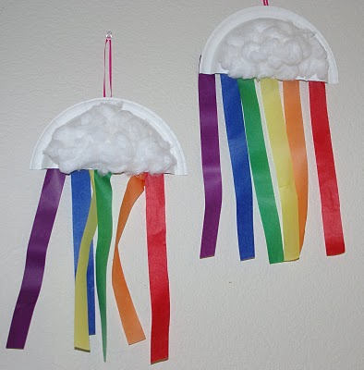
Easy peasy, bright and cheery!

