Writing Task- letter
Think back to last weeks topic learning where you designed your own rainforest animal. Imagine how de-forestation could destroy your animal’s habitat. Your task is to write a letter explaining this.
Please send your completed letter to:
Missemery@newvillage.doncaster.sch.uk
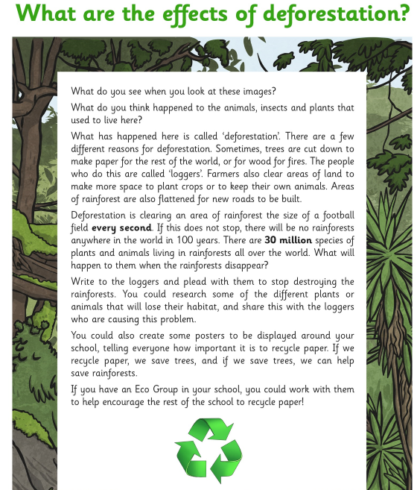

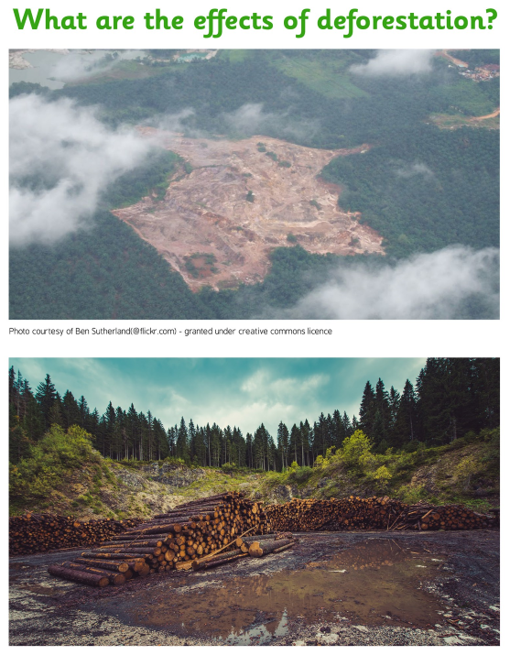

Remember to use your year five features and apply your knowledge of modal verbs from last week’s learning.

Your address goes here

Dear whom it may concern,
I am writing to you today because…

The well-known animal called a ______________ relies on the rainforest as its habitat because…

Its habitat…

Its diet…

Please re-consider your actions…

Yours Sincerely,

