WALT: To solve comparison, sum and difference problems using information presented in a line graph
WILF:
- Find the data from the question on either the X axis or Y axis.
- Draw a line using a ruler from the data to the line
- Draw from the line to either the X or the Y (depending on step one)
- Record your answer
Watch this video to explain line graphs
https://www.youtube.com/watch?v=n2YkbdNORp8

When you have finished your learning, have a go at making your own
https://mathsframe.co.uk/en/resources/resource/111/itp-line-graph
Send a picture to missemery@newvillage.doncaster.sch.uk

Reminder
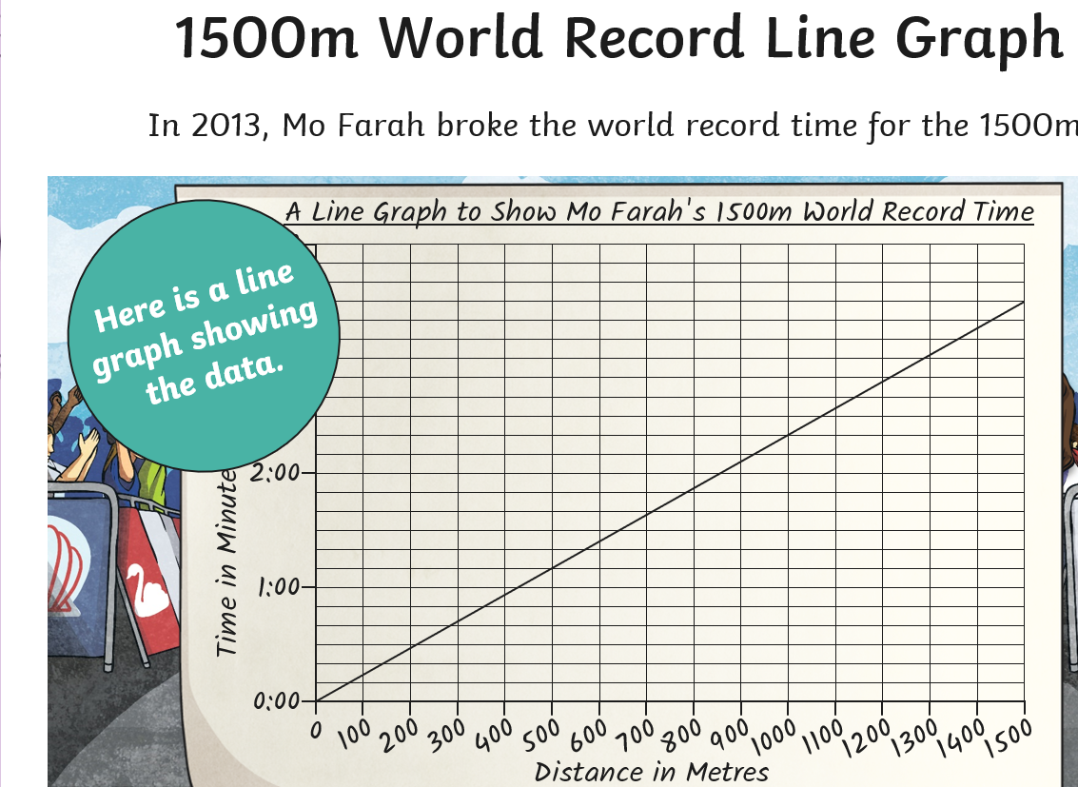

The X axis goes across
The Y axis goes up

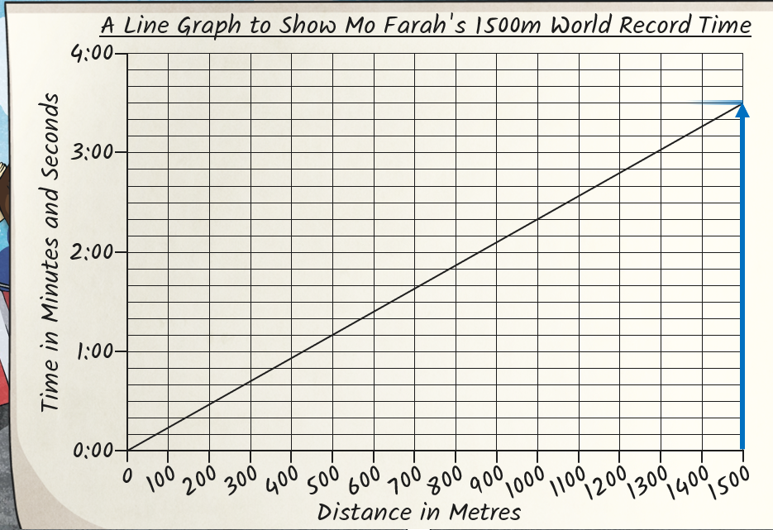
- Start on the X axis, draw a line to where it meets the Y axis.

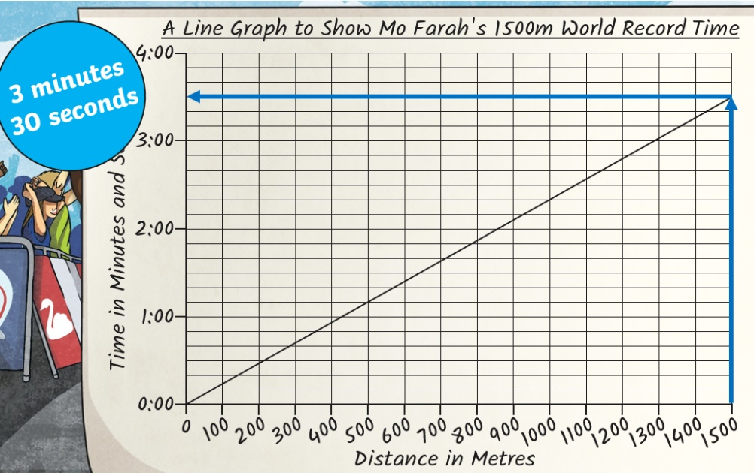

2.Draw across to the Y axis

Practise
Question
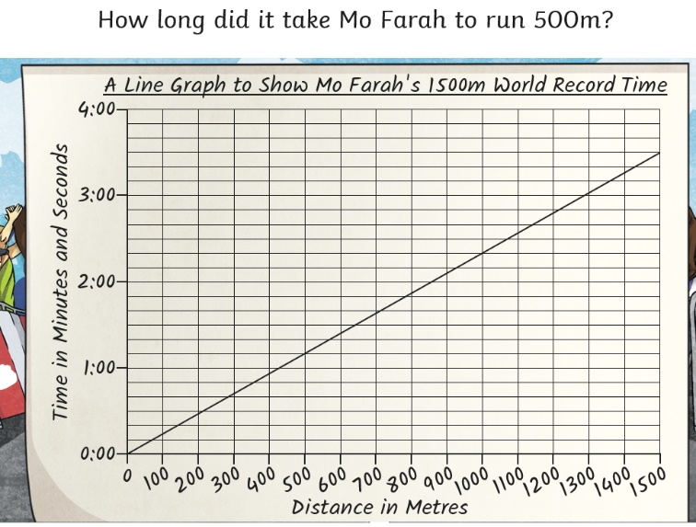
Step one
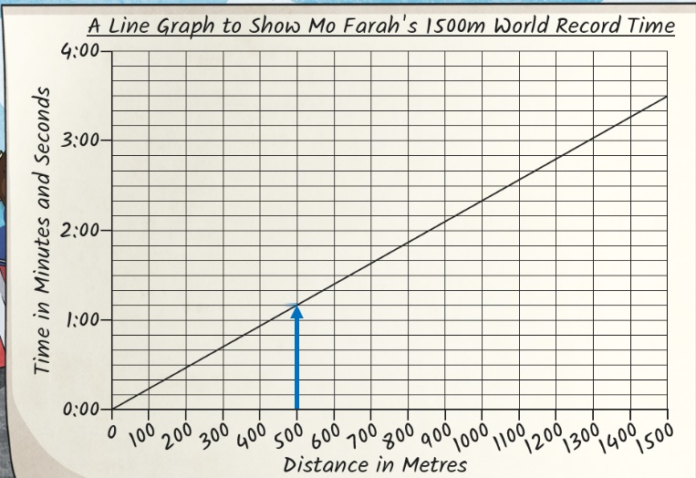
Step two
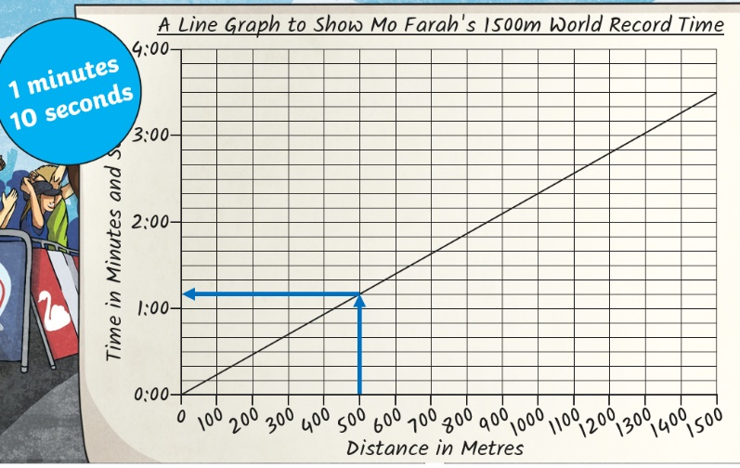

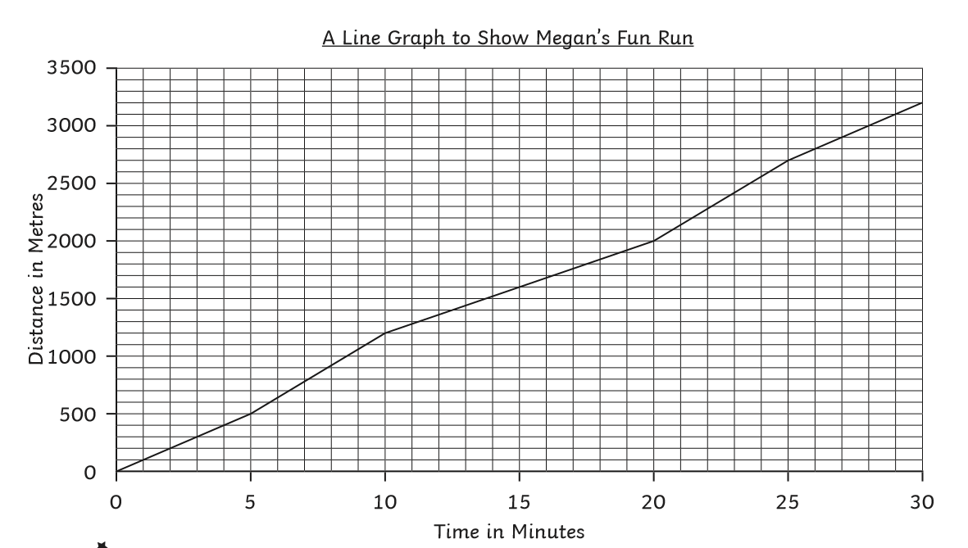
Activity one- Use the graph to match the questions to their answers

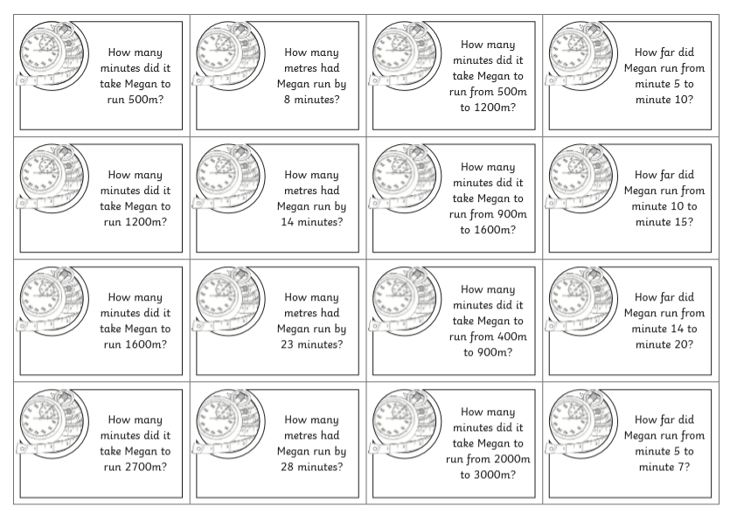
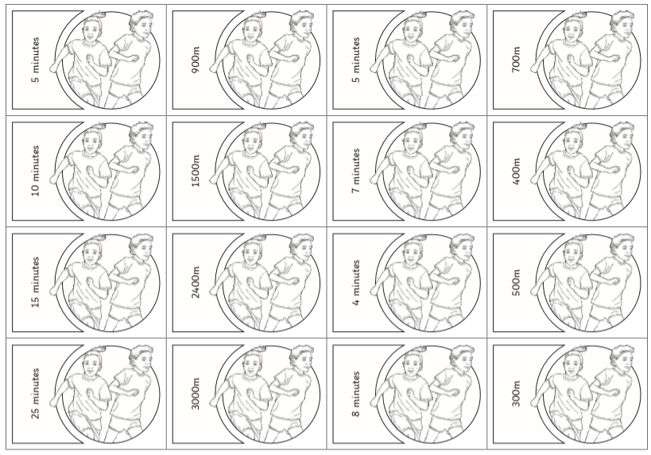#
Challenge
